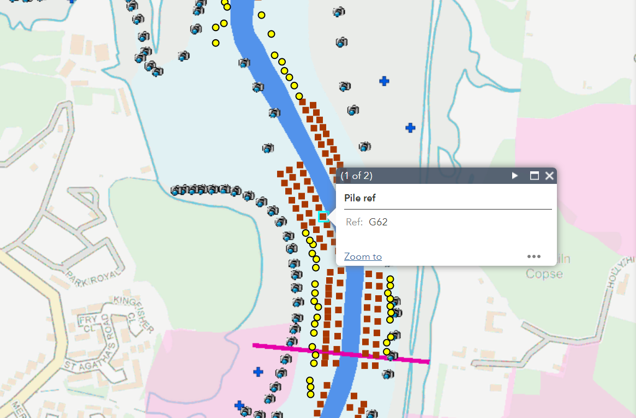

Schematic of Hamble River Mooring showing G62-63

