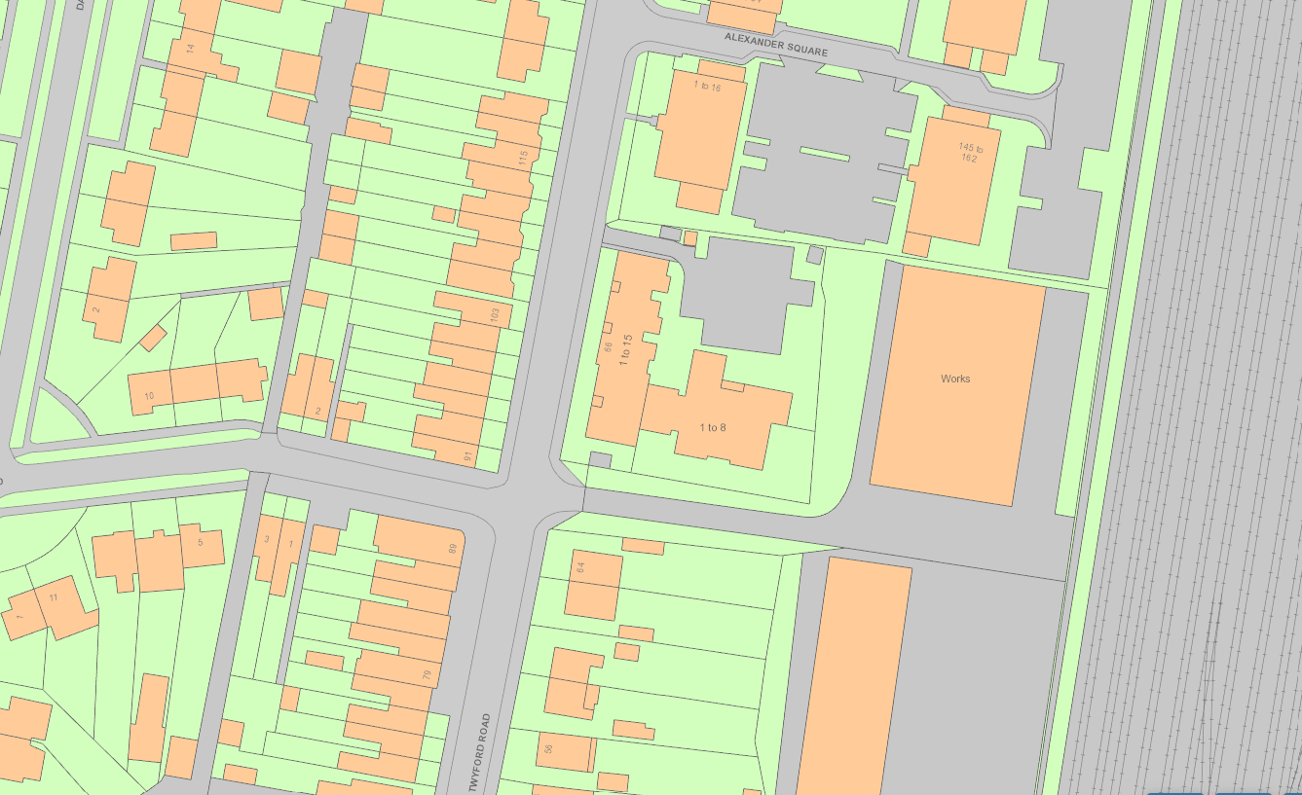
T4126 Horse Chestnut tree

