Planning Condition Discharge Application

Details of materials and samples:

Facing Brick: Forterra Hampton Rural Blend
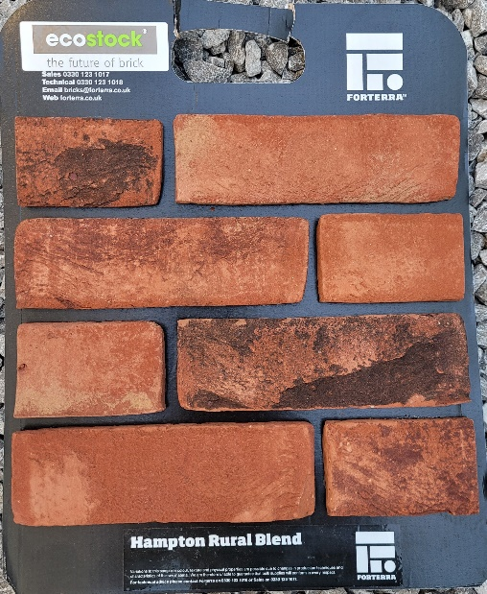

Roof Tile: Sandtoft Interlocking tile
Colour- Flanders
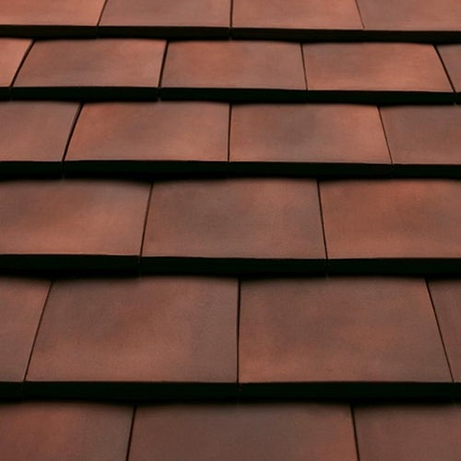

Windows: White UPVC Double glazed windows


Landscaping:
As you look from the roadside to the property, the site will have a 1.8m high fence the left-hand boundary, rear boundary and the right-hand side is made up of 1.8m high to the rear and 1.2m high to the front right.
The property will have a blocked paved driveway to the front, porcelain slabs to the rear for a patio. Garden to be mainly laid with lawn with flower beds to the boundaries with some new trees being planted to the rear garden.

Foul sewage will be disposed of into mains drains. Surface water from the roof will be disposed of into a soakaway system to the rear garden. The surface water from the blocked paved driveway will be disposed of into a soakaway system under the front driveway.

The site will have hoarding to the right-hand side and front left with a pair of large metal site gates boarded for security reasons. These will also be shut during work ours to stop any members of the public walking on to the site without authorisation. The hoarding will also offer protection to the general public when they are walking along the path. All construction material will be stored on site with lorries being able to reverse onto the site to unload the materials and making sure the highway does not get blocked. All deliveries can enter from Bournemouth Road and then reverse onto the site and leave exiting onto Bournemouth Road. A site operative with a pressure washer will be tasked with cleaning all vehicles’ wheels before leaving site to ensure pavements and highways are kept clean. Arrangements have been made for site operatives to park their vehicles on the driveway of 10 Keble Road, SO53 3DS.
During construction there will be a skip on site at all times to make sure waste is disposed of currently and contained to one area. Any cutting of masonry products will be cut with water to stop any dust from leaving the site to neighbouring properties.

