Dear Valdeep,
I will try this method one more time! Following our previous examination of the treehouse it is clear that it is sadly beyond repair.

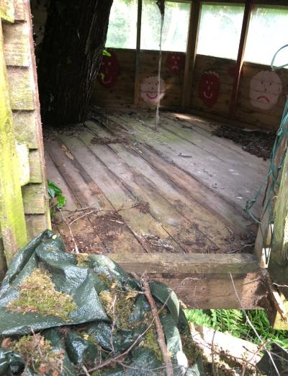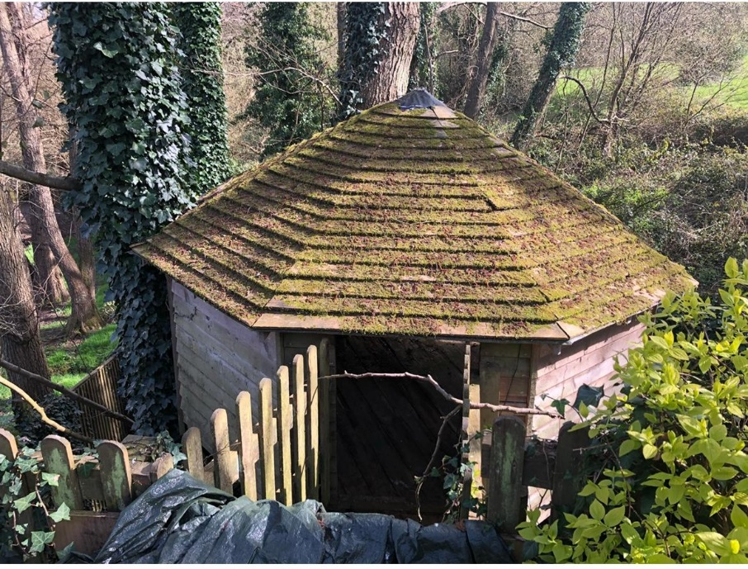

To replace the treehouse with new to create many hours of family fun for years to come.

Window


3.3m

Window Window

Door
Walkway with spindled 1.1m sides
Gate

We will build a new bridge / walkway from the garden over to the treehouse which will look like this, with 1.1m high spindled sides.

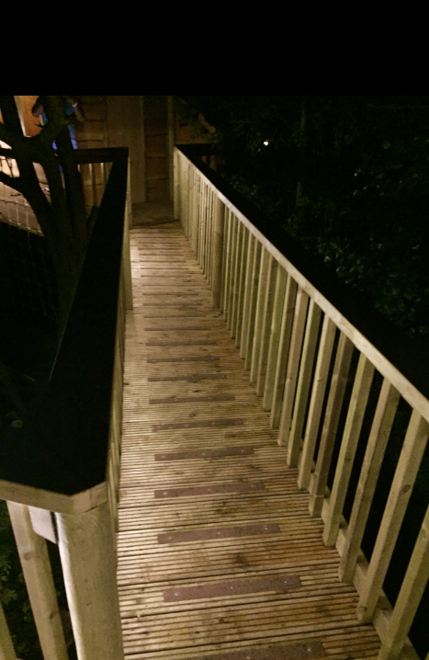

I propose to construct the sides from waney edge larch a more subtle look.

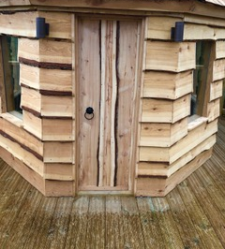

The roof will be marine ply with waterproof felt tiles which will not rot unlike the existing roof boards.

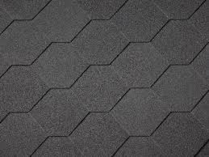

The treehouse will have 3 double glazed toughened glass windows.

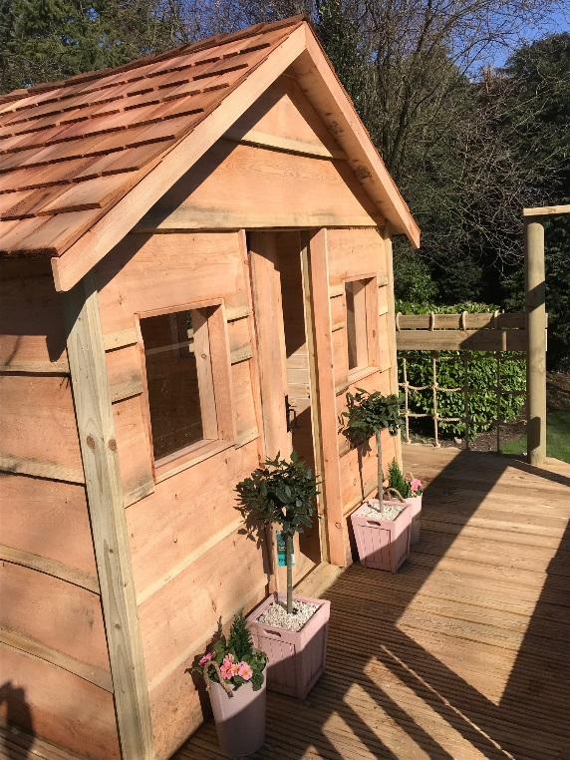

If you wish to fully insulate the building and internally clad the building that will be at an additional cost of £2448. As seen below.

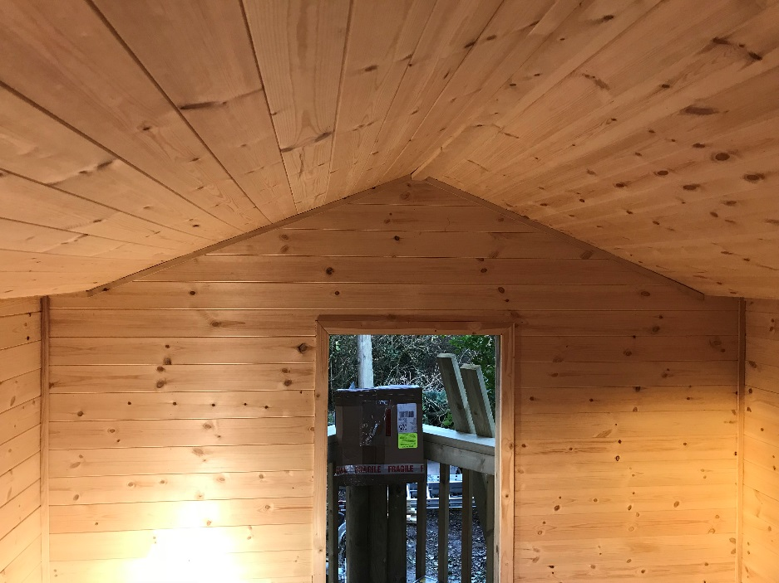

I have not costed for the removal of the existing treehouse and its disposal if you wish us to do so add £1788

Cost to supply new treehouse as described above £13,442
Vat to be added at 20 %

Please let me know, if you wish for the work to be carried out Lead time 4 weeks, it will be 3 week build.

Kind regards Dick

