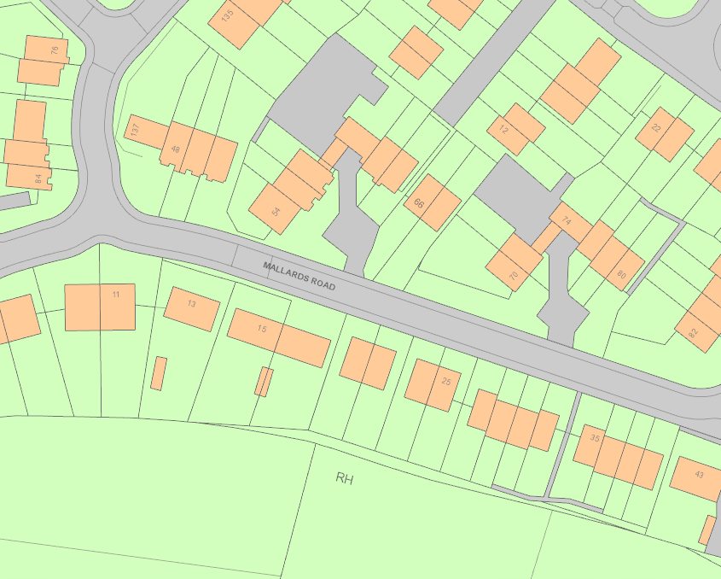
T3787.59 English Oak
T3787.5 English Oak

