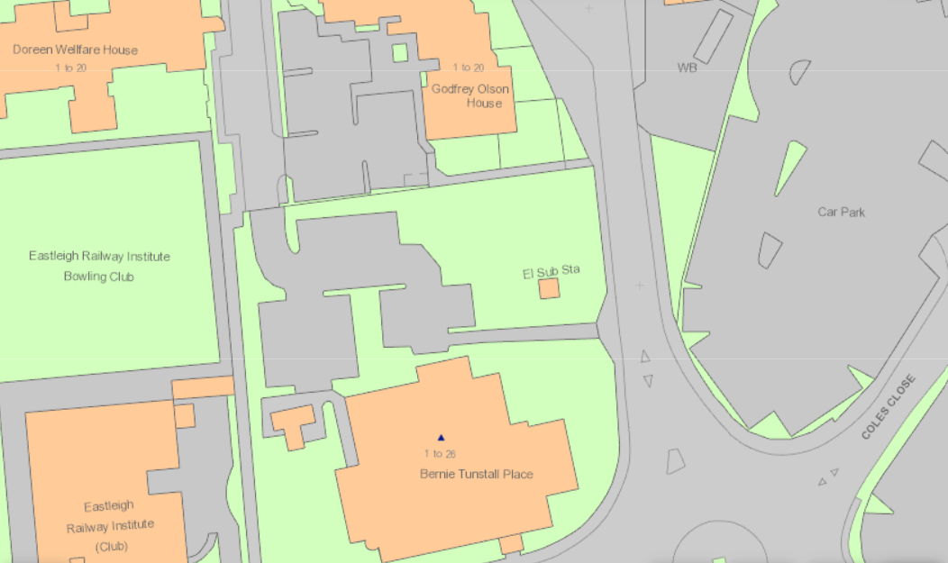
T4172 Holm Oak
T4173 Holm Oak
TG166.1 Lime

