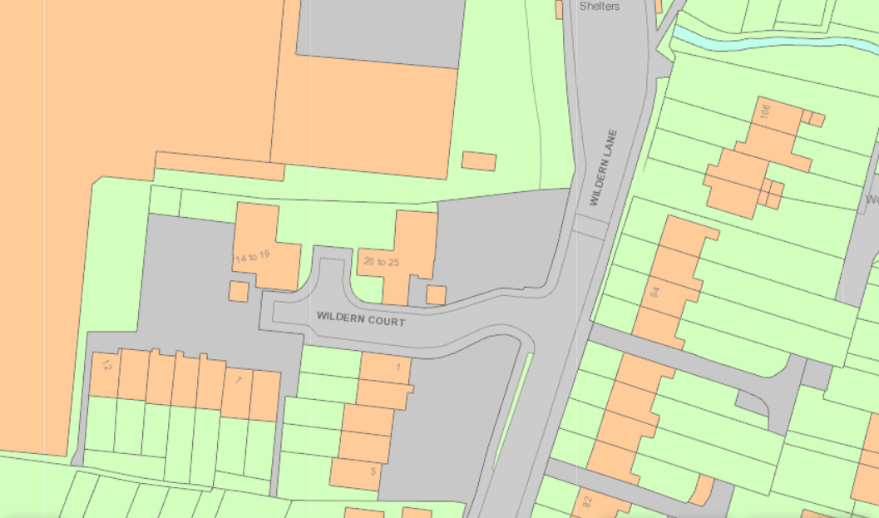
T3669 Oak tree
T3668 Oak tree

