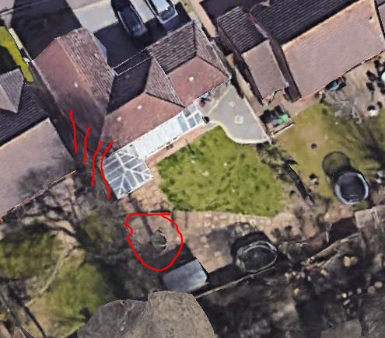
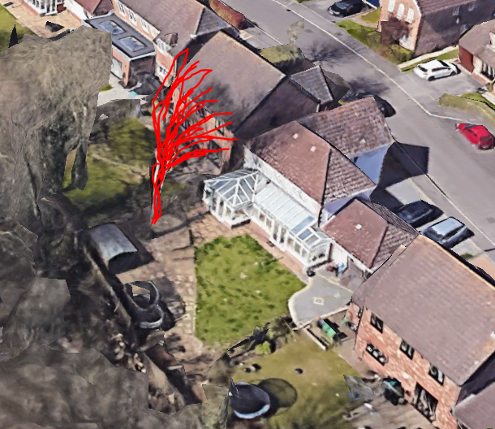

These pictures are taken from Google Earth and I’ve shown the location and growth of the ash concerned. We would like permission to have the tree reduced in height by 4 – 5m and the overhanging growths removed. Now that the oak has gone, the ash is free to regrow into a more stable shape but must be reshaped first.

