Condition 9 – Hard Landscaping

Requested:
- a photo of what is implemented
- update to the Abley Letchford Partnership plan to correspond with implemented block paving.

Parcel C2a is now 100% complete.
Parcel C2b is now 100% complete.

Block Paving

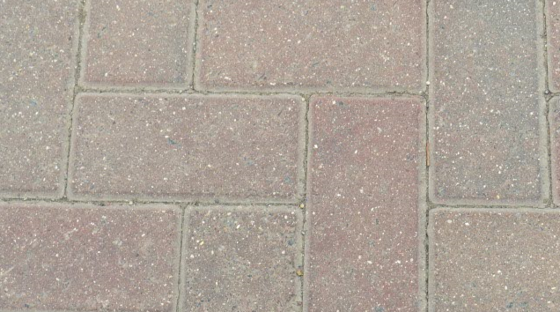
MARSHALLS TEGULA BLOCK PAVING as per CONSTRUCTION MAKEUP Plans:
PARCEL C2b 17-301/201
PARCEL C2a 17-301/101

Extract taken from construction makeup plan 17-301/201 showing block paving area:

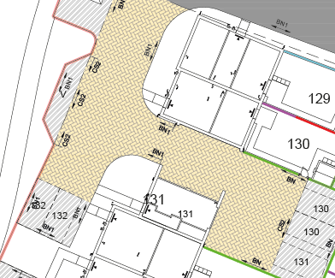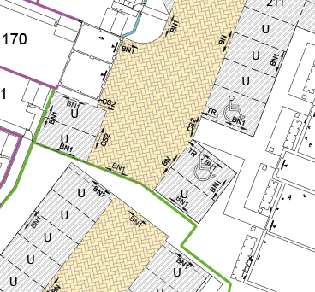
Parcel C2a Parcel C2b

