Sustainability and BREEAM Report

Hampshire Fire & Rescue Headquarters, Eastleigh

Redevelopment of Live Fire Training Site

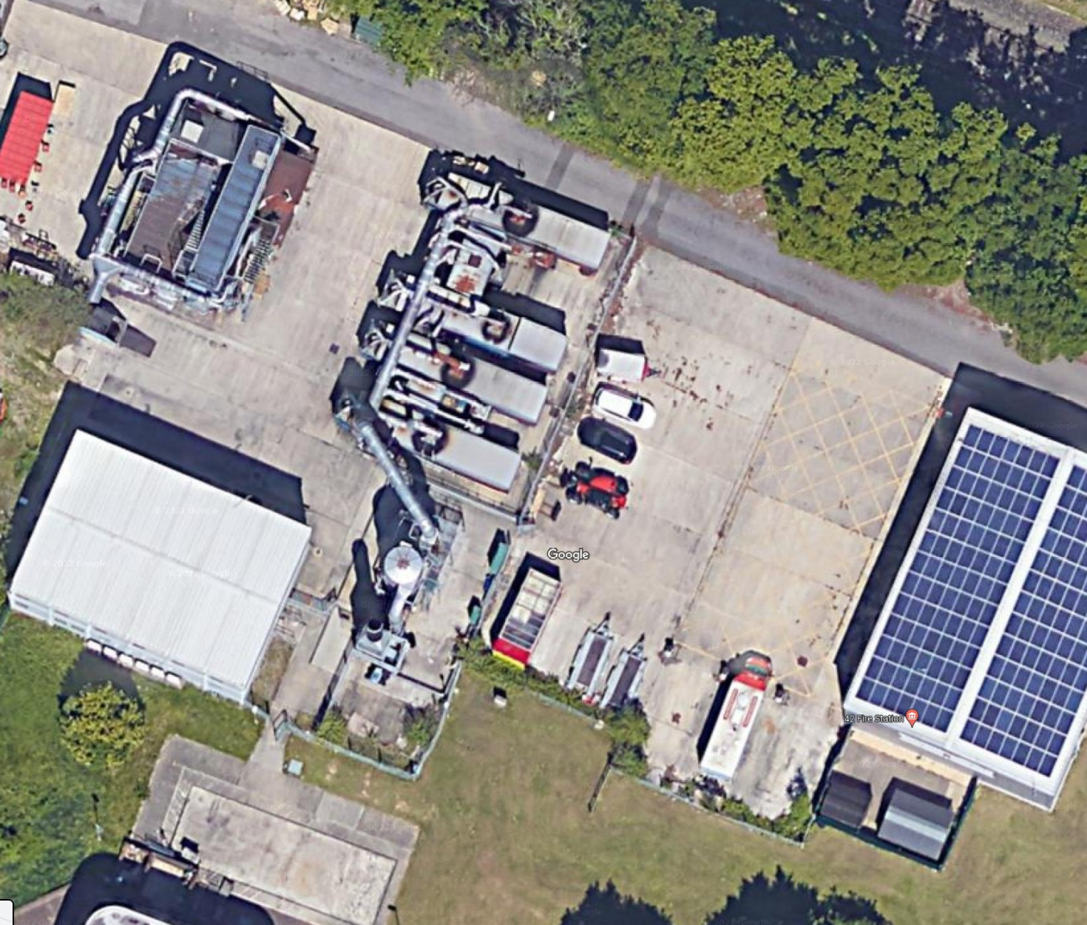

August 2022

Contents

1. Executive Summary 4
2. Introduction 5
3. Drivers of Sustainability 9
4. National Policy 11
5. Local Policy 13
6. Energy Usage and Carbon Emissions 15
6.1. Policy Review 15
6.2. Development Sustainability Features 16
6.3. BREEAM 17
6.4. Summary 17
7. Water Consumption 19
7.1. Policy Review 19
7.2. Development Sustainability Features 19
7.3. BREEAM 20
7.4. Summary 20
8. Transport 21
8.1. Policy Review 21
8.2. Development Sustainability Features 22
8.3. BREEAM 26
8.4. Summary 26
9. Construction Site Management 27
9.1. Policy Review 27
9.2. Development Sustainability Features 27
9.3. BREEAM 28
9.4. Summary 29
10. Sustainable Design 30
10.1. Policy Review 30
10.2. Development Sustainability Features 30
10.3. BREEAM 31
10.4. Summary 32
11. Flood Risk 33
11.1. Policy Review 33
11.2. Development Sustainability Features 33
11.3. BREEAM 34
11.4. Summary 34

12. Noise 35
12.1. Development Sustainability Features 35
12.2. Summary 35
13. Ecology 36
13.1. Policy Review 36
13.2. Development Sustainability Features 36
13.3. BREEAM 37
13.4. Summary 37

Executive Summary

This report considers the sustainability measures to be incorporated within the proposed Hampshire Fire and Rescue Headquarters in Eastleigh. The proposed development shall comprise of a two-storey modular building accommodation providing primarily office and welfare accommodation, a dedicated bin store and an enclosed vehicle cleaning bay. The existing site use, live fire training facility, is being relocated to an alternative site.
This document reviews the requirements at both National and Local level, as set out in the National Planning Policy Framework (2012) and Eastleigh Borough Council policies.
It is recommended that development sustainability features that will reduce the CO2 emissions of the HFRS - Wessex redevelopment from a base Part L 2013 compliant build. This is to be achieved through passive design, energy efficient measures incorporating design features such as energy efficient lighting, sub-metering of relevant areas, exceeding the regulatory requirements of ‘U’ values and occupancy sensing in relative areas.
Further to this, we are looking at the energy requirements of the new building with a view to reducing the CO2 emissions further through renewables such as air source heat pumps, solar PV and other equally efficient methods.
Additional measures have been adopted as a means of reducing carbon emissions associated with the development such as using construction materials that will be responsibly and legally sourced, achieving Green Guide ratings between A+ and D. In addition to this, any insulation materials specified will have a Green Guide rating between A+ and D, also being responsibly sourced.
Conserving water resources within the local area are equally important and it is anticipated that the specification of sanitary fittings such as dual flush toilets and low flow taps will increase the water efficiency of the building and have the added benefit of saving on running costs in the long term.
The development is located within the Hampshire Fire and Rescue Headquarters and is to replace an existing live fire training centre / area of the site. The existing facility is being re-located to an alternative site.
Due to its location, it is in close proximity to major roads (M3 Motorway) and public transport (Eastleigh Railway Station is one mile away) nodes, as well as a range of primary local amenities such as a food outlets, cash points, leisure centre and retail establishments. These features allow for the reduction of vehicle-based travel by the occupants and in turn transport related pollution.
Noise maps sourced from DEFRA, highlight that the development site itself is subject to sources of noise pollution as nearby main roads (M3 motorway) and railway lines do fall into the highest noise level brackets. This coupled with the emergency response nature of parts of the overall site adds to the levels.
Due to the office nature of the proposed scheme, it is anticipated that the proposed development will not contribute to an increase in the noise levels of the area and will in fact reduce the noise levels due to the change of use in terms of operational procedures on this part of the site and the removal of the live fire training element.
The incorporation of these sustainability measures allows for the proposed redevelopment to be deemed sustainable whilst targeting compliance with local and national policy.

Introduction

This report has been prepared by Hampshire County Council, to investigate the issues of sustainability surrounding the proposed HFRS - Wessex redevelopment in Eastleigh, hereafter referred to as ‘the Site’.

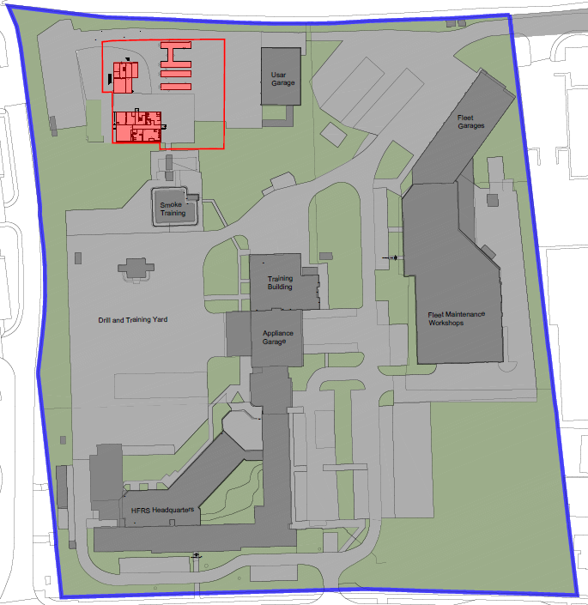
Fig 2.0 – Existing Site Plan – The buildings highlighted in red are currently used for Live Fire Training and are to be removed as part of the redevelopment.
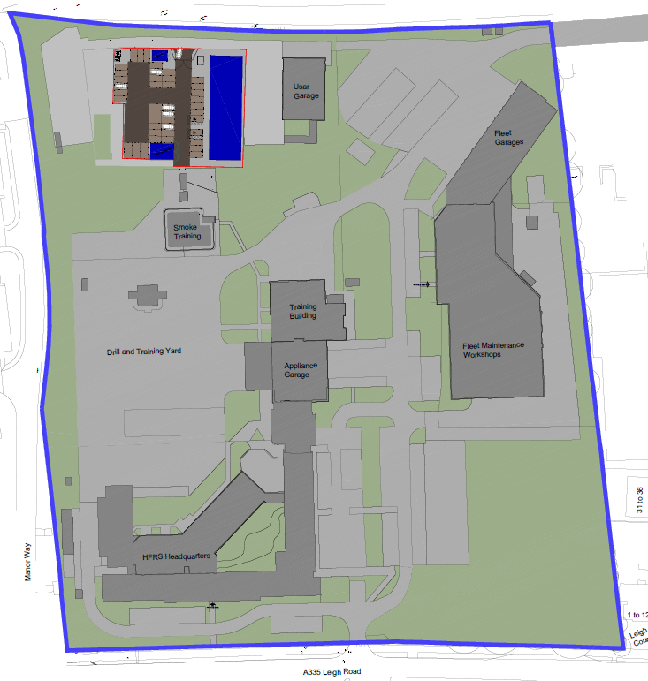
Fig 2.1 – Proposed Site Plan

Government policies have been reviewed for guidelines and recommendations on each issue, at both national and local level as well as the requirement for the development to achieve a BREEAM New Construction 2014 ‘Good’ rating.
The proposal comprises a new two storey modular building to replace an existing version as well as a Bin Store and Vehicle Cleaning bay. The proposed modular building floor plans can be seen in Figures 2.2 and 2.3 below. Fig 2.4 shows a more detailed Site Plan.

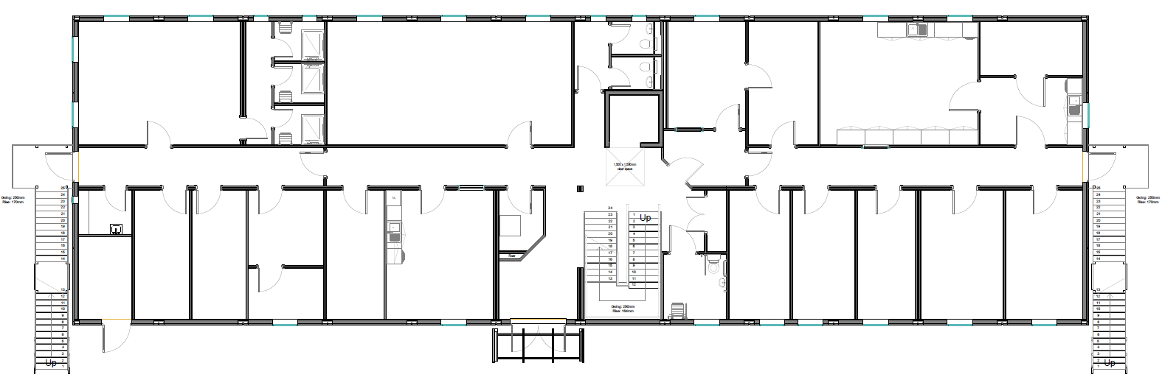
Fig 2.2 – Ground Floor Plan

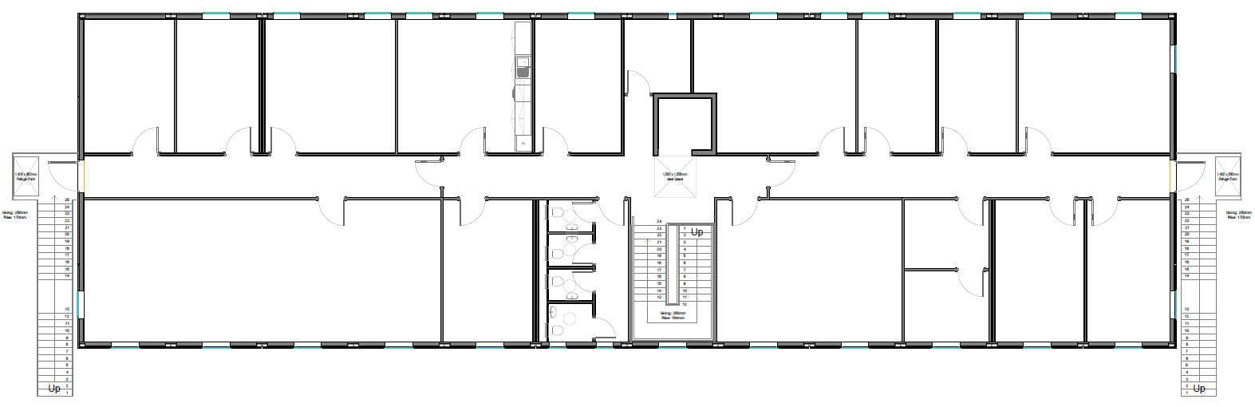
Fig 2.3 – First Floor Plan

By utilising the existing surfaces, we are reducing the requirement for any new concrete, a carbon high element, and although not entirely unavoidable, keeping this to a minimum is a benefit.
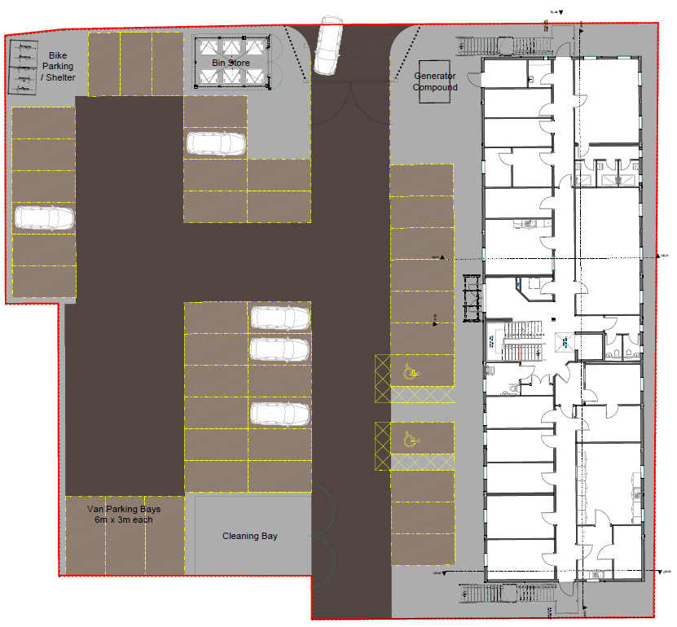
Fig 2.4 – Detailed Site Plan

Drivers of Sustainability

The term Sustainable Development, is defined by the Department for the Environment, Food and Rural Affairs as:

‘… making sure people throughout the world can satisfy their basic needs now, while making sure that future generations can also look forward to the same quality of life. It recognises that the “three pillars” – economy, society and environment – are interconnected.’

To achieve this objective of sustainable development in any industry, sector strict regulations have been put in place that have filtered down through EU Directives from the European Climate Change Programme, to National UK Acts such as the Climate Change Act 2008, to Local Policy in the form of Core Strategies. However, there are larger drivers behind the concept of sustainable development.

Kyoto Protocol In 1997, the Kyoto Protocol was adopted as part of the United Nations Framework Convention on Climate Change, to which the UK is a signatory. The key feature of the protocol was the binding targets that were set for industrialised countries to reduce their Green House Gas emissions by 12.5% below 1990 levels by 2008-2012.

Cancun Agreements since the initial adoption of the Kyoto Protocol, extensive research has been put forward as to the causes and markers of climate change from the Intergovernmental Panel on Climate Change, which has led to new targets and objectives being made.

In 2012, the international community met to discuss new directions for responding to climate change by adopting new agreements. The key objectives of the Cancun Agreements are:

- Establish clear objectives for reducing human-generated greenhouse gas emissions over time to keep the global average temperature rise below two degrees.
- Mobilise the development and transfer of clean technology to boost efforts to address climate change, getting it to the right place at the right time and for the best effect.
- Assist the particularly vulnerable people in the world to adapt to the inevitable impacts of climate change.
- Protect the world’s forests, which are a major repository of carbon.
- Establish effective institutions and systems which will ensure these objectives are implemented successfully.

COP21: Paris Global Climate Agreement in December 2015, a global climate deal was reached in a summit involving all of the world’s nations. The targets of this aimed principally to curb the dangerous levels of climate change and drive an increase low-carbon infrastructure investment. Numerous organisations and corporations also committed to helping create a greener future by making their own pledges through the course of the summit.

The key elements of the agreement are:
- To keep global temperatures "well below" 2.0C above pre-industrial times and "endeavour to limit" them even more, to 1.5C.
- To limit the amount of greenhouse gases emitted by human activity to the same levels that trees, soil and oceans can absorb naturally, beginning at some point between 2050 and 2100.
- To review each country's contribution to cutting emissions every five years so they scale up to the challenge.
- For rich countries to help poorer nations by providing "climate finance" to adapt to climate change and switch to renewable energy.

BRE’s COP21 Climate Pledge (December 2015) "We commit to continue to drive best practice and carbon reduction, as we have through the use of BREEAM for the past 25 years. By reaching over 9,000 BREEAM rated buildings we predict emissions savings will be in excess of 900,000 tonnes of CO2, compared to regulatory minimum performance requirements, by 2020. Saving not only carbon but bringing wider benefits to both the owner and occupiers."

National Policy

This section aims to highlight the guidance available and the minimum requirements at national level regarding sustainable development, through the key objectives set out in the Governments National Planning Policy Framework (2012).

Section 4 – Promoting Sustainable Transport
30. Encouragement should be given to solutions which aim to reduce greenhouse gas emissions and congestion.
35. Plans should protect and exploit any opportunities for the use of sustainable transport modes.
39. If setting local parking standards for any development, planning authorities should consider:
- The accessibility of the development;
- The type, mix and use of development;
- The availability of and opportunity for local transport;
- Local car ownership levels;
- An overall need to reduce the use of high emission vehicles.

Section 7 – Requiring Good Design
56. Good design is a key aspect of sustainable development.
57. It is important to plan positively for the achievement of high quality and inclusive design for all developments, including individual buildings, public and private spaces and wider area development schemes.
58. Local authorities should develop robust policies that set out the quality of developments. Policies and decisions should aim to ensure that developments:
- Will function well and add to the overall quality of the area, not just for the short term but over the lifetime of the development;
- Establish a strong sense of place, using streetscapes and buildings to create attractive and comfortable places to live, work and visit;
- Optimise the potential of the site to accommodate development, create and sustain an appropriate mix of uses (including incorporation of green and other public space as part of developments) and support local facilities and transport networks;
- Respond to local character and history, and reflect the identity of local surroundings and materials, while not preventing or discouraging appropriate innovation;
- Create safe and accessible environments where crime and disorder, and the fear of crime, do not undermine quality of life or community cohesion;
- Are visually attractive as a result of good architecture and appropriate landscaping.

Section 10 – Meeting the Challenge of Climate Change, Flooding and Coastal Change
94. Local planning authorities should adopt proactive strategies to mitigate and adapt to climate change.
95. Local Planning authorities should:
- Plan for new developments in locations & ways which reduce greenhouse gas emissions;
- Actively support energy efficiency improvements to existing buildings.
96. Local authorities should expect new developments:
- To comply with adopted Local Plan policies on local requirements for decentralised energy supply unless this can be demonstrated that this is not feasible or viable;
- To take account of landform, layout, building orientation, massing and landscaping to minimise energy consumption.
97. Local planning authorities should recognise the responsibility on all communities to contribute to energy generation from renewable or low carbon sources. They should:
- Have a positive strategy to promote energy from renewable and low carbon sources;
- Design their policies to maximise renewable and low carbon energy development;
- Consider identifying suitable areas for renewable and low carbon energy sources and supporting infrastructure;
- Identifying opportunities where development can draw its energy supply from decentralised, renewable or low carbon energy supply systems and for co-locating potential heat customers and suppliers.
100. Inappropriate development in areas at risk of flooding should be avoided by directing development away from areas at highest risk, but where development is necessary, making it safe without increasing flood risk elsewhere.

Section 11 – Conserving and Enhancing the Natural Environment
109. The planning system should contribute to and enhance the natural and local environment by:
- Protecting and enhancing valued landscapes, geological conservation interests and soils;
- Recognising the wider benefits of ecosystem services;
- Minimising impacts on biodiversity and providing net gains in biodiversity where possible, contributing to the Government’s commitment to halt the overall decline in biodiversity, including by establishing coherent ecological networks that are more resilient to current and future pressures;
- Preventing both new and existing development from contributing to or being put at unacceptable risk from, or being adversely affected by unacceptable levels of soil, air, water or noise pollution or land instability;
- Remediating and mitigating despoiled, degraded, derelict, contaminated and unstable land, where appropriate.

Local plans should set out strategic priorities for the area; this should include strategic policies to deliver the provision of infrastructure for transport, telecommunications, waste management, water supply, wastewater, flood risk and coastal change management, and the provision of minerals and energy (including heat).

Local Policy

This section aims to highlight guidance available and the minimum requirements at local level from Eastleigh Borough Council, which states the Council’s vision, spatial strategy and policies for the future development of the area.

Eastleigh Borough Council Core Strategy Development Plan Document: Sustainable Development Principles Development will be permitted which:
- Makes efficient use of land, buildings and infrastructure;
- Is located so as to reduce the need to travel;
- Promotes a mix of uses;
- Conserves the use of resources including water and energy through a reduction in their use;
Supports the economic wellbeing of the population. Protects and enhances:
- The health, education and safety of the local population;
- The quality of natural resources including water, air, land and biodiversity;
- The character and quality of local landscapes and the wider countryside;
- The historic and cultural features of acknowledged importance.

Sustainable Resources Development proposals will be accompanied by a Sustainability Statement demonstrating how current best practice in the sustainable use of natural resources has been incorporated.

Renewable Energy Generation Development for the generation of energy from renewable resources will be permitted unless there are unacceptable locational or other impacts that could not be outweighed by wider environmental, social, economic or other benefits.

Renewable Energy Development proposals for five or more net additional dwellings, or for 500 square metres (GEA) or more of floorspace for other development, will be accompanied by an energy demand assessment demonstrating how (potential) carbon dioxide emissions will be reduced by at least 10% and will provide at least 20% of their energy requirements from on-site renewable energy generation.

Sustainable Waste Management Development will be permitted which makes provision for the management and treatment of waste in accordance with the Hampshire Unitary Authorities Joint Minerals and Waste Local Development Framework, and local waste management strategies. Development will be permitted which:
- Minimises the quantity of waste requiring treatment;
- Maximises the re-use, recovery and recycling of waste materials;
- Minimises the environmental consequences of waste production and treatment.

Transport and New Development will be permitted where mitigation against the transport impacts which may arise from that development or cumulatively with other proposals is provided.

This shall be achieved through the submission of a transport assessment or transport statement, and where appropriate:
- Contributions towards local public transport and strategic transport improvements;
- Contributions to transport modelling work;
- The implementation of works to the highway;
- The provision of new and the improvement of existing pedestrian and cycle routes;
- The provision of travel plans to promote sustainable travel patterns for work related trips;
- The entering into of freight or bus quality partnerships with the local authority and/or third parties.

Energy Usage and Carbon Emissions

Government policies require significant energy reductions from buildings. Building a Greener Future sets a planned trajectory (delivered via Part L of the building regulations 2022) with aspirations that all non-domestic new buildings to be zero carbon by 2020. The Climate Change Act (Nov 2008) sets the UK targets of; CO2 reduction of 26% by 2020 and CO2 reduction of 80% by 2050.

Policy Review
National Planning Policy Framework (2012)
Section 10 – Meeting the Challenge of Climate Change, Flooding and Coastal Change
New developments should comply with local requirements regarding decentralised energy, unless this is not feasible. Developments should comply will local strategy to promote generation of energy from renewable and/ or low carbon sources.

Eastleigh Borough Council Core Strategy Development Plan Document (2008)
Policy CS11: Renewable Energy Generation
Development for the generation of energy from renewable resources will be permitted unless there are unacceptable locational or other impacts that could not be outweighed by wider environmental, social, economic or other benefits.

Policy CS12: Renewable Energy
Development proposals for five or more net additional dwellings, or for 500 square metres (GEA) or more of floor space for other development, will be accompanied by an energy demand assessment demonstrating how (potential) carbon dioxide emissions will be reduced by at least 10% and will provide at least 20% of their energy requirements from on-site renewable energy generation.

Policy CS13: Sustainable Waste Management Development will be permitted which makes provision for the management and treatment of waste in accordance with the Hampshire Waste and Minerals Plan, and local waste management strategies.

Development will be permitted which:
- Minimises the quantity of waste requiring treatment;
- Maximises the re-use, recovery and recycling of waste materials;
- Minimises the environmental consequences of waste production and treatment.

Development Sustainability Features

An Energy Statement adopts the following methodology in reducing carbon emissions for the Site; Be Lean, Be Clean, Be Green.
The total baseline energy and carbon emissions for the notional development (built to Part L 2013), taking into account regulated energy demands are: • 1,628,516 kWhr/year • Tonnes CO2/annum
Unregulated energy use is not covered by existing regulations and includes energy consumed by the occupants through activities and appliances; in this case it would typically be cooking and small power usage (appliances, computers etc.). The following unregulated energy use for the Site was calculated: • 459,790 kWhr/year • 159.00 Tonnes CO2/annum

Be Lean
To provide energy and carbon saving further to a base Part L (2022) build; targeting compliance with local and national policies, the following passive design and energy efficiency measures are recommended.
The following ‘U’ values shall be incorporated within the development, in accordance with Part L2A of the Building Regulations (2022):
- External Walls - U = 0.26 W/m².K;
- Exposed Floors - U = 0.18 W/m².K;
- Exposed Flat Roofs - U = 0.18 W/m².K;
- Glazing - U = 1.6 W/m².K; (G Value = 0.43);
- Air Permeability - 8 m3/hr/m2@ 50 Pa.

Together with the above passive design measures, the proposed energy strategy includes the following energy efficiency measures throughout the development:
- The provision of energy efficient lighting (PIR controls and occupancy sensing in relevant areas);
- The provision of energy efficient display lighting;
- The provision of zonal thermal and lighting controls;
- The provision of variable speed pumps and fans;
- The provision of energy metering;
- Specific Fan Powers improved beyond Part L requirements.

Be Clean
It was investigated to establish if there were any existing decentralised energy networks near the proposed site using the Department of Energy and Climate Change CHP database. It has been concluded that there are no suitable existing nearby CHP systems to which a connection may be possible.
The use of a CHP is not recommended for use within this Development as there is a low heat demand (during the winter); this makes the use of a CHP plant inappropriate for use at this Development due to its energy profile. For the provision of a CHP installation to be commercially viable a base load, in this case heating and hot water must extend for a minimum operational period of 4,000 – 5,000 hours per annum. The Development has a low heating and domestic hot water demand per annum.

Be Green
The energy statement explores further means of reducing energy and carbon emissions for the Site, through the use of renewable technologies. The report concludes that the most suitable technologies for this development are Air Source Heat Pumps (ASHP), which are to be utilised.
Applying the above measures into the SBEM (HEVACOMP Version 25.06.9) models produced for the site, the energy savings generated by the introduction of these measures can be calculated.

BREEAM

Energy Performance
An Energy Performance Ratio is to be calculated, taking into consideration the building’s operational demand, primary energy consumption and total resulting CO2 emissions. It is hoped that two BREEAM credits can be awarded under this issue through the incorporation of the energy strategy.

Renewable Technology
To determine the best possible options regarding renewable technologies a feasibility study has been conducted, in the form of an Energy Statement (CBC, 24/11/2016). The energy statement recommends the implementation of ASHP. The recommended use of the aforementioned renewable technology aims to provide a 5.34% CO2 emission reduction of the development’s baseline carbon emissions.

Energy Monitoring
Monitoring of energy consuming systems shall be undertaken through the installation of sub-meters on energy consuming systems such as heating, cooling and hot water and in relevant building areas. It is anticipated that all sub-meters will have a pulsed output to enable connection to a Building Energy Management System.

Summary
The recommendation that the development sustainability features will be able to reduce the CO2 emissions in total from a base Part L compliant build.
This is to be achieved through passive design, energy efficient measures incorporating design features such as energy efficient lighting, sub-metering of relevant areas, upgrading of ‘U’ values and occupancy sensing it relative areas.
Further to this, the conclusion that the installation of Air Source Heat Pumps amongst other items will contribute towards the reduction in CO2 emissions through renewables. This is to be taken forward with the detailed design.

Water Consumption

The ever-increasing impacts of climate change are continuously inflating demand for water, as well as increasing a need for awareness towards water usage. The South East is already under a large amount of pressure regarding water resources. To contribute towards mitigating this issue, the Site design will consider various means of being economical with water consumption.

Policy Review
Sustainable Development Principles of Development will be permitted which:
- Makes efficient use of land, buildings and infrastructure.
- Is located so as to reduce the need to travel.
- Promotes a mix of uses.
- Conserves the use of resources including water and energy through a reduction in their use.
- Supports the economic wellbeing of the population.
- Protects and enhances: The health, education and safety of the local population.
- Protects and enhances the quality of natural resources including water, air, land and biodiversity.
- Protects and enhances the character and quality of local landscapes and the wider countryside.
- The historic and cultural features of acknowledged importance.

Development Sustainability Features
In order to comply with the above policy requirements, it is anticipated that various measures shall be undertaken, and specific features installed to reduce the building’s water consumption. It is anticipated that the lack of live fire training on the site will consider an improvement in the consumption of potable water during fit out works, through the use of water efficient components on all sanitary fittings, such features including low flow taps and dual flush toilets.
It is expected that water meters with a pulsed output will be specified to the main building with sub-meters taken to the vehicle cleaning bay and bin store to allow the Client to monitor the water usage to the different parts of the site.
To further reduce water consumption associated with the operation of the Site, it is anticipated that any landscaping will rely on precipitation rather than any forms of mechanical irrigation.

BREEAM
Water Monitoring Water meters shall be specified on the mains water supply to each unit and it is anticipated that each meter shall have a pulsed output to enable a connection to a Building Management System for the monitoring of water consumption.

Summary
To ensure the sustainability of the development it is anticipated that a reduction in potable water usage for the development will be considered.
To be further sustainable it is anticipated that this development shall include the installation of pulsed water meters which will have the ability to be connected to a Building Management System, to enable water consumption monitoring by the building occupants.
The inclusion of the above sustainability features allow for the Site to be deemed sustainable with regard to water consumption.

Transport

Transport produces a large proportion of the country’s greenhouse gas emissions, something which government at both national and local level are striving to combat, especially through planning frameworks for new developments. Solutions to transport issues are to be incorporated into the design of the development.

Policy Review
National Planning Policy Framework (2012) Section 4 – Promoting Sustainable Transport Encouragement should be given to solutions which aim to reduce greenhouse gas emissions, especially through opportunities for sustainable transport, with large developments delivering a travel plan for building users.

Eastleigh Borough Council Core Strategy Development Plan Document (2008) Policy CS24: Transport and New Development will be permitted where mitigation against the transport impacts which may arise from that development or cumulatively with other proposals is provided. This shall be achieved through the submission of a transport assessment or transport statement, and where appropriate:
- Contributions towards local public transport and strategic transport improvements;
- Contributions to transport modelling work;
- The implementation of works to the highway;
- The provision of new and the improvement of existing pedestrian and cycle routes;
- The provision of travel plans to promote sustainable travel patterns for work related trips;
- The entering into of freight or bus quality partnerships with the local authority and / or third parties.

Development Sustainability Features
The proposed scheme is located in the Western area of Eastleigh, this can be seen below in Figure 8.1. This central location allows for the excellent provision of public transport with several bus stops surrounding the site, the closest being located directly opposite the Site on The Ring. The bus route servicing these stops will provide building users access to other areas within Eastleigh as well as other towns including Wokingham and Ascot.
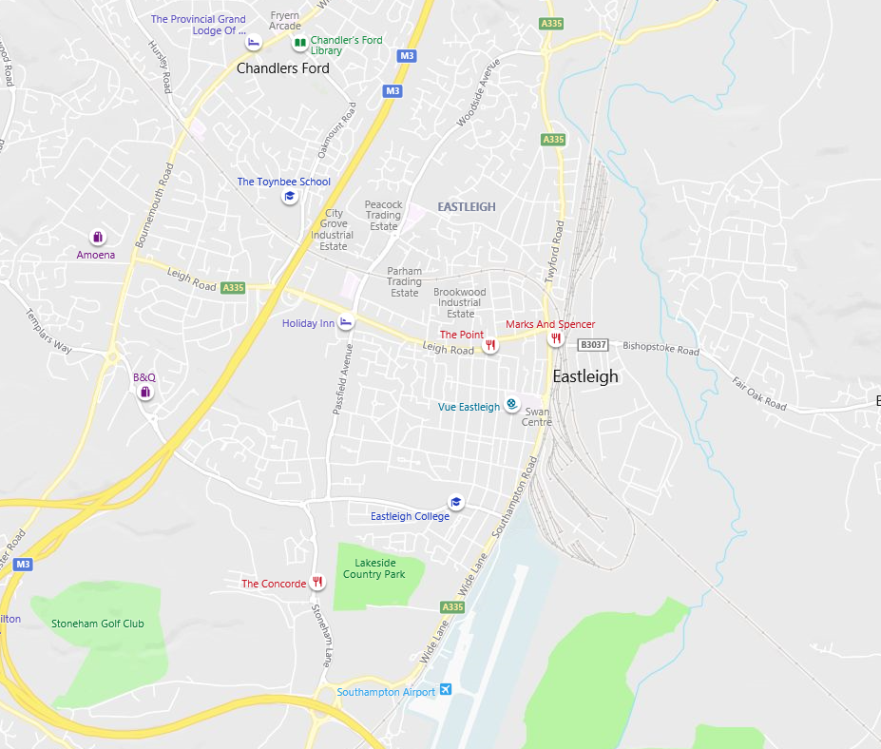

The development is also in relatively close proximity to Eastleigh train station at approximately a 1.0 mile walk. The station provides travel to further afield destinations including London Waterloo, Southampton and so on. Local public transport accessibility can be seen in Figure 8.2 below.
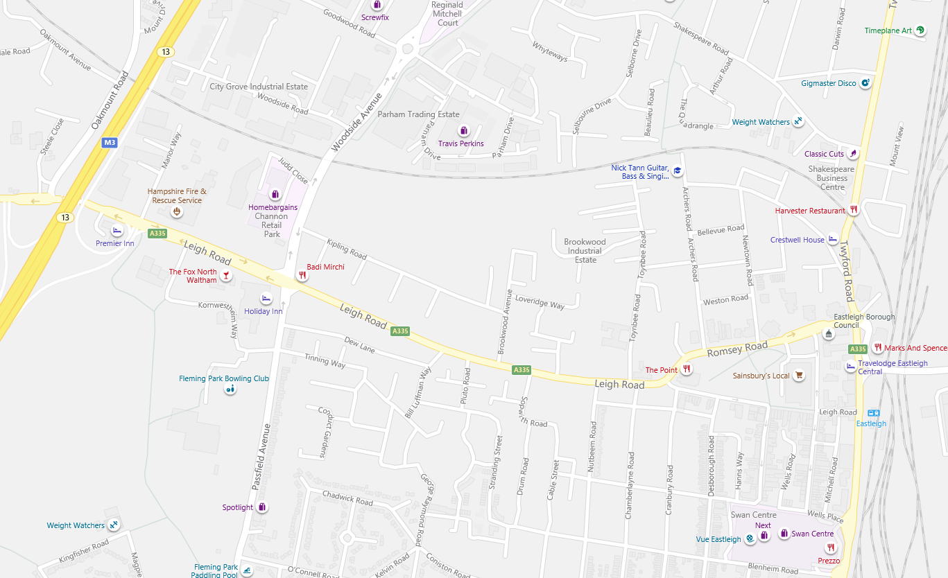

Figure 8.3 highlights that the development location provides access to the local cycle network, providing a sustainable means of commuting to other areas and amenities within the town. In order to encourage building users to adopt cycling as a sustainable commuting method, cycle storage facilities will be provided for the site which shall be both sheltered and secure.
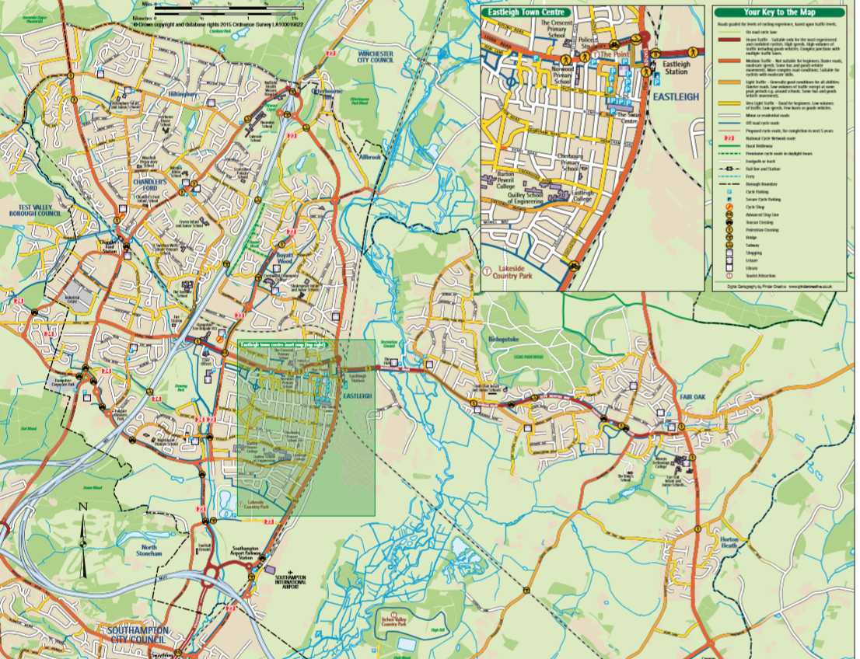

National Planning Policy Framework (2012) Section 4 – Promoting Sustainable Transport Encouragement should be given to solutions which aim to reduce greenhouse gas emissions, especially through opportunities for sustainable transport, with developments delivering a travel plan for building users.

Developments will be permitted where mitigation against the transport impacts which may arise from that development or cumulatively with other proposals is provided. This shall be achieved through the submission of a transport assessment or transport statement, and where appropriate:
- Contributions towards local public transport and strategic transport improvements;
- Contributions to transport modelling work;
- The implementation of works to the highway;
- The provision of new and the improvement of existing pedestrian and cycle routes;
- The provision of travel plans to promote sustainable travel patterns for work related trips;
- The entering into of freight or bus quality partnerships with the local authority and/or third parties.

The location of the development is in proximity to a significant number of primary amenities such as cashpoints, postal services and a leisure centre. The provision of primary amenities within walking distance should reduce the need for extended car based travel and in turn decrease transport related emissions within the area.

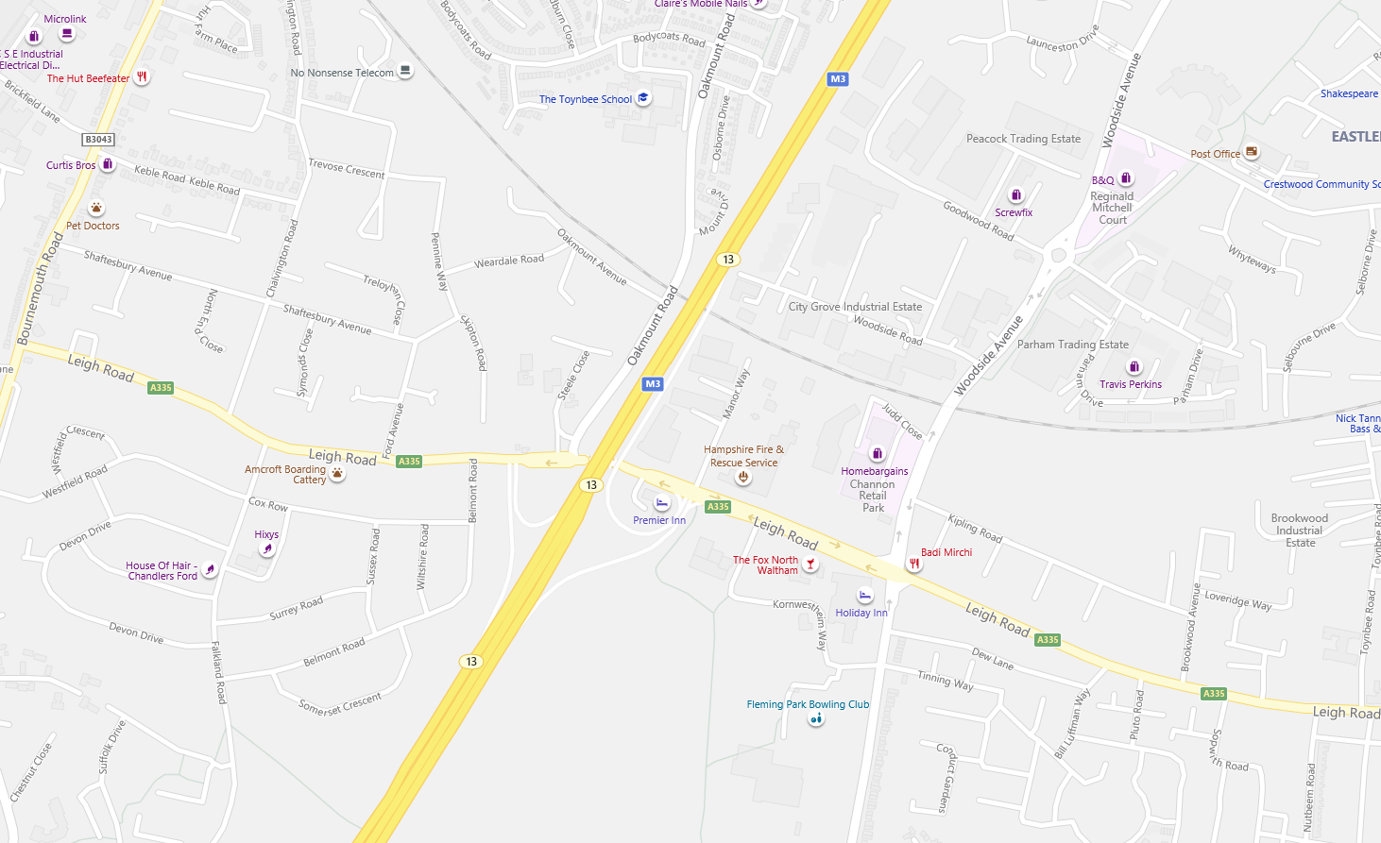

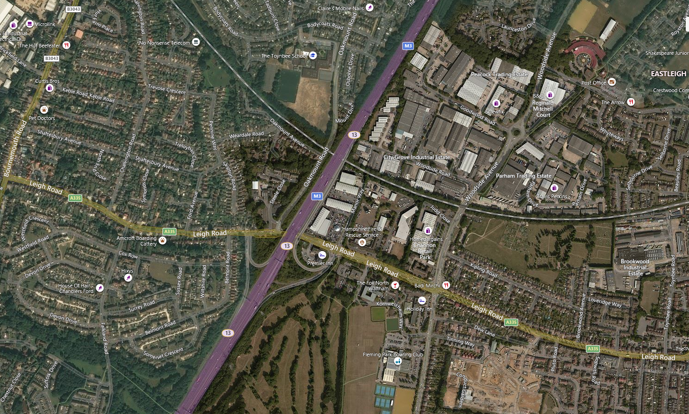

BREEAM
Public Transport Accessibility
The Site, due to its location in Eastleigh town centre, is in close proximity to a number of different types of public transport nodes providing access to a variety of bus services as well as services from Eastleigh train station, thereby reducing transport related pollution from private vehicles.

Proximity to Amenities
This development is within close proximity to various forms of local amenities including a leisure centre, cash point, food outlets and other retail outlets within walking distance, as a result reducing the need for extended travel by private car.

Cycle Storage
As part of the design of the development, there will be provision on site for cycle storage. All cycle storage will be sheltered and secure.

Motorbike parking is also being provided on site.

Summary
The above provisions aim to make the Site easier to access for all building users, as well as offering a sustainable means of commuting.
The development is located in Eastleigh, and therefore is already situated in close proximity to a significant number of local primary amenities including a cash point, post box and food outlets as well as a leisure centre, minimising the need for extended car based travel.
The inclusion of the above sustainability features allow for the Site to be deemed sustainable with regard to transport.

Construction Site Management

A large proportion of all waste is due to construction and demolition works. The need for new materials needs to be minimised, by re-using existing buildings stock and materials where possible and providing a Resource Management Plan for all construction sites. It is becoming a greater requirement now to construct buildings that are flexible and can be re-used; this must be made evident in proposals approaching the council.

Policy Review
National Planning Policy Framework (2012) Local plans should set out strategic priorities for the area; this should include strategic policies to deliver the provision of infrastructure for waste management, water supply and wastewater.
Sustainable Waste Management Development will be permitted which makes provision for the management and treatment of waste in accordance with the Eastleigh Local Plan and local waste management strategies. Development will be permitted which:
- Minimises the quantity of waste requiring treatment;
- Maximises the re-use, recovery and recycling of waste materials;
- Minimises the environmental consequences of waste production and treatment.

Development Sustainability Features
In order to comply with national and local policy, it is anticipated that certain measures will be put into place for this development, such as a Resource Management Plan which monitors the site energy and water consumption and ensures that that site timber is legally and responsibly sourced in accordance with the UK Government’s Timber Procurement Policy. Further to this the Resource Management Plan should also monitor the resource efficiency of the development construction works as well as the percentage of non-hazardous materials, excavation and construction waste which have been diverted from landfill.
It is expected that the main contractor will also set targets and monitor site consumption data for water consumption, energy consumption as well as fuel from deliveries and collection of waste and materials to and from site. Monitoring of such actions can encourage contractors to become more resource efficient to meet given targets.
Additionally, it is expected the main contractor will comply with best standards as set out in the Considerate Constructors Scheme, achieving a score which is considered as exceeding compliance with the criteria of the scheme.
National Planning Policy Framework (2012) Local plans should set out strategic priorities for the area; this should include strategic policies to deliver the provision of infrastructure for waste management, water supply and wastewater.
To ensure the sustainable construction of the development, the project will consider the concept of the waste hierarchy as seen in Figure 9.1 below. The waste hierarchy recognises the need for waste to be considered for a variety of waste streams before being sent to land fill as a last resort. The hierarchy is as follows:
- Waste minimisation;
- Reusing or waste or up cycling;
- Recycling of all applicable materials;
- Recovery of energy from waste (anaerobic digestion plants);
- Waste is sent to landfill.
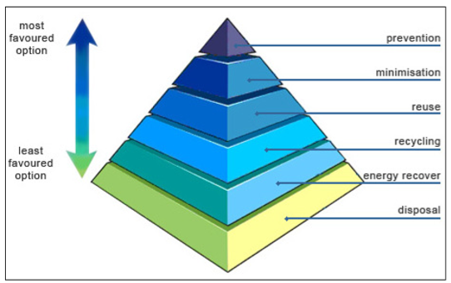
Figure 9.1 Waste Hierarchy Diagram

BREEAM
Construction Waste Management
To promote resource efficiency via the effective management and reduction of construction waste, it is anticipated that a Resource Management Plan will be provided which highlights all waste streams generated by the construction works. It is anticipated that the development shall have a target resource efficiency for non-hazardous waste during construction based on the building’s gross internal area. A further target has been set of diverting from landfill at least 70% by volume of non-demolition waste or 80% by volume including demolition waste.

Responsible Construction Practices
To recognise and encourage construction sites which are managed in an environmentally and socially considerate manner, a Considerate Constructors Scheme should be adhered to, achieving a score between 35 and 39.
In addition to the above, in order to encourage construction sites to be managed in an environmentally sound manner in terms of resource use, energy consumption and pollution, responsibility will be assigned to an individual for monitoring, recording and reporting energy, water and transport consumption data.

Summary
It is anticipated that this development will produce a Resource Management Plan, highlighting the correct waste streams for recycling these materials. In addition to this, during construction it is anticipated there will be a target resource efficiency for non-hazardous waste based on the building’s gross internal area.
The development should adhere to a Considerate Constructors Scheme, achieving a targeted score of between 35 and 39, with all data concerning energy and water consumption and transportation of materials being recorded by a nominated team member. As a result of these measures, the Site may be deemed sustainable as regards to construction site management.

Sustainable Design

Good urban design is essential in providing a varied and sustainable environment, which can facilitate opportunities for positive contributions within communities. As part of sustainable design for developments, it is essential that suitable design principles are followed to maximise opportunities for energy reduction as well as ensuring buildings follow or enhance the character of an area. Developments should also give further consideration to the level of security and comfort that is provided for future building users, including thermal and visual comfort, inclusivity and safe access.

Policy Review
National Planning Policy Framework (2012)
Section 7 – Requiring Good Design
Good design is a key aspect of sustainable development and local authorities should aim to ensure that developments establish a strong sense of place while responding to local character and supporting local transport links.

The Sustainable Development Principles which allow developments to be permitted which
- Makes efficient use of land, buildings and infrastructure;
- Is located so as to reduce the need to travel;
- Promotes a mix of uses;
- Conserves the use of resources including water and energy through a reduction in their use;
- Supports the economic wellbeing of the population. Protects and enhances:
- The health, education and safety of the local population;
- The quality of natural resources including water, air, land and biodiversity;
- The character and quality of local landscapes and the wider countryside;
- The historic and cultural features of acknowledged importance.

Development Sustainability Features
The proposed development shall include a variety of features which are regarded as having a good sustainable design. It is anticipated that any external lighting specified will be designed to reduce unnecessary light pollution during night time hours. This can be achieved through the use of time switches or daylight sensors which switch off lighting between 2300hrs and 0700hrs as well as cut off luminaires that reduce light spill.
To ensure that overheating will not occur during summer months and the building is suitably insulated as well as allowing for adaptation due to the effects of climate change, it is anticipated that the development will use building fabrics with enhanced ‘U’ values which go beyond the minimum requirements of Part L (2013); further to this the energy efficiency measures discussed within Section 6.0 will be incorporated into the design of the development. It is anticipated that such measures will lower the building’s energy requirements making its operation feasible and practical for years to come.

To provide a fully sustainable development it is also anticipated that the materials used for the following main elements of the development shall be rated under the Green Guide to Specification achieving ratings between A+ and C:
- External walls;
- Ground floor;
- Upper floors;
- Roof;
- Windows and doors.

To provide a development which remains sustainable during its operation phase, it is anticipated that space will be provided for the provision of waste storage facilities with additional space of recyclable waste streams. This is to enable building users to sort waste before collection and minimise the quantity of waste that may end up at landfill.

BREEAM
Visual Comfort
It is anticipated that all florescent lamps will be fitted with high frequency ballasts to prevent the flickering of lights. Further to this all lighting should be design in compliance with the relevant CIBSE guidelines and/ or British Standards.

External Lighting
It is anticipated that all external lighting will be no less than 60 lamp lumens per circuit Watt and will have energy efficient components. Additionally, external lighting is expected to be controlled through PIR or daylight sensors. Further to this any security lighting, will be controlled through a time switch to prevent operation during daylight hours.

Reduction of Night Time Light Pollution
To ensure external lighting is concentrated in the appropriate areas and upward lighting is minimised, there will be an external lighting strategy. It is expected that all external lighting between 2300hrs and 0700hrs (excluding security and safety lighting) will be able to be automatically switched off through timers and light sensors. Any security lighting used at these times will comply with the lower lighting levels recommended.

Safety and Security
It is anticipated that consultation with the local Crime Prevention Design Advisor will be undertaken to ensure that the development complies with the principles of Secured by Design.

Summary
In order to comply with national and local policies, the Site shall strive to provide both to building users and the local community a building of sustainable design.
Measures should be taken to ensure the thermal and visual comfort of future building users, through efforts such as a lighting levels in accordance with CIBSE guidelines and a thermal comfort strategy which considers zones and user controls.
External lighting except safety and security lighting should be designed to be switched off automatically through the use of timers of day light sensors.
The above design features allow for the Site to be of sustainable design.

Flood Risk

The Flood and Water Management Act 2010, puts emphasis on rather than managing floods through defences, to instead make space for water storage. The extent of potential flooding for the Site from fluvial sources can be seen below in Figure 11.1, sourced from The Environment Agency.

Policy Review
National Planning Policy Framework (2012)
Section 10 – Meeting the Challenge of Climate Change, Flooding and Coastal Change
In order to adapt to climate change, inappropriate development in areas at risk of flooding should be avoided.

The Development will be permitted which:
- Makes efficient use of land, buildings and infrastructure;
- Is located so as to reduce the need to travel;
- Promotes a mix of uses;
- Conserves the use of resources including water and energy through a reduction in their use;
- Supports the economic wellbeing of the population.
Protects and enhances:
- The health, education and safety of the local population;
- The quality of natural resources including water, air, land and biodiversity;
- The character and quality of local landscapes and the wider countryside;
- The historic and cultural features of acknowledged importance.
National Planning Policy Framework (2012) Section 10 – Meeting the Challenge of Climate Change, Flooding and Coastal Change In order to adapt to climate change, inappropriate development in areas at risk of flooding should be avoided.

Bracknell Forest Borough Council Core Strategy Development Plan Document (2008) Policy CS1: Sustainable Development Principles Development will be permitted which: • Makes efficient use of land, buildings and infrastructure; • Is located so as to reduce the need to travel; • Promotes a mix of uses; • Conserves the use of resources including water and energy through a reduction in their use; • Supports the economic wellbeing of the population. Protects and enhances: • The health, education and safety of the local population; • The quality of natural resources including water, air, land and biodiversity; • The character and quality of local landscapes and the wider countryside; • The historic and cultural features of acknowledged importance.

Development Sustainability Features
The flood map below in Figure 11.1 demonstrates that the proposed development is at low risk from fluvial flooding. Additionally, the flood map shown in confirms that the Site itself is only at minimal risk from surface water flooding. As such it is anticipated that the proposed development will implement measures to prevent any increase of risk of surface water flooding to the surrounding areas due to redevelopment of the site.
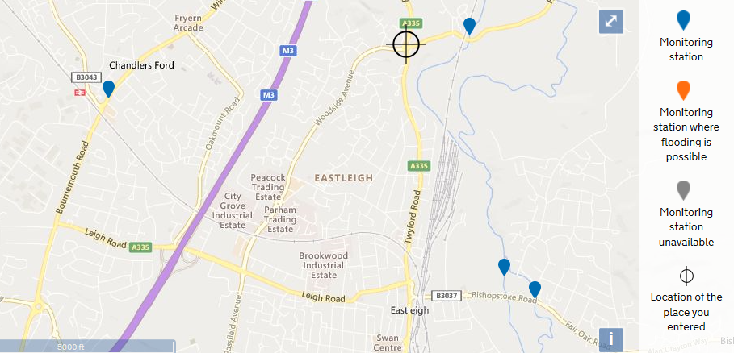
The existing site is made up predominantly of buildings and impermeable surfaces. Though the proposed Site will still have large proportions of impermeable surfaces it is anticipated that Sustainable Urban Drainage systems (SUDs) will be incorporated if required to minimise the risk of surface water flooding to the site and surrounding areas, as a result of the proposed development.

BREEAM
Surface Water Runoff A drainage strategy will be implemented to ensure that the volume of run-off during storm events is no greater post-development than it was pre-development.

Summary
Flood maps sourced from the Environment Agency highlight the Site is not at risk of flooding from fluvial flooding and is located within Flood Zone 1. In addition to this, the maps further confirm that the road directly to the west of the Site is at risk from surface water flooding, as such it is anticipated that suitable SUDs measures will be implemented, where required, to mitigate the potential impacts from the proposed development.

Noise

Noise is a subjective concept that can affect people differently, however there are set standards as to acceptable levels of noise, for different areas and times of day. In this instance, the proposed development would be subject to potential noise pollution from main roads and railways.

Development Sustainability Features
The areas surrounding the Site consist predominantly of similar building uses; retail and office and as such it is anticipated that the proposed development will not contribute to increasing the noise levels of the area.
It should be noted that the noise levels are ‘A’ weighted and as such only demonstrate sounds on a frequency that would affect human populations, it does not consider noise on frequencies that may affect any local habitats.

Summary
Noise mapping data sourced from DEFRA, highlight that the Site is subject to sources of noise pollution from the surrounding roads, railways and International Airport. As the proposed scheme is similar to the existing buildings surrounding the site, it is anticipated that the development will not contribute to increasing the back ground noise levels of the area.

Ecology

Ecology is essential within many communities, with the mix of flora and fauna facilitating benefits such as flood alleviation and pollution amelioration. In addition to this, areas with a wealth of green spaces and an abundance of biodiversity are seen to provide a positive contribution to a community.

Policy Review
National Planning Policy Framework (2012)
Section 11 – Conserving and Enhancing the Natural Environment
The planning system should protect and enhance valued landscapes, minimise impacts on biodiversity.
The Development will be permitted which:
- Makes efficient use of land, buildings and infrastructure;
- Is located so as to reduce the need to travel;
- Promotes a mix of uses;
- Conserves the use of resources including water and energy through a reduction in their use;
- Supports the economic wellbeing of the population.
Protects and enhances:
- The health, education and safety of the local population;
- The quality of natural resources including water, air, land and biodiversity;
- The character and quality of local landscapes and the wider countryside;
- The historic and cultural features of acknowledged importance.

Development Sustainability Features
The wider site is bounded by mature trees and vegetation which are important as part of the local landscape character. However, there are no trees within the application site and other than the single specimen approximately 5 metres to the south of the site, the majority of the trees are found within the north and west boundaries of the application site, adjacent to the railway line and the industrial estate. These trees are of some distance to the existing and proposed buildings and none will be removed/ affected as part of the proposal.
Additionally, a number of mature trees are sporadically located within the wider HFRS site, providing further screening and limited vegetation.
Public greenspace can be found approximately 300m to the south of the site. This area comprises amenity areas and parkland. One pond is located approximately 890m south of the site.
An extended Phase 1 ecological survey was undertaken by HCC Ecology team on 30 January 2017 at Hampshire Fire and Rescue Headquarters, in connection with a proposal of the construction of a two storey building extension (permission F/17/80244) approximately 140m to the south of the proposal site.

BREEAM
Mitigating Ecological Impact
It is anticipated that an Ecology Assessment for the Site will confirm the ecological value and species richness of the site and confirms that there will be no negative change in ecological value due to the development.

Enhancing Site Ecology
The Ecology Assessment recommends that an enhancement of the area with bird or bat boxes are likely to be required.

Summary
It is anticipated that an ecological value of the existing site will be confirmed within the Ecology Assessment. It is also expected that an Ecologist will put forward landscaping measures to enhance the ecological value of the site; typically this is achieved through the use of species of local importance or through measures such as bat or bird boxes.
It is anticipated that the incorporation of recommendations provided by the Ecologist will allow for the Site to be deemed sustainable regarding ecology.

