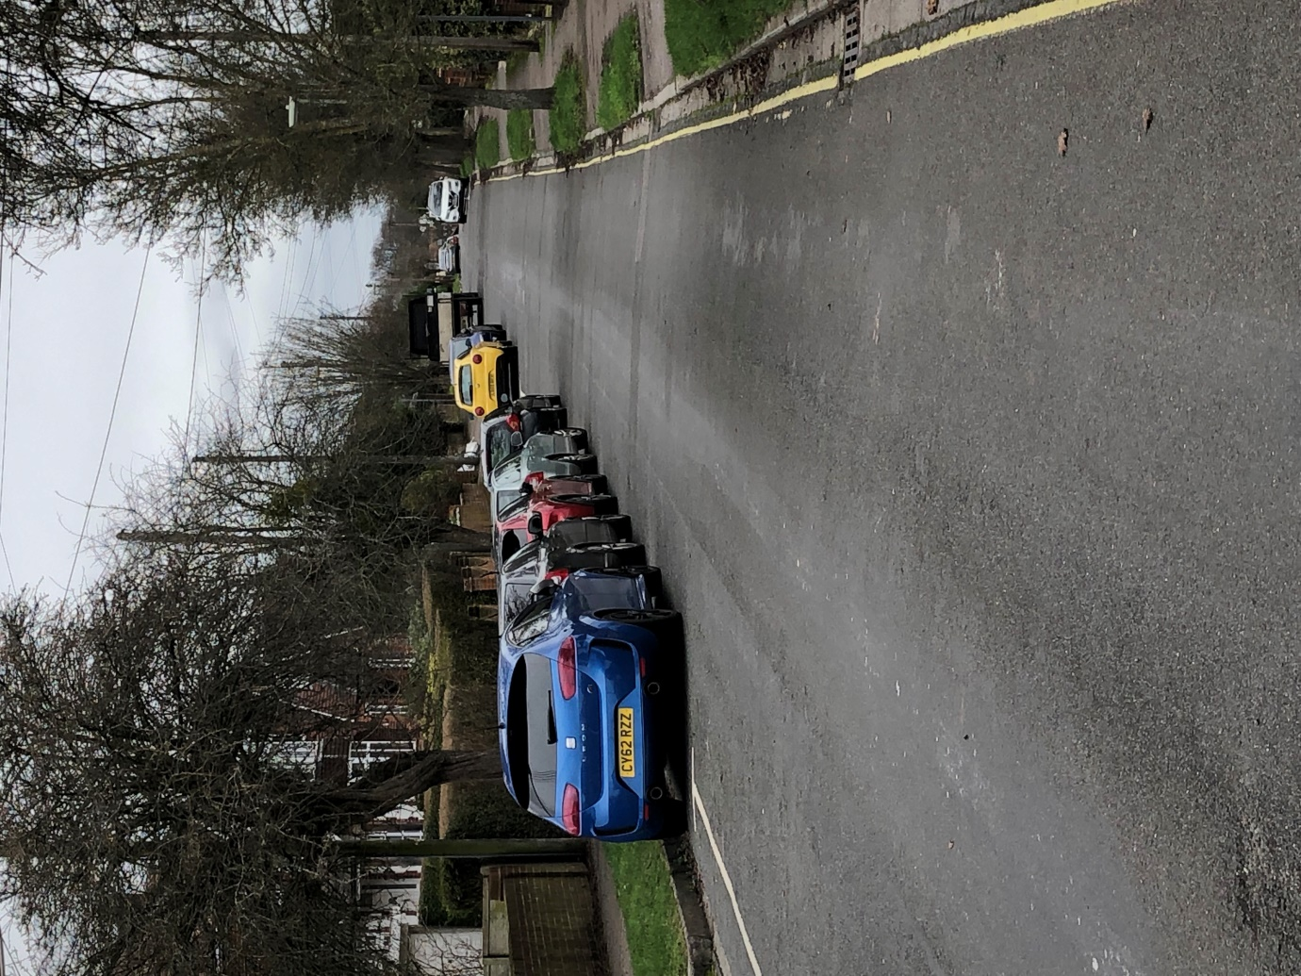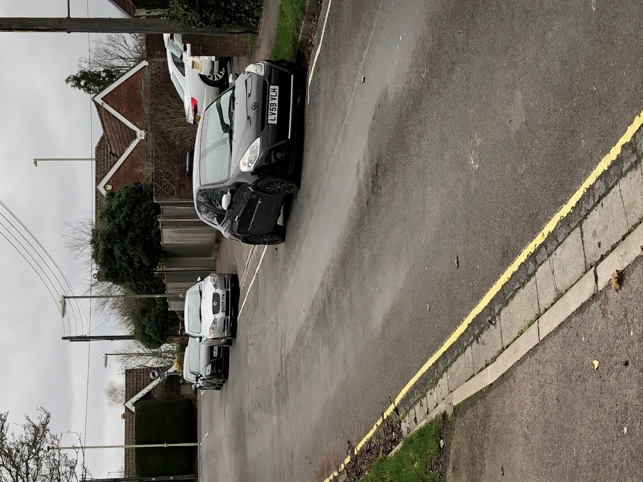
Towards Chalvington Road from No. 12 Keble Rd
Towards Bournemouth Road from No. 12 Keble Rd.

