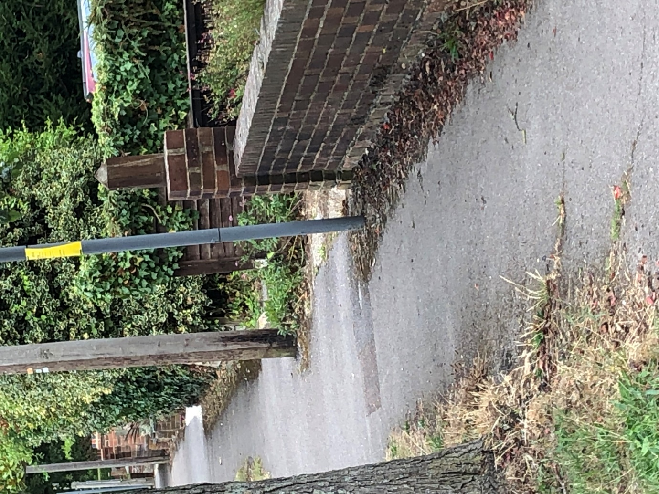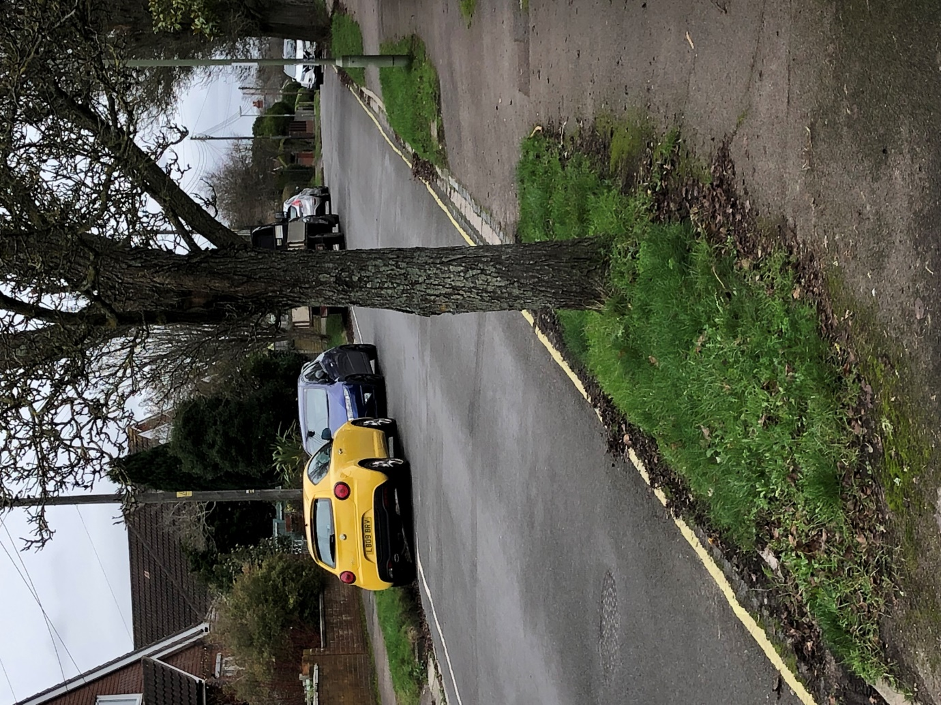
View of top of driveway to No. 16 Keble Rd.

View to Chalvington Road from No. 12 Keble Road.

