Mr & Mrs A Brooks
1 Tower Place
West End
Southampton
SO30 3DL

Tree Preservation Order No: 330 Ref T28

Oak Tree

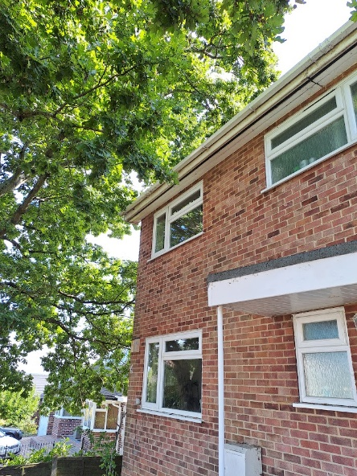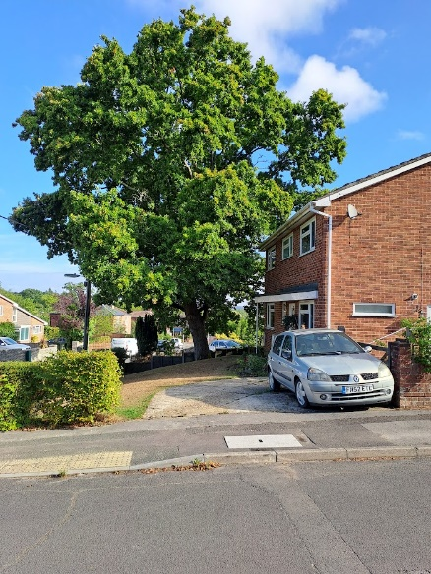

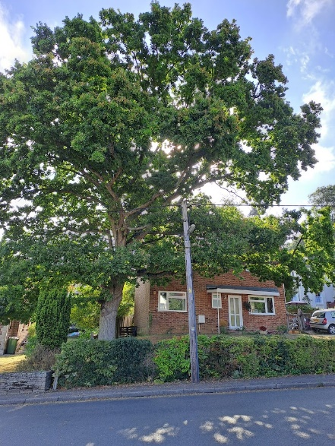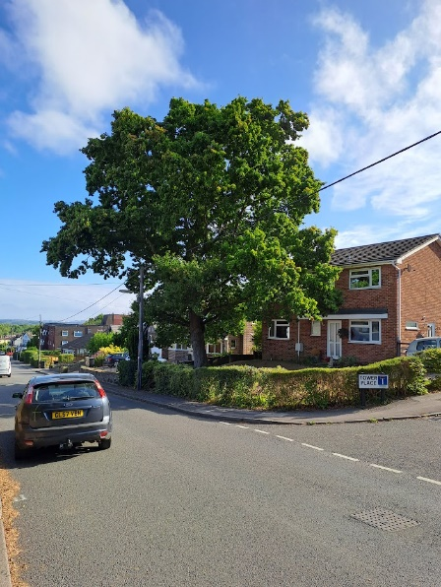

Previous Planning Applications relating to this tree.

T/13/73066 - 1 Tower Place, West End, Southampton, SO30 3DL
- Valid date: 05/08/2013

T/33798/001/00 - 1 Tower Place, West End,
- Valid date: 04/07/2001

