Removal / felling of Ash tree at 11, Mallett Gardens, SO30 2NH
Further to our recent height reduction planning submission, we have been advised that the Ash may well be past saving due to it’s exposed position, the “lions tail” growth, the rot having set into the base of the trunk and the lean of the tree towards the house. We will replace the Ash with a Beech or Cherry tree along the back fence. Providing there are no objections from any other residents we would like to fell this tree under this planning submission, if there are objections then we would like to continue with the height reduction under the other planning application (providing there are no objections to that, which we don’t believe there have been, of course)

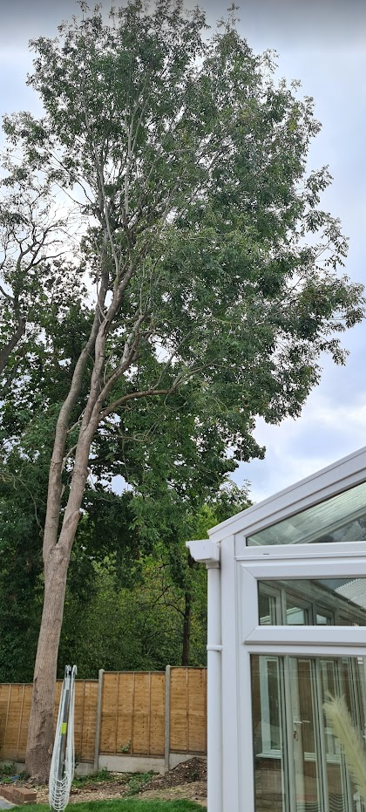
Showing extreme single sided growth and exposed position.

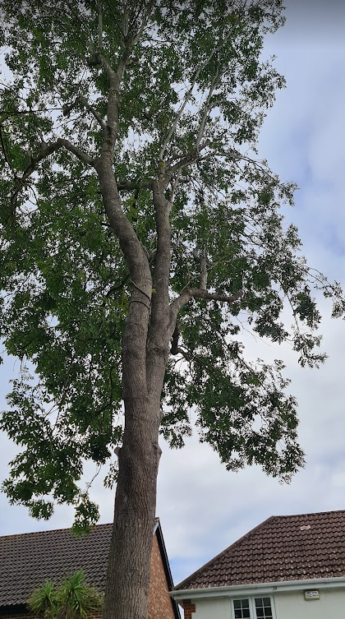
Showing lean towards house and single sided growth
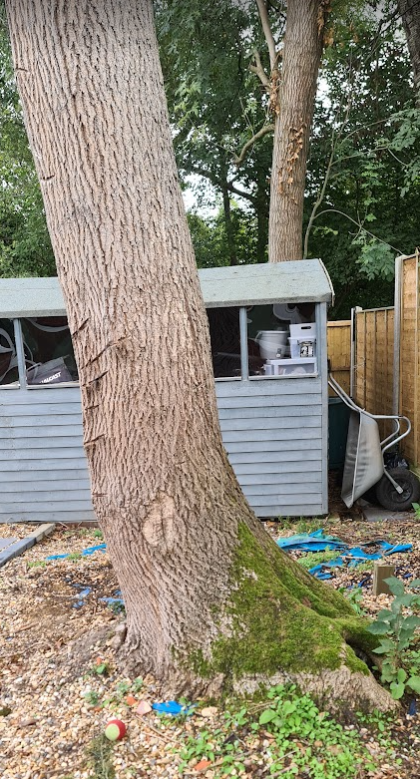
Showing lean and rot to the base of the trunk
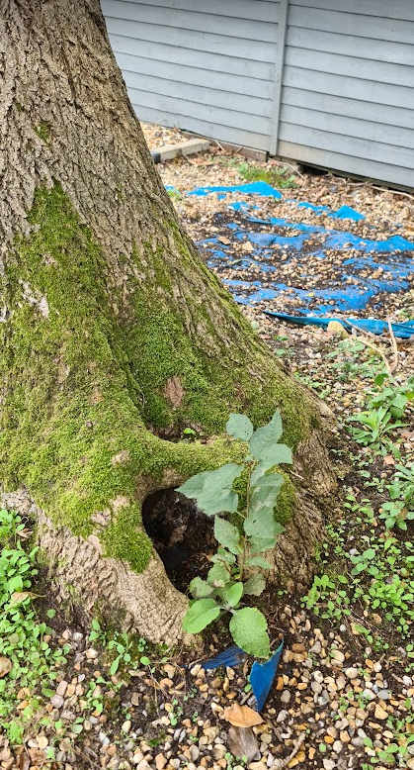
Rot to the base of the trunk

