Sketch plan for Meadow Cottage, SO50 9HQ

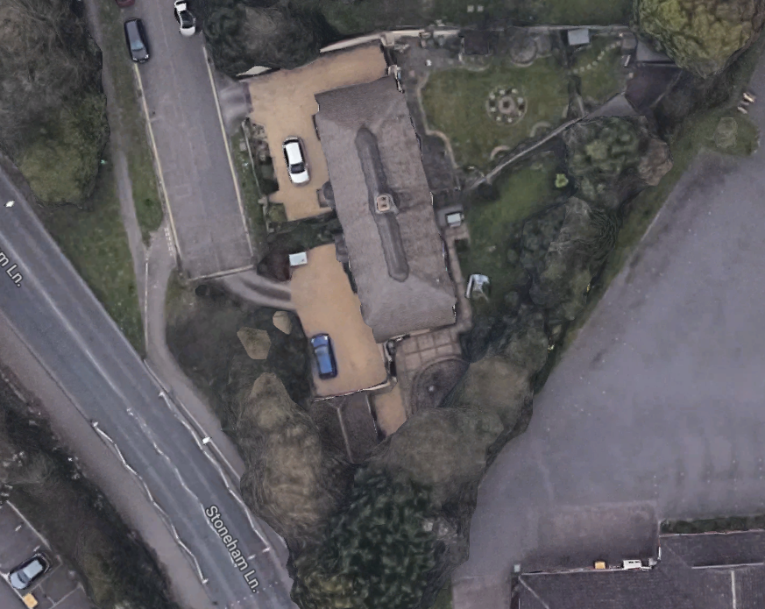
G2
G1

G1 – Crown lift conifers on Meadow Cottage side of boundary to provide 6 metre clearance of building
G2 – Re-pollard group of Willows along boundary back to previous points

