Sketch Plan for 142 Pitmore Road
T1 Oak – tree removal due to a fallen limb has mishappened the tree and to reduce it back to anything that would safely recover would result in the loss of its amenity value.

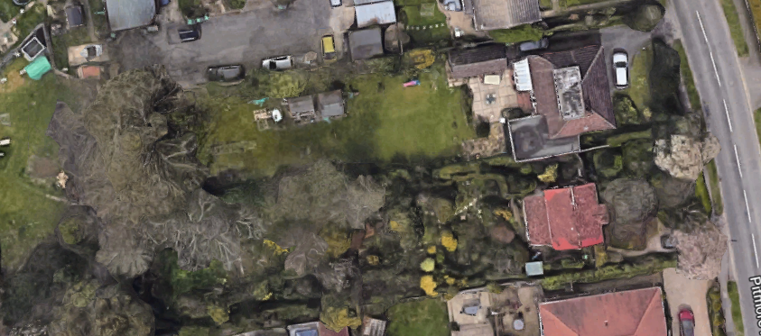
142
T1

