No3’s shed application H/22/93708

We would like to object to this planning application on the grounds that the applicant will have no where to park except for on street which will further add to the already congested parking in the area.
This type of shed along with the neighbouring shed is out of context for the area & looks more like an electric control room. Adding another shed of this nature will bring down the look & feel of the development.
Below is a snip of the application where the applicant states.
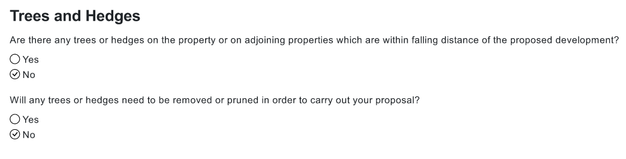
This statement is not true, there has been quite a considerable amount of hedge & tree trimming to the rear of the shed to allow the shed to be sited.
Below is further snips were the applicant goes on to state.
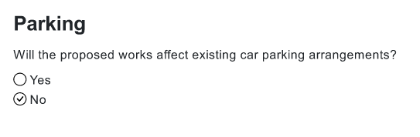
Again, this is not true. If this application is granted, then the applicant will have nowhere to park a vehicle as there will not be enough room within their allocation of the car park. This will lead to more on street parking in an already congested area or they will have to park within the turning circle which falls under others ownership & is for access only.
Below is a snip from the restricted covenants on this parcel of land of which the applicant has a right of access, but the ownership, outside the applicant’s allocation belongs to others, namely No1,6,7, & 8 on the development. It is unfortunate that the applicant sold off a parcel of their land to No4 on the development, if this had not happened the applicant would have enough space to accommodate the application of a shed with car parking. The applicant’s entitlement falls within HP416909
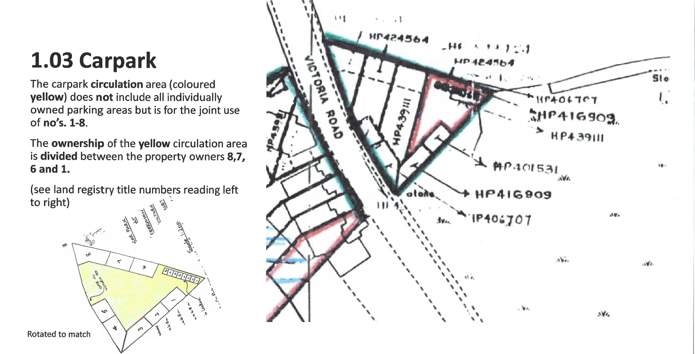

Not for the first time, we as owners have been excluded from the consultation process & would like to understand the reason for the exclusion.

