Sketch plan for 57a Kingsway, SO53 1FH
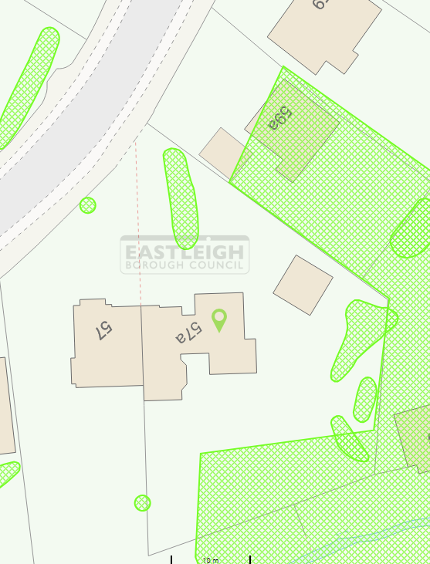
T2
T1

