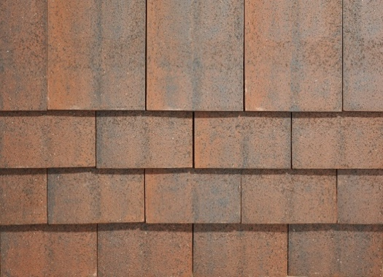 | Roof Covering (plots 1-7)  Manufacturer: SIG Roofing  Style: Sherwood  Colour: Orange/Brown  Technical  Machine made tile, rustic/weathered finish
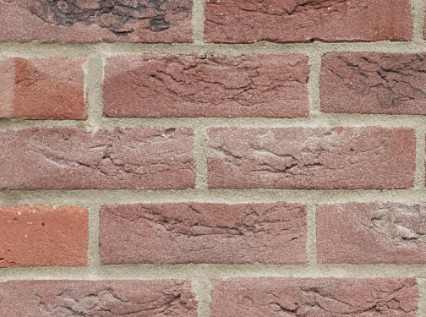 | Brick  Manufacturer: AAB  Style: DR19B - Old Westmill Red Multi  Technical  Stretcher bond  Mortar  Off White
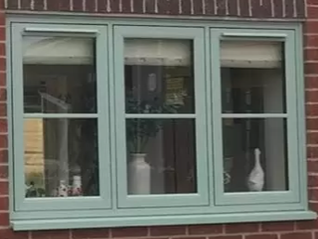 | Windows  Manufacturer: Spire Glass  Style: Sculpted Casement  Colour: White  Technical  UPVC Flush Casement Windows Astragal bars
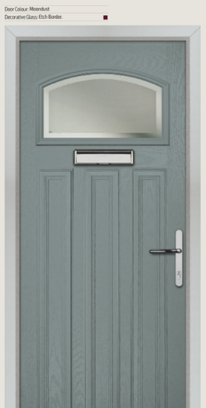 | Front Doors  Manufacturer: Spire Glass  Style: Tudor with etched glass  Colour: Slate  Technical  GRP composite  Details  Door Furniture, letterbox, handle, door numeral in satin chrome finish
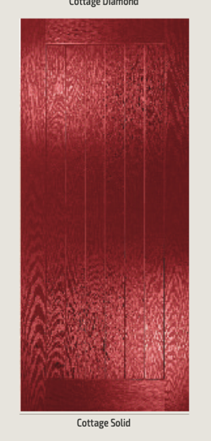 | Rear/Side Doors  Manufacturer: Spire Glass  Style: Cottage Solid  Colour: Slate  Technical  GRP composite  Details  Door handle in satin chrome finish

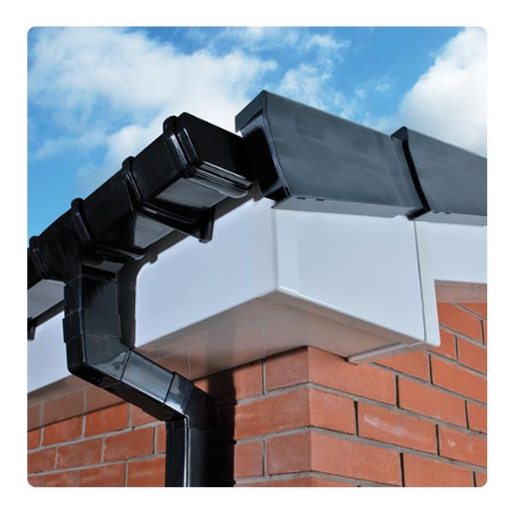 | Fascia & Soffit  Manufacturer: TBC  Style: UPVC Ogee.  Colour: White  Technical  N/A
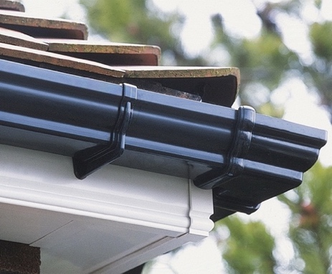 | Rainwater Goods  Manufacturer: Marley (or similar)  Style: Ogee  Colour: Black  Technical  UPVC
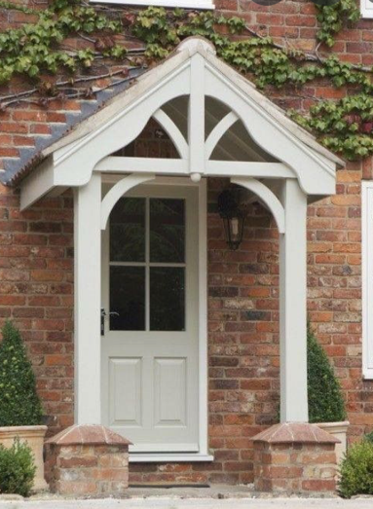 | Porches  Manufacturer: N/A  Style:  Colour:  Technical  Timber painted posts similar to Romsey Road  As per KSA elevation Drawings. Not imagine. (Colour only).
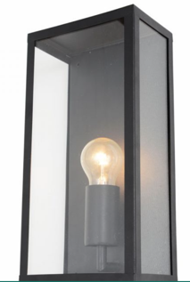  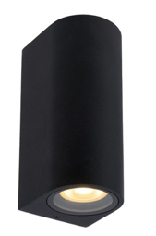 | External Wall Lights  Front  Forum Minerva Outdoor Wall Light  Colour: Black  https://www.lighting-direct.co.uk/minerva-half-lantern-black.html  Rear and Side  Lucide Zaro Curved Outdoor Up & Down  Colour: Black  https://www.lighting-direct.co.uk/lucide-zaro-curved-outdoor-up-down-wall-light-black.html
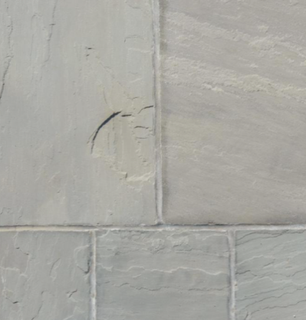 | Patio and Paths  Manufacturer: Silverland Stone  Style: Kashmire 570×570,  Colour: Grey Sandstone
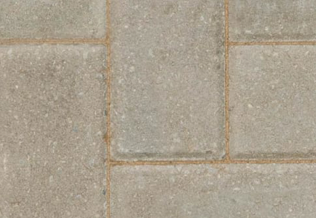 | Block Paving  Manufacturer: Marshalls Keyblok 60  Style: Natural  Technical: Keyblok® 200 x 100 x 60mm
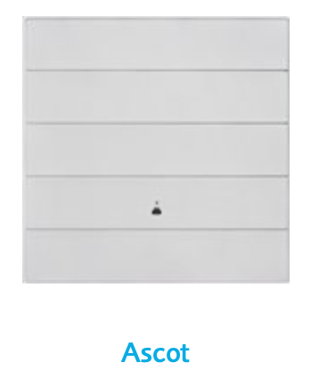 | Garage Doors  Manufacturer:  Style: Up and Over  Colour: Slate Grey 7015
*All materials subject to availability

