Tree Work – 23 Oakwood Road – Overview from House looking East
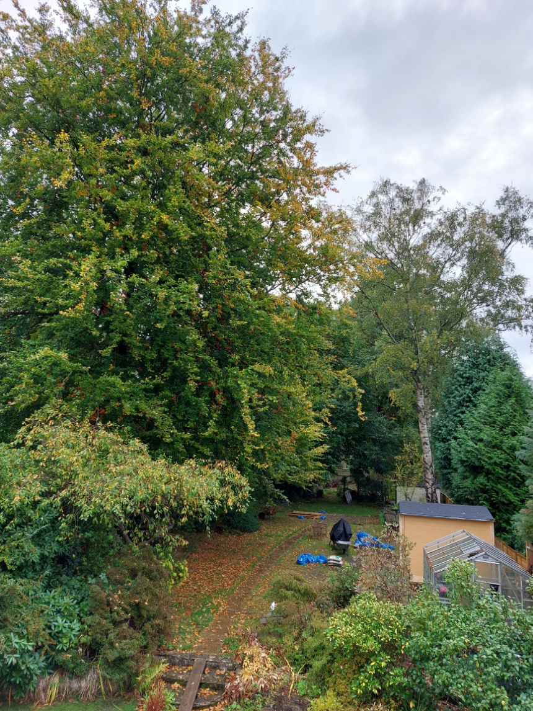
Tree C – Hornbeam – barely visible under branches of Tree B
Tree B – Beech
Tree A – Silver Birch
25 Oakwood Road
21 Oakwood Road
NB - Leylandii to the right of Tree A are in 25 Oakwood Road garden

