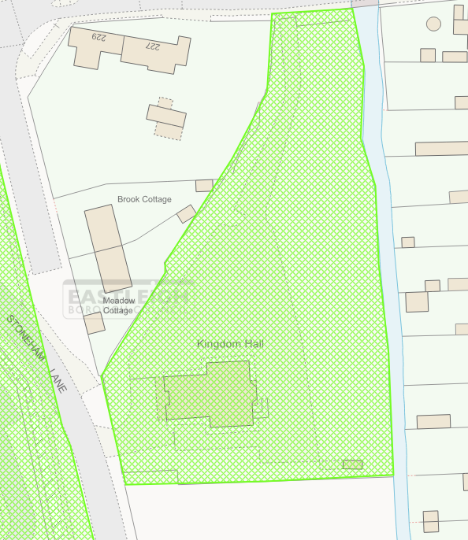
T1 - Conifer
G1 – all Willows running alongside Monks Brook

