Design & Access statement for replacement of the existing Garden Machinery Store with a new Machinery store that includes a swimming pool plant room, a lockable garden store, a wet floor shower room and finally a wc to replace the existing wc that was entered from within the day room.

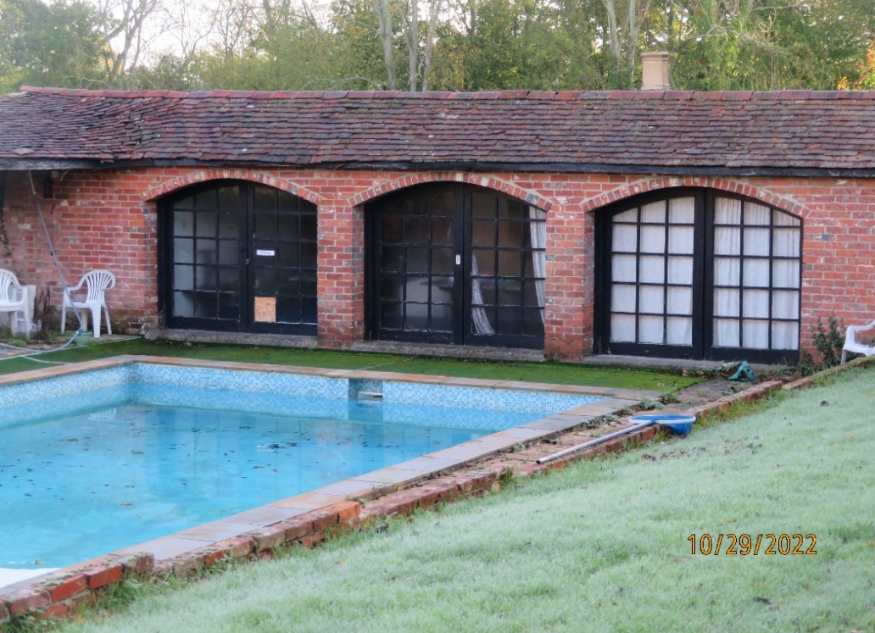

Front view of the existing pool house

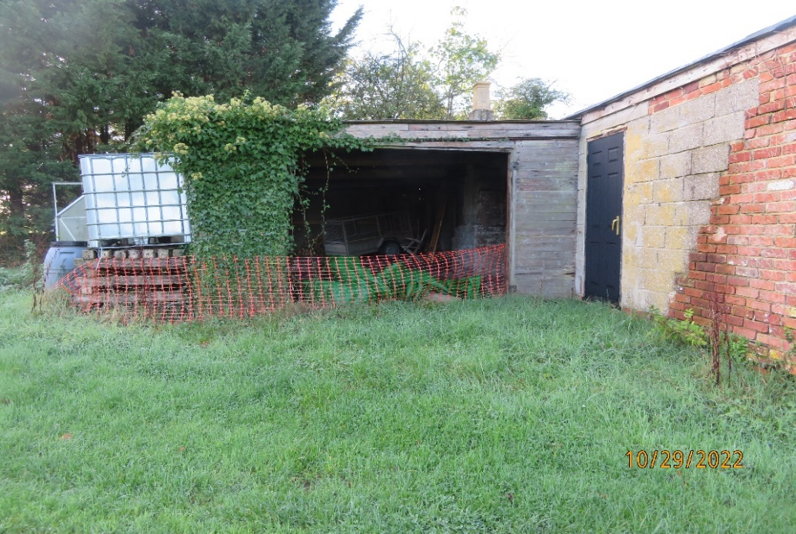

North View of the existing Machinery Store

The existing machinery store has a flat roof that is supported on what appears to be telegraph poles. The walls are corrugated sheeting fixed to horizontal timbers fixed to the timber poles. The structure is in a very poor condition and therefore to be
re-built having timber framed walls and be clad with horizontal weatherboarding similar to the walls of the winery at that the very north end of the site.
The new extension to be built up on a reinforced concrete raft foundation so that it will not affect any tree roots.
A new shower room to be added in the new rear extension is to be relocated at the rear of the pool house and the drainage connected to an existing near-by foul water drain.
The existing pool plant room that is at the moment situated in the main house to be repositioned within the rear extension behind the Day Room
New folding door assembly to be fitted in the north wall of the dayroom to give a view over the vineyard. that is to be built up from a raft foundation so that it will not affect any tree roots and the existing wc.

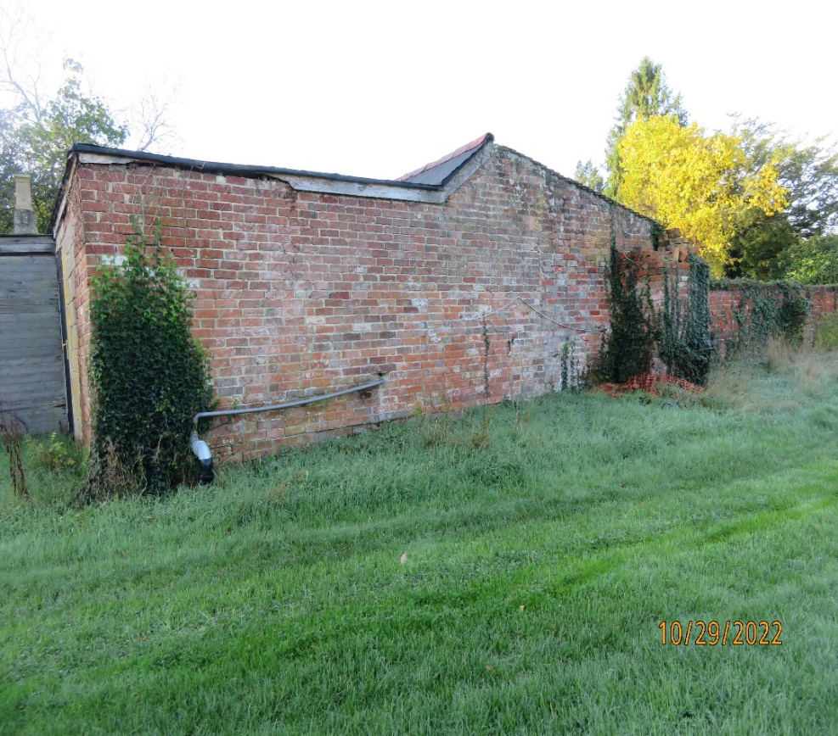

North elevation of the existing pool house.

