Sketch plan of affected trees at St Mary’s Churchyard (not to scale)

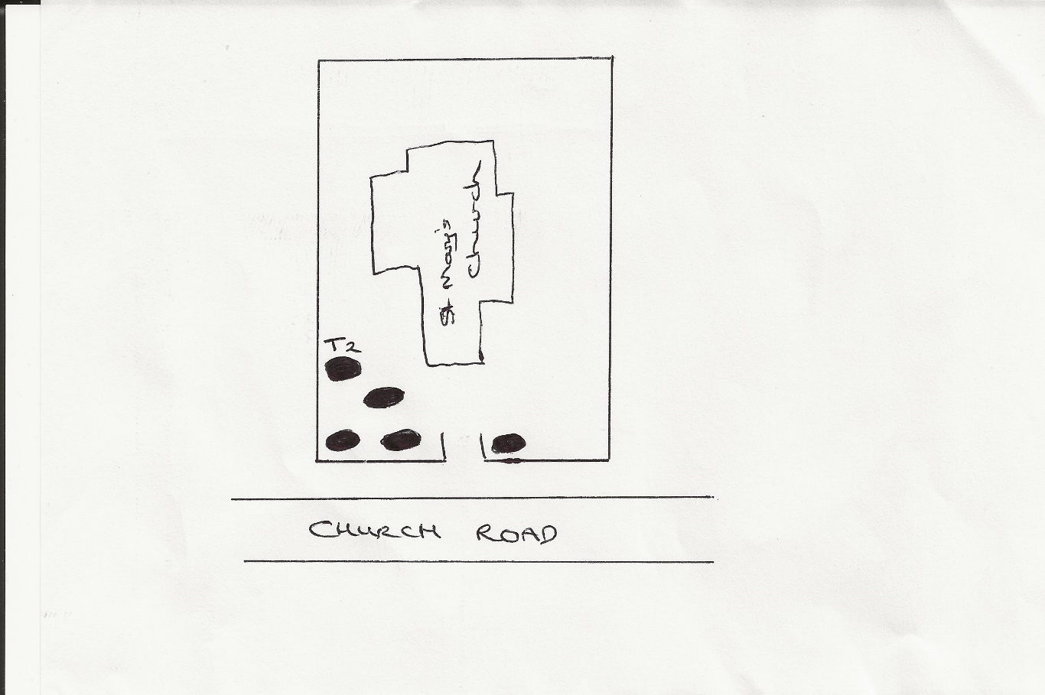

T2 is the beech tree, for which we want to reduce the crown by 2 to 3 meters.
Yellow arrow marks the sycamore tree, which is an example of the sucker growth, which we would like to remove from all protected trees

