Boundary Wall & Carport

We reinstated the boundary/retaining wall and added a return wall. We kept two sides open and added a flat roof to make it into a carport. The boundary wall in stepped back from the boundary to allow a clear sight line from 22, 24 & 26a. The pedestrian footfall past the house will continue to increase with the new students at Deer Park, and the drop from the pavement is an unnecessary risk. We also have had several cars ground out on the verge due to misinterpreting the pavement/drop.

Carport materials - Built in block, to be rendered to match the house. Rubber flat roof in grey, to match window and door frames. Car charging port will be in the carport to provide for electric vehicles.

Driveway
We are looking to grade the driveway including entrance, both of which have deteriorated. We are proposing to use a combination of permable pavers and stone to allow for the surface water coming off Grange Road. Alternatively, the drive will be paved with only permable pavers and an additional soakaway will be added. Both options will ensure that surface water has somewhere to drain to. The entrance has deteriorated so badly that it is causing difficulty exiting the drive safely and causing damage to cars unless they come in slowly.

The walls and gates will improve privacy for both our property and our neighbours across the road, who currently suffer with the lights of our vehicles shining into their lounge and bedroom due to angle of the driveway. The installation gates will stop cars driving onto our drive and turning around on our drive (another incident last week). This is an issue we have struggled with for a number of years, and with the increase of traffic since Deer Park School construction/opening were expecting to this continue to increase. Another factor is the security of the property, especially with an in case of break ins and vehicle theft in the local area. There is also several other properties in our road with walls of similar height, also in similar style.

24 Grange Road before the old wall and hedge was removed

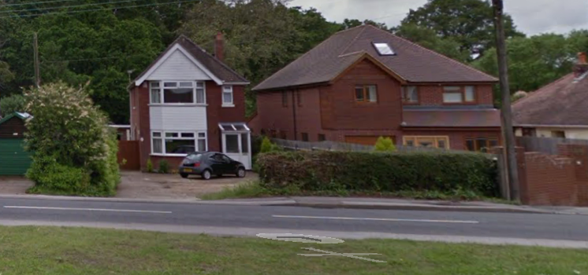

Neighbours wall and gates
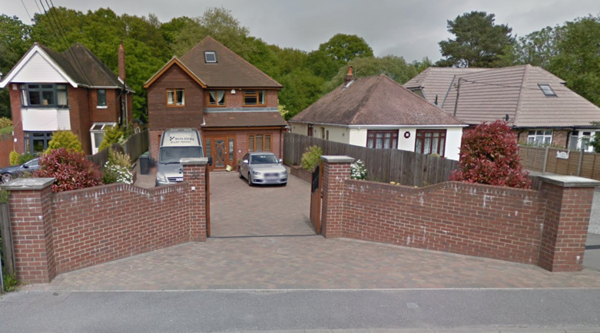

After – Both of these properties now have rendered walls
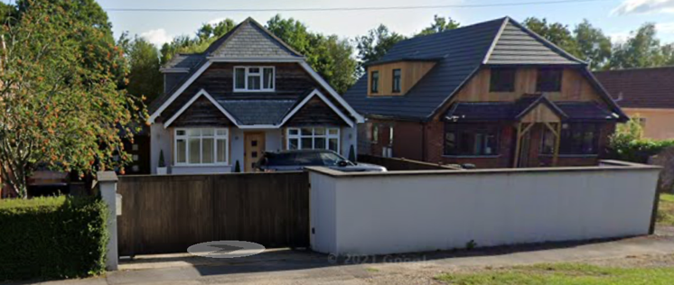
Before

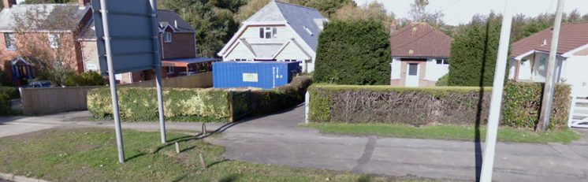
Neighbours boundary before
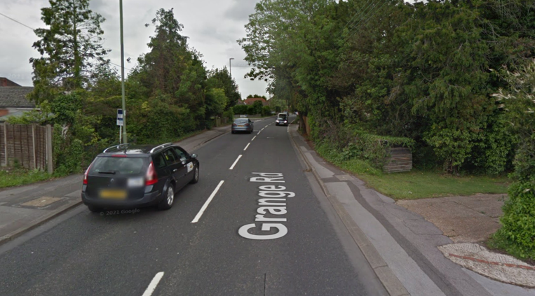 After – both higher than new boundary wall
