Tree Officer
Eastleigh Borough Council
Eastleigh House
Upper Market Street
EASTLEIGH
SO50 9YN
My Ref: D2316L1TWAP
18th April 2023

Dear Tree Officer,

RE: 6 BEECHWOOD RISE, SOUTHAMPTON SO18 3PW
TPO TREE WORK APPLICATION

In accordance with instructions from Mr R Kitchen I have prepared the following tree report to accompany an application for TPO tree work consent relating to the above site. This letter is in addition to and should be read with the TPO tree work application dated 18th April 2023. The tree locations are shown on the plan AC1 attached to the TPO tree work application. Photos of the trees are attached to this letter.

- Proposed work - T1 – oak – fell (see photos 1 and 2): The tree leans and has a narrow crown with extensive old pruning wounds, dead wood and die-back. There is old damage at the base with decay and a developing cavity. This tree has diminishing vigour and poor long-term prospects and is becoming a safety liability.

- Proposed work - T2 – oak – fell (see photos 1 and 3): The tree has a narrow crown with extensive old pruning wounds, dead wood and die-back. There is old damage at the base with decay and a developing cavity. This tree has diminishing vigour and poor long-term prospects and is becoming a safety liability.

- Proposed work - T3 – oak – fell (see photos 1, 4 and 5): The tree has lost its central leader and has extensive old pruning wounds, dead wood and die-back. There is old damage at the base with decay and a developing cavity. This tree has diminishing vigour and poor long-term prospects and is becoming a safety liability.

- Proposed work - T4 – birch – fell (see photos 6 and 7): This tree is on the adjacent footpath and overhangs the site, where its crown significantly casts shade on and greatly reduces the effectiveness of the solar panels installed on the only suitable side of the roof.

- Proposed work - T5 – birch – fell (see photos 6 and 7): This tree is on the adjacent footpath and overhangs the site, where its crown significantly casts shade on and reduces the effectiveness of the solar panels installed on the only suitable side of the roof.

Please call me if you would like to discuss any of these points.

Yours sincerely
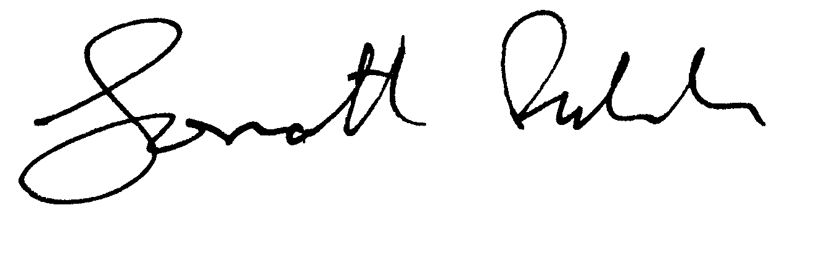
Jonathan Fulcher DipArb FArborA

Encs

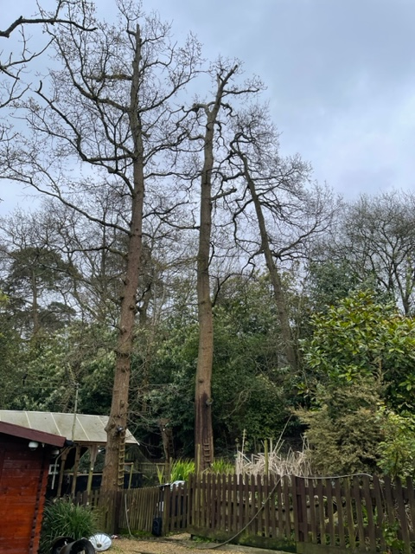
T2
T3
T1
T6
Photo 1: Trees T1, T2 and T3 – oaks - looking east and showing poor crown form, dead wood and die-back

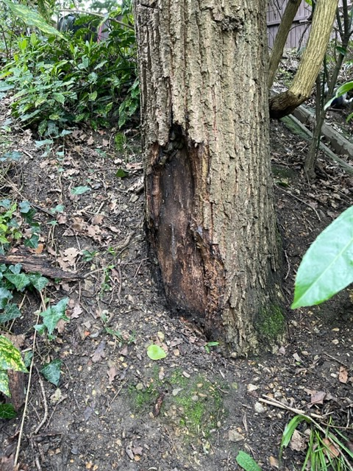
Photo 2: Base of trunk of T1 3 showing decay and developing cavity

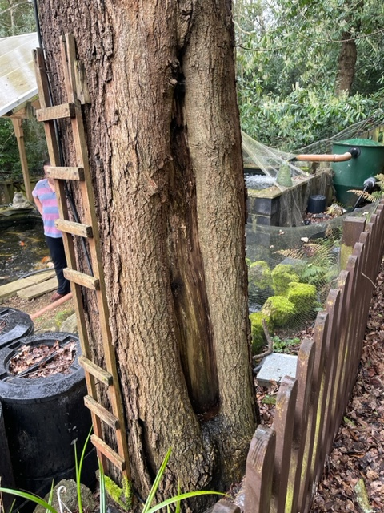
T6
Photo 3: Lower trunk of T2 showing decay and developing cavity

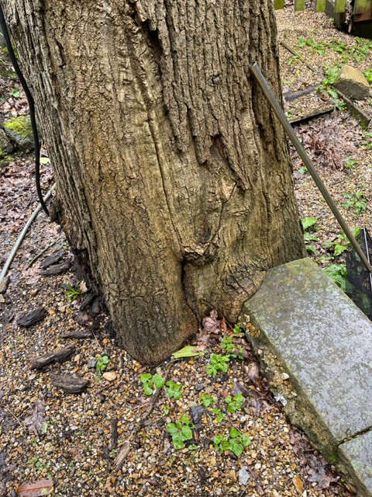
Photo 4: Base of trunk of T3 showing old basal damage and decay

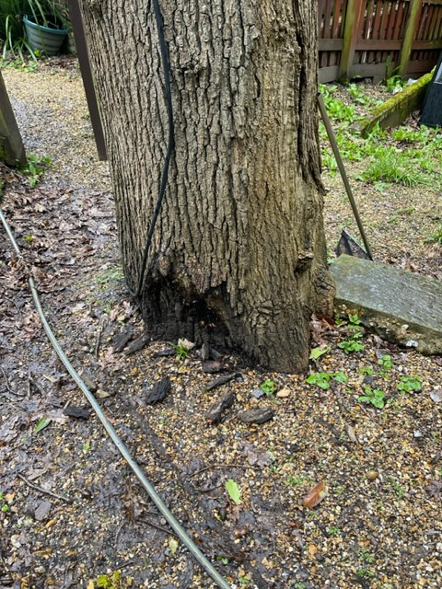
Photo 5: Base of trunk of T3 showing old basal damage and decay

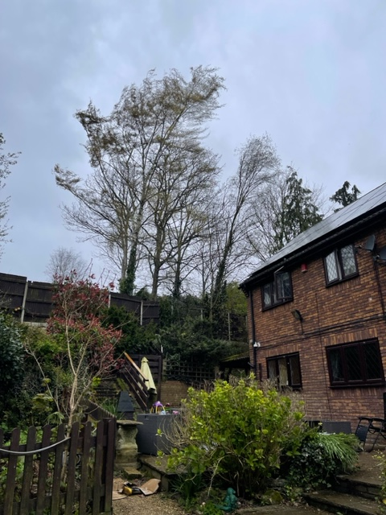
T4

T5
Photo 6: Birches T4 and T5 looking southwest and showing influence on solar panels

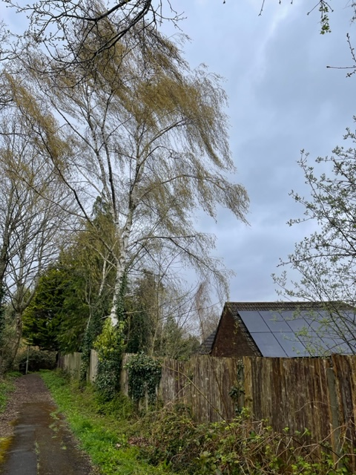
T5
T4
Photo 7: Birches T4 and T5 from adjacent footpath looking southeast and showing influence on solar panels

