
Scope Sheet
21055 / SDP1 / Netley station / 218647 | Complete

Job Number (If Known) | 21055

Tree ID | 218647

Client | SWR

Route | Wessex

ELR | SDP1

Up or Down | Downside
647 - platform 1 car park

Mileage

Local Name | Netley station

Prepared by | GEORGIA DURRANT

Location | Netley (NTL), Netley, Southampton SO31 5PT, UK  (50.8748493, -1.3418128)

Inspection

Scope Of Works

Description of Works | 218647 - oak to cut back from building by 2 M reduce other side by 2 M to help balance out canopy.

Main Work Activities | Large Trees
 | Aerial Works

Photo of Works
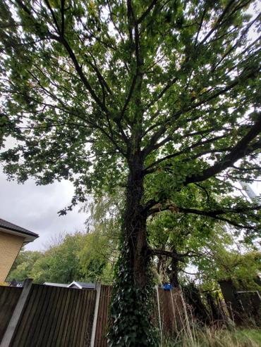  Photo 1 | 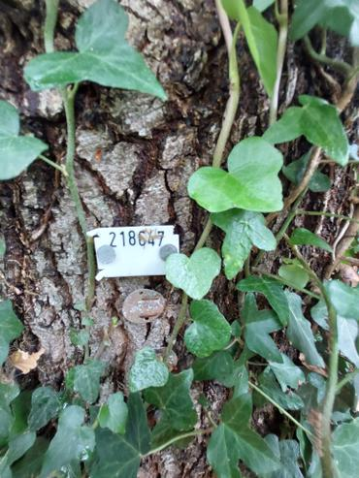  Photo 2 | 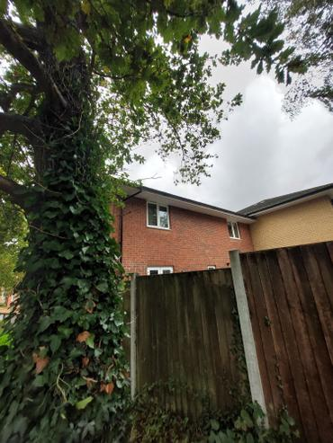  Photo 3
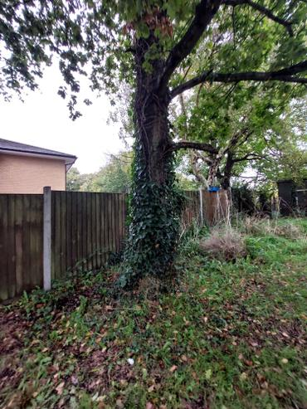  Photo 4 | 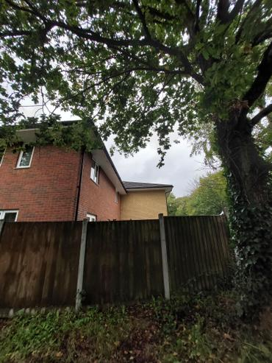  Photo 5

Environmental

Checks Needed | TPO Check

Watercourses | No

Others

Appendix

Photo 1

Photo 2 | Photo 3

Photo 5 | Photo 6

