CEMP Controls

Project/Task title: One Horton Heath
Principal Contractor: Luddon Construction
Start date: 17.04.2023
Duration: 52 weeks
Site Manager: Mark Hill 07472370768
Site Environmental Representative: Justin Holmes 07903051037
Environmental / Ecological issues | Best practicable means control measures to be implemented: | Location of control measures | Comments
Noise and  vibration | Noise and vibration  All woks shall be carried out using Best Practicable Means according to the Control of Pollution Act 1974 and with reference to BS5228 “Code of practice for noise and vibration control on construction and open sites” and the Institute of Air Quality Management’s “Guidance on the assessment of dust from demolition and construction”. Noise, vibration and dust shall be monitored, and good records kept of this, control measures deployed onsite and of any complaints or actions regarding amenity impacts and harm including nuisance due to pollution. In the case of there being a complaint, this shall be promptly investigated, and remedial actions put in place where pollution is adverse within 24 hours or works shall cease until they can be. Records shall be made available to the Council upon reason request such as when visiting the site offices in relation to a complaint about impact to amenity, harm including nuisance due to pollution  The core hours of construction are considered to be 08.00 hours - 18.00 hours Monday to Friday, and up to 1pm on a Saturday. No Sunday working anticipated.  A period of one hour before and after normal core working hours will be used for start-up and close-down of activities. This will include movement to place of work, unloading, maintenance and general preparation work. This will not include the operation of plant or machinery likely to cause disturbance to residents or businesses.  Plant and equipment conforming to relevant national standards, directives or recommendations on noise and/or vibration emissions will be appropriately selected. Noise and vibration levels have been identified based on equipment used at each stage – see attachment 1.  Vehicles, plant and equipment are to be switched off when not in use.  Noise monitoring will be undertaken in the event of any issue being raised by the public or adjacent properties. Please refer to drawing 1 and attachment 1.  Luddon’s Traffic Management Plan will give consideration to the transportation of construction materials, spoil and personnel to reduce the risk of increased noise and/or vibration impacts during construction. For traffic management please refer to drawing 2, for stockpile location please refer to drawing ‘’Parameter Plan Green Infrastructure PP 03’’Rev. P35 issued by client.  Vehicles and mechanical plant are to be fitted with effective exhaust silencers and are to be maintained in good working order and operated in a manner that minimises noise emissions.  Roads will be well maintained to minimise noise generated from surface irregularities.  Ramping up piling and other activities generating noise and vibration to allow wildlife to move away in good time.  Informing Project workers via e.g., tool box talks of noisy sources on site with appropriate signage and provide appropriate PPE.  All workers on site will be made aware of the need to keep noise and disruption to a minimum from plant and vehicles  Limiting traffic speeds on site road 10mph to avoid excessive noise. Speed limit signs will be set up on haul road approx—every 100m. For haul road location please refer to drawing 3.  Additional noise attenuation devices and barriers will be installed where noise levels exceed limits, based on the outcomes of noise monitoring results.  For Predicted sound levels during construction work, please refer to attachment 1 | CEMP  Attachment 1  Drawing 1 Location of sound level meters  Drawing 2 Traffic management plan  Parameter Plan Green Infrastructure PP 03’’Rev. P35  Drawing 3 Temporary haul road
Lighting | Lighting will only be used where necessary and direct to avoid disturbance to sensitive receptors and ecological habitats (areas of woodland/ tree lines). Lighting will be towable to the location of ongoing work in autumn and winter time or when necessary.  All lighting will be downward and inward facing towards the working area. All lighting will be switched off when not required..  Where it will be required lights will be adjusted to the minimum luminosity , low-energy consumption fittings and motion sensor will be used where possible. | CEMP
Dust / air  quality | Site team will be daily visually monitoring dust from vehicles on site and if required a cleaning station will be set up to clear vehicle’s wheels before leaving site.  Stockpiles, haul roads and construction activities will be monitored and if required dust suppression will be implemented. This may include dampening down stockpiles or access roads. Activities such as cutting / breaking concrete will have dust suppression as standard.  Washout water will be caught up by channels constructed up-slope of the area with a bank on the lower side. Channels will be lined with geotextiles or shingle. Sediments from the channel will be removed frequently.  Every effort will be made to monitor the weather forecast in order to implement controls ahead of sustained dry spells when there is an increased risk of dust pollution.  No works which may result in sediment pollution of downstream water courses will be taken in the vicinity of watercourses during heavy rainfalls. | CEMP
Bird hazard management | Water from the excavation will be pumped out regularly to the sump lined with geotextiles and shingle, so any wide areas of water won’t be developed. The location of sump will be positioned at the point near the area of ongoing work, the location of the sump will be decided at the beginning of each activity and changed according to the work progress. Sediments from the sump will be removed frequently.  If necessary bare loose soil will be compacted to reduce suitability for bird species.  All waste, including food waste, will be controlled to avoid build-up.  Waste will be segregated and placed in covered skips. | CEMP  Site waste management plan  BIRD HAZARD ASSESSMENT issued by Client
Soil stabilisation  – use of cement / lime | N/A
Use of chemicals /  fuel on site. | Fuels, Oils and other hazardous liquids will be securely and safely stored on the secure site in proprietary containment and only enough taken to site for the day’s use.  In addition, Fuel bowsers will be double skinned and kept away from watercourses. Spill kits will be kept in the vicinity of any fuel bowsers in the event of leaks or spills when refuelling.  Spill kits will be stored in plant where able and plant nappies will be applied to static plant where required  Subcontractors are accountable for supplying their own spill kits and supplying training to their personnel in their use. Spills will be reported in accordance with EA Guidance.  All incidents involving spillage of oil or chemicals or other harmful substances will be reported immediately and any spillage that leaks into drains, waterways or ground that cannot be contained will be investigated. | CEMP  COSHH assessments  Emergency response / spill control
Water quality – dewatering / discharge (sediment control) | Prior to any excavation works, silt fences will be erected across the width of the stream downstream of the works.  Barriers to trap coarse sediment will be installed at all points where discharged water leaves the site before it can wash into waterways.  Fencing/barriers will be regularly inspected.  Extra sediment fencing will be kept in the compound area for emergency repairs.  Temporary drainage aligned to the temporary haul road will be installed at the early stage of the project to reduce the volume of stormwater reaching the disturbed area on site. Please refer to drawing 3, temporary land drain ST25-ST16.  If required, diversion channels will be used to divert uncontaminated stormwater around the disturbed area. The channel will be constructed up-slope of the disturbed area with a bank on the lower side. Channels will be lined with geotextiles or shingle. Sediments from the channel will be removed frequently.  If required, a silt buster will be positioned at the outfall headwall connected with SudS. Water will be pumped through the siltbuster into the newly constructed MH’s. This will ensure that any silts flowing through the new drainage into the ponds shall have the silts removed prior to being discharged into the brooks.  No discharge to the watercourses is to take place without a permit.  Haul road will be maintained in good condition, and any required repairs will be done immediately after discovery. | CEMP  Drawing 3 Temporary haul road
Water quality/mud transfer  – wheel wash and cement washout. | Luddon will assess the requirements for a road sweeper if there are any sign of Muck, concrete or other materials being taken off site by vehicles.  Wash out skip will be allocated in the compound areas. Please refer to site layout drawing 4.  The site area will be cleaned as required controlling the mud and dust created. Vehicle movements on and off site will be constantly monitored. | CEMP  Drawing 4 Site layout
Stream / watercourse diversions. | Prior to any work commencement on-site, water samples for each location (above and below the works) will be taken to prove existing condition of the streams. Water sampling will be carried throughout the duration of the works. Testing records include: date, time, location, visual, odour, pH level, suspended solids, temperature , conductivity and other observation or comments.  Prior to any work commencement the stream must be inspected and checked for the presence of fish.  Plant and equipment will be, where feasible, moved away from the Flood Zone at the end of each day .If plant and equipment cannot be moved away from the flood zone then additional measures will be put in place, such as bunding and booms for example.  Waste will be removed from the works area at regular intervals .In the event of a flood that would result in overtopping of the temporary works, plant and equipment will be moved from the area where safe to do so.  Weather conditions and water flows will be monitored regularly to foresee any potential flooding or high flow events that could impact the works area.  Materials will be stored away from the flood zone and transferred to the works area where possible direct from the compound locations  A temporary 600mm twin wall pipe will be installed in new trench to divert flows prior to start of bridge construction with dams constructed at either end.  Fish Screen-profile wire to be mounted directly on the end of the intake pipe located in the Quobleigh stream.  Designated refuelling areas will be away from watercourse – minimum 30m from watercourse  Flumes/pipes will be regularly checked for blockage/debris in inlet and outlet  Bunded bowsers/plant nappies/drip trays/spill kits will be used on site.  Emergency spill response training will be provide as a toolbox talk  Visual inspection and testing of the watercourse will be taken regularly- Prior to any work commencemen on-site water sample for each location of temporary and permanent construction of bridges will be taken to prove existing condition of the streams. Then, water will be visually monitored weekly and during or following a rainfall event, water sampling will be taken once per month to ensure quality is within pre-agreed parameters. Testing records include: date, time, location, visual,odour, pH level, suspended solids, temperature , conductivity and other observation or comments  Silt containment measures, buffer zones, oil booms and spill kits will be checked are in good working order.  Any anomalies will be reported to the client. | Record of weekly inspection and record of water quality test certificates
Tree removal and tree protection | No work will take place within the root protection zone of retained trees. Protection zones have already been implemented by the client and marked by heras panels.  If work will be required in his areas ECoW shall be notified in advance so that appropriate mitigation measures can be implemented where necessary.  All site-based staff will be aware of the protection zones. Tree protection measurements will be showed during a site induction.  A 10m separation distance will be observed between trees and any substance injuries to their health, including fuels, oil,bitumen,cement, concrete and other chemicals. | Tree Management Plan, drawing 11705/P24 issued by the client
Waste management | Good housekeeping policy will be adopted during the lifecycle of the project.  All excavated material, except concrete, tarmac, will be used for future backfill/landscape work and therefore no material will be disposed off site.  A register (including transfer records) of all hazardous and non-hazardous waste removed from Site will be maintained by the Luddon site management team and made available for audit. All wastes will be removed from Site by a suitably licensed waste carrier to a suitably licensed or permitted waste management facility for recycling or disposal. All Waste Transfer Notes will be held for 3 years minimum.  Multiply skips ( for different materials) with proper marking, will be located in the compound area. | Site waste management plan FOR-EN-O3  Drawing 4 site layout
Prevention of run-off (spoil storage) | Silt fencing will be installed around stockpiles and upslope of drainage ditches during all earthworks and construction work, straw bale arrangements will be deployed, as necessary, to reduce any silt in run-off arising from working areas.  Temporary drainage aligned to the temporary haul road will be installed at the early stage of the project to reduce the volume of stormwater reaching the disturbed area on site. | CEMP
Great Crested newts | A 250m buffer zone around the Chalcroft pond has been identified as potential GCN habitat and GCN licenses are in place for the northern area and Chalcroft. All works will be comply with the license requirements provided by the client.  If suspected that a Great Crested Newt has been found during work, the work will be suspended and the advice of ECoW will be sought.  Works will be undertaken during daylight hours only.  All site personnel will be aware of what great crested newts look like and where there natural habitats are . It will be communicated during the site induction. | Ecological Constrains Plan  J00689-011  J00689-012 issued by client
Owls | Nesting barn owls are present in Chalcroft farm and there are two active nest boxes present onsite to the south of Chalcroft and in the Centre of Foxwood.  If an owl nest is identified in the area to be cleared, the nest will be left with a suitable exclusion zone, which will be agreed with the ECoW,  until nesting has finished.  The site team will not leave any steep-sided containers of water uncovered on the site (to avoid the risk of barn owls drowning).  Noisy static machinery will be kept away from any trees occupied by owls.
Nesting birds | Whenever possible work involving ground clearance or removal of trees and hedges will be carried out between September and March to avoid the bird nesting season. If this work has to be carried out during nesting season then the area will be checked for active nests prior to the work being carried out | Ecological Constrains Plan  J00689-011  J00689-012 issued by client
Bats | Work will be carried out outside the exclusion zone remaining around the Bats Roosts Building. Should the scope of work change and activities are required within the exclusion zone, the works will be reviewed by the ECoW and can only proceed if approval is given before the commencement of works. | Ecological Constrains Plan  J00689-011  J00689-012 issued by client
Dormice | The presence of dormice has been highlighted in the vicinity of Foxwood.  Where possible works will be undertaken between May and October, when the dormice are active.  Good site practices will be implemented such as covering excavations or ramping them to ensure dormice are able to exit the excavation and are not impacted during the work.  Access will be via the existing track and over agreed routes only with no exceptions.  No waste will be left on site.  If will be suspected that a Dormice has been found during work, work will be suspended and the advice of ECoW will be sought  All site personnel will be aware of what dormice look like and where there likely habitat could be. It will be communicated during the site induction. | Ecological Constrains Plan  J00689-011  J00689-012 issued by client
Invasive species - Japanese knotweed (Fallopia japonica) and Himalayan balsam (Impatiens glandulifera). | Area W1 where Himalayan balsam is present is not adjacent to the road and drainage construction work carried out by Luddon.  If any of the invasive species- Japanese knotweed or Himalayan balsam will be found on-site Ecological Clerk of Works will be informed immediately.  A fence that can be clearly seen will be installed and marked out the area of issue. Luddon will also erect signs to warn people working there that the area is infested / contaminated.  All vehicles leaving the infested area and / or transporting infested soil/materials will be thoroughly pressure-washed in a designated wash-down area before being used for other work.  Personnel working on or between sites will ensure their clothing and footwear are cleaned where appropriate to prevent spread.  Water used to clean vehicles, and boots will be controlled.  All site personnel will be aware of what invasive species look like and their associated issues. It will be communicated and recorded during the site induction and toolbox talks, record will be kept within the site folder. | Tree Management Plan, drawing 11705/P24 issued by client
OTHER

CEMP Controls

Attachment 1

Table 1. Predicted sound levels during construction work

Works will be split into two phases carried out in parallel time. Individual work sections will take place simultaneously but will be carried out in different road chainages.
At the beginning of each activity, the noise level will be measured from the boundary of the nearest property with sound level meter. If the level exceeds a noise exposure limit of 85 dB, additional protection measurements will be provided ex. noise barriers.
Date  *Dates are subject to change | Activity | Construction plant assumptions | Approx. quantity | L_{Aeq,T}@ 10m  (dB)- BS 5228-Code of practice for noise and vibration control on construction and open sites
Northern Section- the most affected neighbours- Residents Fir Tree Lane- the nearest property in approx. distance 30m from the nearest location of work (location of new pump station)
24/04/23-3 weeks | Construction of turning heads | 17T wheel excavator | 1 | 66
24/04/23-3 weeks | Construction of turning heads | Self-propelled compaction equipment | 1 | 67
24/04/23-3 weeks | Construction of turning heads | 9t dumper | 1 | 76
24/04/23-3 weeks | Construction of turning heads | Road lorry | Max 5 no per day | 83
24/04/23- 6 weeks | Earthworks- Excavation of road box and construction of haul roads in the location the of footpath | 21t/35t tracked excavator | 7 | 80
24/04/23- 6 weeks |  | 25t Articulated dump truck(s) | 7 | 81
24/04/23- 6 weeks |  | CAT D6 Dozers | 3 | 79
24/04/23- 6 weeks |  | Self-propelled compaction equipment | 2 | 80
24/04/23- 6 weeks |  | Road lorry | Max 50 no per day | 83
09/05/23- 5 weeks | Construction of SuDs Features and bio retention swales | Same as Earthworth, plant will be shared between activities
23/05/23- 11 weeks | Construction of gravity foul main and rising main | 21-35t tracked excavator | 2 | 80
23/05/23- 11 weeks | Construction of gravity foul main and rising main | 6-9T Dumper | 2 | 69
23/05/23- 11 weeks | Construction of gravity foul main and rising main | Electric water pump/Diesel water pump | 3 | 68
23/05/23- 11 weeks | Construction of gravity foul main and rising main | Self-propelled compaction equipment | 3 | 80
23/05/23- 11 weeks | Construction of gravity foul main and rising main | Concrete mixer truck | 1 | 79
08/09/23-11 | Construction of pumping station including piling work | Tracked mobile crane max 55 t | 1 | 70
08/09/23-11 | Construction of pumping station including piling work | Concrete mixer truck + truck mounted concrete pump + boom arm | 1 | 78
08/09/23-11 | Construction of pumping station including piling work | Silent piler-pile press-in technology | 1 | 69
08/09/23-11 | Construction of pumping station including piling work | 35 t tracked excavator | 1 | 79
08/09/23-11 | Construction of pumping station including piling work | 25t Articulated dump truck(s) | 2 | 81
08/09/23-11 | Construction of pumping station including piling work | Road lorry | 1 | 83
19/05/23- 12 weeks | Construction of land drainage | 21-35t tracked excavator | 2 | 80
19/05/23- 12 weeks | Construction of land drainage | 6-9T Dumper | 2 | 69
19/05/23- 12 weeks | Construction of land drainage | Electric water pump/Diesel water pump | 3 | 68
19/05/23- 12 weeks | Construction of land drainage | Self-propelled compaction equipment | 3 | 80
19/05/23- 12 weeks | Construction of land drainage | Concrete mixer truck | 1 | 79
27/06/23-13 weeks | Construction of road and footpath bridges (Foxwood; Tollbrook Bridges;Quobleight) | Hammer rig | 1 | 89
27/06/23-13 weeks |  | Drop Hammer pile rig power pack (precast concrete piles) | 1 | 69
27/06/23-13 weeks |  | 21-35t tracked excavator | 2 | 80
27/06/23-13 weeks |  | Cranage to lift the bridges | 1 | 77
05/10/23- 7 weeks | Road construction | Grader | 1 | 86
05/10/23- 7 weeks | Road construction | Asphalt paver (+ tipper lorry) | 1 | 75
05/10/23- 7 weeks | Road construction | Road roller | 1 | 80
05/10/23- 7 weeks | Road construction | Road lorries | Max 20 no per day | 83
05/10/23- 7 weeks | Road construction | Wheeled excavator | 1 | 66
07/08/23- 20 weeks | Utility works in footpath (HV, BT, Streetlighting, Virgin) | 21-35t tracked excavator | 2 | 80
07/08/23- 20 weeks | Utility works in footpath (HV, BT, Streetlighting, Virgin) | 6-9T Dumper | 2 | 69
07/08/23- 20 weeks | Utility works in footpath (HV, BT, Streetlighting, Virgin) | Electric water pump/Diesel water pump | 3 | 68
07/08/23- 20 weeks | Utility works in footpath (HV, BT, Streetlighting, Virgin) | Self-propelled compaction equipment | 2 | 80
23/11/23-12 weeks | Footpath Construction | 21-35t tracked excavator | 2 | 80
23/11/23-12 weeks | Footpath Construction | 6-9T Dumper | 2 | 69
23/11/23-12 weeks | Footpath Construction | Self-propelled compaction equipment | 2 | 80
23/11/23-12 weeks | Footpath Construction | Road lorries | Max 20 no per day | 83
14/02/24-4 weeks | Top soiling | 21 tracked excavator | 2 | 80
14/02/24-4 weeks | Top soiling | Road lorries | Max 30 per day | 83
Southern Section- the most affected neighbours- Chalcroft Business Park in approx. distance 150m from the nearest location of work (road/footpath construction)
15/06/23- 5 weeks | Earthworks- Excavation of road box and construction of haul roads in location of footpath | 21t/35t tracked excavator | 7 | 80
15/06/23- 5 weeks |  | 25t Articulated dump truck(s) | 7 | 81
15/06/23- 5 weeks |  | CAT D6 Dozers | 3 | 79
15/06/23- 5 weeks |  | Self-propelled compaction equipment | 2 | 80
15/06/23- 5 weeks |  | Road lorry | Max 50 no per day | 83
26/06/23- 4 weeks | Construction of SuDs Features and bio retension swales | Same as Earthworth, plant will be shared between activities
13/07/23- 21 weeks | Construction of gravity foul main and rising main | 21-35t tracked excavator | 2 | 80
 |  | 6-9T Dumper | 2 | 69
 |  | Electric water pump/Diesel water pump | 3 | 68
 |  | Self-propelled compaction equipment | 3 | 80
 |  | Concrete mixer truck | 1 | 79
24/08/23-11- 12 weeks | Construction of pumping station including piling work | Tracked mobile crane max 55 t | 1 | 70
24/08/23-11- 12 weeks | Construction of pumping station including piling work | Concrete mixer truck + truck mounted concrete pump + boom arm | 1 | 78
24/08/23-11- 12 weeks | Construction of pumping station including piling work | Silent piler-pile press-in technology | 1 | 69
24/08/23-11- 12 weeks | Construction of pumping station including piling work | 35 t tracked excavator | 1 | 79
24/08/23-11- 12 weeks | Construction of pumping station including piling work | 25t Articulated dump truck(s) | 2 | 81
24/08/23-11- 12 weeks | Construction of pumping station including piling work | Road lorry | 1 | 83
13/07/23- 18 weeks | Construction of land drainage | 21-35t tracked excavator | 2 | 80
13/07/23- 18 weeks | Construction of land drainage | 6-9T Dumper | 2 | 69
13/07/23- 18 weeks | Construction of land drainage | Electric water pump/Diesel water pump | 3 | 68
13/07/23- 18 weeks | Construction of land drainage | Self-propelled compaction equipment | 3 | 80
13/07/23- 18 weeks | Construction of land drainage | Concrete mixer truck | 1 | 79
15/12/23- 15 weeks | Road construction | Grader | 1 | 86
15/12/23- 15 weeks | Road construction | Asphalt paver (+ tipper lorry) | 1 | 75
15/12/23- 15 weeks | Road construction | Road roller | 1 | 80
15/12/23- 15 weeks | Road construction | Road lorries | Max 20 no per day | 83
15/12/23- 15 weeks | Road construction | Wheeled excavator | 1 | 66
29/08/23- 22 weeks | Utility works in footpath (HV, BT, Streetlighting, Virgin) | 21-35t tracked excavator | 2 | 80
29/08/23- 22 weeks | Utility works in footpath (HV, BT, Streetlighting, Virgin) | 6-9T Dumper | 2 | 69
29/08/23- 22 weeks | Utility works in footpath (HV, BT, Streetlighting, Virgin) | Electric water pump/Diesel water pump | 3 | 68
29/08/23- 22 weeks | Utility works in footpath (HV, BT, Streetlighting, Virgin) | Self-propelled compaction equipment | 2 | 80
08/02/24-17 weeks | Footpath Construction | 21-35t tracked excavator | 2 | 80
08/02/24-17 weeks | Footpath Construction | 6-9T Dumper | 2 | 69
08/02/24-17 weeks | Footpath Construction | Self-propelled compaction equipment | 2 | 80
08/02/24-17 weeks | Footpath Construction | Road lorries | Max 20 no per day | 83
14/02/24-3weeks | Top soiling | 21 tracked excavator | 2 | 80
14/02/24-3weeks | Top soiling | Road lorries | Max 30 per day | 83
Sweeping and dust suppression
Daily | Sweeping | Road sweeper |  | 76
Daily | Dust suppression | Dust suppression unit trailer |  | 78
Lorry movements on access road- 20 no o of deliveries per day
Daily | deliveries | Lorry |  | 79

Drawing 1 Location of sound level meters

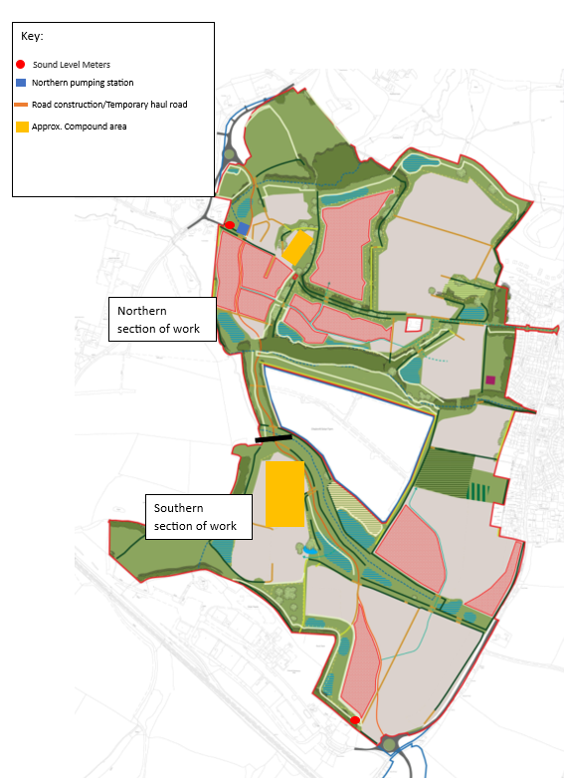

Drawing 2 Traffic management plan

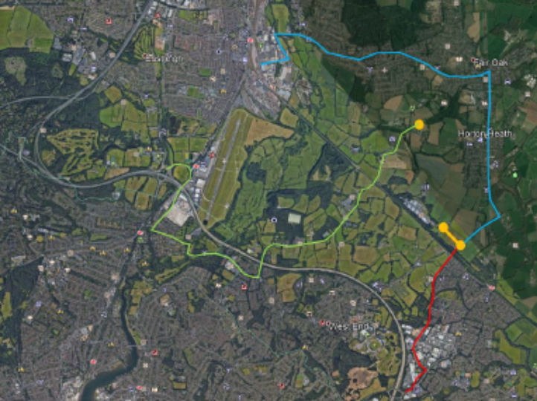

The red route demonstrates the main construction route to the south of the site and follows the M27 at Junction 7, Charles Watts Way, Tollbar Way, Bubb Lane and the new link road. This route is the most suitable, avoiding constrained roads where possible.

To access the northern parcel of the site it is likely the green route would be used which involves Junction 5 of the M27, A335, Wide Lane, the A27/ Mansbridge Road and Allington Lane. Both routes were used as part of the Allington Lane/ Link Road roundabout and Bubb Lane/ Link Road/ Burnetts Lane roundabouts construction.

Site traffic management plan
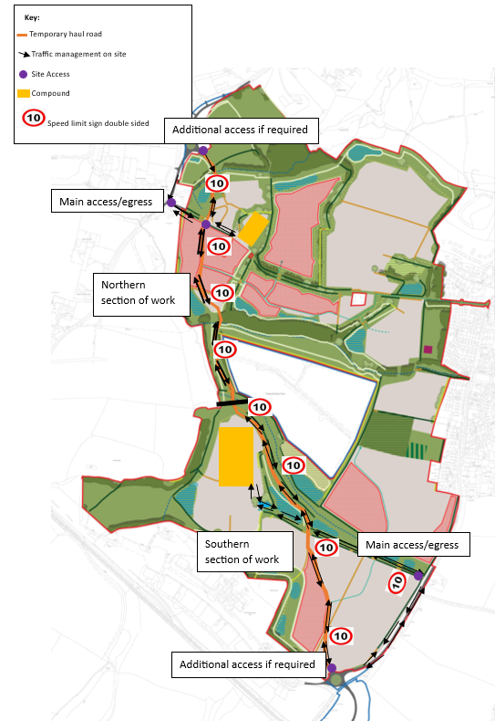

Drawing 3 Haul road
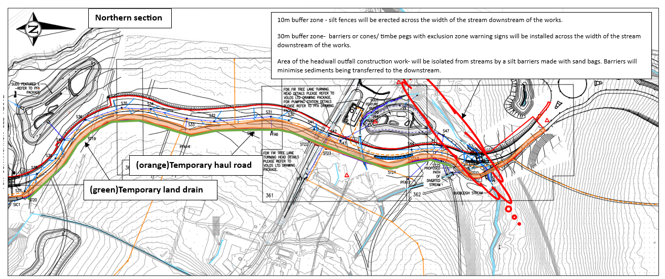
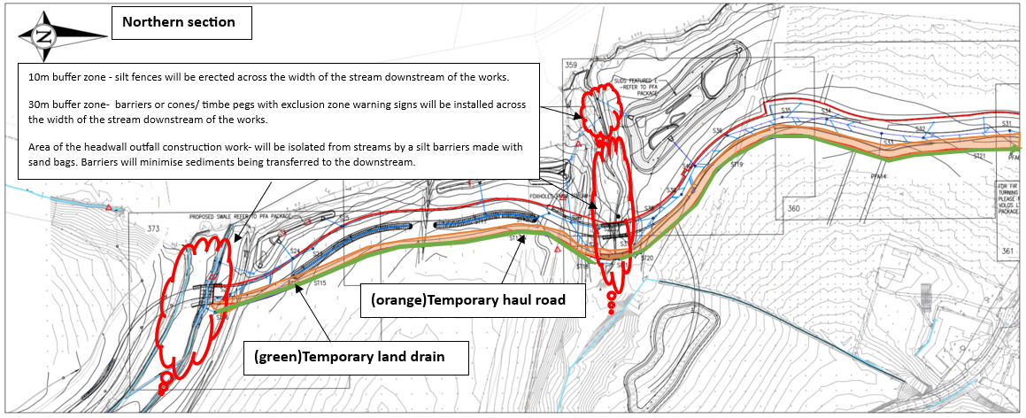
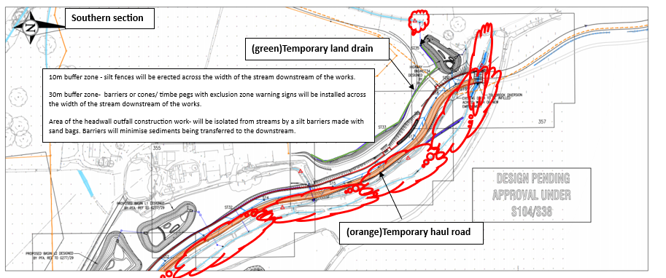
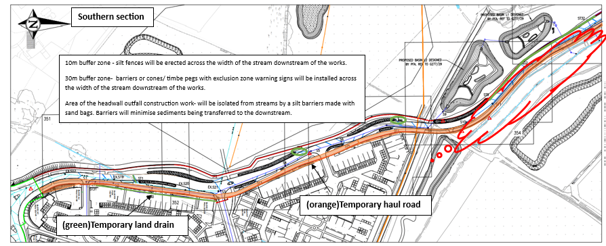

Drawing 4 Site layout
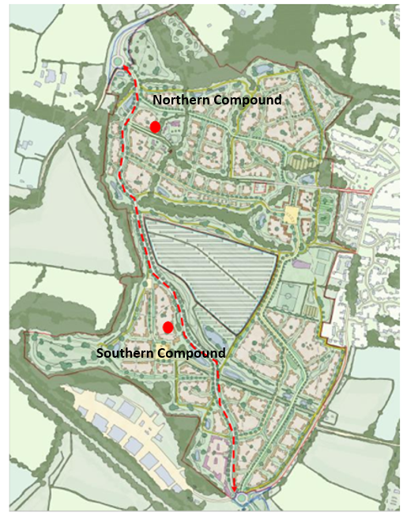

Northern compound
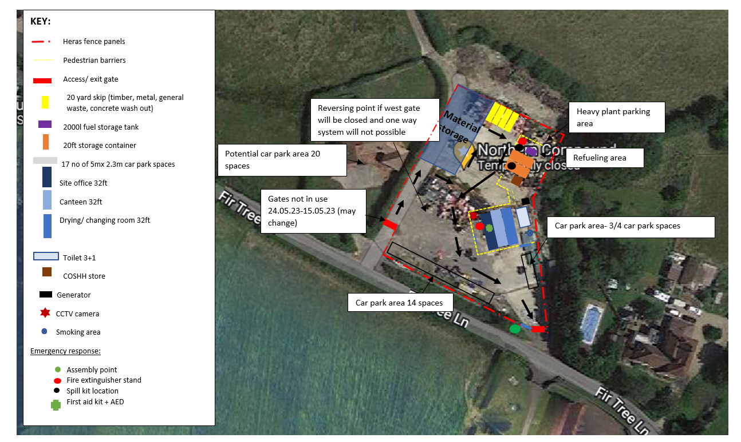

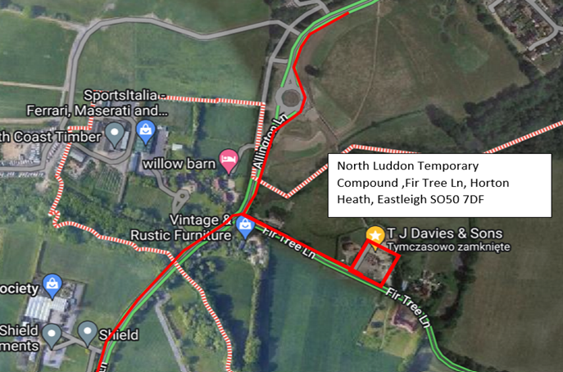

Southern compound
