2 Beechwood Rise, West End SO18 3PW
Planning Statement
2 Beechwood Rise is a substantial detached house dating from about 2009 in a development of similar sized and styled properties.
The proposal is for a single storey rear extension of modest proportions in relation to the house to provide a dining space to the kitchen.
The proposed finish of the extension is in brickwork to match the existing ground floor walls of the house with a flat roof; the roof to have a tiles perimeter in similar tiles to the existing roof tiles. This will also allow it to tie it into the roofline of the existing garage roof on the East elevation.
The design of the extension would mean that it would normally fall within the scope allowed by permitted development, however a planning condition on the original construction (Ref: Eastleigh Borough Council Z/28176/017/00) restricts development to the North and East elevations.
To the existing East elevation there is a side door leading into the garage. It is proposed to partially block this and provide a small side window in this location. It is also proposed to provide a new side door in the side wall of the extension. It is noted the neighbouring property on this elevation is a mirror image of No 2, albeit on a slightly higher level, and therefore this elevation is onto the side of the garage of the property. . It is considered therefore that the extension will not lead to an increase in overlooking to the neighbouring property and privacy will continue to be provided by the existing 1.8m high fence.
The photograph (Google Streetview) shows the relation of No2 to the neighbouring property:
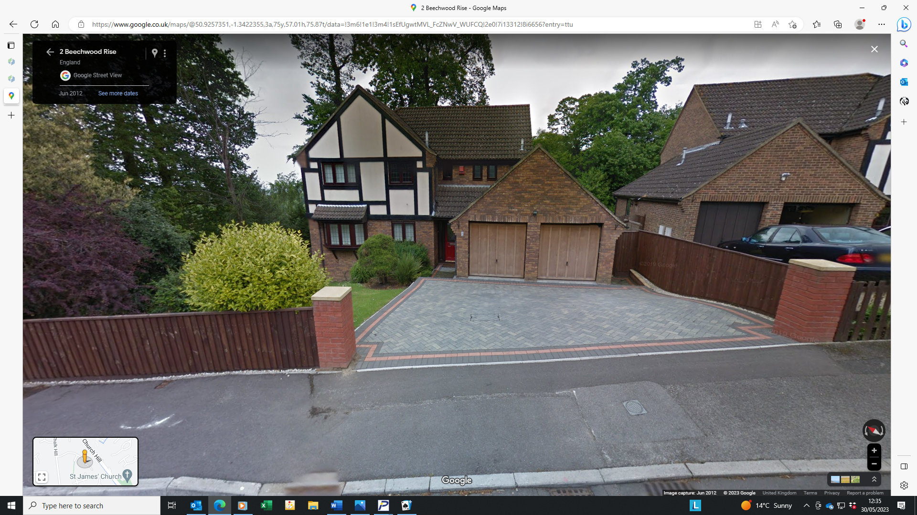

To the North elevation there is currently a pair of French doors. The proposal provides for a window in the North elevation of the extension. This will be at the same elevation as the existing French doors and therefore it is considered that there will be no greater overlooking from this elevation (or arguably less).
The other window in the extension is to the West elevation which is not covered by the planning restriction and looks across the rear garden and existing patio of the property.
The photograph below, taken from Google Mapping, shows the relation of the property to the neighbouring houses to the North.

