Knight Architectural Design Ltd.
A
D
K
NIGHT
RCHITECTURAL
ESIGN
Unit 7 The Quarterdeck
Port Solent
Hampshire PO6 4TP

Unit 4 Wellington Park, Tollbar Way,
Hedge End, Southampton SO30 2QU

Design Statement

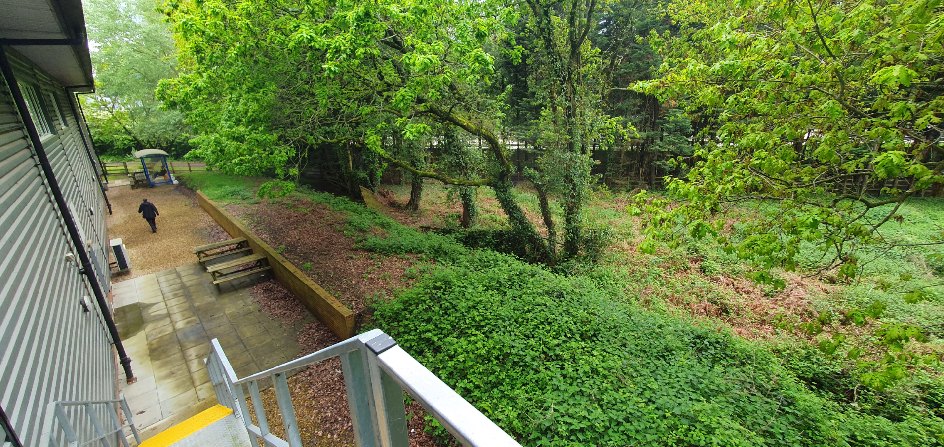
Existing Rear of Site

Page
Contents

Location 2
Current Situation 2
Proposed 2
Proposed Plans 3
Conclusion 4
Site Photos 4-5

Location
The Site of proposed works is to the rear of the unit 4 at Wellington Park, off Tollbar Way in Hedge End Southampton, SO30 2QU.
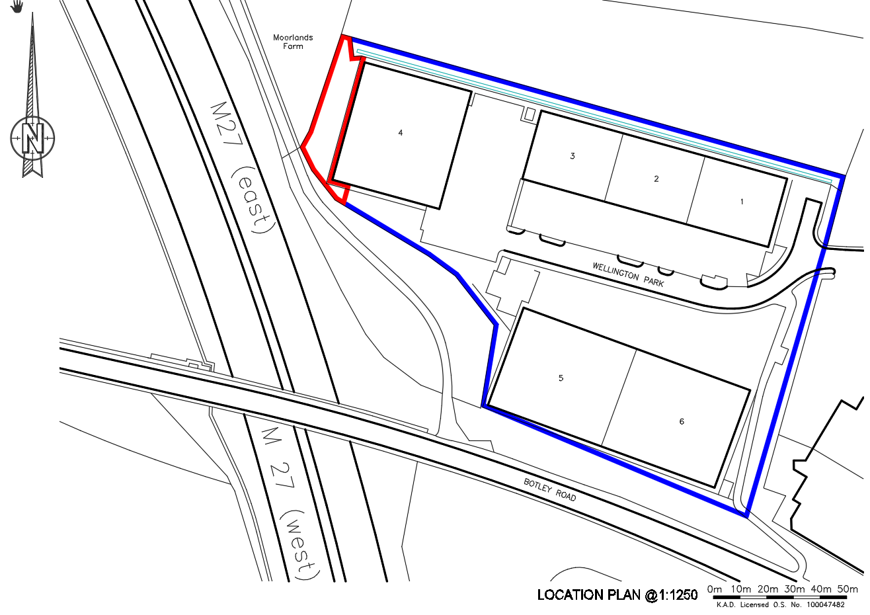 Current Situation
Currently towards the rear of site there are several issues related to the fence around the rear. The fence at the west side of Unit 4 has collapsed due to overgrowth of trees in the line of the boundary.
The fence at the southwest of Unit 4 is a small fence that is easy to climb over thus there have been reports of illegally entering the site to use the rear area for late night parties and recreational drug taking.
Proposed
The Proposal is to erect a palisade fence around the rear of the unit for protection of property. A fence that wraps around the rear of the site to the edge of the boundary up to a point where the lower fence is covered by foliage. The 2.4m high fence will keep out any trespassers from entering the property.
There will be a need to remove a few part fallen trees that have currently grown into and has caused partial collapse of the existing fence.

Proposed Plans
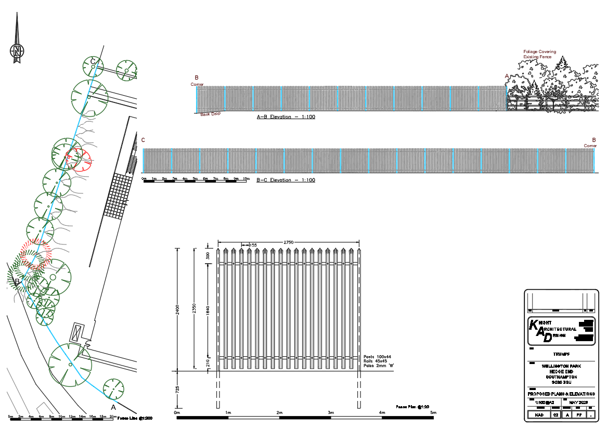
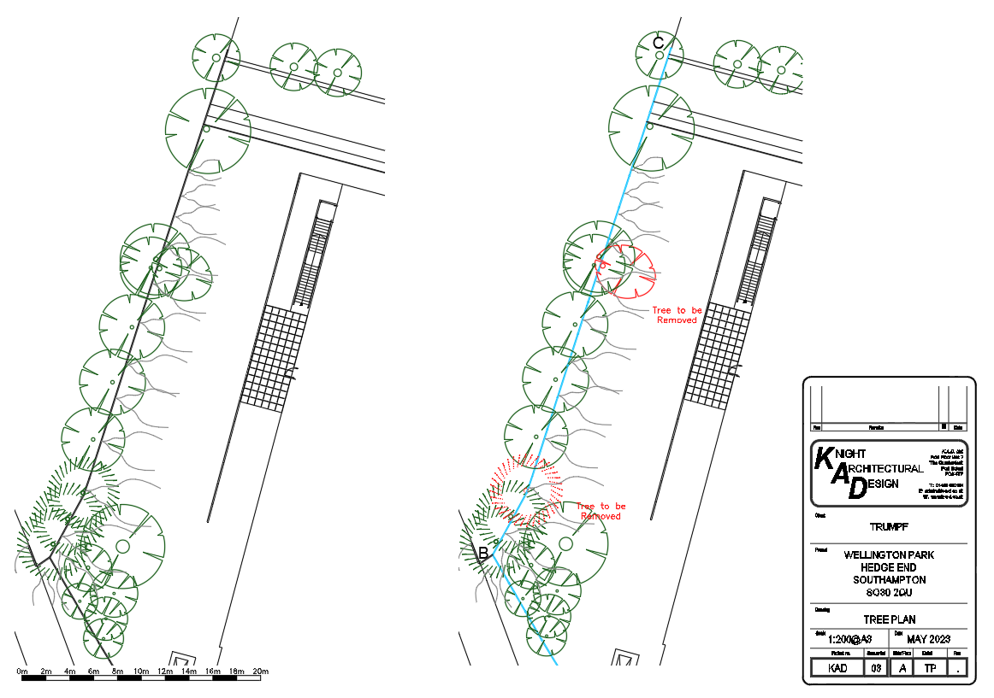

Conclusion
The scheme will help with the issues currently presented on site as a strong steel high fence will keep trespassers out of site and withstand future wildlife growth.
As the proposed works is to take place in an area not visible to public there will be no issue with the change from the split rail fence to the palisade fence from a visual standpoint. The fence will stop short of the neighbouring SSSI.
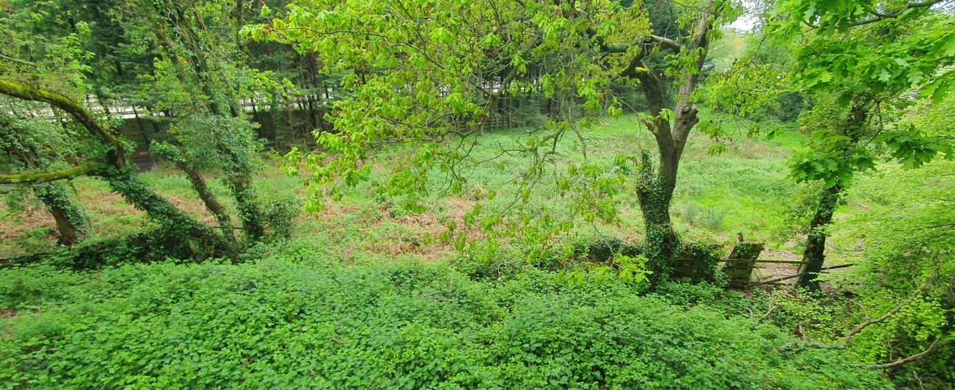
Photos

Photo of rear collapsed fence section B-C
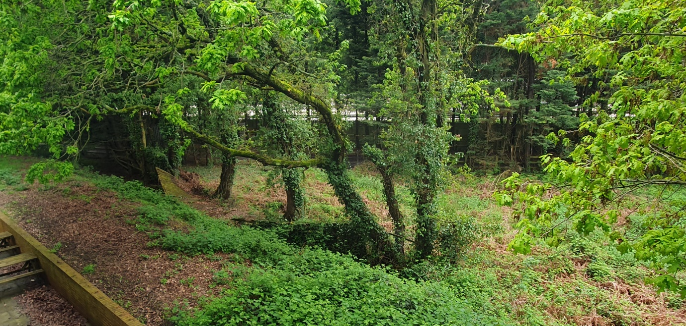

Continued Photo of rear collapsed fence section B-C

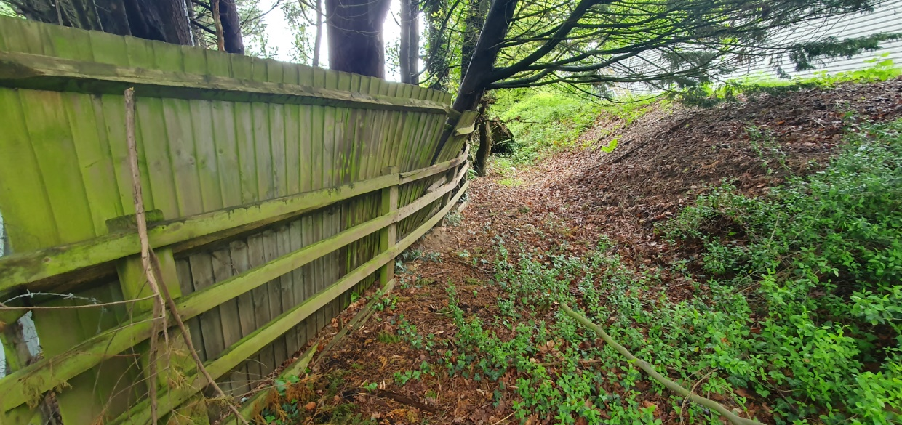
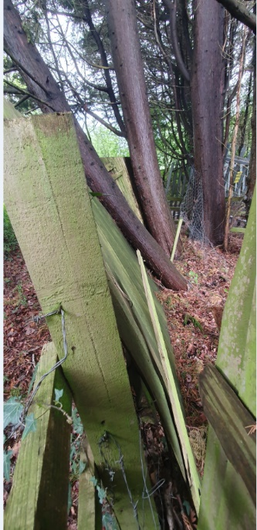

Photo of rear collapsed fenced with evidence of tree causing the damage.
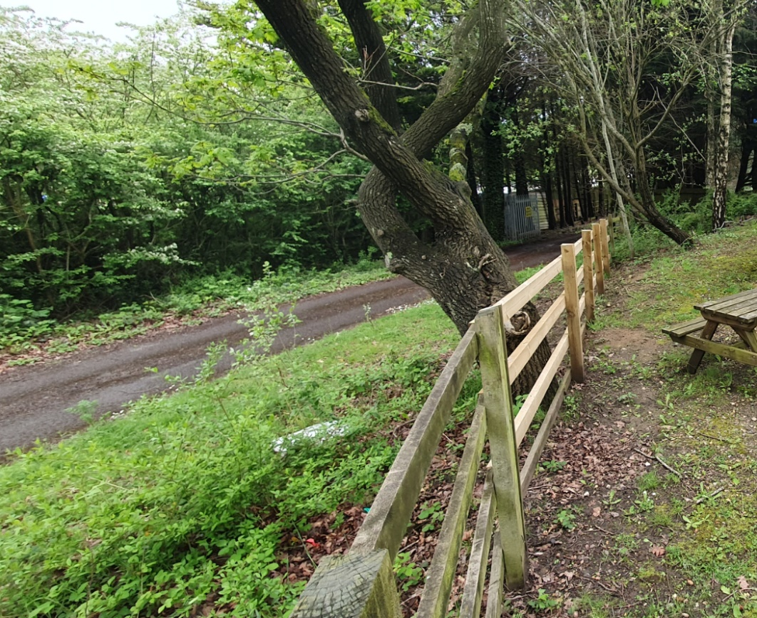

Photo of south west split rail fence section A-B.

