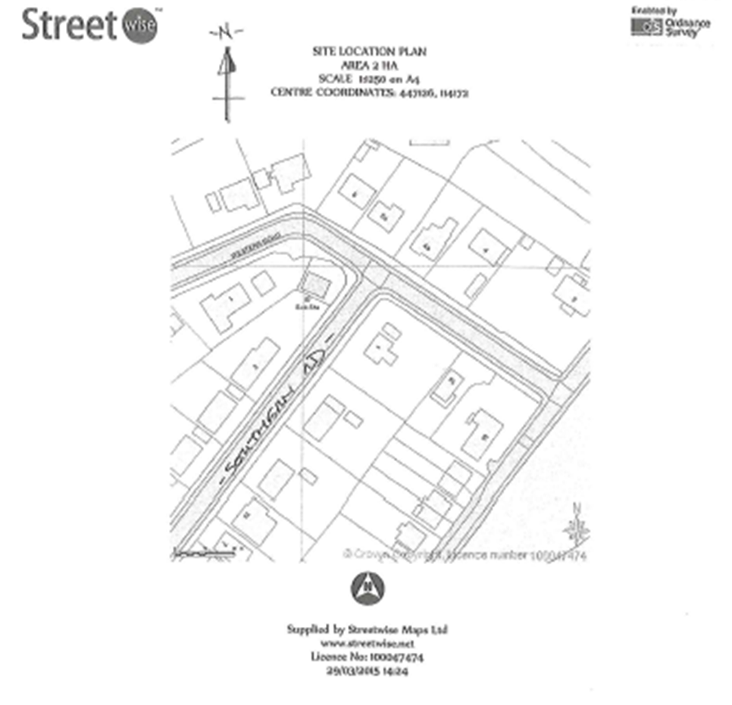

1 southern road

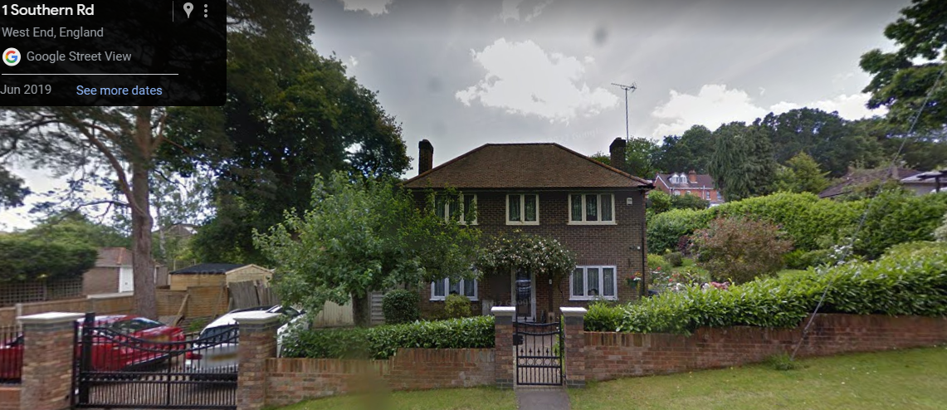
1 southern road - Front view

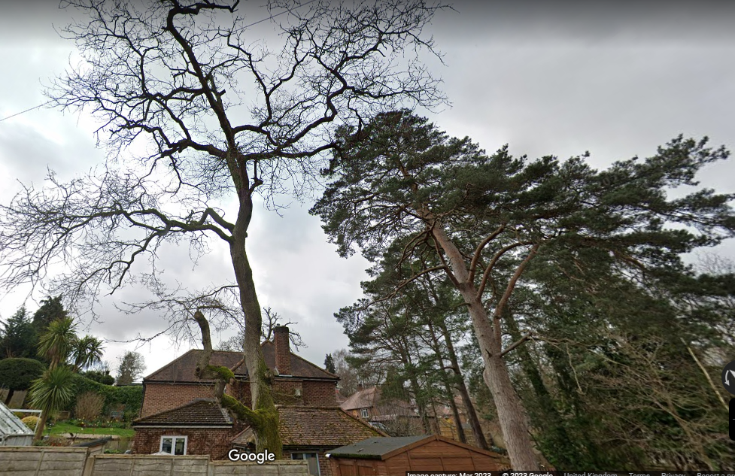
1 southern road – side view (from western road). Pine tree on right – dead oak tree on left

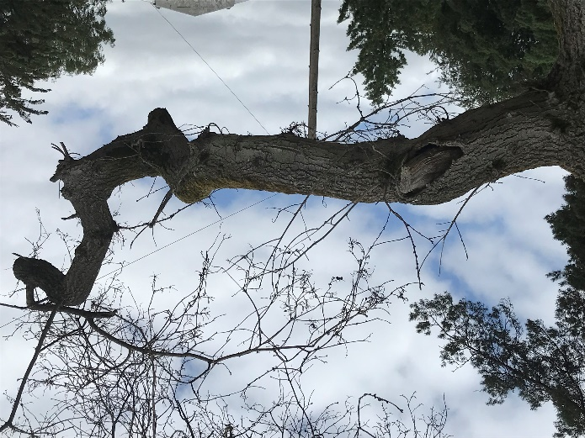
The oak tree has been slowly dying over the last five years. We have had limbs removed via planning permission in the hope of saving the tree. The oak only partially came out in leaf in 2022, so we waited to see if it would come into leaf a proper in 2023 but it did not, and the pictures below were taken today (2.7.23). There is no leaf, the bark is lifting and cracking and small branches are starting to fall off. This tree is clearly dead.

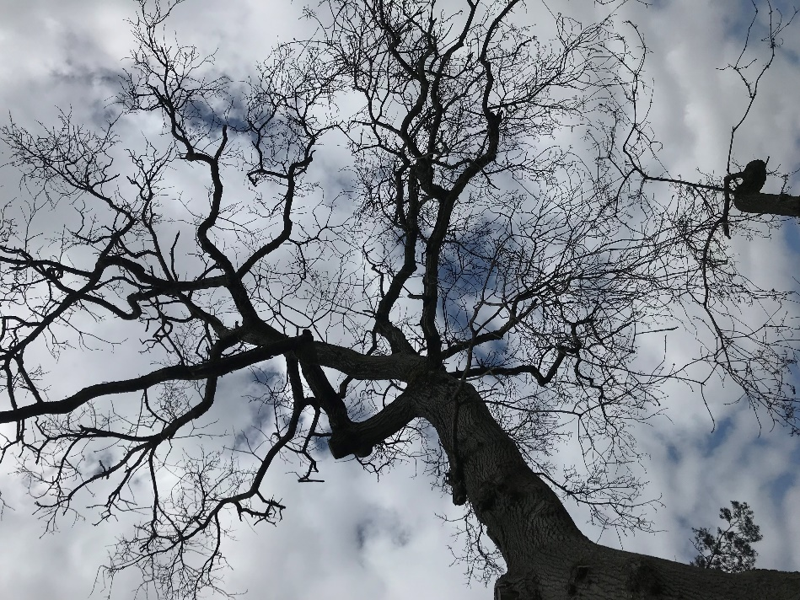

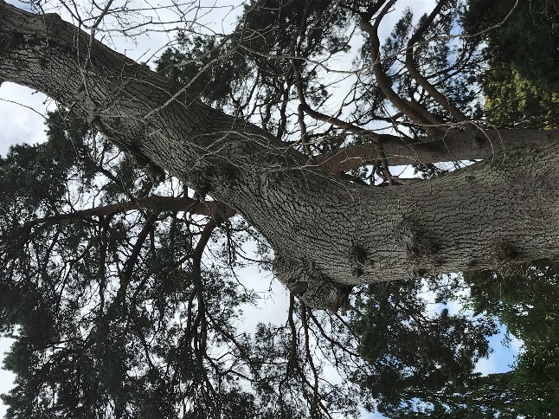

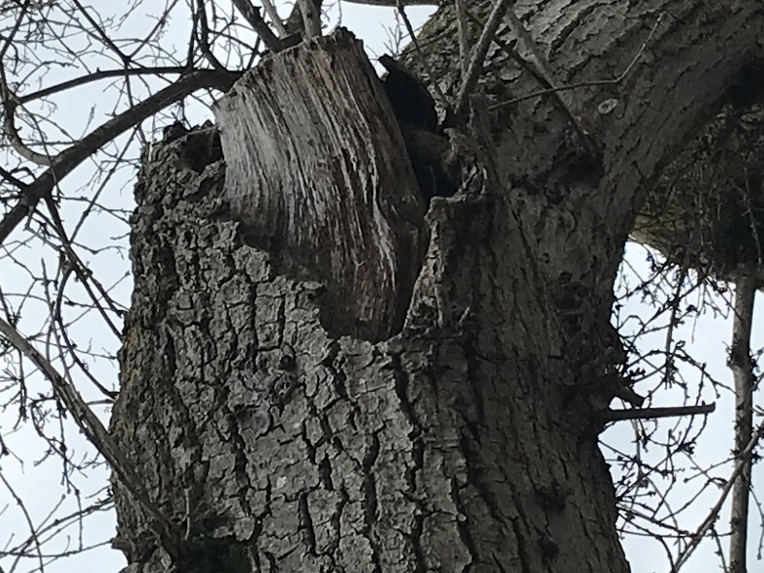
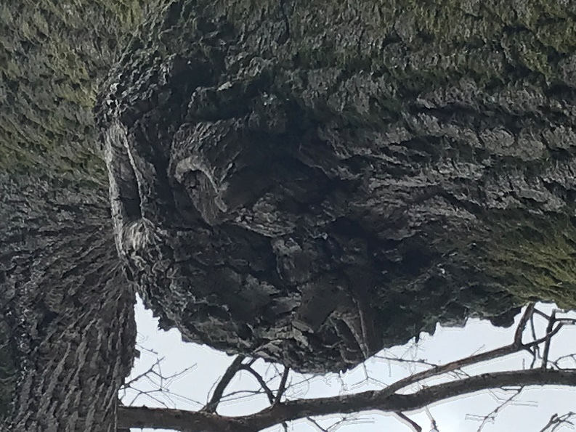

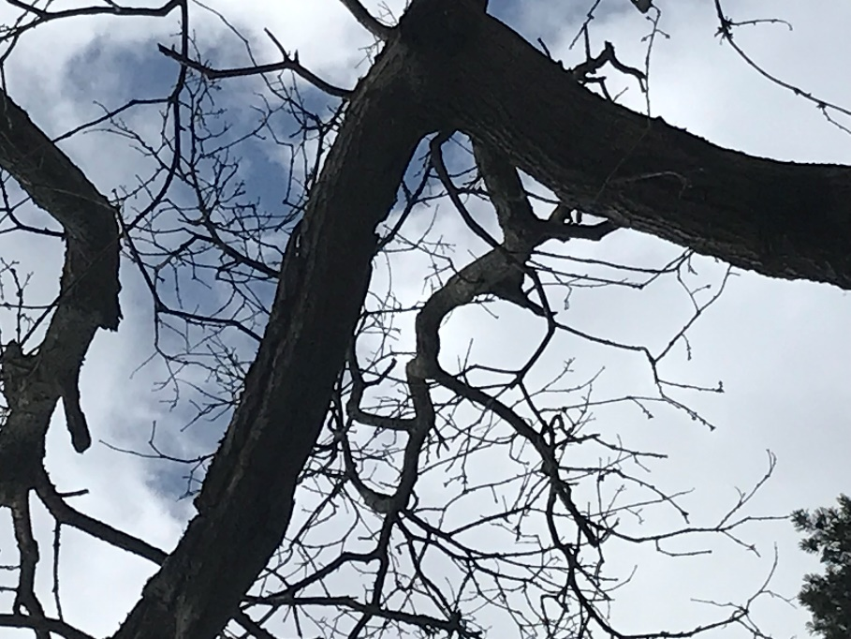

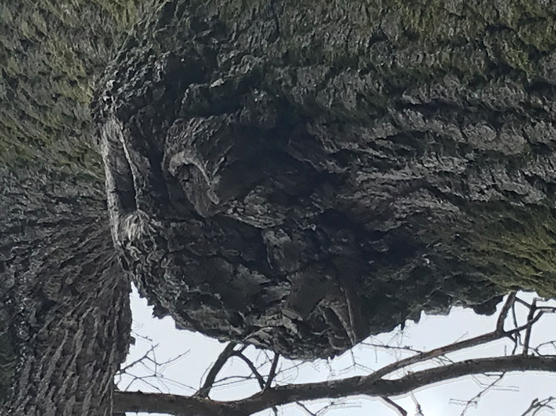

Tree Key:
Trees preservation order number 333 – G20 and W1

= Pine tree

= Oak tree
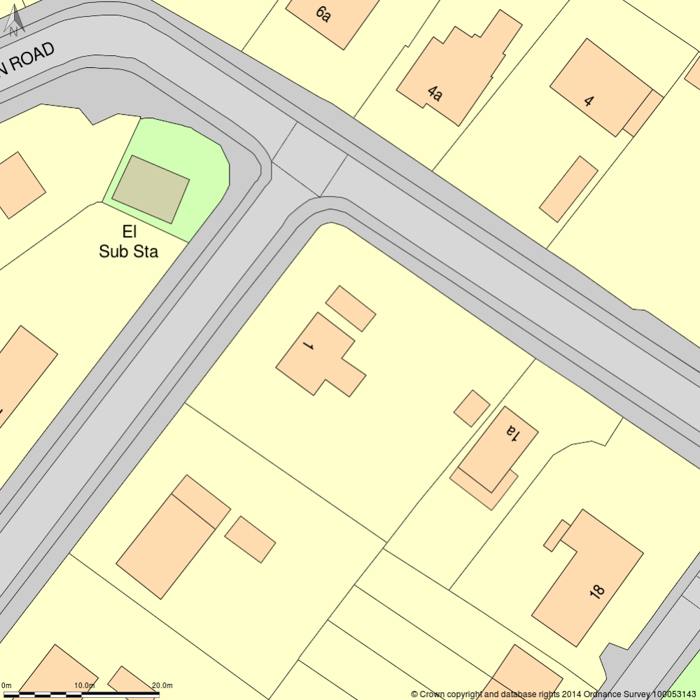

Pine tree (circa 70 years old)

Scientific name Pinus
Life stage Over-mature
Remaining years 30+
Branch spread 6.3m
Height 30m
Canopy height from ground 3.10m
First significant branch (direction) South/west facing, 3.10m from ground
Stem diameter 570mm

Oak tree (circa 80 years old)

Scientific name Quercus
Life stage Over-mature
Remaining years 0
Branch spread 11.4m
Height 30m
Canopy height from ground 2.5m
First significant branch (direction) East facing, 2.5m from ground
Stem diameter 650mm

