Sketch Plan for Westgate House, St Mark Close, Winchester Road, SO53 2DY
T1 Beech
T2 Oak

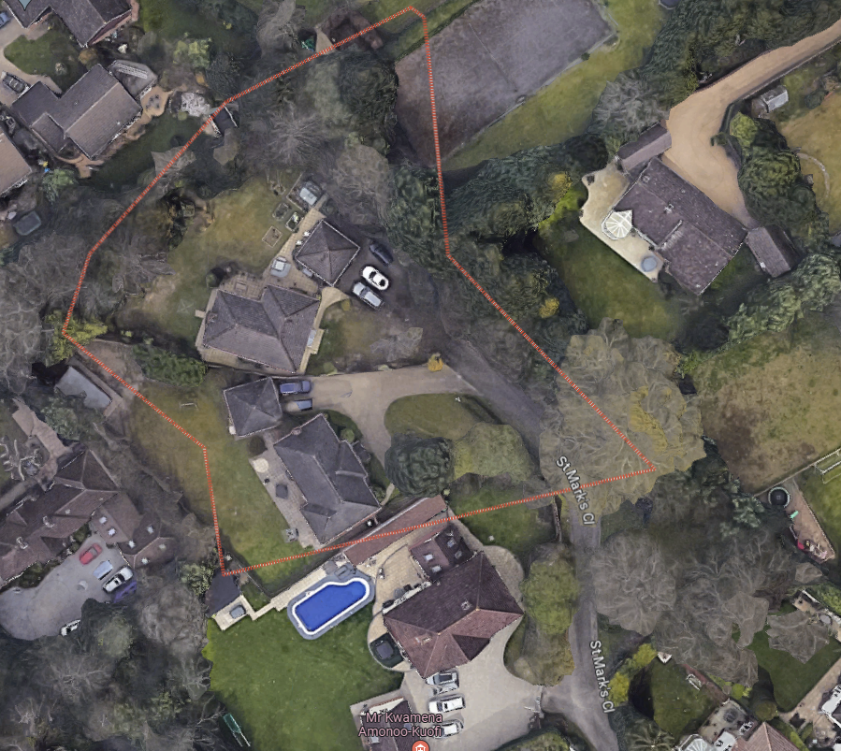
T2
T1

