Fleming Park Football Pitches – Ball Stop Netting
Design and Access Statement

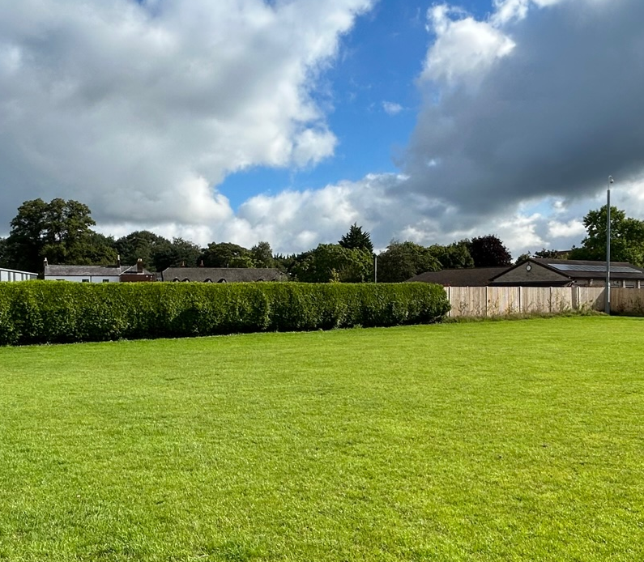

- Introduction and Background
The football pitch provision to the north of Places Leisure Eastleigh has previously been utilised for 4x 7v7 pitches. Due to the relocation of the Eastleigh District Mini Soccer League, these grass pitches are now going to be allocated for 2x 9v9 pitches, mean that the orientation of the pitches will change to north/south. To reduce a health & safety risk and prevent footballs entering the bowls club and to reduce the risk of damage to the green and clubhouse, ball stop netting is required.
The netting will be circa 6m in height and will run along the length of the bowls club fence, approximately 45m in length. The netting will enable the two sporting activities to be delivered in harmony and without conflict. Additional ball-stop netting is not perceived necessary on the remainder of the site as it does not present the same probability of occurrence due to the orientation of the pitches, or potential consequences should the ball leave the playing area due to their location within the site and distance from the site boundaries.
There will be no change of use.
Context
With the orientation of the pitches now changing to accommodate 9v9 match play provision, a health and safety concern has been raised relating to stray footballs entering the bowls club. This project seeks to alleviate that risk and ensure that the two sports can be delivered simultaneously to benefit the health and wellbeing of local residents.
Location and Layout
The attached plans highlight the proposed location of the ball stop netting. The existing fence line can be seen in the photo below.

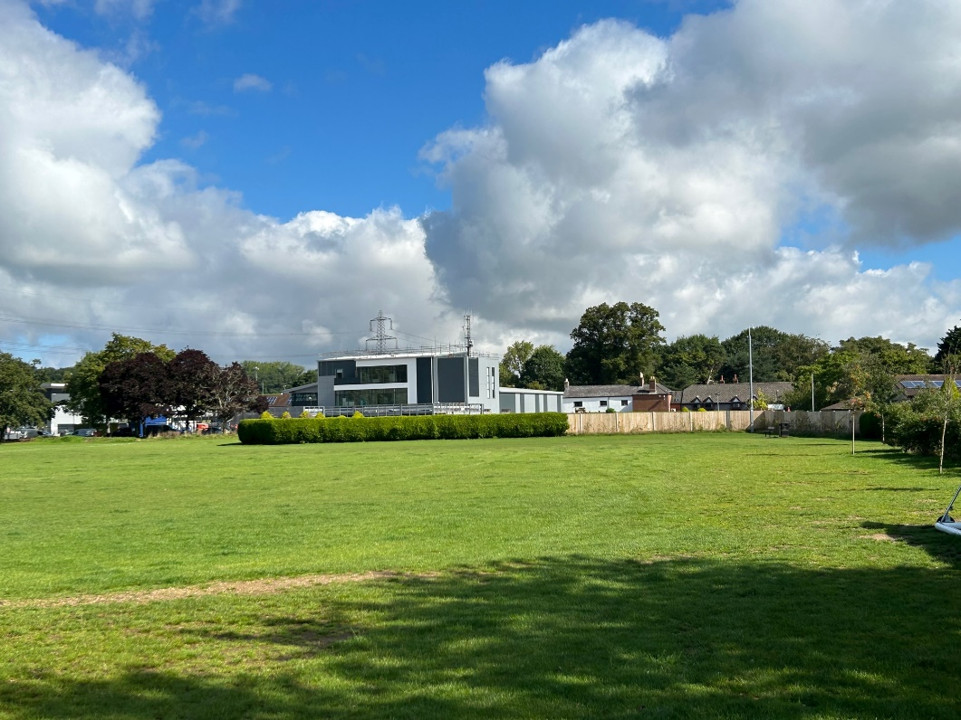
Material and Appearance
To minimise the visual impact of the additional ball stop netting, green galvanised posts will be used. The ball stop netting will consist of a heavy duty nylon net that is suspended between the posts.
The image below shows an example of the visual appearance of the ball stop netting proposed for installation (note the colour of the system will be green to match surroundings).

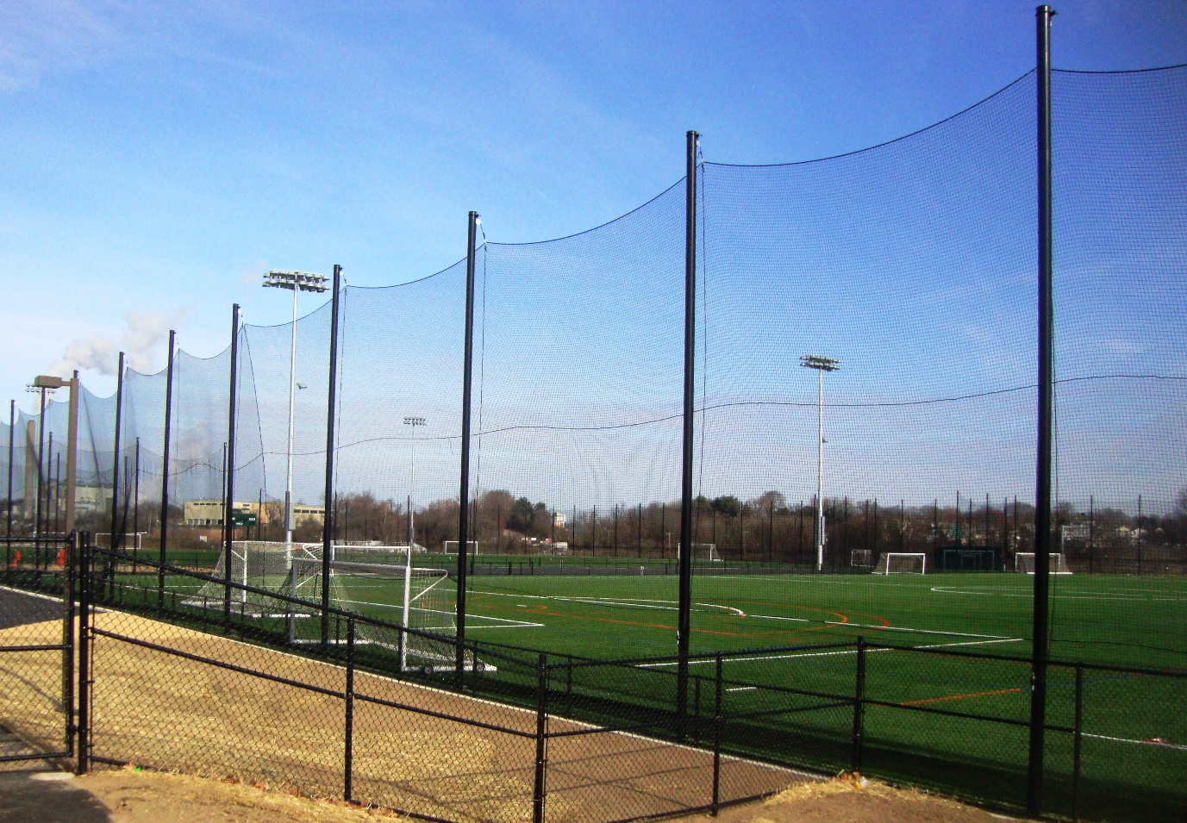

These materials provide continuity with the existing landscape and park and due to the surrounding vegetation and lack of neighbouring properties, will have minimal visual impact from outside the site.

Access
This application does not have any access considerations.
Summary
The proposals have been developed with the aim of minimising the health and safety risks of footballs leaving the site and landing in the adjacent bowls club. Mitigating this risk will enable the site to be used to its full potential to increase its positive contribution to the community it serves.

