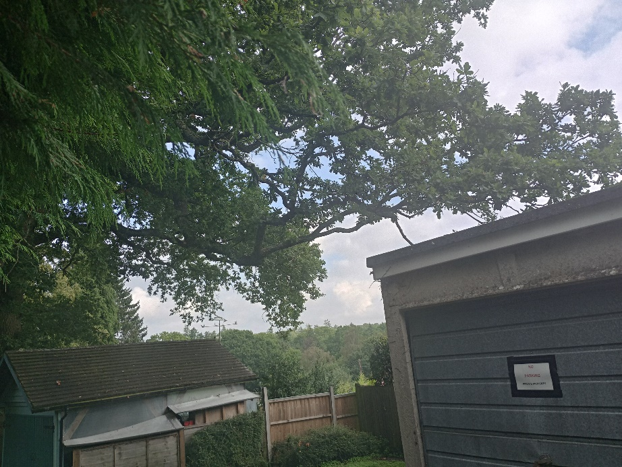
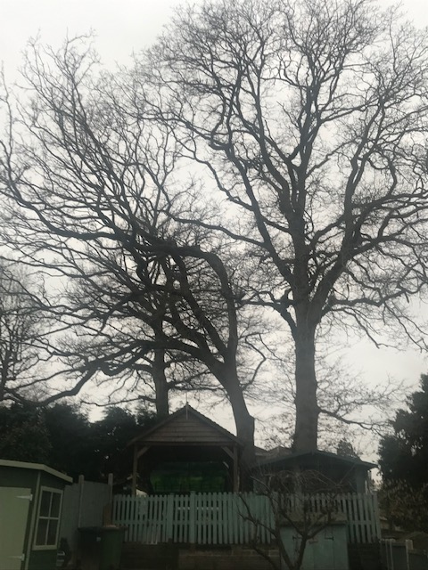
Lower overhanging branch on
Oak tree 2
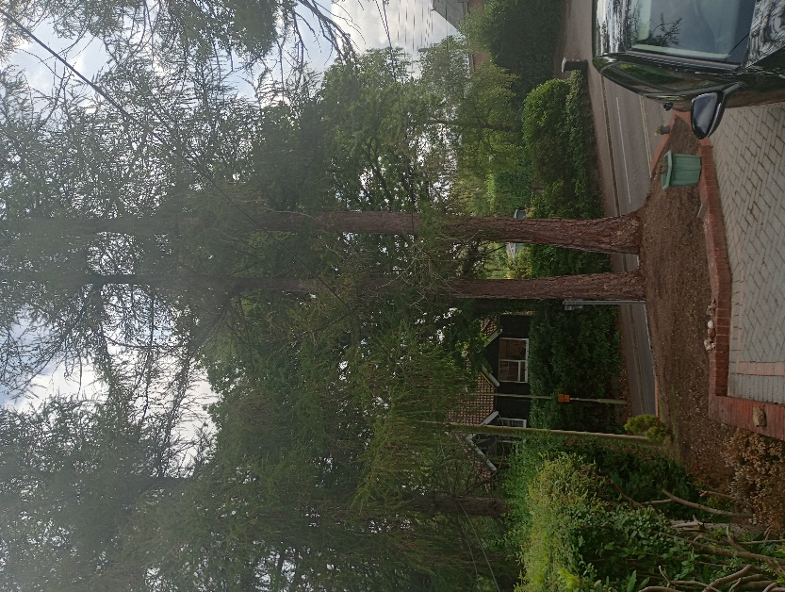
Larch tree 2 on the left
Larch tree 1 on the right

Oak tree 1 on the right
Oak tree 2 on the left

