

- Twyford Road, Eastleigh, SO50 4HJ
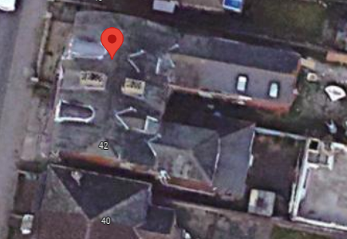

Introduction
This document has been prepared by DWG Plans Ltd. on behalf of Anil Dass the client The document has been produced in support of a planning application for a change of use from an 3 flats and salon to a 9 bedroom HMO. The proposal includes the re-configuration of internal layouts and a conversion of the basement area along with a new bay window to the basement and a larger dormer to the rear.

- Site Context

Site address
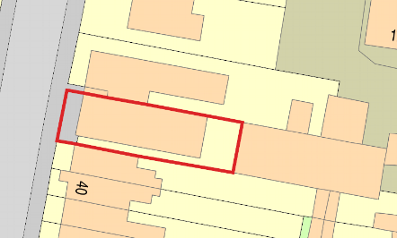

44 Twyford Road
Eastleigh
SO50 4HJ

OS Grid reference
Reference: SU 4574 1969

Local Authority

Eastleigh Borough Counil

Ward

Eastleigh North Ward

Site

The property is a four-storey residential building located on
Twyford Road, consisting of a basement level, salon, x2 existing 1 bed flats
and an existing 3 bed flat.

- Additional Information

Entrance and Access
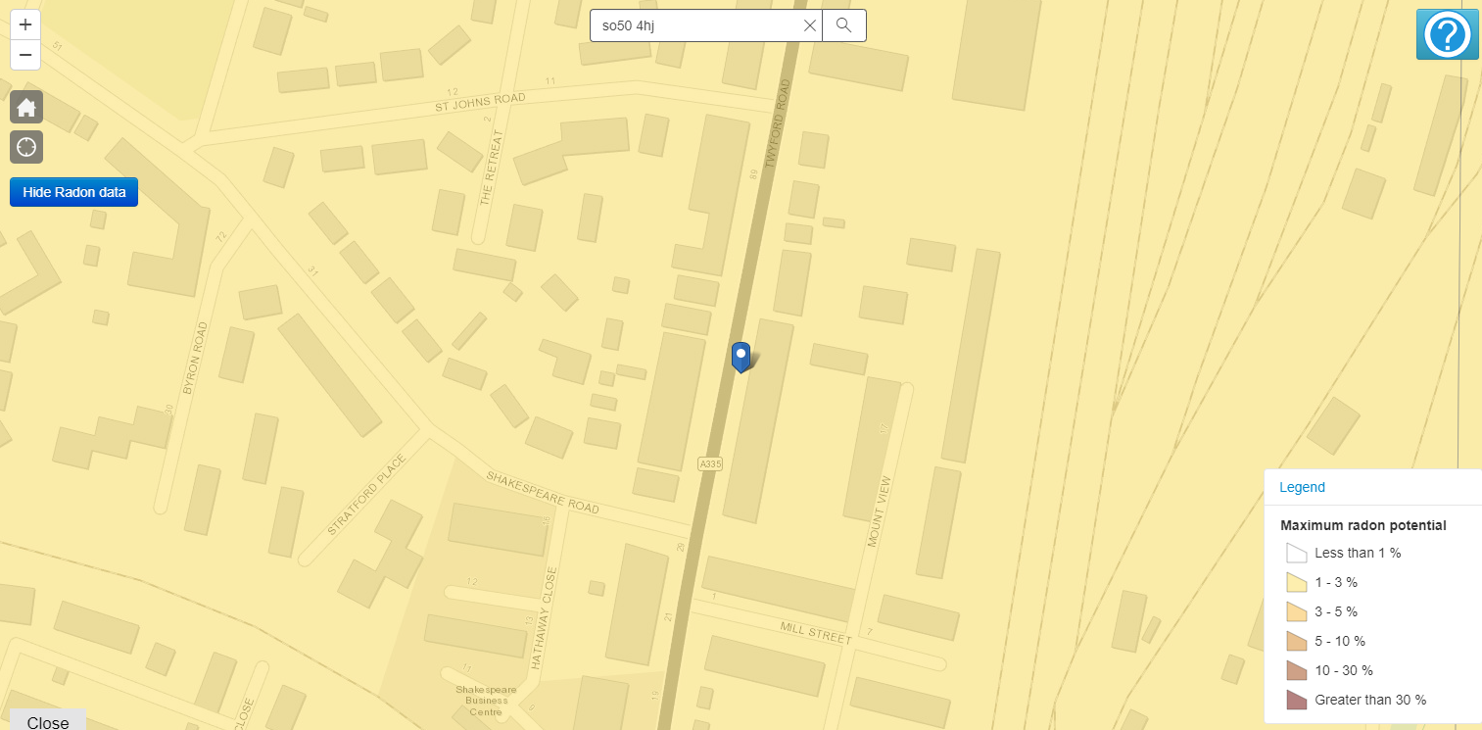
The access to this property has changed slightly.
The front entrance will be blocked up and access to the property will be on the south facing side elevation.

Parking & bicycle Provision

There will be no allowance for car parking but there will be a bike store to the rear of the property which will house up to 10 bikes. There is local transport near by.

Refuse

There will be x2 1100 litre Euro bins to the rear of the property.
See DWG Plans 02797 Site Plan for location.

Contamination

The proposal site is located within 1-3% radon affected area.
Appropriate mitigation strategy to be agreed with LABC before
Commencement of works.

Flood Risk
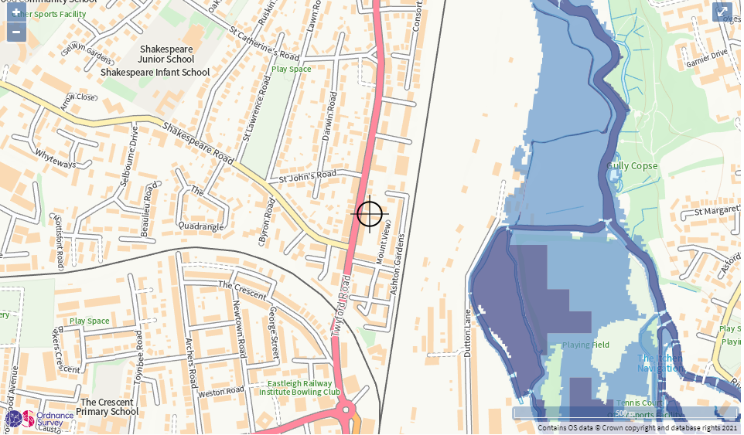

The proposal is not located within a flood risk area from
River, sea or surface water.

Arboriculture

No trees will be impacted by the proposal

01: Uk Map of Radon
02: Environmental Agency Flood Planning Map

- Additional Information Cont…

Biodiversity

Please refer to bio-diversity checklist.

Right to Light

The proposal does not affect any window positions or sizes and
Therefore, no change to current right to light is sought.

National Space Standards

The rooms sizes exceed the space standards of the national space standards and within Eastleighs standards.

- Site Photographs

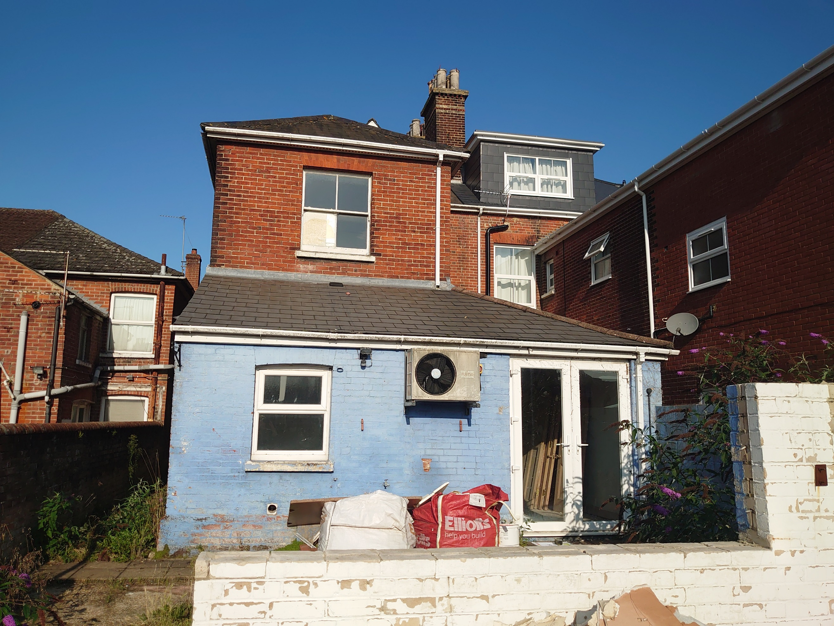
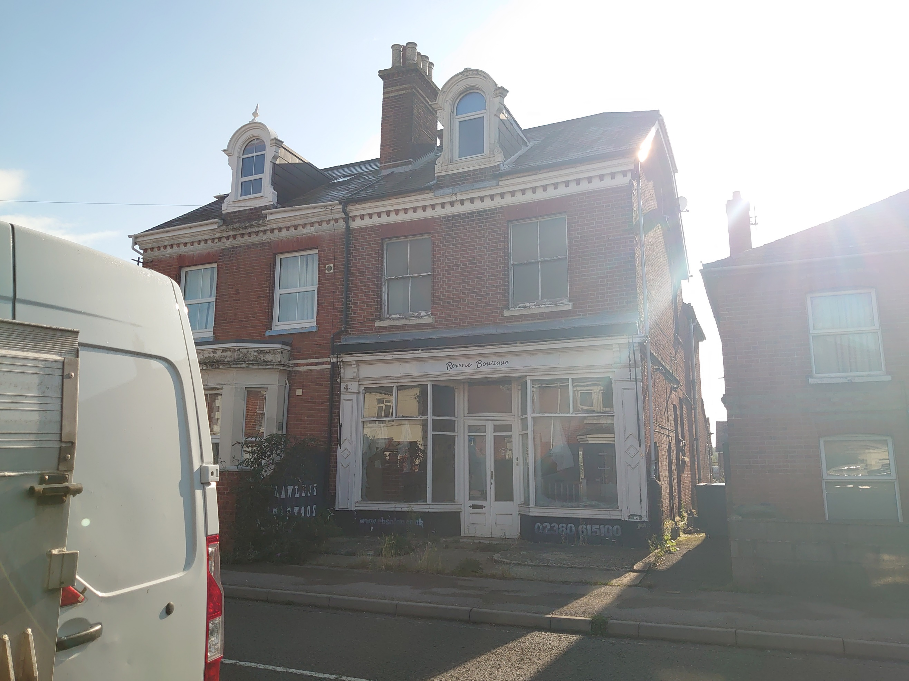
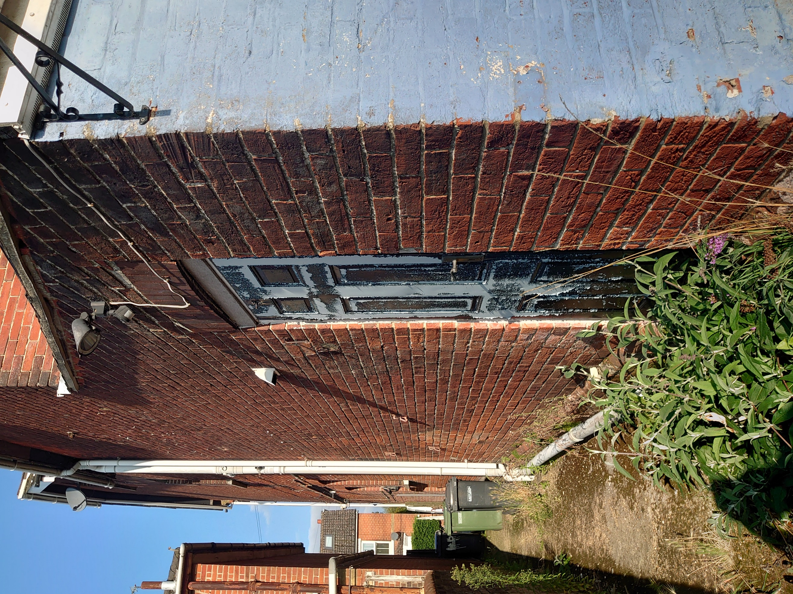

- Proposal

Proposed works consist of mainly internal configuration of
The rooms to allow for a 9 bedroom HMO to be created.
Refer to existing and proposed plans for more detail.

The basement area will house the communal areas of a kitchen/dining and living area.
A new bay window will be created to give natural light into this area along with another means
Of escape.
.

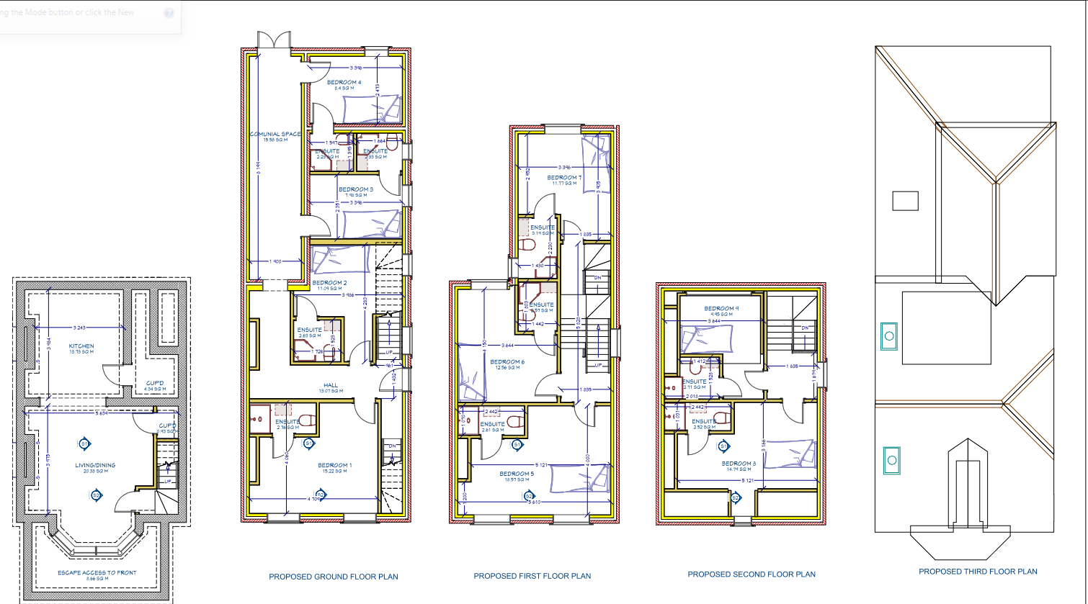

- Proposal Cont…

The newly created bay window will be brick and render to match the existing materials.
The new larger dormer will be tile hung to the external to match that of 46 Twyford Road.
.

There will be x2 new Eurobins supplied, 1 for recycling and 1 for general waste.
These will be situated to the rear of the property near to the rear elevation.
See DWG Plans 02797 Site Plan for exact position.

- Conclusion

This proposal has been prepared in response to the requirements and aspirations of the client, establishing additional bedrooms with careful reconfiguration of the existing space. The proposal is not looking to change any external appearance apart from the newly created bay window (no different to number 46 Twyford Road and the enlargement of the dormer to the rear to also match number 46 Twyford Road) and will therefore maintain the character of the street scene. It is our view that the unit typologies and sizes are appropriate to this setting and will provide much needed residential accommodation to this part of Eastleigh.

