Application No. F/17/82214 : Use of land as civil engineering contractor's yard, with associated storage, storage containers, parking, fencing and landscaping - Land adjacent Unit 2CB Deer Park Farm, Knowle Lane, Fair Oak, SO50 7DZ

Condition 7

Prior to commencement of development, a Landscape and Ecological Management Plan (LEMP) shall be submitted to and approved in writing by the Local Planning Authority. This shall include:

- A planting plan for the site to include details of planting locations, species and size;
- Details of reptile habitat creation;
- Biodiversity net gain calculations;
- Timings for the implementation of planting and habitat creation;
- Details and locations of proposed bird nest boxes within the hedge;
- Details of ongoing management procedures and responsibilities.

The development shall thereafter be carried out in accordance with the approved details, and for a period of no less than 5 years after planting, any plants or trees which are removed, die or become seriously damaged or defective, shall be replaced as soon as is reasonably practicable with others of the same species, size and number as originally approved.

The Deer Park Farm Industrial Estate development proposals include a number of ecological enhancement measures. These comprise the establishment of wildflower rich grassland, a corridor of woody habitats that incorporates logpile deadwood habitat and the installation of bird nesting boxes and bat roosting boxes.

This document outlines the main provisions for the implementation of a LEMP as required to discharge Condition 7 of the Deer Park Farm Industrial Estate development planning consent.

Wildflower Rich Grassland Habitat Creation

Wildflower rich grassland will be created along hedgerow and access road verges by seeding with a diverse mixture of wildflower and wild grass species to create tall herb rich wildflower grassland. These works will proceed in accordance with the following considerations:

- Cultivation of the ground surface within wildflower rich grassland seeding areas would be undertaken to provide a viable seedbed. The incorporation of soil ameliorants is unlikely to be required;

- The species mixture used for seeding wildflower rich grassland will include the following:

Wild Flowers  Achillea millefolium Yarrow  Betonica officinalis Betony  Centaurea nigra Common Knapweed  Centaurea scabiosa Greater Knapweed  Daucus carota Wild Carrot  Filipendula ulmaria Meadowsweet  Galium album Hedge Bedstraw  Galium verum Lady's Bedstraw  Knautia arvensis Field Scabious  Leontodon hispidus Rough Hawkbit  Leucanthemum vulgare Oxeye Daisy  Lotus corniculatus Birdsfoot Trefoil  Origanum vulgare Wild Marjoram  Plantago media Hoary Plantain  Poterium sanguisorba Salad Burnet  Primula veris Cowslip  Prunella vulgaris Selfheal  Ranunculus acris Meadow Buttercup  Rhinanthus minor Yellow Rattle  Rumex acetosa Common Sorrel  Silene dioica Red Campion  Silene flos-cuculi Ragged Robin  Trifolium pratense Wild Red Clover | Grasses  Agrostis capillaris Common Bent  Cynosurus cristatus Crested Dogstail  Festuca rubra Slender-creeping Red-fescue  Phleum bertolonii Smaller Cat's-tail

- Seeding would require the provision of suitable soil and weather conditions. In particular, seeding is likely to be most successful if undertaken during the autumn. Seed would be applied at a maximum density of 40 kgha⁻¹;

- The principal establishment phase aftercare for wildflower rich grassland areas is likely to focus on spot treatment to control pernicious weeds;

- Longer term grassland management would involve seasonal cutting and removal of arisings. Cutting management would take place during late summer.

Hedgerow Habitat Creation

The creation of site perimeter hedgerow habitat would utilise open ground bare rooted tree and shrub planting. These works will proceed in accordance with the following considerations:

- Tree and shrub planting would comprise a variety of broadleaved tree and shrub species, as listed below:

Species | % of planting mixture
Hazel Corylus avellana  Blackthorn Prunus spinosa  Hawthorn Crataegus monogyna  Goat Willow Salix caprea  Field Rose Rosa arvensis  Pedunculate Oak Quercus robur  Crab Apple Malus sylvestris  Rowan Sorbus aucuparia | 20  12  12  12  12  12  10  10

- Tree and shrub planting would utilise 45 – 60 cm bare rooted nursery transplants obtained from a local provenance and planted in three rows at 750 mm staggered centres;

- Trees and shrubs would be pit planted. Planting pits would be backfilled with 50% excavated material and 50% peat free tree planting mulch compost;

- All planted trees and shrubs would be fitted with tree shelters to aid establishment and provide protection from deer browsing;

- Woodland planting aftercare would comprise weed control and replacement of failed trees and shrubs;

- Long term hedgerow management would comprise side trimming every other year to allow the hedgerow to develop a structurally varied habitat character.

Reptile Refugia Habitat Creation

Reptile refugia habitat would be introduced to verge locations within the hedgerow habitat creation area as shown below:
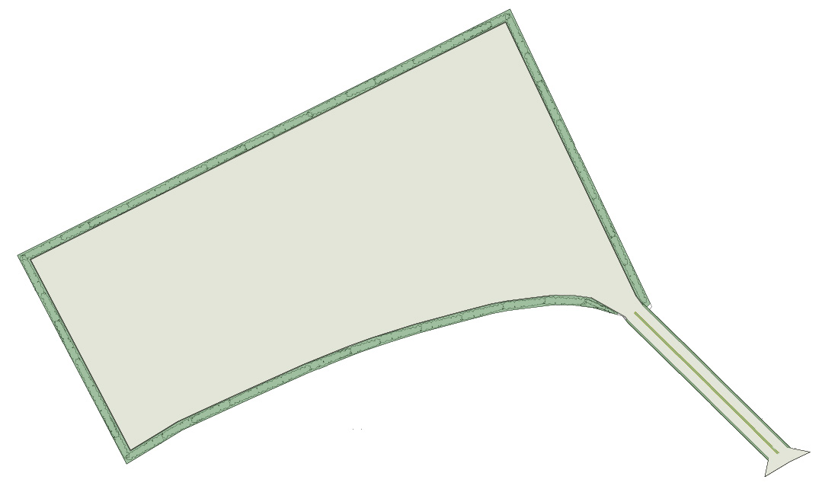
Reptile refugia habitat locations

Reptile refugia habitat would comprise the following:

- Gaps within the hedgerow planting would be created to accommodate the creation of reptile refugia habitat;
- Placement of inert rubble heaps around 500 millimetre diameter and no greater than 350 millimetres high;
- Rubble heaps should have minimal dust and fines to ensure that a wide variety of cavity spaces are provided;
- Conceal rubble heaps with sections of cut timber with a maximum diameter of 250 millimetres and no greater than 1.0 metre long, organised in stacks around 1.0 metre high and 1.5 metres long. This will provide cover habitat that could be used by reptiles and hedgehogs, and deadwood decay microhabitat of value for invertebrate conservation.

Once installed, the reptile refugia habitat will be protected from disturbance

Installation of Bird Nesting Boxes and Bat Roosting Boxes

Timber posts would be installed at equal spacings within the hedgerow habitat creation corridor for use as locations for installation of bird nesting and bat roosting boxes. The following bird nesting and bat roosting boxes will be installed on the posts at a minimum height of 2.5 metres:

- 4 no. Schwegler type 1B hole-fronted bird nesting boxes;
- 4 no. Schwegler type 2FN bat roosting boxes.

Timber posts will be of a sufficient dimension to provide a stable support for the nesting and roosting boxes specified.

LEMP Delivery Programme

Wildlife habitat creation and management provisions described within the LEMP would be implemented at an appropriate time during delivery of the Deer Park Farm Industrial Estate development. Specific habitat creation and habitat management actions would be undertaken according to the following programme:

 | Time Following Implementation of LEMP
 | Year 1 |  |  |  | Year 2 |  |  |  | Year 3 |  |  |  | Year 4 |  |  |  | Year 5
Activity | Q1 | Q2 | Q3 | Q4 | Q1 | Q2 | Q3 | Q4 | Q1 | Q2 | Q3 | Q4 | Q1 | Q2 | Q3 | Q4 | Q1 | Q2 | Q3 | Q4
S1
S2
S3
S4
P1
P2
B1
B2
L1

S1 – Seeding areas: ground preparation
S2 – Seeding areas: seed application
S3 – Seeding areas: aftercare (weed control)
S4 – Seeding areas: aftercare (cutting)
P1 – Hedgerow tree and shrub planting
P2 - Hedgerow tree and shrub planting aftercare
B1 – Bird box installation
B2 – Bat box installation
L1 – Reptile refugia habitat placement

