**SUPPORTING STATEMENT FOR THE INSTALLATION OF A WALK-IN FREEZER WITH TIMBER CONSTRUCTION AND SEDUM PLANTED ROOF**

We, Marcus Darcy and Hulya Darcy, the proprietors of Pirate Pasties in Hamble, are submitting this supporting statement for our application to install a walk-in freezer. This statement elaborates on our plan to construct a covering using timber, incorporate trellis siding covered with climbing plants, and install a sedum planted roof. We believe that these design choices will not only enhance the visual aspect of our establishment but also contribute significantly to the promotion of biodiversity and the overall environmental quality of the area.

**Timber Construction with Trellis Siding:**
Our choice to construct the walk-in freezer with timber aligns with our commitment to respecting the historical significance of Capstan House, a building that was originally constructed with local red brick. Timber is a natural, sustainable material that will harmonize with the surrounding area, preserving the historical character of the building. The trellis siding, covered in climbing plants, will serve multiple purposes:

- **Aesthetic Enhancement:** The trellis, adorned with climbing plants, will add a touch of natural beauty to the building. This will not only create an attractive and welcoming façade but also soften the industrial appearance of a freezer structure.

- **Promotion of Biodiversity:** Climbing plants attract pollinators and other wildlife, contributing to the local ecosystem. By providing a habitat for birds and insects, we aim to support biodiversity in the area, contributing to the ecological health of the neighborhood.

- **Environmental Benefits:** Plants on the trellis will provide shade, helping to regulate temperatures within the freezer and reducing energy consumption. This green feature aligns with our commitment to sustainability and environmental responsibility.
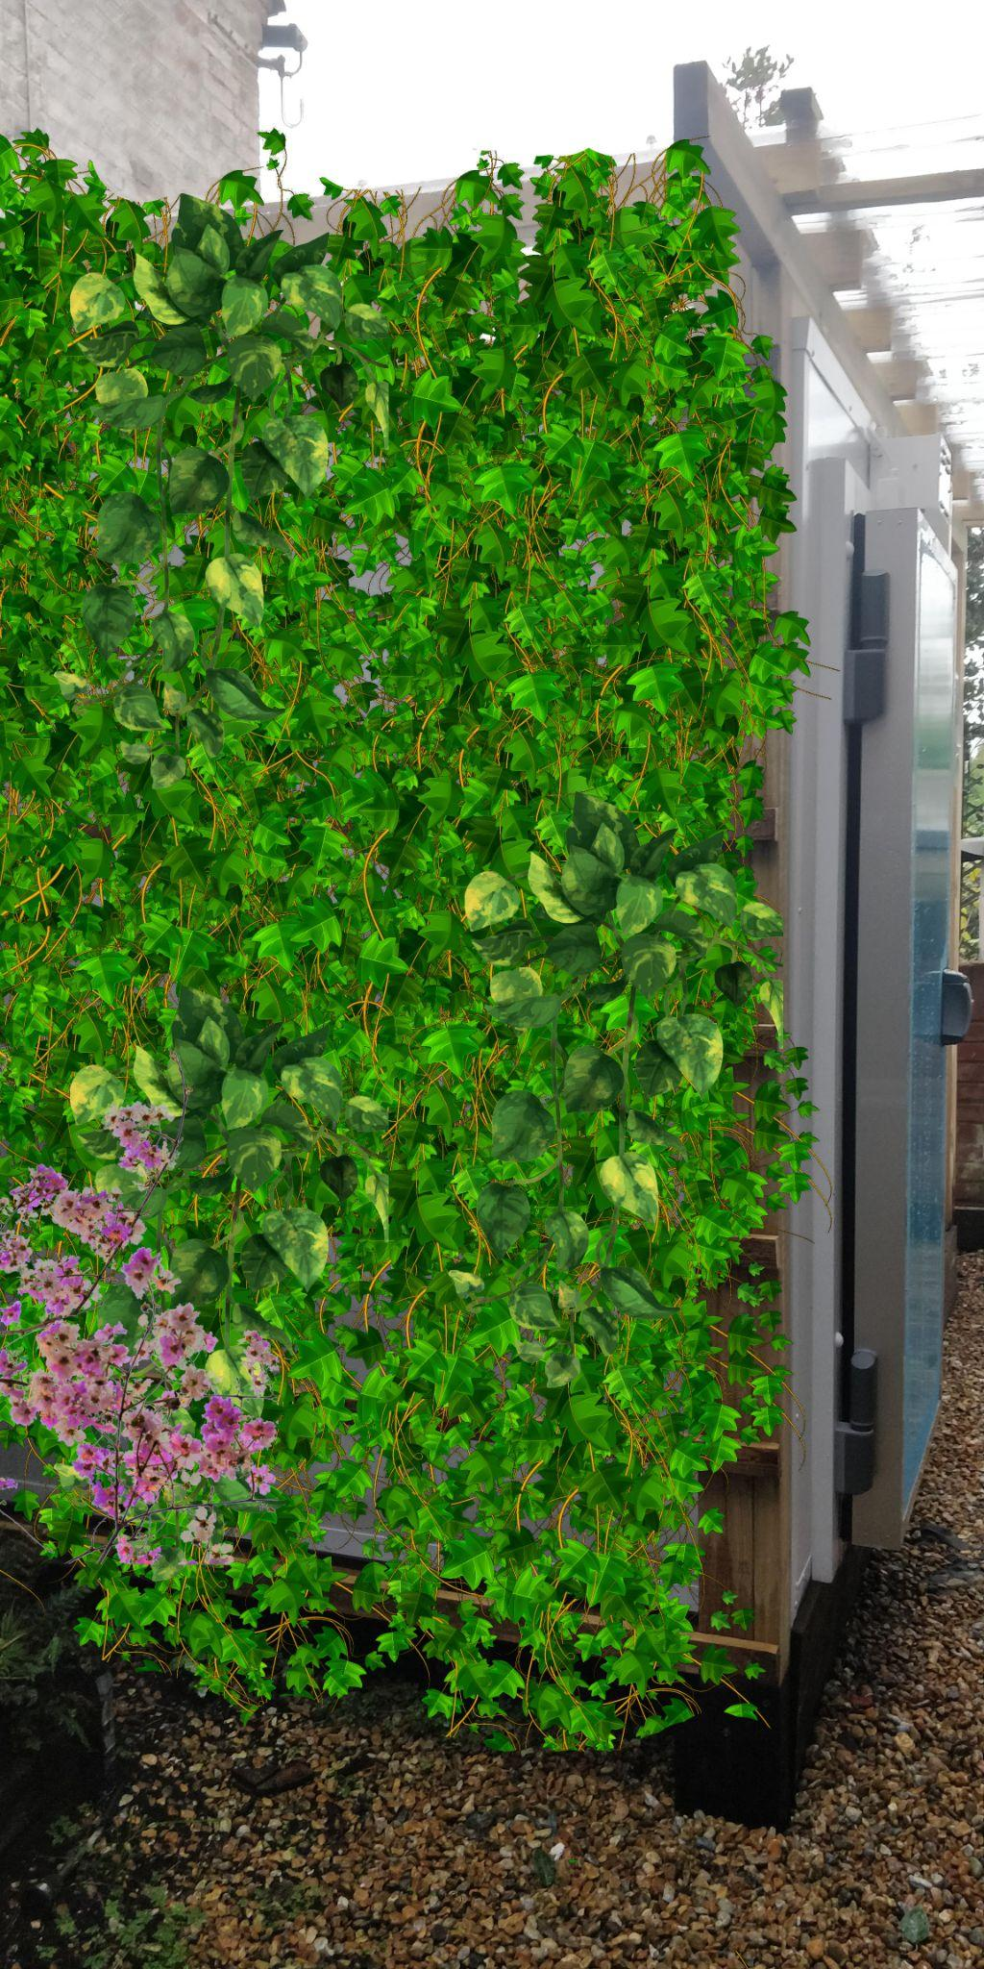

**Sedum Planted Roof:**
The installation of a sedum planted roof further exemplifies our dedication to environmental stewardship and the visual enhancement of Capstan House:

- **Visual Appeal:** A sedum planted roof will not only add a lush, green layer to the building but also provide a visually appealing sight. This "living" roof will blend seamlessly with the environment, enhancing the building's aesthetics.

- **Biodiversity Promotion:** Sedum plants attract a wide variety of pollinators, such as bees and butterflies. This promotes biodiversity and contributes to the ecological richness of the area.

- **Environmental Benefits:** The sedum roof acts as a natural insulator, providing temperature regulation for the freezer below. It also aids in the filtration and retention of rainwater, reducing runoff and helping to mitigate flooding.

- **Air Quality Improvement:** Sedum plants naturally improve air quality by absorbing carbon dioxide and releasing oxygen. This, in turn, contributes to the overall wellbeing of the community.
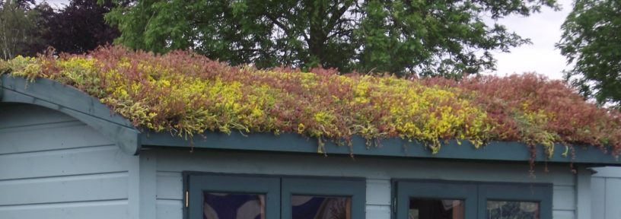

In conclusion, our plan for a timber construction with trellis siding, covered in climbing plants, and a sedum planted roof is not merely a design choice but a holistic commitment to the preservation of Capstan House's heritage, the enhancement of its visual appeal, and the promotion of biodiversity. These features, along with the installation of the walk-in freezer, are integral to our goal of maintaining the vibrancy of Pirate Pasties and our contribution to the local community. We kindly request your favorable consideration of our application, recognizing the manifold benefits these design choices will bring to our establishment and the surrounding area.

With gratitude,

Marcus Darcy
Hulya Darcy

