LINDEN HOMES – LINDEN COLLECTION GROUP FINISHING SPECIFICATION 2023

FOR PRIVATE SALE

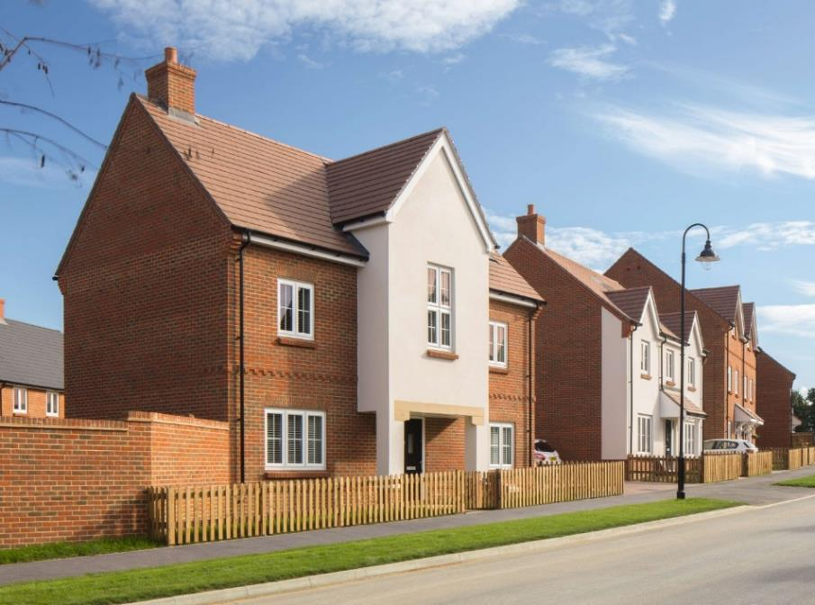

User Guide 3
1.0 EXTERNAL JOINERY 4
1.1 Window Type 4
1.2 Window Ironmongery 4
1.3 Main Entrance Door 4
1.4 Front Door Numerals (Houses & Apartments) 5
1.5 Rear Entrance Door 5
1.6 Garage Personnel Door 5
1.7 PCVu French and Patio Doors 6
1.8 Garage Up & Over Doors 6
1.9 Fascia & Soffit 7
2.0 INTERNAL JOINERY 7
2.1 Staircase Construction – Houses 7
2.2 Windowboard 8
2.3 Door Kits – House & Apartments 8
2.4 Internal Garage Personnel Door 9
2.5 Skirting 9
2.6 Architrave 9
2.7 Internal Door Furniture 9
2.8 Airing Cupboard Requirement 11
2.9 Loft Access Hatch 11
3.0 KITCHENS 11
3.1 Worktops & Splashbacks 12
3.2 Appliances 13
3.3 Kitchen Sink/Taps 14
4.0 ELECTRICAL FITTINGS 15
4.1 Electrical Fittings- General 15
4.2 Aerial/Data/Communications/TV/Satellite 16
4.3 Lighting Internally 16
4.4 Lighting Externally 17
4.5 Doorbell 18
4.6 Mechanical Extraction to Kitchen/Utility/Bathrooms/Ensuites/Cloakrooms 18
4.7 Smoke Alarms & Carbon MOnoxide Detectors 18
5.0 PLUMBING AND HEATING 18
5.1 Boiler Type & Manufacturer 18
5.2 Cylinder Type & Manufacturer 19
5.3 Heating Control 19
5.4 Radiator Style & Manufacturer 20
5.5 Outside Tap 20
6.0 SANITARYWARE 20
7.0 WALL TILING & FLOOR COVERINGS 25
7.1 Walls 25
7.2 Tile Choices 26
7.3 Floor Tiling 27
8.0 DECORATIONS 27
8.1 Internal Walls – General 27
8.2 Internal Walls – Bathrooms 27
8.3 Ceilings – General 27
8.4 Ceilings – Bathrooms 27
8.5 Woodwork & Joinery – Pre-Primed 27
8.6 Meterboxes 28
8.7 Stairs - General 28
8.8 Garages 28
8.9 Internal Mastic 28
9.0 External Features 28
9.1 Path to Entrance Doors 28
9.2 Patio Area 28
9.3 Front & Rear Gardens 28
9.4 Fencing 29
9.5 External Lighting 30
10.0 COMMUNAL AREAS TO APARTMENTS (Apartment Blocks up to 11m in height) 31
10.1 Main Block Entrance Door- Apartments 31
10.2 Access Control 31
10.3 Internal Communal Doors- Apartments 31
10.4 Individual Flat Entrance Doors 31
10.5 Communal Area Ironmongery 31
10.6 Heating 33
10.7 Flooring 33
10.8 Mailboxes 33
10.9 Decorative Finishes 34
10.10 Staircase Railings and Balustrades 34
10.11 Television Aerial 34
10.12 External Light Facilities 35
10.13 Lighting 35
10.14 Lift Finish 35
10.15 Signage 36
10.16 Smoke Alarms & Carbon Monoxide Detectors 36
10.17 Management Company 37
11.0 REVISIONS 37

User Guide
This document is the Linden Homes Linden Collection Group Finishing Specification and provides information in respect of selectable level of fixtures and fittings, sales and marketing default choices and basic regulatory compliance.

THIS SPECIFICATION, WHICH VISTRY GROUP LTD RESERVES THE RIGHT TO VARY, SHALL NOT FORM PART OF ANY CONTRACT.

This specification has been prepared with regard to current availability of fittings, materials, and present design proposals. Since these may be required to be altered for reasons of availability beyond the Company’s control, the Company reserves the right to alter and/or substitute without notice, alternatives which the Company considers equally suitable.

The document is not intended to be highly technical and must be read in conjunction with all group technical drawing issues, group specification, standard details, trade specifications.

This document should be used in conjunction with the Group Trading Agreement Schedule, outlining all group wide recognised suppliers.
This specification document also refers to apartment build where applicable.

1.0 EXTERNAL JOINERY

1.1 Window Type

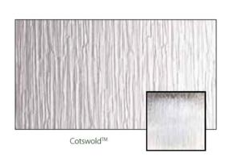
PVCu white windows with energy efficient sealed units. Obscure glazing, where indicated on working drawings will be Cotswold design. For style of windows please refer to the external materials schedule and working drawings.

Roof Windows
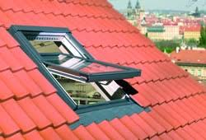 | All roof windows to be in timber and achieve a minimum G-value of 0.55. Colour as per external material schedule.  Altaterra code KAV B900 (pine), KAVB910 (White finish)  Roof windows to wet rooms to be white PVC finish (Code: KPV B900)  Glazing is not to be obscured. Flashing kit required to suit profile of specified roof tile.

1.2 Window Ironmongery
Casement 2-point locking system. Ground floor lockable. Escape windows on upper floors, please refer to working drawings. Finish to be white.

1.3 Main Entrance Door
Restricted range of Door Styles as below  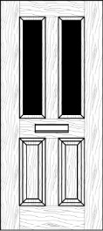  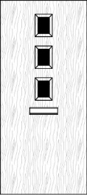  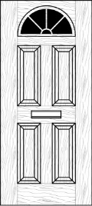  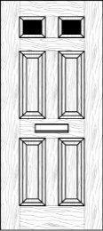 | Doors - GRP external door insulated with polyurethane foam CFC free insulation. All doors pre-finished in white internally.  Frames - White UPVC frame with mobility threshold. Cill to be two part if manufacturer system allows.  Ironmongery - Door to be fitted with 3-point locking system and satin chrome finish lever handle. 2no keys to be provided for each door. Satin Chrome letterplate, door viewer and door chain mobility threshold.  Glazing (where applicable) to be Cotswold obscure. Letterplate between 700mm and 1700mm from bottom edge of door.  Internal lock snib to be provided to facilitate door locking/unlocking without the need for key operation to front door only.  Pre-finished either Black or White external subject to planning. Refer to working drawing /Plot schedule.

1.4 Front Door Numerals (Houses & Apartments)
Door Numerals not included as standard.

1.5 Rear Entrance Door
Door Style shown below  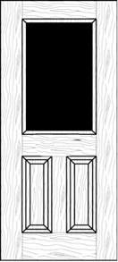 | Doors - GRP external door insulated with polyurethane foam CFC free insulation. All doors pre-finished in white internally.  Frames - White UPVC frame with mobility threshold. Cill to be two part if manufacturer system allows.  Lock - Door to be fitted with 3-point locking system and satin chrome finish lever handle. 2no keys to be provided for each door.  Glazing to be Cotswold obscure.  White external finish only.

1.6 Garage Personnel Door
Door Style Cottage  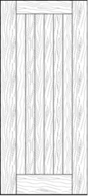 | Doors - GRP external door insulated with polyurethane foam CFC free insulation. All doors pre-finished in white internally.  Frames - White UPVC frame with mobility threshold. Cill to be two part if manufacturer system allows.  Lock - Door to be fitted with 3-point locking system and satin chrome finish lever handle. 2no keys to be provided for each door.  Pre-finished white only.  Note: Garage Personnel doors are only applicable where noted on the site layout / external works layout and are not included as standard.

1.7 PCVu French and Patio Doors
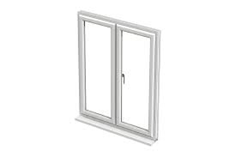 | PVC-u door set construction to consist of a pre-finished PVCu frame.  Ironmongery to be white finish (Refer to external materials schedule).  Espagnolette 3-point locking system installed as standard.  2no keys to be provided for each.

1.8 Garage Up & Over Doors
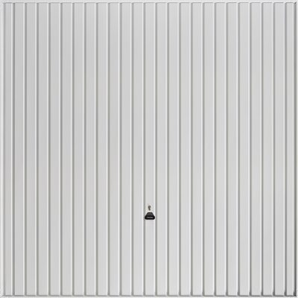 | Pre-finished steel retractable or framed door fixed to steel frame or canopy operation.  White or Black to match front external door.  Secured by design Part Q (Only if applicable). Refer to external materials schedule.  3-point solid bar locking system across width of door.  SBD door type only required to be installed in integral garage with internal door. Standard door to be installed to isolated internal garage and separate garage.

1.9 Fascia & Soffit
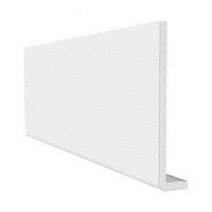 | PVCu square edged profile roof trims white.  Boxed or open un-vented eaves and verge, subject to regional variation. Refer to standard details.  Default colour white – please refer to plot schedule for confirmation of colour.

INTERNAL JOINERY

All timber elements used to be full chain of custody certified.

2.1 Staircase Construction – Houses
Refer to stair graphs for configurations.
FITTING | MATERIAL/SIZE | Finish
Wall Strings | MDF Medite / Braspine | Primed and de-nibbed
Outer Strings | MDF Medite / Braspine | Primed and de-nibbed
Tread | 22mm MDF Medite | Tread protection
Bullnoses | 22mm MDF Medite
Risers | 9mm MDF Medite or Ply
Newels | 82mm Hemlock S/C or Radiata pine | Primed and de-nibbed
Newel Caps | MDF Cap | Primed and de-nibbed
Newel Drops | Part of Newel | Primed and de-nibbed
Baluster | 38mm MDF or 32mm Radiata Pine S/C)  (preassembled) | Primed and de-nibbed
Handrail | 57 x 57 Softwood Handrail | Primed and de-nibbed
Nosing | MDF Medite | Primed and de-nibbed

NOTE: Slip resistant flight protection included

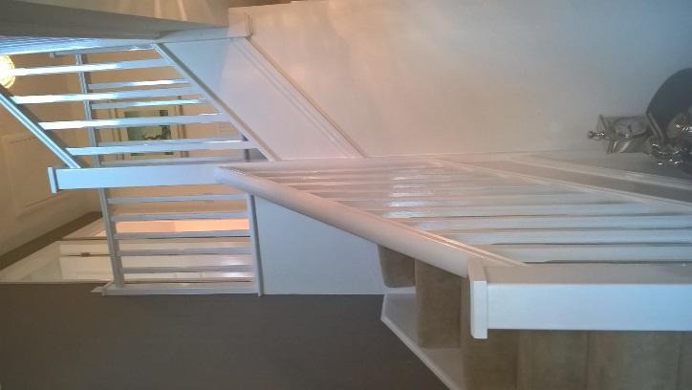
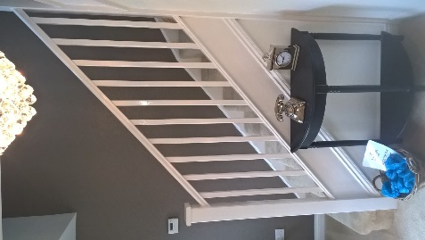

2.2 Windowboard
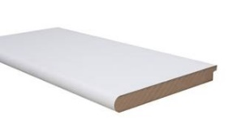 | Window Boards to be 25mm moisture resistant MDF with ‘Bullnose’ leading edge, primed for painting in all rooms, refer to section 8 for paint finish.  unless otherwise below:  Cloakrooms: MDF  En-suites: Ceramic tiling  Bathrooms: Ceramic tiling  Kitchens: MDF

2.3 Door Kits – House & Apartments
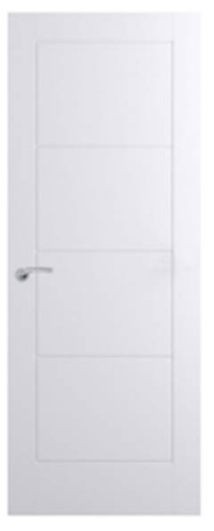 | Internal doors only to be purchased as a door kit pre-routered door & lining with pre-fitted hinges, latch & keeps.  Internal doors to Premdor Ladder Door either pre-finished or primed, refer to section 8 for paint finish.  Double doors to have flush meeting stiles supplied with hinges only.  All fire doors to include hardwood threshold.  Door construction hollow core or FD30 if shown on working drawings.

2.4 Internal Garage Personnel Door
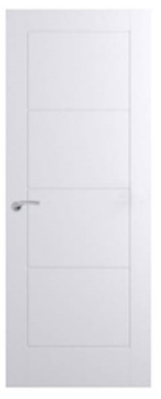 | Internal garage personnel door to be purchased as a complete fire door set. Premdor Ladder door either pre-finished or primed, refer to section 8 for paint finish.  Frame to be supplied with smoke seal and intumescent strip.  Door set supplied with door, primed softwood frame, no cill, BS 5 lever sash lock and hinges

2.5 Skirting
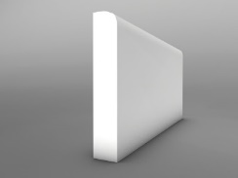 | 14.5mm x 119mm primed MDF Pencil Rounded, refer to section 8 for paint finish.

2.6 Architrave
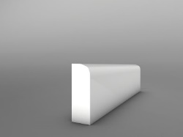 | 14.5mm x 58mm Pencil Rounded Architrave primed MDF, refer to section 8 for paint finish.

2.7 Internal Door Furniture
Note: When using door-kits, hinges & latches are included.
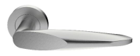 | 1 Set SZA6021 lever on rose by Carlisle Brass satin finish.
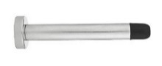  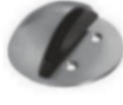 | 1 no Projecting Wall Mounted Door Stop satin finish  Or  1 no Floor Mounted Door Stop satin finish

Double Doors Non-Fire:
 | 2 set SZA6021 lever on rose by Carlisle Brass satin finish.
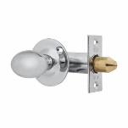 | 2 no British pattern door rack – bolt and oval turn Satin Chrome.
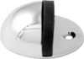 | 2 no Projecting Wall Mounted Door Stop satin finish  Or  2no Floor Mounted Door Stop satin finish.

Bathrooms, En-suites & Cloakrooms:
 | 1 set SZA6021 lever on rose by Carlisle Brass satin finish.
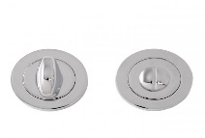 | 1 no Bathroom Turn & Release satin finish.
1 no Projecting Wall Mounted Door Stop satin finish

Or

1no Floor Mounted Door Stop satin finish.

Integral Garage Personnel Fire Door:
Note: Must be a fire tested door set

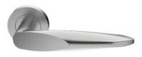 | 1 set SZA6021 lever on rose by Carlisle Brass satin finish.
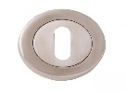 | 1 no Satin Chrome Concealed Fix Standard Escutcheon.
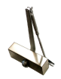 | 1 no Boss TS1.224B Size 3 Budget Overhead Door Closer.
 | 2 no British pattern door rack – bolt and oval turn Satin Chrome
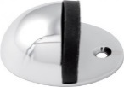  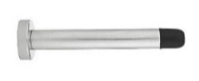 | 1 no Projecting Wall Mounted Door Stop satin finish  Or  1no Floor Mounted Door Stop satin finish.

2.8 Airing Cupboard Requirement
Softwood slatted shelving for airing cupboard constructed from 25 x 50mm PSE softwood, unpainted. Please refer to standard detail.

2.9 Loft Access Hatch
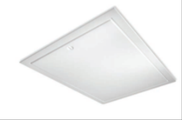 | Proprietary white insulated loft access hatch refer to working drawing for fire rating  Standard non fire rated.  Or  Fire rated 1hr contemporary part L hinge down loft access hatch.

3.0 KITCHENS

Kitchen
All Houses and Apartments  Example Hacienda Grey Driftwood  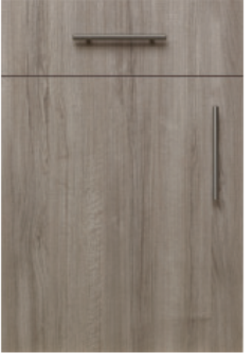  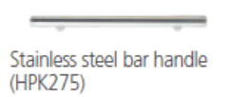 | Symphony Kitchens Koncept.  Vista 15mm soft plus carcass (110-degree hinges).  Choice of frontals and handles from:  Frontal matched.  600mm deep worktops on all wet runs where required.  Washing machine and dishwasher space provided. Fridge / Freezer space or Fridge/Freezer housing if integrated, refer to appliance spec.  Each kitchen to include a maximum of one 600mm base unit with single drawer above door, standard drawer box with soft close grab mechanism.  Boiler Housing to Boilers situated in the Kitchen Only. Boiler Housings to be 900mm, cloaking pieces to be provided by Symphony to hide all pipework.
  Range: Hacienda
  Front | Handle options
  Grey Driftwood | HPK275, HPK642, HPK885
  Light Driftwood | HPK275, HPK642, HPK885
  Platinum | HPK275, HPK642, HPK885
  Nordic Blue | HPK275, HPK642, HPK885
  Range: Plaza
  Front | Handle options
  Cashmere | HPK671, HPK643, HPK796
  Porcelain | HPK671, HPK643, HPK796
  Cobble Grey | HPK671, HPK643, HPK796
Boiler Housing | Boiler Housing to Boilers situated in the Kitchen Only. Boiler Housings to be 900mm, cloaking pieces to be provided by Symphony to hide all pipework.

3.1 Worktops & Splashbacks
Worktops
All house type standard 40mm Postformed worktop with 95mm upstand and mason mitred joints

Worktops
Example Marble Siroco  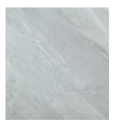 | All house type standard 40mm Postformed worktop with 95mm upstand and mason mitred joints.  Choice of Standard worktops from:  - Alaska  - Alpine White  - Brazilian Walnut  - Copper Slate  - Dark Ash  - Everest Black  - Marble Siroco (See picture example)  - Oak Block  - Pastel Oak  - Tectonica  - Carbon Steel  - Conway Elm

Splashbacks
All house types and apartments Unbranded 60cm wide stainless-steel splashback from Symphony

3.2 Appliances
Oven
Apartments  KFW3841JHIX  Indesit single stainless steel under worktop.  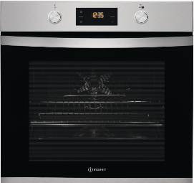  Energy Rating: A | 2 & 3 Bed Houses  KFW3841JHIX  Indesit single stainless steel under worktop.  Energy Rating: A |  | 4 & 5 Bed Houses  KFW3841JHIX  Indesit single stainless steel under worktop.  Energy Rating: A
Hob
Apartments  PAA 642 IX/I WE  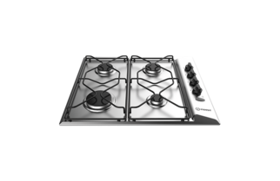  Indesit hob 60cm gas stainless steel | 2 & 3 Bed Houses  PAA 642 IX/I WE  Indesit hob 60cm gas stainless steel. |  | 4 & 5 Bed Houses  PAA 642 IX/I WE  Indesit hob 60cm gas stainless steel.
Hood
Apartments and 2 & 3 Bed Houses  IAEINT66 LS GR Unbranded Indesit B/I integrated hood silver  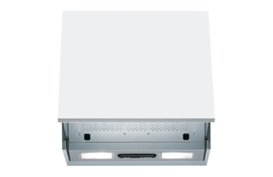 |  | 4 & 5 Bed Houses  UHPM 6.3F CS X/1 Unbranded Indesit B/I hood 60cm chimney stainless steel  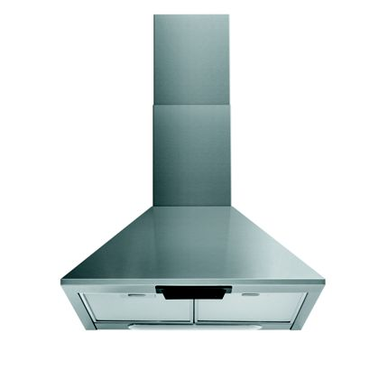
Note: In some instances, should the manufacturer revise their model numbers, Linden Homes will provide an equivalent model to the above specified.

3.3 Kitchen Sink/Taps
Sink/Taps
2 & 3 Bed Houses,  Apartments and Utilities (where applicable)  Eaton - EA9501/TMO35 (This is sold as a tap centre and includes sink, waste and tap)  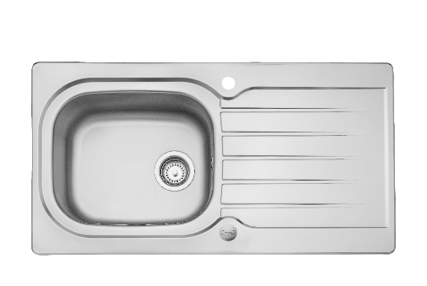 | Part of tap centre pack  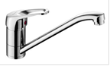
4 & 5 Bed Houses  Eaton - EA9501/TMO35 (This is sold as a tap centre and includes sink, waste and tap) | Part of tap centre pack

4.0 ELECTRICAL FITTINGS

4.1 Electrical Fittings- General
To comply with latest IEE regulations including high sensitivity residual current circuit breakers to all power circuits. Wiring to run vertically to all sockets, switches etc.
32-amp cooker supply provided to properties with double ovens.
Products to be in accordance with the Vistry Group Supply Chain Agreements, as summarised below
Product | Supplier
Heating Controls | Honeywell T3
System 1 Ventilation | Vent Axia
Electrical Accessories (Switches, Sockets & Pendants) | DETA White Slimline  Pendant DETA V1278  Batten Holder DETA V1289  (To include the decorator safety cover as standard to pendant and batten holders)
Consumer Units | BG Electrical CFUD8610LB-H1 (10 way) or CFUD8616LB-H1 (16 way)
Lamps | Greenlighting PL 8.5-watt bayonet cap lamp PL1LED3k-BC
Smoke Alarms | Deta Electrical Smoke Alarm 1164
Heat Alarms | Deta Electrical Heat Alarm 1166
CO2 Detector | Deta Electrical Carbon Monoxide detector 1169
External Light | Greenlighting front door contemporary lantern GL-203LU

Consumer Unit Type
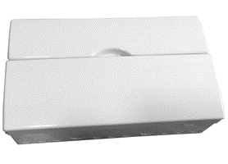 | White consumer unit to the following specification:  Dual RCD High Integrity Int 100A Switch & 1 x 63A + 1 x 80A RCD c/w locking facility Blank.  Consumer units to be 18th Edition CFUD000008/14ALBSPD-H1

Switches/Sockets
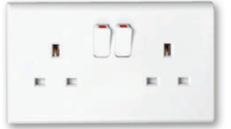 | Single/double switched socket outlets to be provided to all rooms (except cloakrooms, bathrooms, and en-suites).  As shown on working drawings and in accordance with NHBC Standards.

4.2 Aerial/Data/Communications/TV/Satellite
As detailed on electrical layouts.

- Incoming voice and data to be located in service cupboard, service cupboard to include all necessary electrics to install and operate open reach equipment. ONT details on electrical drawing.

- CAT 6 cable to be run from cupboard to lounge.

Multimedia Plate
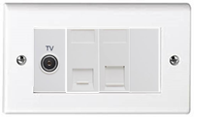 | Media plate to be located in lounge (Deta S1424) location as per working drawing, in addition the following modules should be used:  1 x S1431WH BT Slave Module  1 x S1442 TV Module  1 x 1429 Blank  1 x S1434 WH Cat 6 Module

Telecom points
Apartments, 2 & 3 Bed Houses- telecoms point service cupboard (master), lounge adjacent to main TV position.
4 & 5 Bed Houses- Telecoms point service cupboard (master), lounge adjacent to main TV position, family room.
Houses | Apartments
Star wire to each TV point from the loft space using CT100 co- axial cable with two additional cables to main TV position.  Terrestrial Cables to be left coiled in loft space.  No terrestrial aerials installed as standard.  Cables to be wired to position within fascia on south / southeast elevation to allow SkyQ to locate and connect satellite dish. Under no circumstances should this be wired on prominent elevations including the front elevation. 2m of cable left outside in a neat coil at the intended mini dish location fastened securely by way of clip and cable tie.  Ends of cable taped with self-amalgamating tape. | Star wire to each TV point from the cupboard space using CT100 co- axial cable with two additional cables to main TV position.  Shared terrestrial aerial.  Cables to be wired to riser cupboard and linked to communal dish. 1 communal dish per block.

4.3 Lighting Internally
See below specified room by room. All lights to include low energy lamps.

Ground Floor & 1st Floor (Exc. Kitchen)
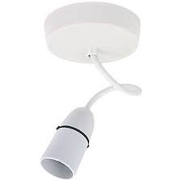 | White pendant lamps throughout with batten light to store (subject to house design).  To include the decorator safety cover as standard. Location and position as detailed on working drawings.
Cloakroom
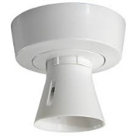 | White batten holder  To include the decorator safety cover as standard.  Equipment type, location and position as detailed on respective electrical layouts.
Kitchen
White pendant lamps throughout with batten light to store (subject to house design).

To include the decorator safety cover as standard.
Location and position as detailed on working drawings.

Bathroom & Ensuites
White batten holder

To include the decorator safety cover as standard.

Equipment type, location and position as detailed on respective electrical layouts.

Garages
Note: Electricity to garages only when Garage curtilage of the plot.
1 no. light fitting & switch (1 by main garage door). Lighting Fitting to be a Pendant.
1 double socket.

White fittings. Equipment type, location and position as detailed on respective electrical plan and in accordance with NHBC Standards.

4.4 Lighting Externally
Wiring to the front and rear only, all as detailed on respective ground floor electrical plan.

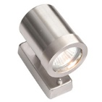 | Front – Green lighting contemporary lantern  Greenlighting Ref: GL-203LU
 | Rear - Wire only to rear of house. Location as detailed on the working drawing. Cable to be terminated in wall junction box.

4.5 Doorbell

No Doorbell Fitted as standard

4.6 Mechanical Extraction to Kitchen/Utility/Bathrooms/Ensuites/Cloakrooms
As a standard all houses type are to be designed for system 1 ventilation. All installations to be strictly in accordance with manufacturer house type designs.

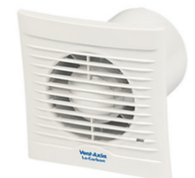 | System 1 Intermittent Fan

4.7 Smoke Alarms & Carbon Monoxide Detectors
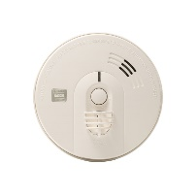  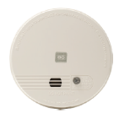 | Mains wired smoke or heat detector (ceiling mounted) to be provided for each floor. Refer to working drawings for locations and type.
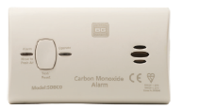 | Battery powered Carbon Monoxide detector (wall mounted next to boiler).

5.0 PLUMBING AND HEATING

5.1 Boiler Type & Manufacturer

Combination boiler or heat only boiler with cylinder storage.

Apartment, 2, 3 & 4 beds | Large 4 & 5 beds
Ideal Logic combi boiler (no cylinder storage).  Apartments, 2, 3 & 4 beds with one separate shower valve (subject to heating design).  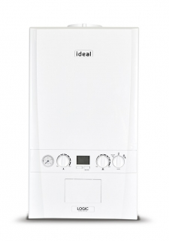 | Ideal Logic system boiler (with cylinder).  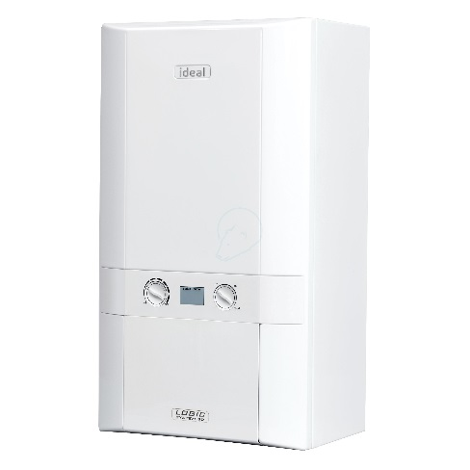  4 & 5 beds with two or more shower valves (subject to heating design).

5.2 Cylinder Type & Manufacturer
Note: The following are typical models only, refer to heating designs for specific details.

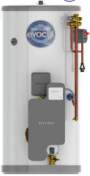 | ThermaQ Pre-plumbed Evocyl unvented cylinder  Default for all 4 beds with more than two or more shower valves & 5 Bed Houses (Subject to heating designs)  Cylinder to include Hot water timer.  Coding  TQPPSO210-V2  Code “210” = capacity  Code “SO” = single zone or “TO” = twin zone

5.3 Heating Control
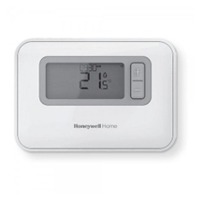 | Honeywell T3 Thermostat

5.4 Radiator Style & Manufacturer
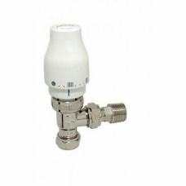  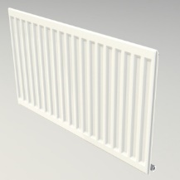 | Radiators - Myson Imperial Premier HE round top radiators. (Manthorpe radiator pipe guide & seal to be used.  Valves - Myson Petite thermostatic radiator valves.

5.5 Outside Tap
No outside tap supplied as standard.

6.0 SANITARYWARE

Bathroom (with en-suite)
Product | Description
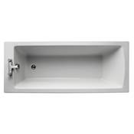  Bath - Standard | E256301 Tempo Arc 170 x 70cm Idealform single ended bath, no tap holes, no handgrips to achieve 110ltrs PPPD  181 Litres
Bath – Water Saving | E256501 Tempo Arc water saving 170 x 70cm Idealform single ended bath, no tap holes, no handgrips to achieve 100ltrs PPPD.  139 Litres
  Bath Panel | E319401 Unilux 1700 Front Panel
  Click Clack | S8840AA 1 1/2" Bath clicker waste & overflow.
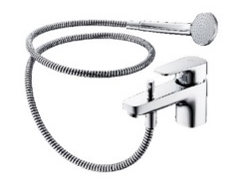  Bath Taps | B1960AA Ceraflex 1 hole bath shower mixer with shower set. Flow rate restricted to 5 ltrs/min. Complete with hose retainer.  (Where a thermostatic shower is installed to a plot as standard or as part of Select and Enhance upgrade package, this product is not included and is replaced with Bath Mixer Tap B1959AA should be fitted).
Blending Valve  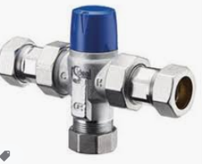 | A5901AA – Under Bath Blending Valve  (To be used where no Thermostatically controlled Tap is installed on bath application)
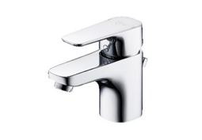  Basin Taps | B1812AA Ceraflex single lever basin mixer inc S8803AA clicker waste. Flow rate restricted to 5 ltrs/min.
Basin / Pedestal | T058601 Tempo 1TH basin 55cm (Refer to bathroom layout for size).  T422401 Tempo pedestal.
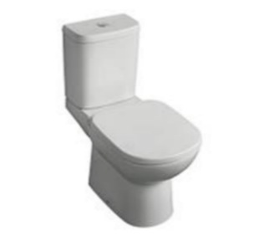  WC - Cistern / Pan | T427101 Tempo close coupled delay fill, valve cistern 4/2.6 Ltr dual flush button bottom supply and internal overflow Cistern  T332101 Tempo close coupled WC pan with horizontal outlet.
  WC - Seat | T690001 Tempo Seat & Cover Slow Close

Bathroom (without ensuite)
Product | Description
Bath - Standard | E256301 Tempo Arc 170 x 70cm Idealform single ended bath, No tap holes, no handgrips to achieve 110ltrs PPPD  181 Litres
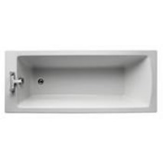  Bath – Water Saving | E256501 Tempo Arc water saving 170 x 70cm Idealform single ended bath, no tapholes, no handgrips to achieve 100ltrs PPPD  139 litres
Bath Panel | E319401 Unilux 1700 Front Panel
Click Clack | S8840AA 1 1/2" Bath clicker waste & overflow
Bath filler & Shower  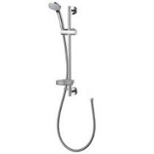  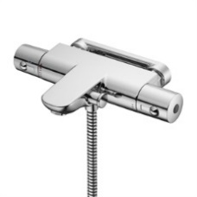 | A7697AA Ceratherm T50 Wall mounted exposed Bath shower mixer. Flow rate restricted to 8 ltrs/min to achieve 110ltrs PPPD, 6 ltrs/min to achieve 100ltrs PPPD.  B9449AA Idealrain S1 shower set with single function 80mm handspray, 1.35m hose, wall mounted holder and hose retaining ring
Bath Screen  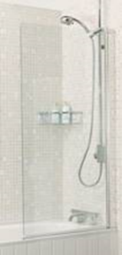 | YEB13S  Embrace 820mm clear glass bath screen.
Basin Taps | B1812AA Ceraflex single lever basin mixer inc S8803AA clicker waste. Flow rate restricted to 5 ltrs/min.
Basin / Pedestal | T058601 Tempo 1TH basin 55cm (Refer to bathroom layout for size)  T422401 Tempo pedestal
WC - Cistern / Pan | T427101 Tempo close coupled delay fill, valve cistern 4/2.6 Ltr dual flush button bottom supply and internal overflow Cistern  T332101 Tempo close coupled WC pan with horizontal outlet
WC - Seat | T690001 Tempo Seat & Cover Slow Close

Ensuite
Product | Description
En-suite shower enclosure  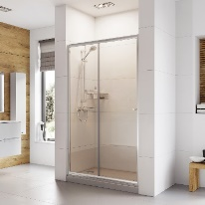 | Romans Haven silver sliding door.  Refer to floor plans for sizes.
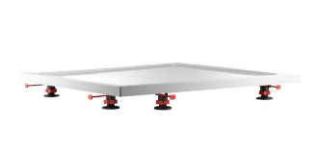  En-suite shower tray | JustTrays Fusion shower tray with 4 upstands and chrome waste. Refer to floor plans for sizes.  Shower tray should be mounted on legs with panel kit.
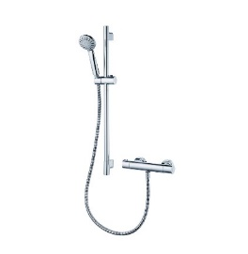  En-suite shower | A7255AA Ecotherm thermostatic shower – UK wall fixings, 600mm kit. Flow rate restricted to 6 ltrs/min to achieve 100ltrs PPPD and allow use of combination boiler
Basin Taps | B1812AA Ceraflex single lever basin mixer inc S8803AA clicker waste. Flow rate restricted to 5 ltrs/min.
Basin / Pedestal | T058601 Tempo 1TH basin 55cm (Refer to bathroom layout for size)  T422401 Tempo pedestal
WC - Cistern / Pan | T427101 Tempo close coupled delay fill, valve cistern 4/2.6 Ltr dual flush button bottom supply and internal overflow Cistern  T332101 Tempo close coupled WC pan with horizontal outlet
WC - Seat | T690001 Tempo Seat & Cover Slow Close

Cloakroom
Product | Description
Basin Taps | B1812AA Ceraflex single lever basin mixer inc S8803AA clicker waste. Flow rate restricted to 5 ltrs/min.
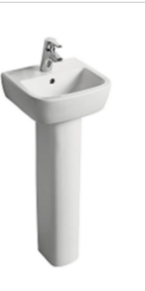  Cloakroom Basin  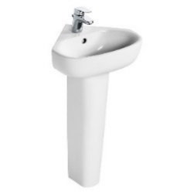  Alternative  (If required) | T059301 Tempo basin 40cm.  T427201 Tempo pedestal.  T290601- Studio Echo 45cm corner Handrinse basin, 1 taphole with overflow.  E158401- Studio Echo Handrinse pedestal.
WC - Cistern / Pan | T427101 Tempo close coupled delay fill, valve cistern 4/2.6 Ltr dual flush button bottom supply and internal overflow Cistern  T332101 Tempo close coupled WC pan with horizontal outlet
WC - Seat | T690001 Tempo Seat & Cover Slow Close

7.0 WALL TILING & FLOOR COVERINGS

7.1 Walls
Ceramic Tiles | Porcelanosa tiles Standard Range Tile Selection  Mastic pointing to internal corners of tiling.  White plastic square edge trims to external corners and square capping to top of half height tiled areas.  Grout colour – refer to table in section 7.2.  Tiles laid landscape.
Kitchen Walls | No tiling.  All window cills to be MDF unless quartz kitchen worktop option selected.
Bathroom | Tiling to bath to be approximately 450mm in height from top of bath.  Splash back to basin only, to be one course of tiles to width of basin.  Tiled window cills.  Except on the below areas –  Full height tiling to length and sides of bath required when high level shower is fitted above the bath.  Full height tiling to all shower walls within shower cubicle (if applicable).
En-suite Walls | Splash back to basin only, to be one course of tiles to width of basin.  Tiled window cills.  Except on the below areas –  Tiling to length and sides of bath to be approximately 450mm in height from top of bath (only with low level shower).  Full height tiling to length and sides of bath required when high level shower is fitted above the bath.  Full height tiling to all shower walls within shower cubicle (if applicable).
Cloakroom Walls | Splash back to basin only, to be one course of tiles to width of basin. Window cills painted window board.

7.2 Tile Choices

Porcelanosa
Tile | Size | Grout Colour
Japan Blanco 25x44.3cm | 25x44.3 | Colourstuk Blanco
Madagascar Blanco 25x44.3cm | 25x44.3 | Colourstuk Blanco
Madagascar Natural 25x44.3cm | 25x44.3 | Colourstuk Gris
Rivoli Blanco (matte) 33.3x59.2cm | 33.3x59.2 | Colourstuk Blanco
Shine dark 33.3x59.2cm | 33.3x59.2 | Colourstuk Antracita
Japan Marine | 25x44.3 | Colourstuk Cemento
Crystal White | 25x44.3 | Colourstuk Blanco
Shine Alumino | 25x44.3 | Colourstuk Gris
Shine Niquel | 25x44.3 | Colourstuk Gris
Shine Platino | 25x44.3 | Colourstuk Blanco
Ona Blanco | 25x44.3 | Colourstuk Blanco
Ona Natural | 25x44.3 | Colourstuk Blanco
Fontana Blanco | 25x44.3 | Colourstuk Blanco

7.3 Floor Tiling
No floor tiling is fitted/supplied as standard.

8.0 DECORATIONS

8.1 Internal Walls – General

Houses - Dulux Trade White Supermatt Emulsion. One mist and two full coats.
Apartments - Dulux Trade White Supermatt Emulsion. One mist and two full coats.

8.2 Internal Walls – Bathrooms

Houses - Dulux Trade White Supermatt Emulsion. One mist and two full coats.
Apartments - Dulux Trade White Supermatt Emulsion. One mist and two full coats.

8.3 Ceilings – General

Houses & Apartments - Dulux Trade White Supermatt Emulsion. One mist and two full coats.

8.4 Ceilings – Bathrooms

Houses & Apartments - Dulux Trade White Supermatt Emulsion. One mist and two full coats.

8.5 Woodwork & Joinery – Pre-Primed

Houses & Apartments–
Solvent Based Option - Dulux Trade Undercoat, two coats followed by Dulux Trade Satin, one coat.
Water Based Option – Dulux Trade Quick Dry Undercoat, one coat followed by Dulux Quick Dry Satin, 2 coats.
Colour White, including window boards, linings, architrave, and skirting.

8.6 Meterboxes

Two coats Dulux Trade Undercoat, one coat Dulux Trade High Gloss, colour to match front doors.

8.7 Stairs - General

Newels and balusters | 3 coats primer in factory - requiring site-application of 1 coat satin.
Strings | 3 coats primer in factory - requiring site-application of 1 coat satin.
Handrail | 3 coats primer in factory - requiring site-application of 1 coat satin.

8.8 Garages
Fair faced blockwork throughout with screeded concrete floor.

Where utility area in the garage is provided – one mist coat and two full coats of Dulux Trade White Supermatt emulsion to utility area only.

8.9 Internal Mastic
White to sanitary ware and coloured where necessary to co-ordinate with tile choice in bathrooms, white to skirting and other timber finishes and colour co-ordinated or clear to kitchens.
Intumescent mastic where detailed on working drawings to be white.

9.0 EXTERNAL FEATURES

9.1 Path to Entrance Doors
900mm wide buff riven paving slab paths to entrance doors. Refer to hard landscaping layout for provision and location.

9.2 Patio Area
Refer to hard landscaping layout for provision and location (Area 1.8m x 1.8m using 450 x 450 x 50mm slabs).

9.3 Front & Rear Gardens
Rotavated front and rear garden. Refer to soft landscaping layout for planting details.
Turfing to Front Gardens.

9.4 Fencing
Boundary and intermediate boundary fencing to be either 1800mm panels or 1800mm brown featheredge on timber posts with timber gravel boards. Concrete gravel boards and posts and closeboard panels to be used only where retaining soil is required. Note: Fencing details may vary, please refer to boundary treatment plan for site specific detail.

9.5 External Lighting
Lighting to footpaths and parking courts to be controlled by dusk to dawn sensors. Refer to external works drawing for lighting design.

10.0 COMMUNAL AREAS TO APARTMENTS (Apartment Blocks up to 11m in height)

The following are specification items which only apply to apartments with communal entrances and staircases:

10.1 Main Block Entrance Door- Apartments
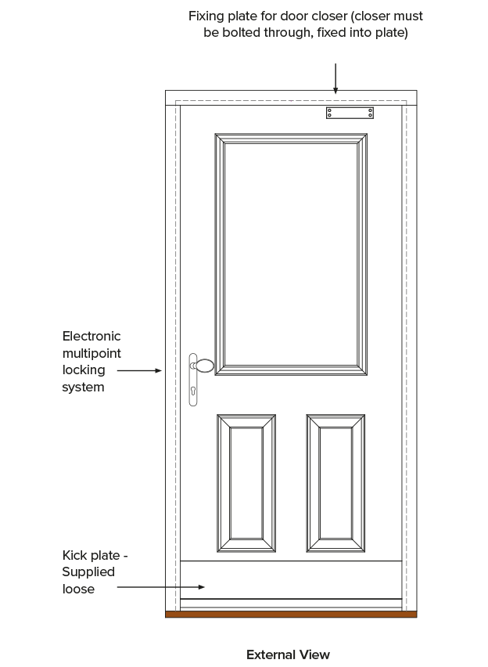 | Composite GRP door set with White UPVC frame and composite cill. Set to be a certified fire door set.  Ironmongery to be Satin Chrome effect to match internal doors.  Door to be fitted with closer, pull handles and push plates and audio only door entry system.  Black or White external finish only subject to planning. Refer to working drawing /Plot schedule.

10.2 Access Control
Audio door entry system with telephone handset located within flat hallway.
Audio Door Entry | 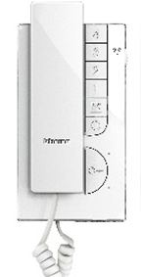
NOTE – Entry panel located at main entrance

10.3 Internal Communal Doors- Apartments
Colour White.
  Internal communal corridor door & service doors | All internal communal doors shall be fitted with appropriate glazed panels, service doors unglazed with FB2 Lock.  Door set to be certified fire door set.  Refer to working drawings and standard details for fire resistance requirements. Fire Certification to be provided by supplier.  To comply with latest fire regulations.

10.4 Individual Flat Entrance Doors
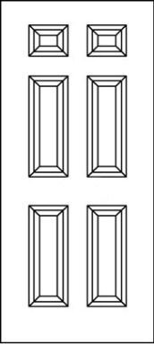 | Flat entrance fire door.  GRP insulated core FD30S self-closing Certified Fire door sets to match internal communal doors, complete with rebated frame. Painted white.  Ironmongery to be Satin Chrome effect to match internal doors and to be provided as part of door set. Door to include door viewer and Multipoint locking system.  Each apartment to be provided with 2 No. keys to the communal entrance door, with an additional 1 No. key for the Management Company.  Fire Certification to be provided by supplier.

10.5 Communal Area Ironmongery
Ironmongery – Apartment / Communal Areas

Glazed Lobby Door
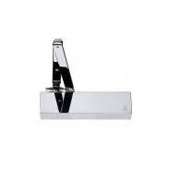 | 1 No. ARROW-ARCHITECTURAL 300RP overhead door closer.
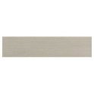 | 1 No. kicking plate to push side of door.
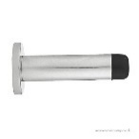 | 1 No. CARLISLE BRASS ref. AA21CP cylinder-pattern, chrome, skirting-mounted doorstop where applicable
 | 2 No. CARLISLE BRASS ref. SEX1016BSS ‘Fire Door Keep Shut’ signs.
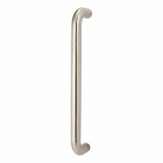 | CARLISLE BRASS PAD1225SSS Eurospec 225mm s/steel D pull handle
Apartment Entrance
 | ARROW-ARCHITECTURAL 325VP overhead closer with reverse pack.
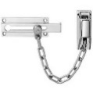 | Chrome plated door chain
 | 2 No. CARLISLE BRASS ref. SEX1016BSS ‘Fire Door Keep Shut’ signs.
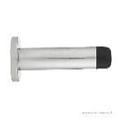 | 1 No. CARLISLE BRASS ref. AZ21CP cylinder-pattern, zinc, skirting-mounted doorstop where applicable
Service Cupboards
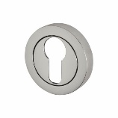 | 2 No. CARLISLE BRASS ref. SZM003CP escutcheons.
 | 1 No Carlisle Brass ref. AZ21CP Cylinder-pattern chrome, skirting mounted door stop where applicable
 | CARLISLE BRASS PAD1150BSS Eurospec 150mm s/steel D pull handle
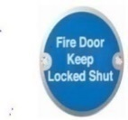 | 1 No. CARLISLE BRASS ref. SEX1015BSS ‘Fire Door Keep Locked’ sign.
Cycle Store
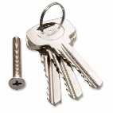 | 1 No. key for the communal cycle store with an additional 1 no. key for the management company.
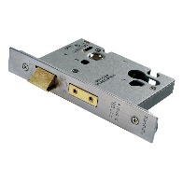 | 1 No. CARLISLE BRASS ref. LSB5525SSS Eurospec Easi T 5 lever BS 3621 Sashlock with nickel plated forend to be supplied with sufficient keys for all flat owners
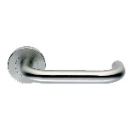 | Set of CARLISLE BRASS ref. SW123SSS levers.
 | 2 No. Carlisle Brass ref. SW103SSS escutcheons to suit
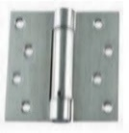 | 1.5 pairs of 100mm, ball bearing, satin stainless-steel grade 13 butt hinges (per leaf).
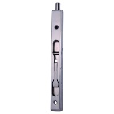 | If a pair of doors is required, then 2 No. 200mm satin stainless steel flush bolts ref. FBT1008SSS required with lock rebate kit ref. ARB5105SSS or dust excluding socket ref. AQ47SC to suit.
 | Cycle stands/racks (refer to working drawings for number and type).
Bin Store
 | 1 No. key (per apartment) for the communal bin store with an additional 1 No. key for the Management Company.
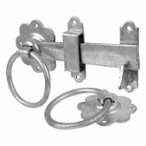 | 1 No. 150mm galvanised ring gate latch.
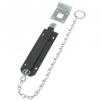 | 1 No. chain bolt (per leaf).
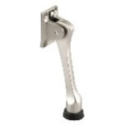 | 1 No. garage heavy duty door holder (per leaf).
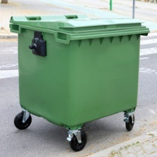 | Euro Bins (if required). Number and specification to LA specification.
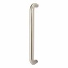 | CARLISLE BRASS PAD1150BSS Eurospec 150mm s/steel D pull handle
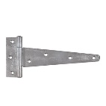 | 1 pair galvanised T-hinges.

10.6 Heating
None provided to communal areas.

10.7 Flooring
  Carpets | Contract needle punch carpeting to entrance, stairs & landings. Must be fire rated  Matwell- colour ebony.  Nosings to communal staircase- colour black.

10.8 Mailboxes
The Safety Letter Box Company model ST1, fitted flush to sacrificial wall.

Final design to be agreed for each respective development.
Colour - Agate grey RAL 7038 if in burgundy wall.
- Wine red RAL 3005 if in grey wall.

Option 1)-

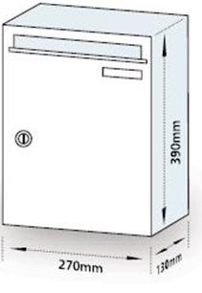  Standard post boxes (wall fitted). | Standard finish (available in most RAL colours at no extra cost).

Option 2)-

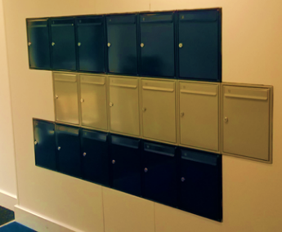 | Standard post boxes (built in/boxed for a flush effect).

10.9 Decorative Finishes
Apartment communal area main walls to receive one mist coat and two full coats of Almond White matt emulsion.

10.10 Staircase Railings and Balustrades
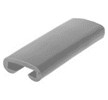 | Square metal vertical balustrading painted Agate grey RAL 7038 with PVC handrail, colour Graphite grey RAL 7024.  Concrete flights and landings with MDF strings and square metal vertical balustrading painted Agate grey RAL 7038 with PVC handrail in Graphite grey RAL 7024.

10.11 Television Aerial
Refer to Section 4.2 Electrical.

10.12 External Light Facilities
Lighting to communal areas to be controlled by PIR.

General | Terminate porch and rear door light supply in external quality wall mounted back box.
External | GREEN LIGHTING GL-MLUX15 LED PIR approach lighting to be provided to underpass situations/main entrances etc.  Refer to site-specific working drawings for courtyard lighting.
Internal | GREEN LIGHTING GL-EPSOM LED bulkhead light fitting to all landings and corridors, linked to manually activated timer switches.  Refer to working drawings.
Common Areas | Provide landlords type single socket at each landing.
Emergency Escape Light | Provide escape lighting to BS5266 Part 1 (2005) and current wiring regulations, to illuminate escape route should mains power fail.

10.13 Lighting
Refer to site specific drawings and specifications for services to bin stores, bicycle stores, courtyard/communal lighting.

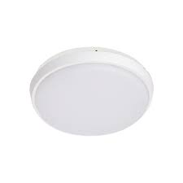  Communal corridor lighting. | GREEN LIGHTING GL-MLUX15 LED bulkhead light fitting to all landings and corridors, linked to manually activated timer switches.  For locations, refer to working drawings.
Emergency Lighting | Please refer to apartment fire design for emergency lighting

10.14 Lift Finish
Car interior walls | Vinyl coated steel- colour grey.
Car door finish | Stainless steel- brushed finish.
Landing door | Stainless steel- brushed finish.
Car operating panel | Stainless steel- brushed finish.
Flooring | Communal area carpet.
Handrail | Anodised aluminium.
Mirror | Half height to rear car wall.
Ceiling | Vinyl coated steel with spotlights- colour grey.

10.15 Signage
Internal and external signage to be on clear acrylic with black text in Foundry Form Sans font.
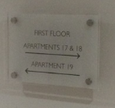 | A4 wayfinder clear acrylic plaque with reversed printed graphics and 4x 19/25mm brushed chrome stand off's for fixing -  297mm (w) x 210mm (h) 10mm.
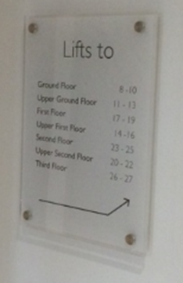 | A3 wayfinder clear acrylic plaque with reversed printed graphics and 4x 19/25mm -  297mm (w) x 420mm (h) 10mm.
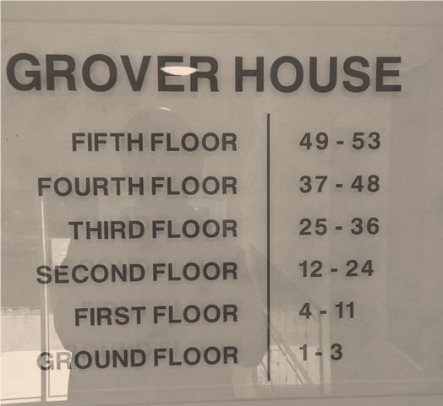 | Bespoke wayfinder clear acrylic plaque complete with reverse printed graphics and 4x 19/25mm brushed chrome stand off's for fixing -  600mm x 600mm 10mm.

10.16 Smoke Alarms & Carbon Monoxide Detectors
Mains wired smoke/heat detector (ceiling mounted) to be provided for each floor. Refer to working drawings for locations and type.

10.17 Management Company
Upon completion an independent fire safety inspection is to be conducted, approved, and certified. This certificate is to be issued to the management company.

11.0 REVISIONS

December 2022  March 2023 | 1.4 – Door Numerals removed as standard  3.2 – Double oven changed to single oven in 4&5 Bed Houses  Fridge Freezer removed from 4&5 Bed Houses  3.3 – Sink changed to 1.0 Bowl as standard to 4&5 Bed Houses  4.1 – Doorbell and Chime Box removed as standard  Track Light to Kitchen removed as standard  4.2 – Media Plate removed  4.5 – Doorbell and Chime Box removed as standard  5.5 – Outside Tap removed as standard  4.2 – Media plate added

