

Walk-Over Tree Survey
Fair Oak and Horton Heath Parish Council
April 2023

Survey details
Site | Multiple Client Owned Sites
Client | Fair Oak and Horton Heath Parish Council
Author | Fred Lamb
Date | 4/5/2023
Reference | N/A

Survey information
Instruction and Scope of Work | Instruction was received from Martin Johnson from Fair Oak and Horton Heath Parish Council (the client) to carry out a walk-over tree survey, in relation to likelihood of structural failure, on all trees with a stem diameter greater than 150mm (measured at 1.5m above ground level) within falling distance of client-owned building structures, car parks, public highways (occasional, frequent or constant occupied target areas) located at the following sites.  - Lapstone Playing Fields  - Lapstone Farm  - Knowle Park  - Horton Heath Community  - Oak Walk  - Fair Oak Cemetery  - Knowle Hill Conservation Area  - Daisy Dip  - -  - New Century Park  - Upper Barn Copse  - Crowdhill Green  Please note: the letter “I” was not used as a site designation to avoid confusion when identifying tree numbers.  The site boundaries have been identified from previous survey maps from the client.  The aim of this report is to provide an overview of the tree survey and to provide management recommendations to the person responsible for the risk management of the site.
Sites and Management | All eleven sites are green spaces and recreation areas. All have public access, with some restrictions in place to protect wildlife at Knowle Park and Lapstone Farm. The apparent main use is for community recreation with a strong management emphasis on conservation or recreation (depending on site).
Targets | The sites are publicly owned with public access. Primary targets are people, both within the site and external to it, and third-party property.  Access restrictions to the sites, or adjacent third-party property, are not considered practical. Risk mitigation by target management has, therefore, not been explored.
Tree Survey Methodology | All trees, identified through the scope of work, underwent a systematic, visual inspection of their external surfaces (survey). This survey was carried out from ground level, and from within public or client-owned target areas, only.  The aim of the survey is to identify any significant structural or physiological conditions of concern, evident at the time of the survey from public or client-owned target areas.  Any significant structural features identified with the trees underwent a VALID Tree Risk Assessment in order to aid decision making.  Only trees where recommendations have been made were recorded and communicated in this report. These may be found in the Schedule.  Tree tags were not used as part of this survey. The tree numbers relate to the plans shown in Appendix 1.  A preliminary inspection interval has been set at 1 year. Therefore, for all trees, including those not listed in the Schedule, the default re-inspection period is 1 year from the date of this report.
Generic Limitations | Individual tree ownership was beyond the scope of this survey; trees not obviously within the site boundaries were not inspected. Obvious features were used (hedges, water courses, ditches, etc.) to determine the site parameters, where not instructed.  Trees are dynamic, living organisms and their condition is subject to change throughout their lifetime. All observations and recommendations relate solely to the arboricultural condition of the tree at the time of the inspection. Trees should be surveyed periodically and after significant change to their environment or situation.  It is not possible to eliminate all risk associated with trees because even those of apparently good condition can fail when the forces acting upon them exceed their inherent strength; some risk must be accepted to experience the benefits that trees provide.  The survey involved minimal interference with the natural environment due to the emphasis on conservation management. Where vegetative ground cover and climbing plants obscured the survey of individual trees from the target areas, removal of these obstructions was only recommended where symptoms of defects, or target occupancy, gave reasonable reason to do this.
Site Visits | Site visits were carried on the following dates;  - Lapstone Playing Fields - 25/4/23  - Lapstone Farm- 25/4/23  - Knowle Park - 2/5/23  - Horton Heath Community - 18/4/23  - Oak Walk - 18/4/23  - Fair Oak Cemetery - 18/4/23  - Knowle Hill Conservation Area - 18/4/23  - Daisy Dip - 28/4/23  - -  - New Century Park - 25/4/23  - Upper Barn Copse - 28/4/23  - Crowdhill Green - 2/5/23
Site Specific Limitations | Knowle Park - Area outlined in blue was not surveyed due to inaccessibility.  Daisy Dip - Area outlined in blue was not surveyed due to inaccessibility.
Recommendations | See Schedule
Re-survey | Re-survey must occur within 1 year, by March 2024

Management considerations
Ash Die Back | A progressive fungal based disease which has been a significant issue for Ash trees in the country in the last ten years.  The disease is quick to have a significant impact on the tree, often killing young trees and severely effecting mature trees often getting to a point where the tree is no longer viable.  Due to the speed of the demise of the tree and the lack of structural integrity left in effected material trees are often removed depending on the risk to people or property.  Due to the way the disease works it often leaves the wood lacking structural integrity and is known to be a safety issue for contractors working on the affected trees.  As part of this survey effected trees have been identified where identifiable features are visible. This may mean another survey in mid-summer when the disease is most visible.  More information on the disease and its management can be found at the following website.  https://www.forestresearch.gov.uk/tools-and-resources/fthr/pest-and-disease-resources/ash-dieback-hymenoscyphus-fraxineus/  Affected trees have been identified in these sites and highlighted in the schedule. A second survey is recommended in mid-summer.
Invasive Non-Native Species | As general management advice for the Fair Oak and Horton Heath Parish Council invasive non-native species have been noted on various sites within the survey.  Invasive species have a detrimental effect on the native flora and fauna, out competing native species for local resources.  These include Prunus laurocerasus (Laurel), Fallopia japonica (Japanese knotweed), Bamboo species and Buddleja davidii (Buddleia ) at Knowle Hill Conservation Area and Fair Oak Cemetery.  Due to their various negative effects in the local environment it  Is recommended to remove these plants, with advice on how best to do so.

Schedule
Site | Tree Ref. | Scientific Name & Common Name | Diameter Bracket (cm) | Height Bracket (m) | Age Class | Observations | Recommendations | Priority | Re-survey
Lapstone Playing Fields | A1 | Salix caprea  Goat Willow | 30-60 | 5-10 | SM | Growth affecting car park lighting column | Clear lamp by 1m | L | March 2024
Lapstone Playing Fields | A2 | Salix matsudana ‘Tortuosa’  Contorted Willow | 0-30 | 0-5 | Y | Outgrowing planting protection cage | Remove dead stem over car park area. Consider removing protective cage. | M | March 2024
Lapstone Playing Fields | A3 | Acer campestre  Field Maple | 30-60 | 10-15 | SM | Low growth encroaching over car park area | Raise to 5m from ground level over carpark area | L | March 2024
Lapstone Playing Fields | A4 | Acer campester  Field Maple | 30-60 | 10-15 | SM | Low growth encroaching over car park area | Raise to 5m from ground level over carpark area | L | March 2024
Lapstone Playing Fields | (A)G1 | Ulmus procera  English Elm | 30-60 | 5-10 | Y | Group of standing dead trees within striking distance of path | Fell to ground level | H | N/A
Lapstone Playing Fields | (A)G2 | Ulmus procera  English Elm | 30-60 | 10-15 | SM | Group of standing dead trees within striking distance of path and school grounds | Fell to ground level | H | N/A
Lapstone Playing Fields | A5 | Quercus robur  English Oak | 90-120 | 15-20 | M | Section of flaking bark on NE side of stem at ground level, deadwood within crown | Remove major deadwood over 50mm and re-inspect in 6 months | M | September 2023
Lapstone Playing Fields | A6 | Quercus roubur  English Oak | 60-90 | 15-20 | SM | Evidence of fungal fruiting bracket at base of tree on SW side | Reduce by 2m and remove major deadwood over 50mm | M | March 2024
Lapstone Playing Fields | A7 | Quercus robur  English Oak | 60-90 | 15-20 | SM | Deadwood within crown over footpath and split leader | Remove major deadwood over 50mm and remove split leader | H | March 2024
Lapstone Playing Fields | A8 | Prunus cerasifera  Cherry Plum | 0-30 | 5-10 | Y | Split at main union | Reduce split limb by 1/2m to reduce end weight | M | March 2024
Lapstone Playing Fields | (A)G3 | Ulmus procera  English Elm | 30-60 | 10-15 | SM | Group of approximately 5 dead trees within striking distance of footpath | Fell to ground level | H | N/A
Lapstone Playing Fields | (A)G4 | Ulmus procera  English Elm | 30-60 | 10-15 | SM | Group of 2 dead trees overhanging neighbouring property | Fell to ground level | H | N/A
Lapstone Playing Fields | A9 | Betula pendula  Silver Birch | 0-30 | 10-15 | Y | Tight union at base of stem with small pocket of decay | Reduce entire crown by 2m | M | March 2024
Lapstone Playing Fields | A10 | Salix caprea  Goat Willow | 15-30 | 5-10 | Y | Hung up stem in neighbouring tree | Remove hanger down to reactive growth just below split/crack | H | March 2024
Site | Tree Ref. | Scientific Name & Common Name | Diameter Bracket (cm) | Height Bracket (m) | Age Class | Observations | Recommendations | Priority | Re-survey
Lapstone Farm | B | N/A | N/A | N/A | N/A | N/A | N/A | N/A | March 2024
Site | Tree Ref. | Scientific Name & Common Name | Diameter Bracket (cm) | Height Bracket (m) | Age Class | Observations | Recommendations | Priority | Re-survey
Knowle  Park | C1 | Quercus robur  English Oak | 150-180 | 15-20 | V | Lack of small twig growth, deadwood present | Remove major unstable deadwood over 50mm | M | March 2024

Site | Tree Ref. | Scientific Name & Common Name | Diameter Bracket  (cm) | Height Bracket (m) | Age Class | Observations | Recommendations | Priority | Re-survey
Horton Heath Community Centre | D1 | Quercus robur  English Oak | 30-60 | 10-15 | EM | Slow/delayed bud formation observed at time of survey. | Re Survey in 6 Months | M | August 2024
Horton Heath Community Centre | D2 | Betula pendula  Silver Birch | 0-30 | 10-15 | Y | Poor form, suppressed by 2 larger specimens | Fell to ground level | L | N/A
Horton Heath Community Centre | D3 | Fraxinus excelsior  Ash | 60-90 | 10-15 | EM | Low level dead stubs from previous poor pruning | Remove 2 low dead stubs over path | M | March 2024
Horton Heath Community Centre | D4 | Prunus avium  Cherry Plum | 0-30 | 0-5 | Y | Poor form, suppressed by larger species, growing on angle over carpark | Fell to ground level | M | March 2024

Site | Tree Ref | Scientific Name & Common Name | Diameter Bracket (cm) | Height Bracket (m) | Age Class | Observations | Recommendations | Priority | Re-Survey
Oak Walk | E1 | Sorbus aria  Whitebeam | 30-60 | 0-5 | EM | Low canopy over path | Raise to 3m | M | March 2024
Oak Walk | E2 | Tilia cordata  Small Leaved Lime | 60-90 | 10-15 | EM | Epicormic growth on stem | Remove epicormic growth | L | March 2024
Oak Walk | E3 | Tilia cordata  Small Leaved Lime | 60-90 | 10-15 | EM | Low canopy over neighbouring carpark | Raise to 5m over car park area | M | March 2024
Oak Walk | E4 | Ulmus procera  English Elm | 0-30 | 5-10 | Y | Dead | Fell to ground level | H | March 2024
Oak Walk | E5 | Crataegeus monogyna  Hawthorn | 0-30 | 5-10 | Y | Canopy growing in close proximity to property | Prune to clear property by 2m | L | March 2024
Oak Walk | E6 | Sorbus aria  Whitebeam | 0-30 | 0-5 | Y | Low epicormic growth | Remove epicormic | L | March 2024
Site | Tree Ref. | Scientific Name & Common Name | Diameter Bracket (cm) | Height Bracket (m) | Age Class | Observations | Recommendations | Priority | Re-survey
Fair Oak Cemetery | F1 | Quercus robur  English Oak | 60-90 | 15-20 | EM | Deadwood within crown | Remove major deadwood (over 50mm) over path | M | March 2024
Fair Oak Cemetery | F2 | Quercus robur  English Oak | 60-90 | 15-20 | EM | Deadwood within crown | Remove major deadwood (over 50mm) over path | M | March 2024
Fair Oak Cemetery | F3 | Quercus robur  English Oak | 60-90 | 15-20 | EM | Deadwood within crown | Remove major deadwood (over 50mm) over path | M | March 2024
Fair Oak Cemetery | F4 | Quercus robur  English Oak | 60-90 | 15-20 | EM | Deadwood within crown | Remove major deadwood (over 50mm) over path | M | March 2024
Fair Oak Cemetery | F5 | Ulmus procera  English Elm | 0-30 | 10-15 | Y | Dead - within striking distance of path | Fell to ground level | H | N/A
Fair Oak Cemetery | F6 | Quercus robur  English Oak | 60-90 | 15-20 | EM | Deadwood over footpath | Remove major dead (over 50mm) over footpath | M | March 2024
Fair Oak Cemetery | F7 | Quercus robur  English Oak | 60-90 | 15-20 | EM | Deadwood over footpath | Remove major dead (over 50mm) over footpath | M | March 2024
Fair Oak Cemetery | F8 | Quercus robur  English Oak | 60-90 | 15-20 | EM | Deadwood over footpath | Remove major dead (over 50mm) over footpath | M | March 2024
Fair Oak Cemetery | F9 | Quercus robur  English Oak | 60-90 | 15-20 | EM | Deadwood over footpath | Remove major dead (over 50mm) over footpath | M | March 2024
Fair Oak Cemetery | F10 | Quercus robur  English Oak | 30-60 | 10-15 | Y | Deadwood over footpath | Remove major dead (over 50mm) over footpath | M | March 2024
Fair Oak Cemetery | F11 | Ulmus procera  English Elm | 0-30 | 10-15 | Y | Dead within striking distance of footpath | Fell to ground level | H | N/A
Fair Oak Cemetery | F12 | Ulmus procera  English Elm | 0-30 | 10-15 | Y | Dead within striking distance of footpath | Fell to ground level | H | N/A
Fair Oak Cemetery | F13 | Pinus radiata  Monterey Pine | 60-90 | 15-20 | M | Deadwood and hanging limb over footpath | Remove dead limb at low level over footpath and hanging limb | H | March 2024
Fair Oak Cemetery | (F)G1 | Quercus robur  English Oak | 30-60 | 10-15 | EM | Deadwood overhanging footpath (Redrup Way) | Remove major deadwood (over 50mm) over footpath | M | March 2024
Site | Tree Ref. | Scientific Name & Common Name | Diameter Bracket (cm) | Height Bracket (m) | Age Class | Observations | Recommendations | Priority | Re-survey
Knowle Hill Conservation Area | G1 | Betula pendula  Silver Birch | 0-30 | 10-15 | Y | Dead | Fell to ground level | H | N/A
Knowle Hill Conservation Area | (G)G1 | Quercus robur  English Oak | 30-60 | 10-15 | Y | Deadwood within canopy over footpath | Remove major deadwood (over 50mm) over path | M | March 2024
Knowle Hill Conservation Area | (G)G2 | Quercus robur  English Oak | 30-60 | 10-15 | Y | Deadwood within canopy over footpath | Remove major deadwood (over 50mm) over path | M | March 2024
Knowle Hill Conservation Area | G2 | Quercus robur  English Oak | 30-60 | 10-15 | Y | Deadwood within canopy over footpath | Remove major deadwood (over 50mm) over path | M | March 2024
Knowle Hill Conservation Area | G3 | Fraxinus exelcior  Ash | 0-30 | 10-15 | Y | Dead | Fell to ground level | H | N/A
Knowle Hill Conservation Area | G4 | Quercus robur  English Oak | 30-60 | 10-15 | Y | Deadwood within canopy over footpath | Remove major deadwood (over 50mm) over path | M | March 2024
Knowle Hill Conservation Area | G5 | Fraxinus exelcior  Ash | 30-60 | 10-15 | EM | Deadwood within canopy over footpath | Remove major deadwood (over 50mm) over path | M | March 2024
Knowle Hill Conservation Area | G6 | Quercus robur | 30-60 | 10-15 | Y | Deadwood within canopy over footpath | Remove major deadwood (over 50mm) over path | M | March 2024
Knowle Hill Conservation Area | G7 | Salix caprea  Goat Willow | 0-30 | 0-5 | Y | Low limb growing over footpath | Remove low limb to clear footpath | M | March 2024
Knowle Hill Conservation Area | G8 | Salix caprea  Goat Willow | 30-60 | 0-5 | Y | Dead leaning tree over footpath | Fell to ground level | H | N/A
Knowle Hill Conservation Area | G9 | Betula pendula  Silver Birch | 30-60 | 10-15 | EM | Hung up limb in canopy over path | Remove split/hung up limb | H | March 2024
Knowle Hill Conservation Area | G10 | Acer campestre  Field Maple | 0-30 | 5-10 | Y | Low branch growing across footpath | Remove low limb affecting path | M | March 2024
Knowle Hill Conservation Area | G11 | Betula pendula  Silver Birch | 0-30 | 10-15 | Y | Dead | Fell dead stem | H | N/A
Knowle Hill Conservation Area | G12 | Quercus robur  English Oak | 60-90 | 10-15 | EM | Deadwood within canopy over footpath | Remove major deadwood (over 50mm) over path | M | March 2024
Knowle Hill Conservation Area | G13 | Quercus robur  English Oak | 30-60 | 10-15 | EM | Deadwood within canopy over footpath | Remove major deadwood (over 50mm) over path | M | March 2024
Knowle Hill Conservation Area | G14 | Betula pendula  Silver Birch | 0-30 | 5-10 | Y | Dead | Fell to ground level | H | N/A
Knowle Hill Conservation Area | G15 | Salix caprea  Goat Willow | 0-30 | 5-10 | Y | Hung up branch in crown over footpath | Remove hanger | H | March 2024
Knowle Hill Conservation Area | G16 | Quercus robur  English Oak | 30-60 | 10-15 | Y | Deadwood over footpath | Remove major deadwood (over 50mm) over path | M | March 2024
Knowle Hill Conservation Area | G17 | Quercus robur  English Oak | 30-60 | 10-15 | Y | Deadwood over footpath | Remove major deadwood (over 50mm) over path | M | March 2024
Site | Tree Ref. | Scientific Name & Common Name | Diameter Bracket (cm) | Height Bracket (m) | Age Class | Observations | Recommendations | Priority | Re-survey
Daisy Dip | H1 | Acer platanoides  Norway Maple | 30-90 | 10-15 | SM | Tight union at 1.5m. Overhanging neighbouring private property | Reduce canopy by 2/3m | M | March 2024
Daisy Dip | (H)G1 | Salix caprea  Goat Willow | 30-60 | 10-15 | SM | Old coppice stools weak unions. Growth overhanging private property | Pollard to approximately 1.5m from ground level | M | March 2024
Daisy Dip | H2 | Acer platanoides  Norway Maple | 60-90 | 10-15 | SM | Included union at base of tree | Reduce SE side of crown by 2/3m | M | March 2024
Daisy Dip | H3 | Alnus glutinosa  Alder | 30-60 | 15-20 | SM | Twin stemmed tree with tight union at base and evidence of rubbing | Fell to ground level | M | N/A
Site | Tree Ref. | Scientific Name & Common Name | Diameter Bracket (cm) | Height Bracket (m) | Age Class | Observations | Recommendations | Priority | Re-survey
New Century Park | J1 | Poplus nigra  Lombardy Poplar | 90-120 | 10-20 | M | Snapped hung up branch over footpath | Remove hung up limb | H | March 2024
Site | Tree Ref. | Scientific Name & Common Name | Diameter Bracket (cm) | Height Bracket (m) | Age Class | Observations | Recommendations | Priority | Re-survey
Upper Barn Copse (N) | K1 | Prunus Avium  Wild Cherry | 0-30 | 5-10 | SM | Low hanging canopy over path. | Raise to 3m | M | March 2024
Upper Barn Copse (N) | K2 | Poplus alba  White Poplar | 0-30 | 0-5 | Y | Failed tree hanging in adj tree over footpath | Fell to ground level | H | March 2024
Upper Barn Copse (N) | (K)G1 | Poplus alba  White Poplar | 0-30 | 10-15 | Y | Group of poplar growing on a lean over footpath | Fell to ground level | M | March 2024
Upper Barn Copse (N) | K3 | Prunus avium  Wild Cherry | 30-60 | 5-10 | SM | Deadwood in canopy over seating area | Remove major deadwood over 50mm | M | March 2024
Upper Barn Copse (N) | (K)G2 | Quercus robur  English Oak | 30-90 | 5-10 | M | Deadwood within canopy in most trees along footpath | Remove major deadwood over 50mm | M | March 2024
Upper Barn Copse (N) | K4 | Fraxinus excelsior  Ash | 0-30 | 5-10 | Y | Growing on heavy lean over footpath and towards property | Fell to ground level | M | March 2024
Upper Barn Copse (S) | K5 | Castenaea sativa  Sweet Chestnut | 30-60 | 15-20 | SM | Hanging snapped branch in lower canopy | Remove hanger | H | March 2024
Upper Barn Copse (S) | (K)G3 | Qurcus robur  English Oak | 60-90 | 15-20 | M | Deadwood within canopy | Remove major deadwood over 50mm, over footpath | M | March 2024
Site | Tree Ref. | Scientific Name & Common Name | Diameter Bracket (cm) | Height Bracket (m) | Age Class | Observations | Recommendations | Priority | Re-survey
Crowdhill (E) | L1 | Quercus robur  English Oak | 30-60 | 5-10 | SM | Standing dead tree close proximity to footpath | Monolith to 4m from ground level | M | March 2024
Crowdhill (E) | L2 | Salix caprea  Goat Willow | 0-30 | 10-15 | SM | Hanging/Snapped limbs over footpath | Remove hanging snapped limbs | H | March 2024
Crowdhill (E) | L3 | Quercus Robur  English Oak | 30-60 | 10-15 | SM | Deadwood over footpath | Remove deadwood over 50mm, over footpath | M | March 2024
Crowdhill (E) | L4 | Fraxinus excelsior  Ash | 60-90 | 10-15 | SM | Multistemmed tree with weak union at approximately 1.5m | Pollard to 2m from ground level retaining crack/cavities as habitat | H | March 2024
Crowdhill (E) | L5 | Salix alba  White Willow | 90-120 | 15-20 | M | Multiple cracked hanging limbs and cavities observed within canopy | Reduce central stem above historical tear out/wound by 2/3m, Reduce limb with hazard beam by 2/3m & remove any split hanging limbs over path | H | March 2024
Crowdhill (E) | L6 | Fraxinus excelsior  Ash | 30-60 | 15-20 | SM | Ash displaying signs of ADB | Monolith to 4/5m from ground level | H | March 2024
Crowdhill (E) | L7 | Quercus robur  English Oak | 90-120 | 15-20 | M | Fungal brackets observed at base of tree, deadwood within canopy over footpath | Remove major deadwood over 50mm, over path. Monitor (6 months) | M | September 2023
Crowdhill (S) | L8 | Quercus robur  English Oak | 60-90 | 15-20 | M | Deadwood observed in canopy over footpath | Remove major deadwood over 50mm, over path | M | March 2024
Crowdhill (S) | L9 | Quercus robur  English Oak | 60-90 | 15-20 | SM | Deadwood observed in canopy over footpath | Remove major deadwood over 50mm, over path and reduce hazard beam by 2/3m | M | March 2024
Crowdhill (S) | L10 | Quercus robur  English Oak | 60-90 | 15-20 | SM | Deadwood observed in canopy over footpath | Remove major deadwood over 50mm, over path | M | March 2024
Crowdhill (S) | L11 | Quercus robur  English Oak | 60-90 | 15-20 | SM | Deadwood observed in canopy over footpath | Remove major deadwood over 50mm, over path | M | March 2024
Crowdhill (S) | L12 | Quercus robur  English Oak | 30-60 | 15-20 | Y | Deadwood observed in canopy over footpath | Remove major deadwood over 50mm, over path | M | March 2024
Crowdhill (S) | L13 | Castanea sativa  Sweet Chestnut | 30-60 | 10-15 | Y | Stool of coppiced chestnut with dead central stem | Fell dead stems | H | March 2024
Crowdhill (S) | L14 | Quercus robur  English Oak | 90-120 | 10-15 | SM | Deadwood observed in canopy over footpath | Remove major deadwood over 50mm, over path | M | March 2024
Crowdhill (S) | L15 | Quercus robur  English Oak | 60-90 | 10-15 | SM | Deadwood observed in canopy over footpath | Remove major deadwood over 50mm, over path | M | March 2024
Crowdhill (S) | L16 | Quercus robur  English Oak | 30-60 | 5-10 | SM | Historical root heave/delamination of bark at base of stem | Reduce by 2/3m | M | March 2024
Crowdhill (Central) | L17 | Quercus robur  English Oak | 30-60 | 5-10 | Y | Deadwood observed in canopy over footpath | Remove major deadwood over 50mm, over path | M | March 2024
Crowdhill (Central) | L18 | Quercus robur  English Oak | 60-90 | 15-20 | SM | Deadwood observed in canopy over footpath | Remove major deadwood over 50mm, over path | M | March 2024
Crowdhill (Central) | L19 | Quercus robur  English Oak | 60-90 | 15-20 | M | Deadwood observed in canopy over footpath | Remove major deadwood over 50mm, over path | M | March 2024
All measurements are approximate. “agl” = above ground level.

Priority:
High Within 1 month from report publication
Moderate Within 6 months from report publication
Low Within 12 months from report publication

Appendix 1 - Site Plans
Lapstone Playing Fields
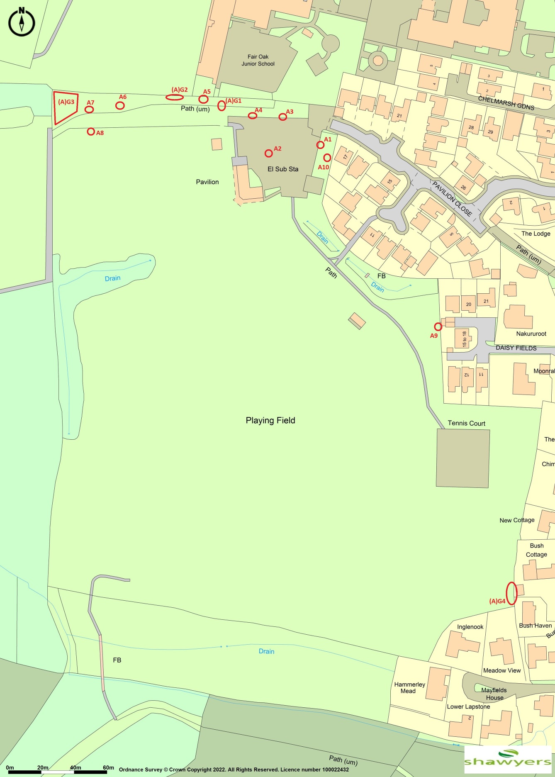
Lapstone Farm N/A
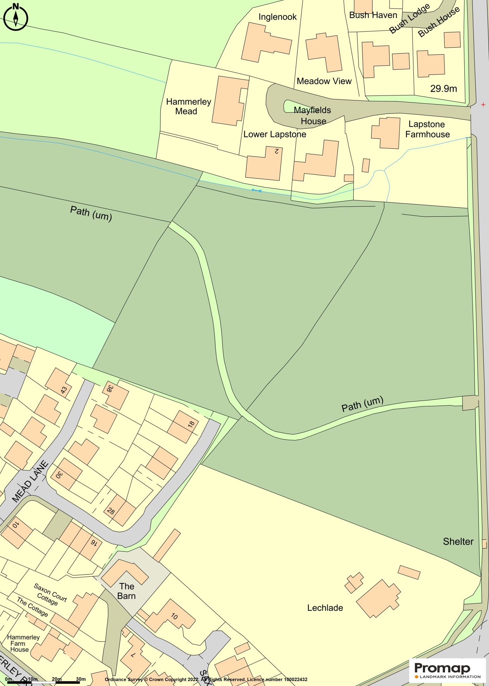

Knowle Park
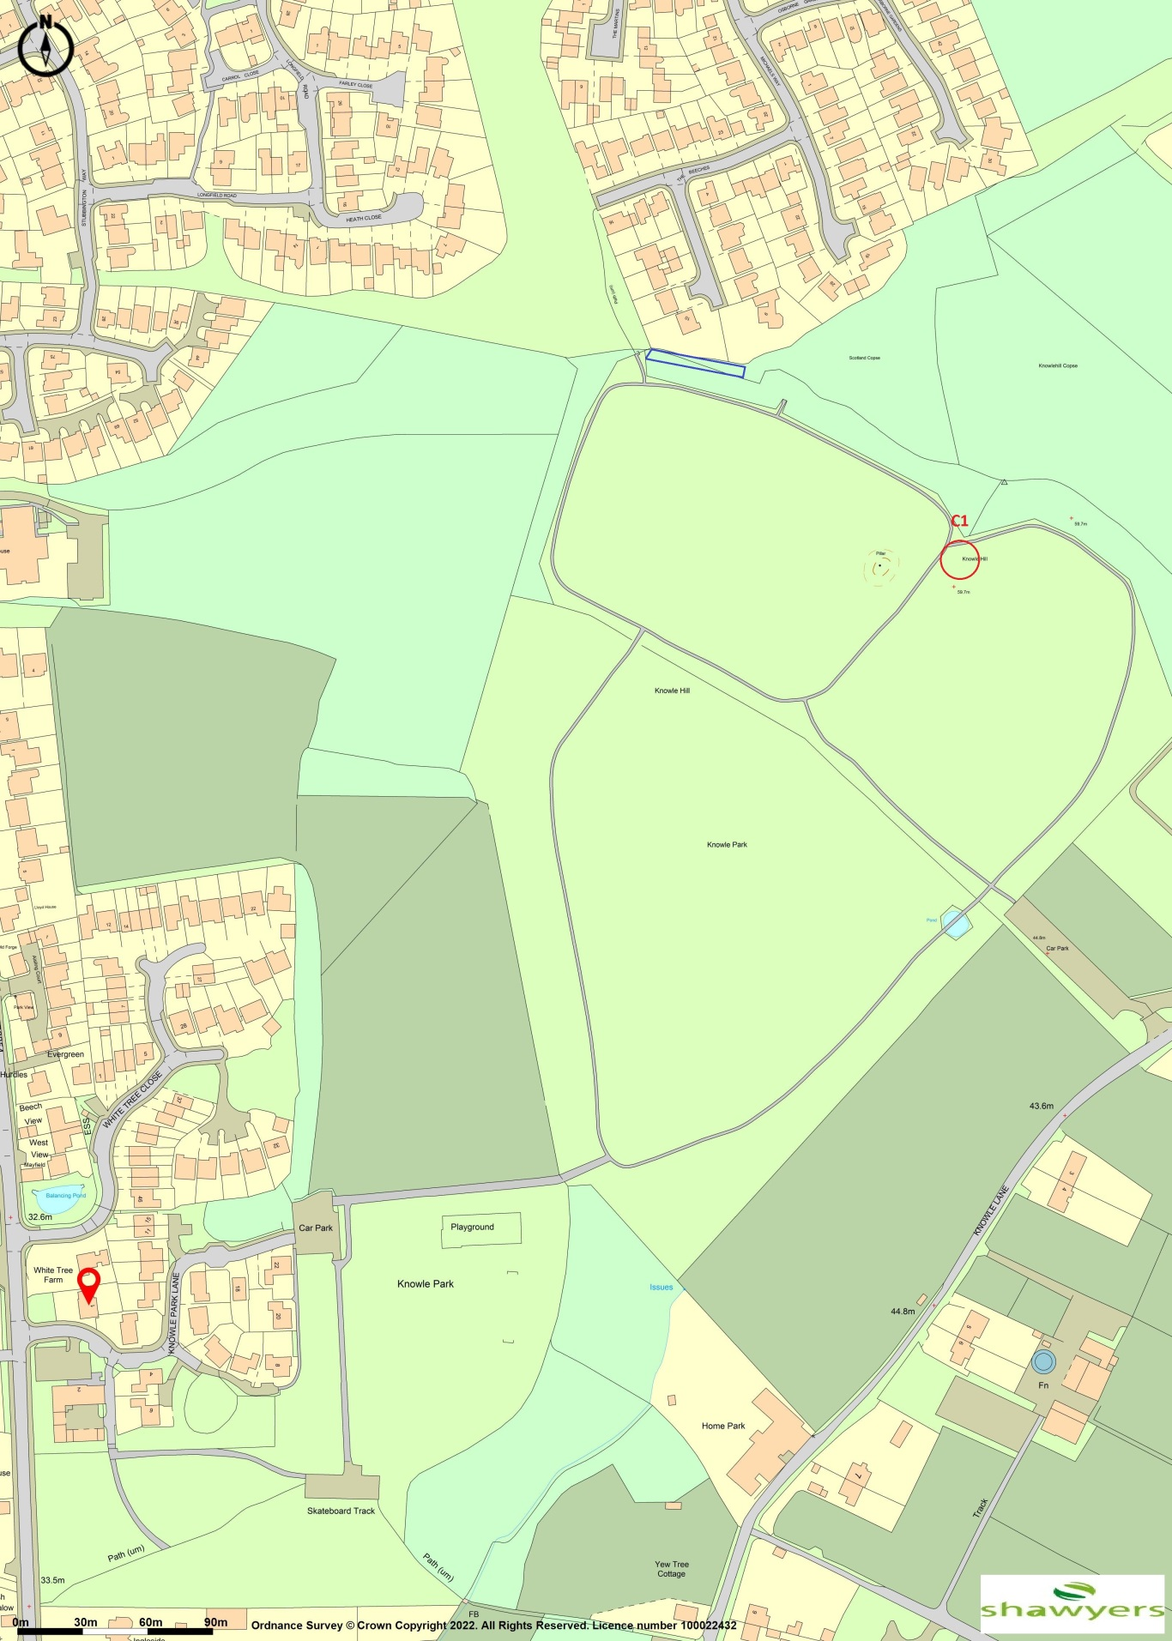

Horton Heath Community Centre
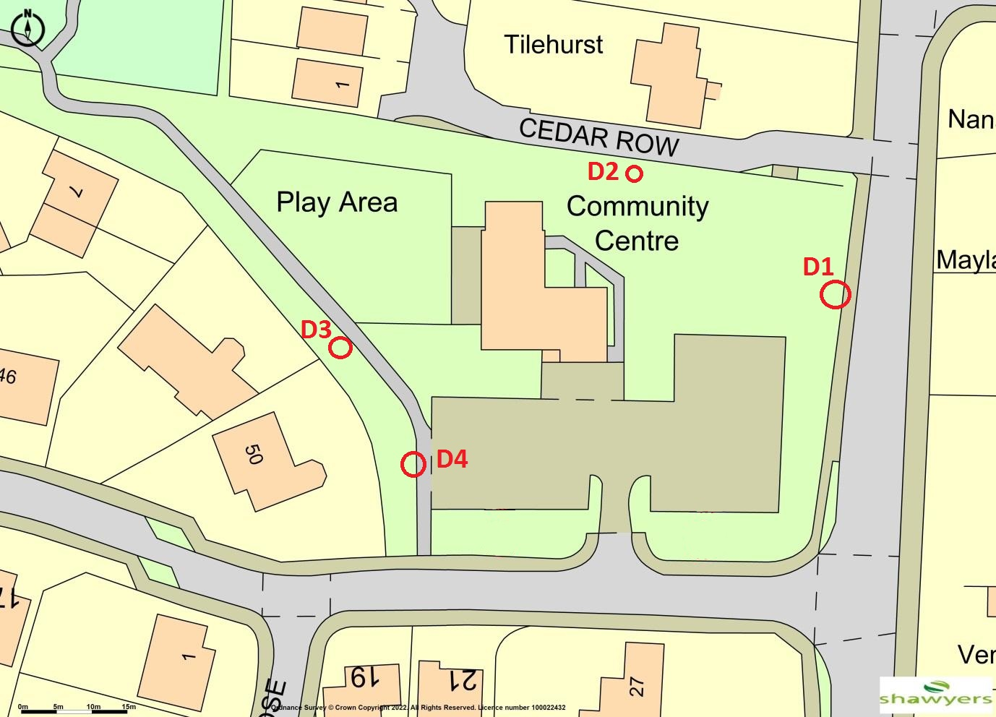

Oak Walk
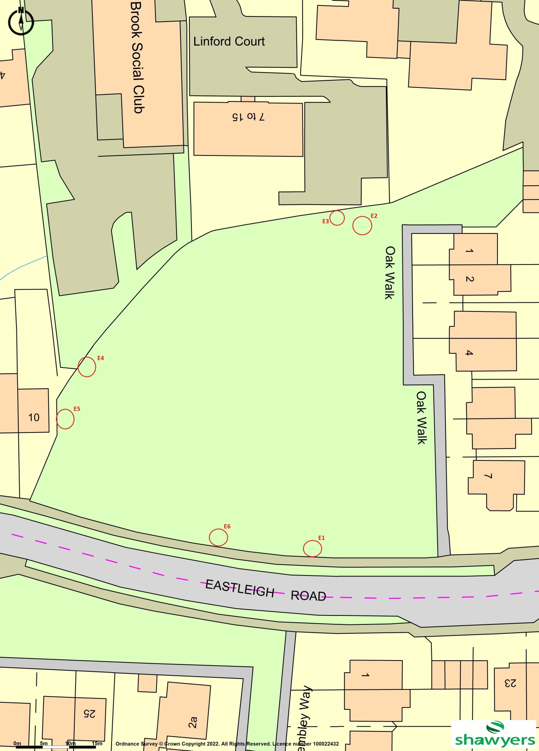

Fair Oak Cemetery
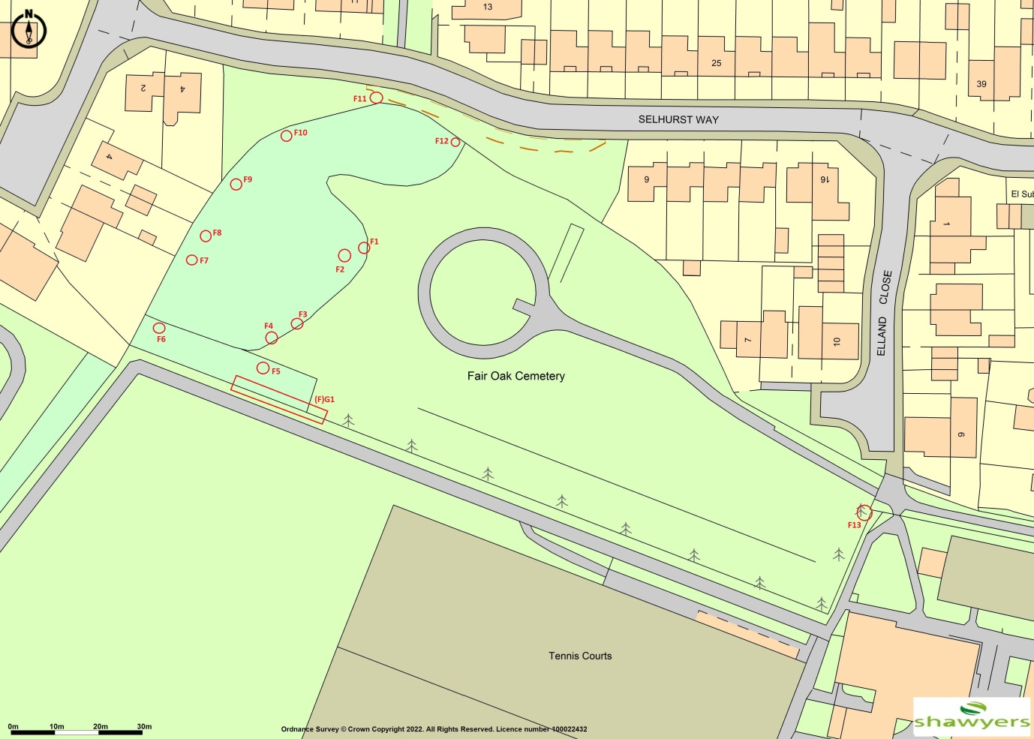

Knowle Hill Conservation Area
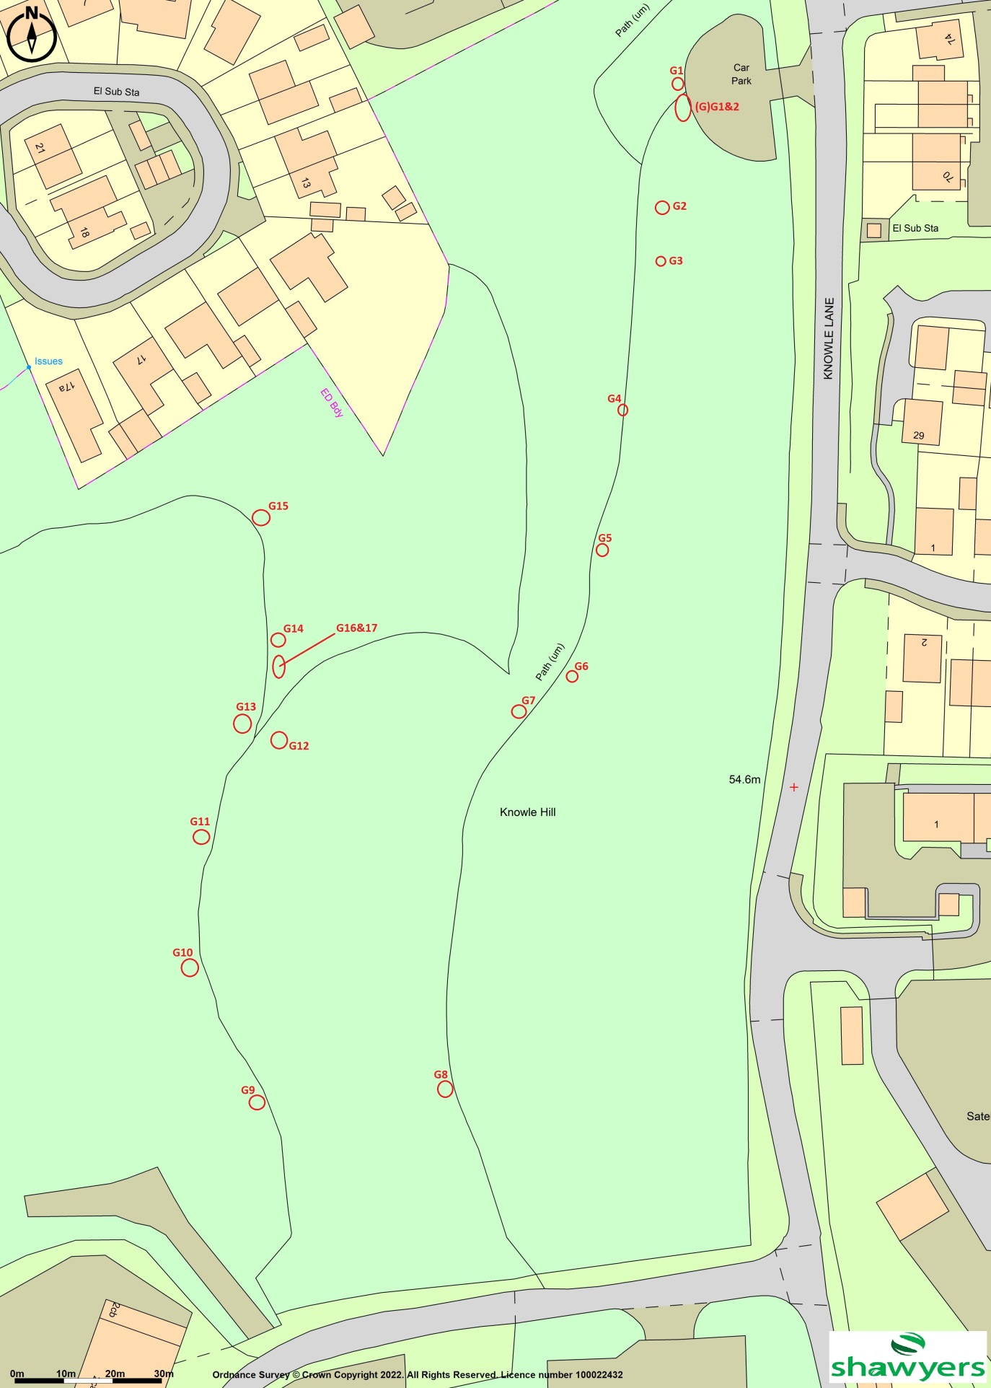

Daisy Dip
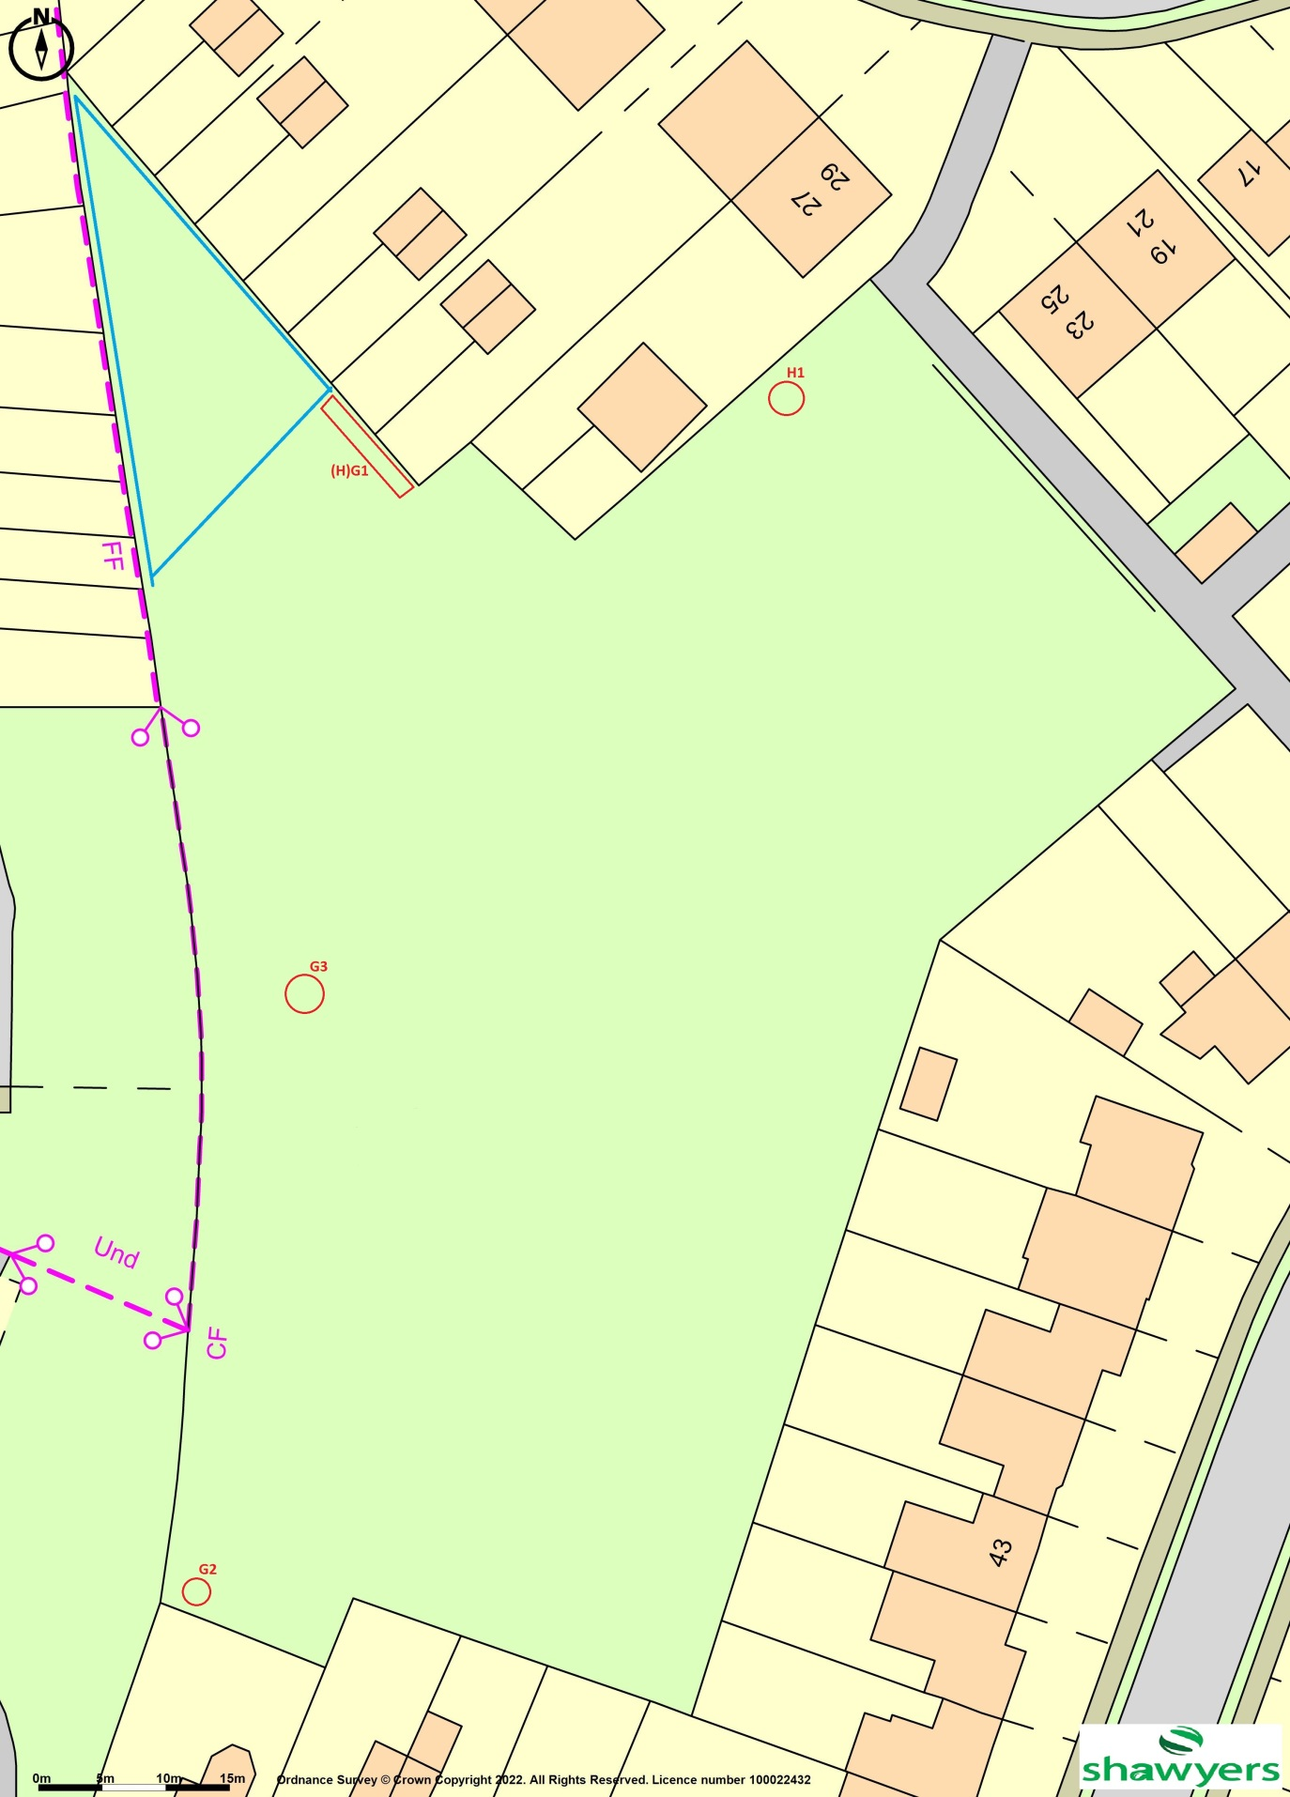

New Century Park
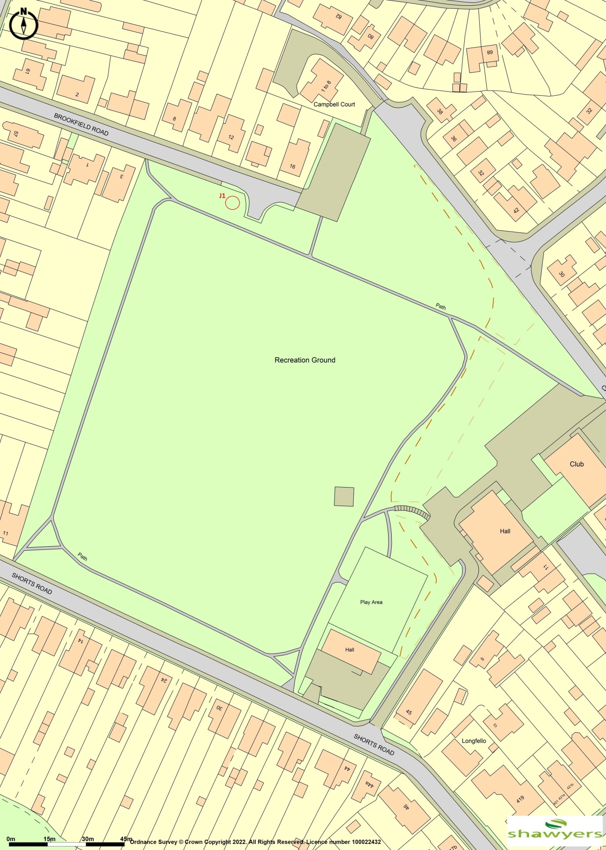

Upper Barn Copse - North
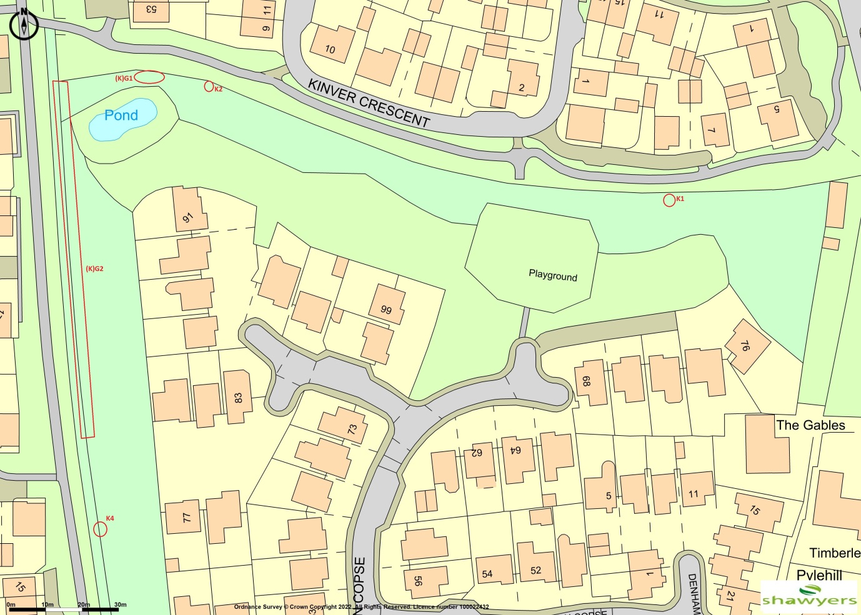

Upper Barn Copse - South
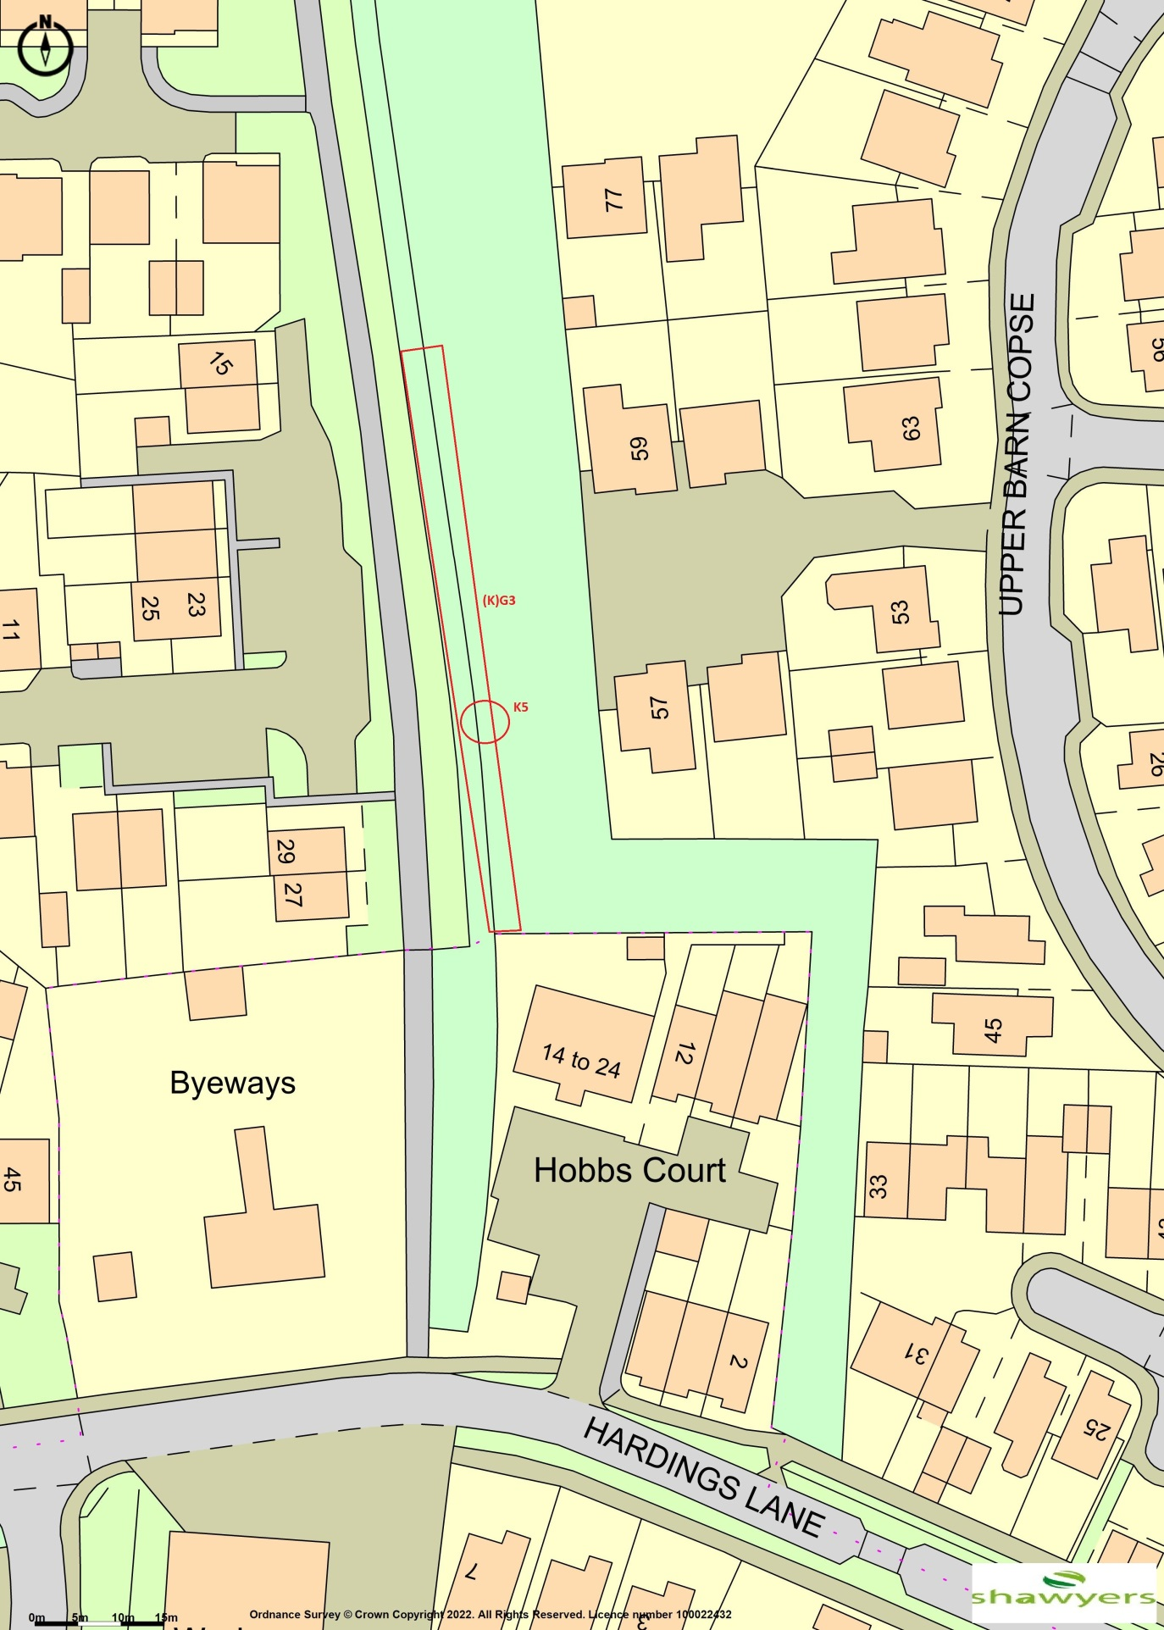

Crowdhill - Central
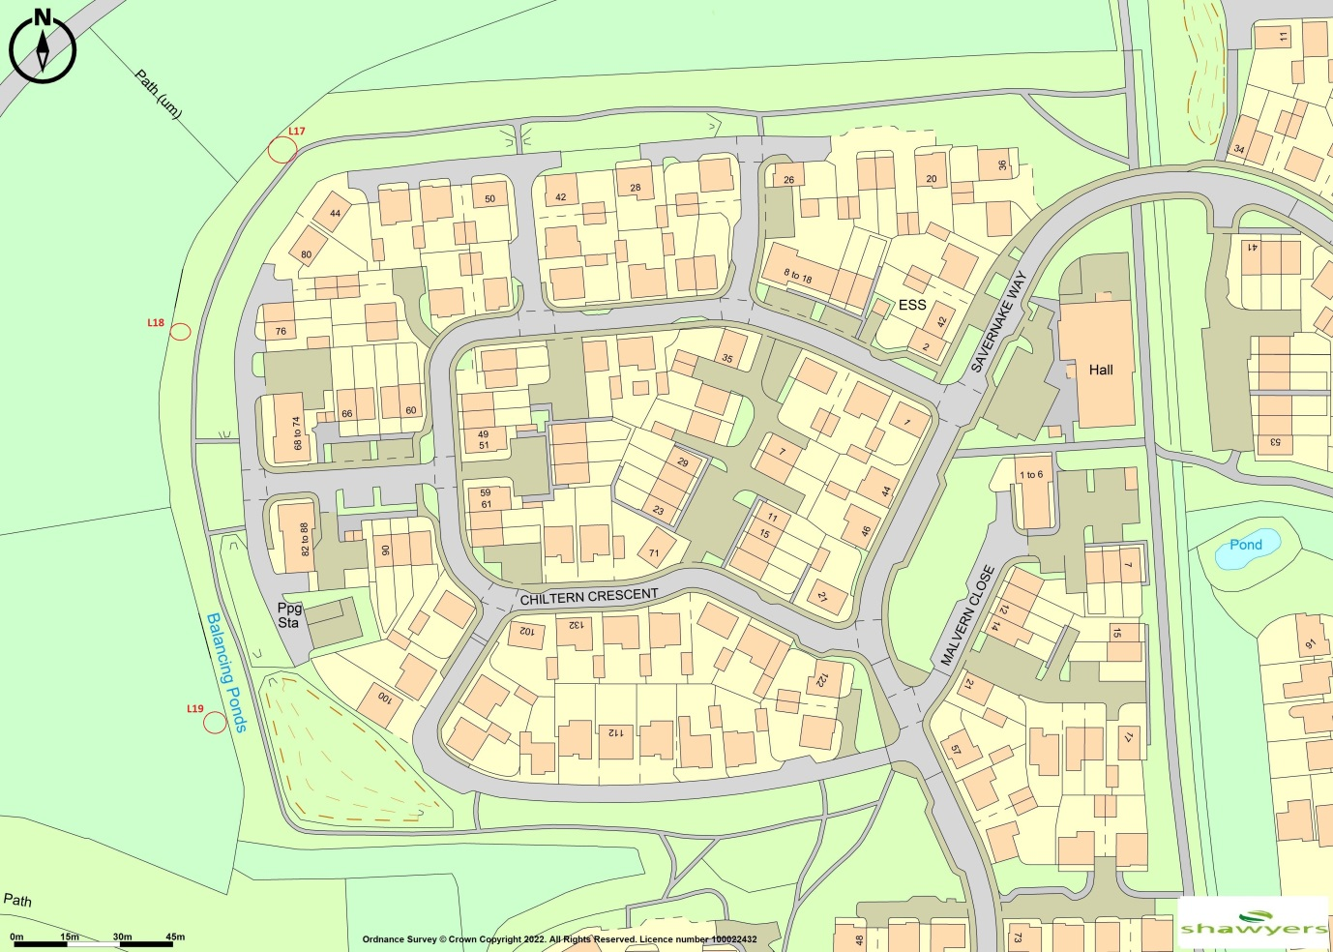

Crowdhill - South
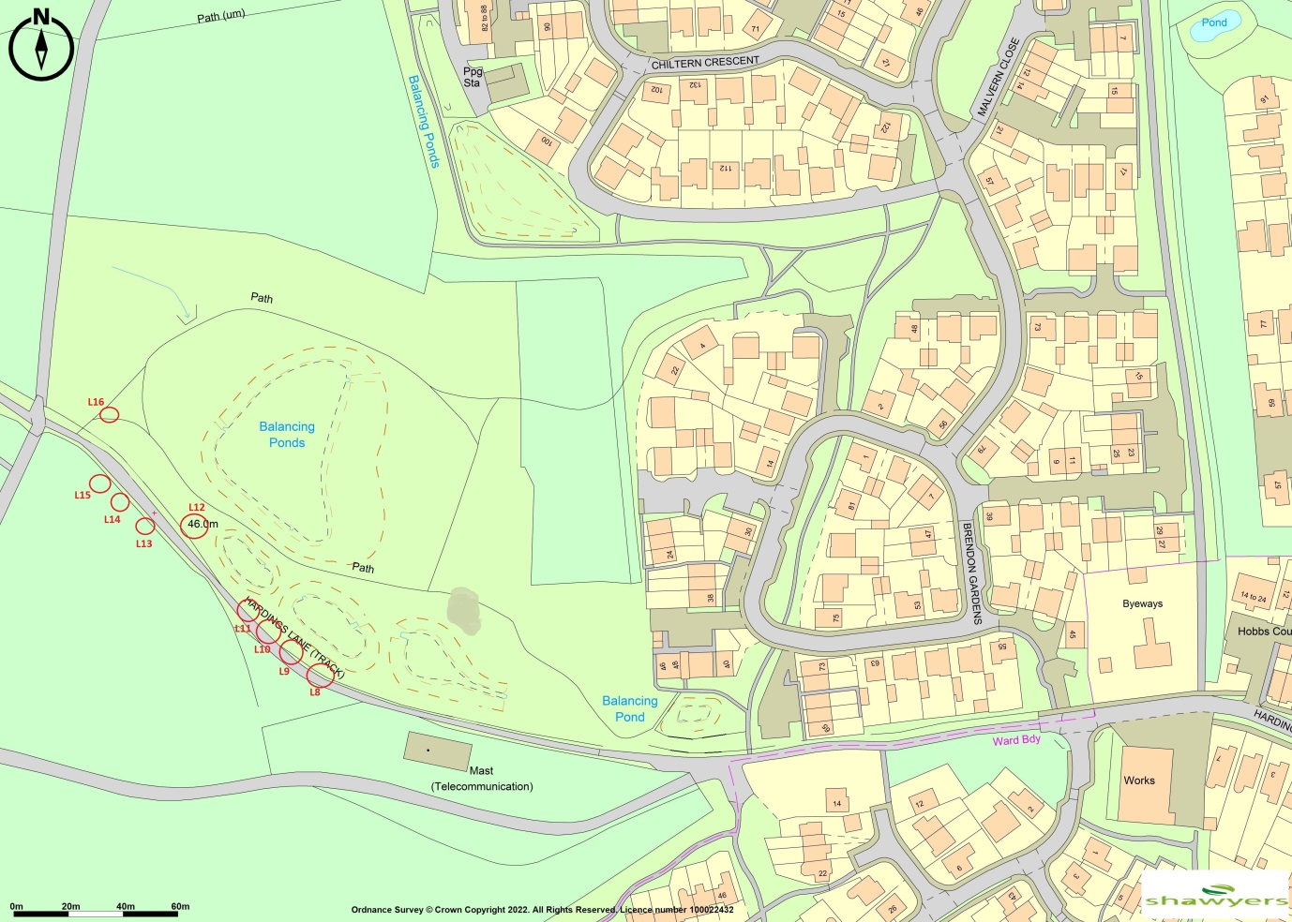

Crowdhill - East
