Drainage Response to Consultee Comments DC/23/94483

EMAIL 1 OF 2

I have reviewed the subsequent comments from the Ecologist and the LLFA – I will reply in two separate emails, as follows;

ECOLOGY COMMENTS
The Amended Drainage Statement by PFA (Phase 3, Issue 2, March 2020) in section 3.1 states that for Basin D The design of the basin will satisfy the criteria of 1 in 100 year rainfall event plus 40% for climate change… and that the location and layout of the basin is such that during an extreme rainfall event beyond the design event, natural exceedance route is towards the Moorgreen Stream located on the northern boundary, which is the point of discharge for all basins.

However, the Main Drainage Sheet 1 of 2 (M380/114) (rev G July 2023) shows an area of potential flooding during a 1 in 100 year plus 40% for climate change rainfall event. These 2 areas are labelled S3015 and S3100. The extent of the predicted floods would cover the area around the houses at plot 495 and 591 and driveways, roadways and footpaths. This is not acceptable; the risk of flooding must be negligible. The Phase 3 Exceedance Flow Routes (sheet 1 of 2, Rev D, May 2023) in this area shows flows moving towards Basin D, so what would cause potential flooding?

It is not clear how the exceedance flows are expected to work in Phase 3D as it appears that the water flow would enter the site along the roadway from the phase to the north (1F) and then exit the site to the same area of vegetation that it already crossed on the way in. Is it possible to have exceedance flows from the north enter this vegetation directly? How will exceedance flows from 3C (Amended Sheet 2 of 2, Rev C, August 2022) affect the area to the south of Phase 3C (2B)? We really need to see the bigger picture to determine whether this exceedance could cause flooding in other phases.

Additional issues may be raised by the LLFA response.

Lisa Malter

ECOLOGY RESPONSE
Although it is considered that the comments are drainage related, which do not affect ecology, our responses are;

The LPA requested the locations of the MicroDrainage flooding to be indicated on a drawing. The flooding indicated on Drawing No. M380/114 Revision G is purely diagrammatic, with the size of the circles representing the amount of flooding indicted by the MicroDrainage calculations during a 1:100 year plus 40% climate change rainfall event; the flooding extents will NOT be circular.

The volume of water is not considered to be an issue, as all of the water will be contained within the road, then overtop the kerbs and flow into Basin D (the road has been designed with a crossfall north to south to ensure this). Properties will not be flooded.

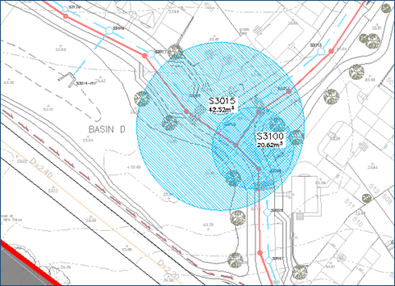

In Phase 3D the access road has a high point where it crosses the existing ditch, which is required for the culvert serving the ditch. Flows would therefore flow south into the site, then follow the road levels west to the low point o/s Plot 458. The road falls south to north, ensuring collected water will overtop the kerbs and enter the retained planted area to the north (which is lower than the access road) before flowing into the retained ditch.

The exceedance flows from 3C will flow into the retained ditch between Phase 3C and 2B. Exceedance flows for Phase 2B are dealt with under that application.

I trust this addresses the comments raised, but please let me know if anything else is needed.

Regards

Dave

EMAIL 2 OF 2

I have reviewed the subsequent comments from the Ecologist and the LLFA – I have just responded to the Ecology, second response as follows;

LLFA COMMENTS
The above documents have addressed the majority of our points however we still have queries in relation to the flood extents shown on the Main Drainage plan. Two overlapping circles are shown but these do not appear to be realistic of the flood extents expected from the chambers, particularly if both flood during the same storm, and no depth are shown.
At present, one plot is completely surrounded by the flood extent circle which would not be acceptable. In addition, a road level of 23.5m is shown down hill of the property but the cross section of the pond indicates a top of bank level of 24.5m. If this is accurate for this location, the exceedance flow routes will not function as identified.
Please provide further detail on the likely flood extents, depths and overland flow routing.

LLFA RESPONSE
The LPA requested the locations of the MicroDrainage flooding to be indicated on a drawing. The flooding indicated on Drawing No. M380/114 Revision G is purely diagrammatic, with the size of the circles representing the amount of flooding indicted by the MicroDrainage calculations during a 1:100 year plus 40% climate change rainfall event; the flooding extents will NOT be circular.

The volume of water is not considered to be an issue, as all of the water will be contained within the road, then overtop the kerbs and flow into Basin D (the road has been designed with a crossfall north to south to ensure this).

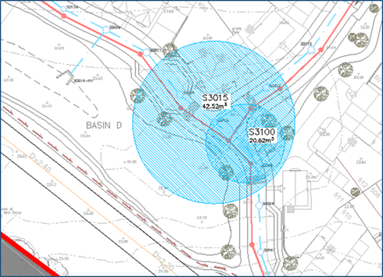

The flooding indicated only occurs during a 1:100 year plus 40% climate change rainfall event, as shown on the MicroDrainage calculations.

The water depth at the low point – the road level here is 23.480m AOD at the lowest side, the top of the pond here has a level of 23.75m AOD so water depth will be 270mm on the south west side of the road near Basin D, before overtopping into the basin. With 50mm high kerbs and 50mm fall on the footway, this means a road level of 23.480m plus 170mm (270mm less 50mm less 50mm) is the critical contour level = 23.650m; it can be in the snap shot below that this level will not affect any of the properties.

Exceedance flows are dealt with on Drawing No. M380/128 Revision D (attached)(already submitted).

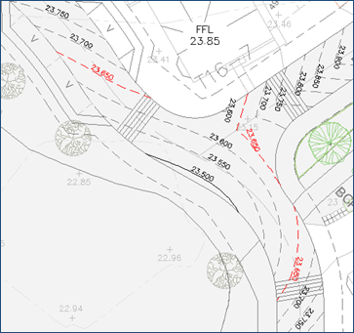

I trust this addresses the comments raised, but please let me know if anything else is needed.

Regards

Dave

