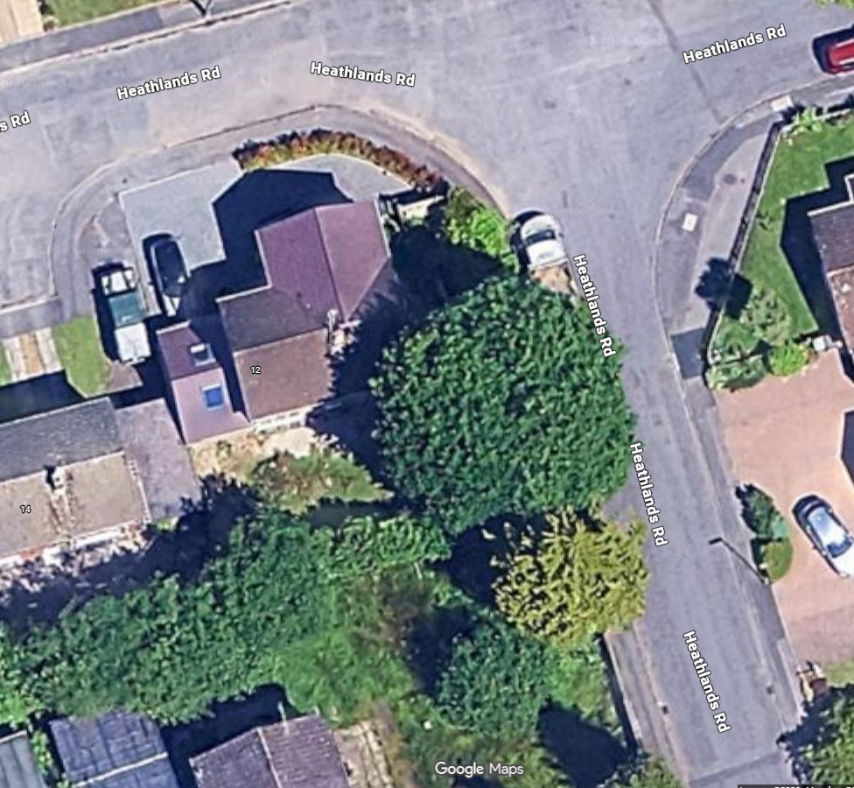
Oak tree TPO 288-E
The oak tree in garden of 12 Heathlands Road, Chandlers Ford SO53 1GW: TPO 288-E

