Design and Access Statement/Planning statement in respect of the proposed change of use of land Winchester Road, Fair Oak SO50 7HD to that of vehicular sales.
The following statement seeks to set out the rationale for the change of land to the north of a garden centre, Winchester Road, Fair Oak from that of open storage and commercial use to that of car sales.
Whilst the site is located in the countryside and thus therefore subject to relevant policies it was clearly subject to an approval for use as open parking in association with a garden centre since at least the early 1980s. More recently it has been used for open storage and has been subject to a variety of consents.
The site therefore comprises previously developed land and has a lawful use for storage purposes.
As such policy DM18 of the adopted local plan confirms the principle of development on site subject to criteria that seeks to ensure that there is no harm to character of the local area.
The application was preceded by a pre-application submission, which sought to establish the principle of development on site.
The following statement will therefore address issues raised by the LPA as well as setting out in detail the relevant planning history of the site; its policy context and the development proposals. It will therefore set out the reasons why the proposals are policy compliant and should be supported.
In support of the application it will be argued that the site is currently underutilised. The majority of the site has a storage use – with part of the site is currently being lawfully used for the storage of vehicles. It is clear that the majority of the site can be used for the additional storage of vehicles and in doing so will generate very low employment levels. Whilst there are some relatively small buildings on site, they currently generate only three jobs. The proposed use will have eleven. There will therefore be a significant increase in employment opportunities in the local area.
The proposed use seeks to provide a car sales operation on-site. Whilst this comprises a sui generis use it is clearly a use that will generate greater employment opportunities than both the existing use, to include vehicular storage. Future plans seek to include a vehicle repair workshop on site and thus there will be a wide range of employment opportunities generated with respect to the proposed use.
The application has been a local employer for a number of years. Initially the business started in 2012 in Fair Oak and this application provides the opportunity to return to the local area. All new employees will be local to the area of Fair Oak.
Site and surrounding area
The development site comprises a rectangular area of land located to the east of Winchester Road, Fair Oak and to the immediate north of a garden centre (and the site was formerly part of the garden centre) as identified in the following extract:
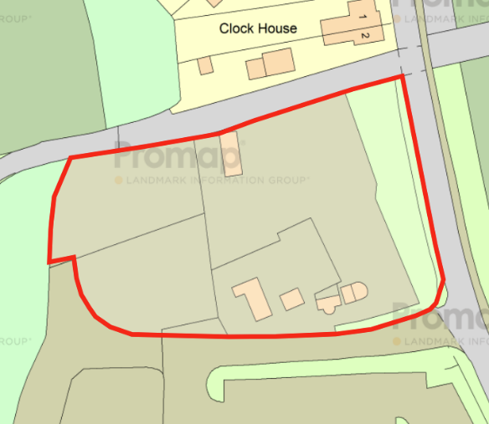
The site area is some 0.5 hectares.
The site in effect comprises four elements as set in the following plan and as follows;
- Hatched red – open storage yard, which is currently vacant.
- Hatched green – offices, and formerly associated with the open storage yard,
- Hatched blue – car storage
- Hatched yellow – additional parking and access to the site
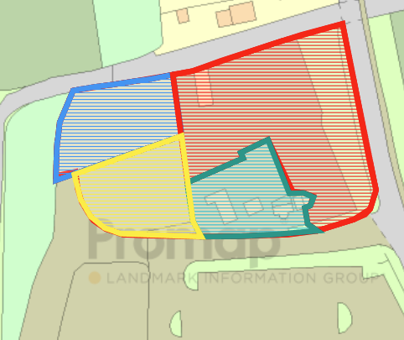
These areas are identified in the above plan and relevant for discussion of the planning history of the site.
The following aerial photograph of the site clearly shows that the site is an open brownfield site with the majority of it hardsurfaced:
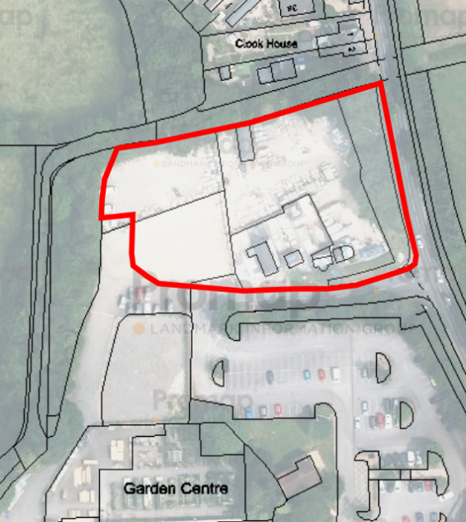
The site is very well screened by mature hedgerows and trees on its western (rear), northern boundaries and for much of its eastern boundary i.e. facing Winchester Road. There is a low hedge in the south-eastern corner of the site that provides some visibility of the site from Winchester Road. The site is predominantly laid to a hardsurface, whilst in the northern portion of the site contains gravel as per the following photographs of the site:
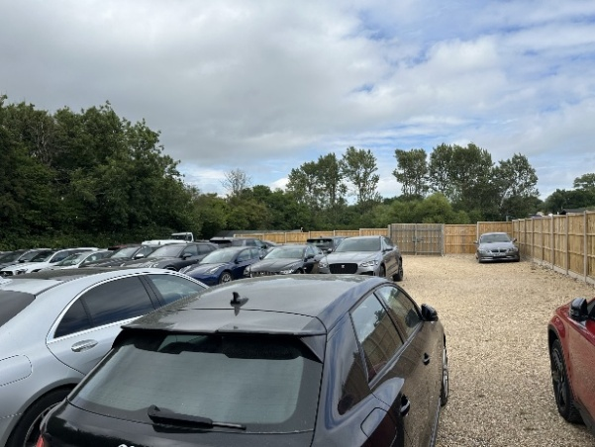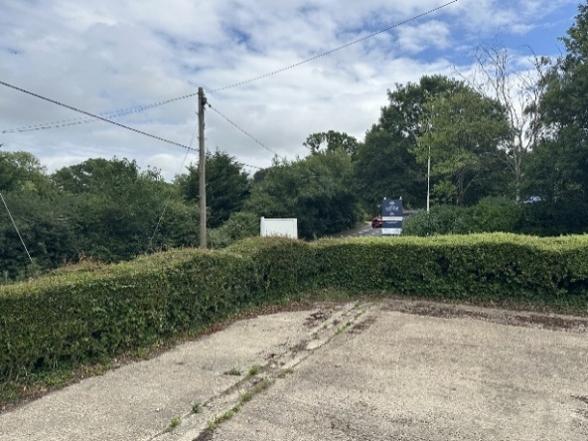
To the south the site has a largely open frontage to the garden centre and to the shared access to the site.
Winchester Road is busy link between Fair Oak and Winchester.
There are local level changes on Winchester Road – the land falls towards the north. However, the land on the site appears to be built up as it is largely flat.
Policy Advice
National advice - Section 38(6) of the Planning and Compulsory Purchases Act 2004 and section 70(2) of the Town and Country Planning Act 1990 require that applications for planning permission be determined in accordable with the development plan unless material considerations indicate otherwise.
Reference is drawn to the National Planning Policy Framework (2024), which sets out
Paragraph 2 of the NPPF states the following:
Planning law requires that applications for planning permission be determined in accordance with the development plan, unless material considerations indicate otherwise. The National Planning Policy Framework must be taken into account in preparing the development plan and is a material consideration in planning decisions.
Paragraphs 7 and 8 refer to the requirement to achieve sustainable development:
7. The purpose of the planning system is to contribute to the achievement of sustainable development, including the provision of homes, commercial development and supporting infrastructure in a sustainable manner. At a very high level, the objective of sustainable development can be summarised as meeting the needs of the present without compromising the ability of future generations to meet their own needs.
8.Achieving sustainable development means that the planning system has three overarching objectives, which are interdependent and need to be pursued in mutually supportive ways (so that opportunities can be taken to secure net gains across each of the different objectives):
a) an economic objective – to help build a strong, responsive and competitive economy, by ensuring that sufficient land of the right types is available in the right places and at the right time to support growth, innovation and improved productivity; and by identifying and coordinating the provision of infrastructure;
b) a social objective – to support strong, vibrant and healthy communities, by ensuring that a sufficient number and range of homes can be provided to meet the needs of present and future generations; and by fostering well-designed, beautiful and safe places, with accessible services and open spaces that reflect current and future needs and support communities’ health, social and cultural well-being; and
c) an environmental objective – to protect and enhance our natural, built and historic environment; including making effective use of land, improving biodiversity, using natural resources prudently, minimising waste and pollution, and mitigating and adapting to climate change, including moving to a low carbon economy.
Paragraph 48 reinforces the requirement to determine planning applications in accordance with the development plan unless material considerations indicate otherwise:
48. Planning law requires that applications for planning permission be determined in accordance with the development plan, unless material considerations indicate otherwise.
Paragraph 56 refers to the use of planning conditions to make an otherwise unacceptable scheme acceptable:
56. Local planning authorities should consider whether otherwise unacceptable development could be made acceptable through the use of conditions or planning obligations.
Section 6 of the NPPF refers to Building a strong, competitive economy:
85. Planning policies and decisions should help create the conditions in which businesses can invest, expand and adapt. Significant weight should be placed on the need to support economic growth and productivity, taking into account both local business needs and wider opportunities for development. The approach taken should allow each area to build on its strengths, counter any weaknesses and address the challenges of the future. This is particularly important where Britain can be a global leader in driving innovation, and in areas with high levels of productivity, which should be able to capitalise on their performance and potential.

Paragraph 88 seeks to support a prosperous rural economy:
88. Planning policies and decisions should enable:
Paragraph 89 seeks to support businesses in rural areas:
Planning policies and decisions should recognise that sites to meet local business and community needs in rural areas may have to be found adjacent to or beyond existing settlements, and in locations that are not well served by public transport. In these circumstances it will be important to ensure that development is sensitive to its surroundings, does not have an unacceptable impact on local roads and exploits any opportunities to make a location more sustainable (for example by improving the scope for access on foot, by cycling or by public transport). The use of previously developed land, and sites that are physically well-related to existing settlements, should be encouraged where suitable opportunities exist.
Annex 2 of the NPPF sets out the definition of previously developed land
Previously developed land
Land which has been lawfully developed and is or was occupied by a permanent structure and any fixed surface infrastructure associated with it, including the curtilage of the developed land (although it should not be assumed that the whole of the curtilage should be developed). It also includes land comprising large areas of fixed surface infrastructure such as large areas of hardstanding which have been lawfully developed. Previously developed land excludes: land that is or was last occupied by agricultural or forestry buildings; land that has been developed for minerals extraction or waste disposal by landfill, where provision for restoration has been made through development management procedures; land in built-up areas such as residential gardens, parks, recreation grounds and allotments; and land that was previously developed but where the remains of the permanent structure or fixed surface structure have blended into the landscape.

Local plan - the adopted local plan is the Eastleigh Borough Local Plan 2016-2036. The site is identified as being located in the countryside as per the following extract:
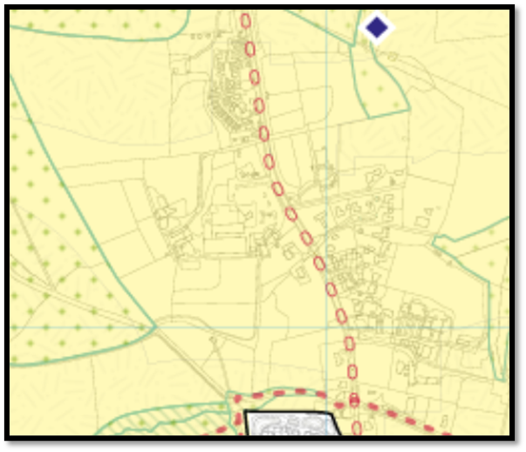
Strategic policy S1, Delivering sustainable development
1. To be sustainable, new development in the Borough should:
c. maintain and help to grow a high-performing local economy that benefits the Borough, south Hampshire and the wider economy, without adverse impact on south Hampshire’s city, town and other centres, the quality of the local environment or local transport networks;…
Policy SP4 seeks refers to employment provision. It provides for provision B2, B8 and E(g) uses and other employment generating uses as follows;
Strategic policy S4, Employment provision
1. To contribute towards sustainable economic growth, provision will be made for additional floorspace for uses in the B2, B8 and E(g) use classes and other employment-generating uses through:
d. new employment development within the urban edge and by the re-use and/or redevelopment of buildings in the countryside (policies DM18 and DM19, Chapter 5);
Strategic policy S5, New development in the countryside
1. Planning permission will be granted for new development in the countryside provided it is related to:
a. the provision of employment through agricultural development (policy DM17), the extension and replacement of existing employment uses (policy DM18) and the re-use of existing buildings (policy DM19);
b. residential extensions and replacement buildings (policies DM18 and 26), limited residential conversions (policy DM19), rural workers’ dwellings (policy DM27) and accommodation for Gypsies, Travellers and Travelling Showpeople (policy DM31);
2. In permitting new development in the countryside the Borough Council will seek to:
a. avoid adverse impacts on the rural, woodland, riparian or coastal character, the intrinsic character of the landscape including the avoidance of adverse landscape impacts on areas adjoining national parks and their settings, the significance of heritage assets and on the biodiversity of the area;
b. secure long-term beneficial management practices that will enhance the landscape and biodiversity of the countryside and coast;
c. avoid sterilisation of mineral resources, in accordance with the Hampshire Minerals and Waste Plan;
d. safeguard the best and most versatile agricultural land unless the benefit of the development clearly outweighs the loss; and
e. protect soils during construction wherever possible in line with the ‘Defra code of practice for the sustainable use of soils on construction sites’.
Policy DM1 seeks to set out general criteria for new development:
Policy DM1, General criteria for new development
1. All new development should (as relevant):
a. not have an unacceptable impact on, and where possible should enhance:
i. residential amenities of both new and existing residents; the character and appearance of urban areas, the countryside and the coast;
ii. biodiversity (avoiding significant adverse impacts); and
iii. the significance of heritage assets;
b. make efficient use of the site, maximise opportunities to increase density and have regard to potential development opportunities on adjoining land;
c. take full and proper account of the context of the site including the character, appearance and land uses of the locality or neighbourhood, and be compatible with adjoining uses and be well integrated with these in terms of mass, scale, materials, layout, density, design and siting, both in itself and in relation to adjoining buildings, spaces and views. Where adjoining development is poor in urban design terms, new development should contribute to improving the character of the area;
d. not involve the loss of or damage to trees, woodlands, hedgerows, ponds, priority habitats or other landscape features of value to the character of the area, for appearance or biodiversity unless they can be replaced with features of equivalent or enhanced value, (recognising that some species and habitats may be irreplaceable);
e. include a landscape scheme covering the design and layout of external space;…
g. provide satisfactory management arrangements for all landscape, green infrastructure and biodiversity enhancement;
Policy DM8, Pollution
1. Development will not be permitted if it is likely to cause loss of amenity or impact on public health or other unacceptable environmental impacts through:
a. air pollution (including odours or particulate emissions);
b. pollution of surface, underground, coastal waters or other watercourses;
c. noise or vibration
d. light intrusion, both generally and with respect to the South Downs National Park’s status as an International Dark Night Skies reserve;
e. or land contamination.
2. Development susceptible to particular forms of pollution will not be permitted:
a. where it will be adversely affected by such pollution, unless measures can be taken that adequately mitigate the polluting effects; or
b. where it would inhibit existing economic or other activities giving rise to acceptable polluting effects.
3. Where a development site is known or suspected to be contaminated, before the site is developed the Borough Council will require the contamination to be remediated to a standard where as a minimum it cannot be defined as ‘contaminated land’ under Part IIA of the Environmental Protection Act 1990.
Policy DM15 refers to safeguarding existing employment sites
Policy DM15, Safeguarding existing employment sites
1. The major existing employment sites as identified on the policies map shall be retained predominantly in employment use classes B2, B8 and E(g). Within these sites the Borough Council will permit:
a. the redevelopment and intensification of use of sites for Use Class B2, B8 and E(g)(ii)/(iii) employment uses;
b. changes of use between use classes B2, B8 and E(g)(ii)/(iii); and
c. workforce training opportunities as defined in policy DM16 below;
subject to the general development criteria and transport policies of this Local Plan including the impact on residential areas.
2. Exceptionally, employment uses other than those in use classes B2, B8 or E(g)(ii)/(iii) (but not E(a)/ (b)/(c) uses or pubs, drinking establishments or hot food takeaways) may be permitted on these sites provided that:
a. they would not have a significant impact on the continued primary use of the site
b. the existing site is causing, or could cause, significant harm to highway safety or to the amenities of the area or to local residents
3. The redevelopment or change of use of other existing employment sites not identified on the policies map currently in class B2, B8 or E(g)(ii)/(iii) uses to non-employment uses, where this is not permitted development, will be permitted provided that it can be demonstrated that the site is no longer in demand for employment use and that criteria a. and b. above are satisfied.
Policy DM18 refers to non-residential buildings in the countryside:
Policy DM18, Extension and replacement of non-residential buildings in the countryside
1. The extension or replacement of non-residential buildings in the countryside will be permitted, subject to the general development criteria and transport policies of this Local Plan and provided that:
a. the existing building is in lawful use and is not subject to a temporary permission;
b. the extension or replacement building is for a non-residential use;
c. the extension or replacement building would not have an urbanising effect on the countryside in terms of its density, scale, massing, layout and height;
d. access, car parking, landscaping and services can be provided without having a detrimental impact on the character of the countryside;
e. so far as possible the property is sustainably located in terms of accessibility by means of transport other than the private car;
f. the extended building or its replacement would be located within the existing curtilage unless its relocation or extension would contribute to improving the character and quality of the local area;
g. in the case of a replacement building, the proposal also includes the demolition of the building to be replaced; and
h. the development would not by itself or cumulatively with other recently permitted schemes undermine the Council’s strategy for the development of employment-related floorspace (see strategic policy S4).
Planning history
There have been three relevant planning applications on site that clearly establish the site is a brownfield commercial site with an authorised use for open storage and business uses. These commercial uses have prompted a pre-application submission in respect of the proposed car sales use.
Planning applications - the site was formerly part of the garden centre located to the south of the site and was part of its car parking area. The site then has fragmented over the years into various storage uses, as per the following;
- Application no. 13732/7 – use of land as garden centre – to regularise the existing use at Beech Farm Nurseries, Crowd Hill, Fair Oak. Conditionally approved 11th February 1982.

The plan accompanying the application includes the whole of the application site, which is designated as a car park.
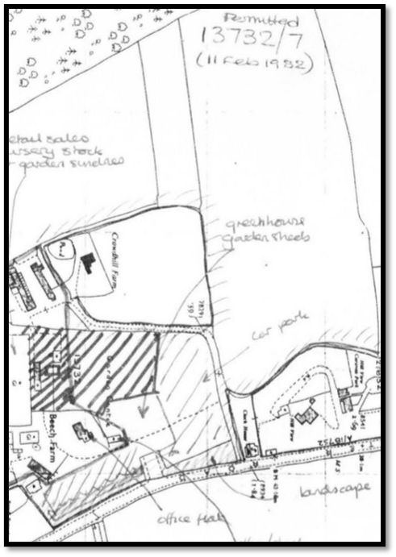
The above plan confirms that the site, in 1982, was a brownfield site.
- Application no. LDC/24/97577 – Silverstone Stone Limited, Garden Centre, Winchester Road, Fair Oak, SO50 7HD Application for Existing Lawful Development: Use of land and building for mixed use for storage, sales and distribution purposes between 07:30-17:30 Monday to Friday and 09:00-16:00 Saturday and Sunday. Approved 12th June 2024.
This consent covered part of the application site (i.e. the area hatched red on the earlier plan), as per the following extract:
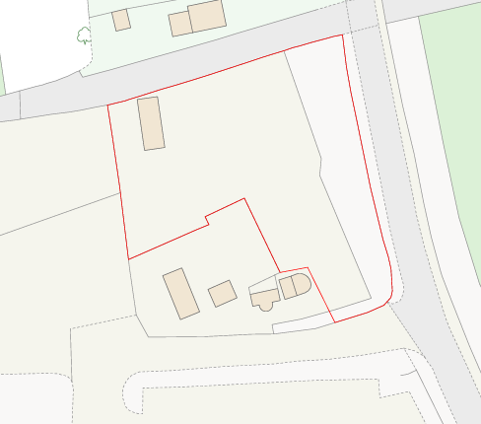
Included with the application is a valuation report, dated 2001, are a number of photographs taken from the highway that also show the presence of the buildings within the site (i.e. the area hatched yellow in the earlier image). These buildings and this part of the site were occupied by a conservatory manufacture business:
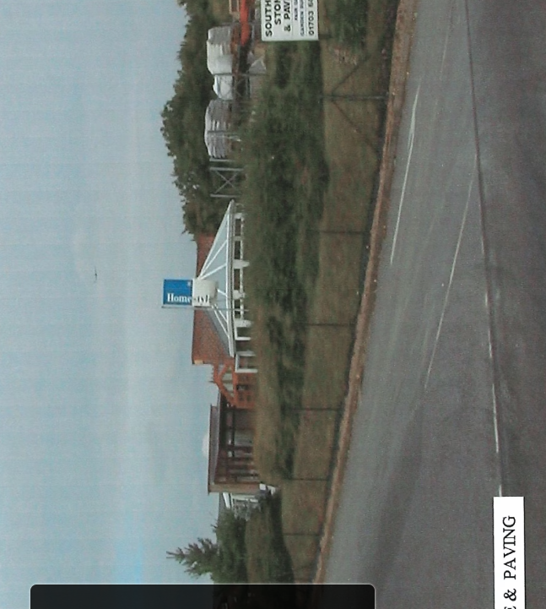
Reference to Google Streetview confirms the presence of the conservatory on-site in November 2008 as per the following extract:
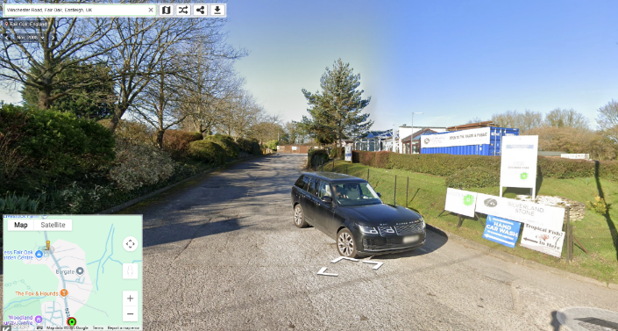
- Application no. LDC/24/98520 – Garden Centre, Winchester Road, Fair Oak, SO50 7HD, Lawful Development Certificate for Existing Use: Open Storage. Approved 4th February 2025.
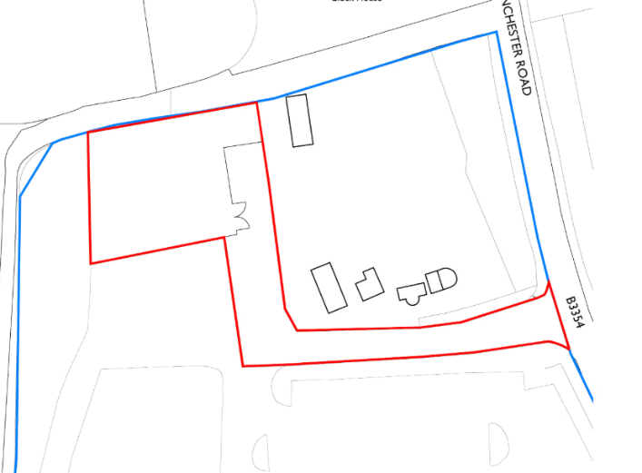
Included in the application is an aerial photgraph of the site, dated 1997, that clearly shows the whole of the site occupied as a brownfield site;
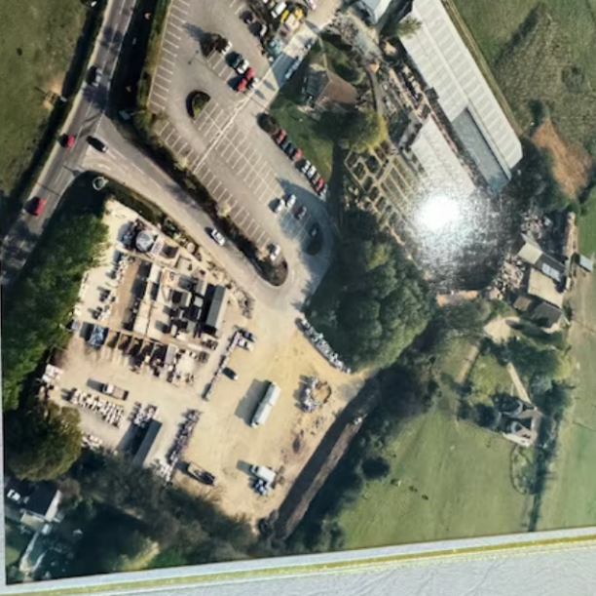

Pre-application submission – the advice was sought on 5th July 2025 in respect of the change of use of the site to car sales. The submission was based on the following plan:

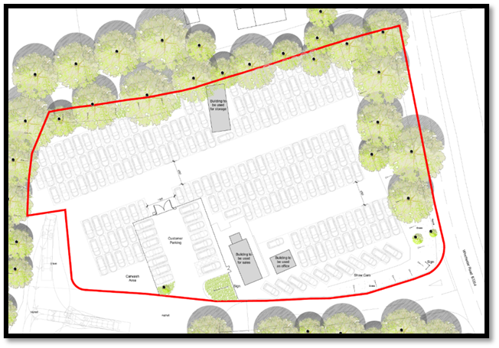

The LPA response was received on the 14th July and made the following points:

- Policy DM15 allows for the change of use of the unallocated employment sites where it can be demonstrated that the site is no longer in demand for employment uses – this should be supported by evidence of active marketing demonstrating that the site is no longer required for employment purposes.
- A comparison of the proposed and existing employment levels should be provided.
- If should be demonstrated that the proposed use will not comprise highway safety, local amenities or neighbouring residential amenities.
- It is likely that there will be no requirement to provide for Biodiversity Net Gain (BNG) on site
- The following supporting information should be provided
  - Details showing security fencing, gates, external lighting, drainage, CCTV and associated signage and audible warning systems
  - Drainage strategy
  - Land contamination
  - Dust management plan
  - Highways statement/turning plan
  - Tree survey

Proposed development
The proposed development seeks to change the use of the site to that of car sales, as per the following extract:
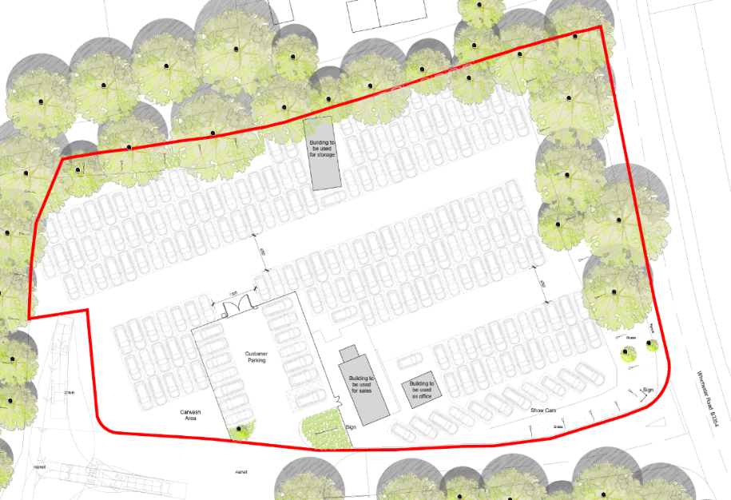
The various elements of the proposed development are as follows:
- Use of the existing shared access from Winchester Road – no new access is formed
- Separate distinct car parking area for customer vehicles (from the shared access) providing 14 car parking spaces.
- Separate access into the site for the delivery of vehicles for sale. Any vehicles delivered to the site will be delivered individually and not be delivered by HGV’s. However, it should be noted that the adjacent garden centre has regular HGV deliveries to the site and will continue to do so. The site plan shows that a turning space for such vehicles can be accommodated on site and that the proposed development will not prejudice such an access.
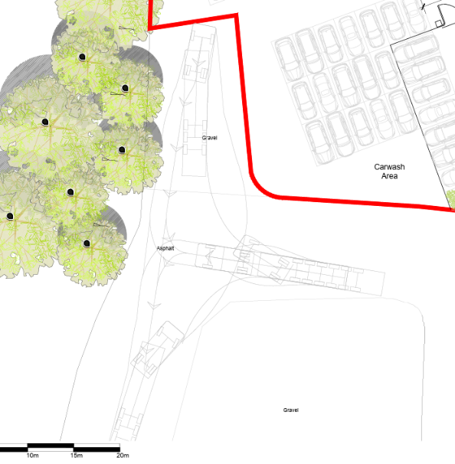
- The retention of three buildings on site for sales, storage and as an office.
- On-site parking for vehicles for sale.
- Signage will be as shown on the site plan and focussed on the site frontage. CCTV cameras will be affixed to existing buildings. There is no intention to provide such cameras on separate poles/structures.
There are no additional buildings to be provided on-site and it is intended that the surfacing will comprise gravel.
The application is supported by the following:
Land contamination report – which confirms that there is a low risk of contamination.
Tree report – confirming that there is no impact on either on-site or off site trees.
Analysis
It is argued that the site is policy compliant and will not create harm to the wider area.
The LPA response to the pre-application submission focusses on the principle of development, with specific concern with regard to the potential loss of employment provision. In particular the LPA note that car sales can contribute to employment and local economic activity, but they fall outside the definition of traditional employment use classes – hence the requirement for a marketing report.
The application is not supported a marketing report. However, it is clear that the rationale in respect of policy DM13 is to protect and enhance employment opportunities. Within this context it should be noted that the site currently is underutilised. It is primarily used to store cars, with few associated employment opportunities. Such storage is clearly consistent with the authorised use of the site and can lawfully continue.
In that context it is clear that B8 storage and distribution uses are increasingly less reliant on site employment opportunities. In this sense the site will be under utilised and will make little contribution to the social and economic fabric of the local area.
Within this context whilst a vehicle sales use is identified as a sui generis use in planning terms that does not mean that it is not an employment generating use and in this instance it has been demonstrated that the proposed use will not only generate new jobs it will also clearly generate more jobs than currently provided on-site.
At the present time the site comprises a low key use and has three employees.
The proposed use will have a total of eleven employees, comprising the following:
- Sales staff – five
- Cleaners/valet staff – two (no need for washing facilities on-site)
- Ancillary staff (drivers) – two
- Office staff/admin – two
The proposed development therefore seeks to provide increased employment levels on site as well as a wide of employment opportunities, to include office staff, cleaners and sales staff.
The LPA response refers to policy advice – both policy S4 and DM15.
Policy S4 refers to the need to support B2, B8 and E(g) use classes and other employment-generating uses, whilst DM15 refers to need to protect the redevelopment or change of use of other existing employment sites not identified on the policies map currently in class B2, B8 or E(g)(ii)/(iii) uses to non-employment uses.
It is clear that the proposed use will generate significant employment opportunities – to allow the proposed change of use will therefore be consistent with both policy S4 in that it is an example of an employment generating use and also that of policy DM15 in that the proposed change of use will not be to a non-employment use.
Whilst it is acknowledged that the site is located in the countryside it is clear that the site is a brownfield site and comprises previously developed land. As such LPA policy advice in the form of DM18 is particularly relevant not least as it allows for the principle of development on such sites, subject a variety of criteria. Addressing these in turn:
a. the existing building is in lawful use and is not subject to a temporary permission – the use of the site is well-established and subject to a variety of consents dating back to at least 1981. Whilst there have been subsequent applications it is clear that the use of the whole site at that date was for vehicular parking ancillary to the garden centre.
b. the extension or replacement building is for a non-residential use – there are no residential uses proposed on-site
c. the extension or replacement building would not have an urbanising effect on the countryside in terms of its density, scale, massing, layout and height – part of the site is lawfully used for the storage of cars the remainder of the site has a B8 storage and E commercial use. The proposals essentially comprise a change of use of the land. Operational development associated with the proposed development comprises the removal of some buildings, the provision of a gravel surface and the provision of replacement fencing where appropriate. There will be no additional urbanising as a result of the proposed development
d. access, car parking, landscaping and services can be provided without having a detrimental impact on the character of the countryside - the existing access (i.e. shared with the garden centre) will be retained. Due to the existing use of the site and the context of neighbouring properties to include the adjoining garden centre located on a busy road the immediate area is in effect urbanised. There will be no harm to the character of countryside as a result of the proposed development.
e. so far as possible the property is sustainably located in terms of accessibility by means of transport other than the private car – the site is located on a busy road with decent local bus links. However, not least as the proposed use is one that will sell cars there will inevitably be vehicular movements. It should be noted that with the rise of internet that provides the opportunity for purchasers to view vehicles, and their service history on-line, that prospective purchasers now typically tend to visit car sales sites only when they have found the appropriate car. Vehicular movements are likely to be minimal and significantly less than those visiting the garden centre – the application anticipates that there will be 10-15 customers visiting the site on a typical day (i.e. two per hour), whereas the garden centre has in excess of 1,000.
f. the extended building or its replacement would be located within the existing curtilage unless its relocation or extension would contribute to improving the character and quality of the local area - the use of the site is contained with the established planning unit
g. in the case of a replacement building, the proposal also includes the demolition of the building to be replaced – no new buildings are proposed
h. the development would not by itself or cumulatively with other recently permitted schemes undermine the Council’s strategy for the development of employment-related floorspace (see strategic policy S4) – it is clear that the proposed development will not undermine the LPA’s employment strategy.
It is therefore argued that the proposed development is in accordance with Policies S4, DM15 and DM18. It is also compliant with the other policies of the Local Plan;
- Policy S1 seeks to help and support local the local economy – which will be achieved here.
- Policy S5 supports development in the countryside where it comprises the replacement of an existing use (in conjunction with policy DM18). The proposals seek to use an existing brownfield site.
- DM1 – seeks high quality development. This is achieved by creating no harm to neighbouring residential properties; creating no impact on biodiversity; it takes account of the local area and creates no harm to retained trees or hedgerows and
- DM8 – the proposals will not create any pollution.
The proposals will make an efficient use of land and create employment opportunities. It comprises sustainable development and be compliant with the principles of the NPPF.

