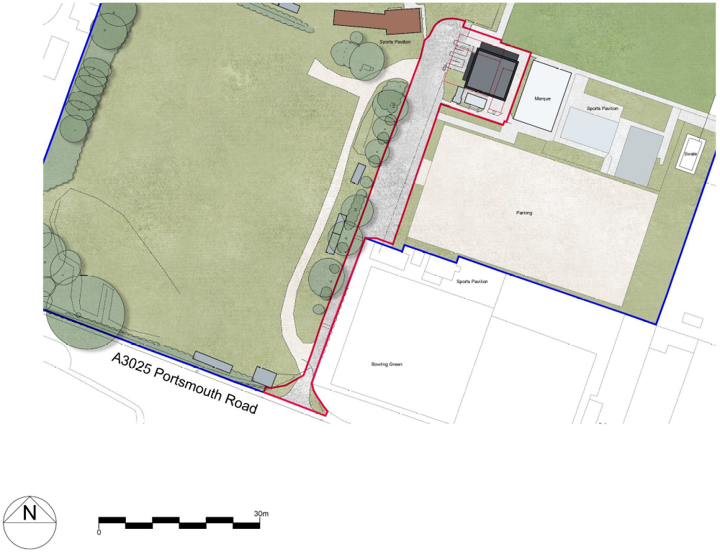
Construction compound
Small Vehicle
parking
Large Vehicle
parking

