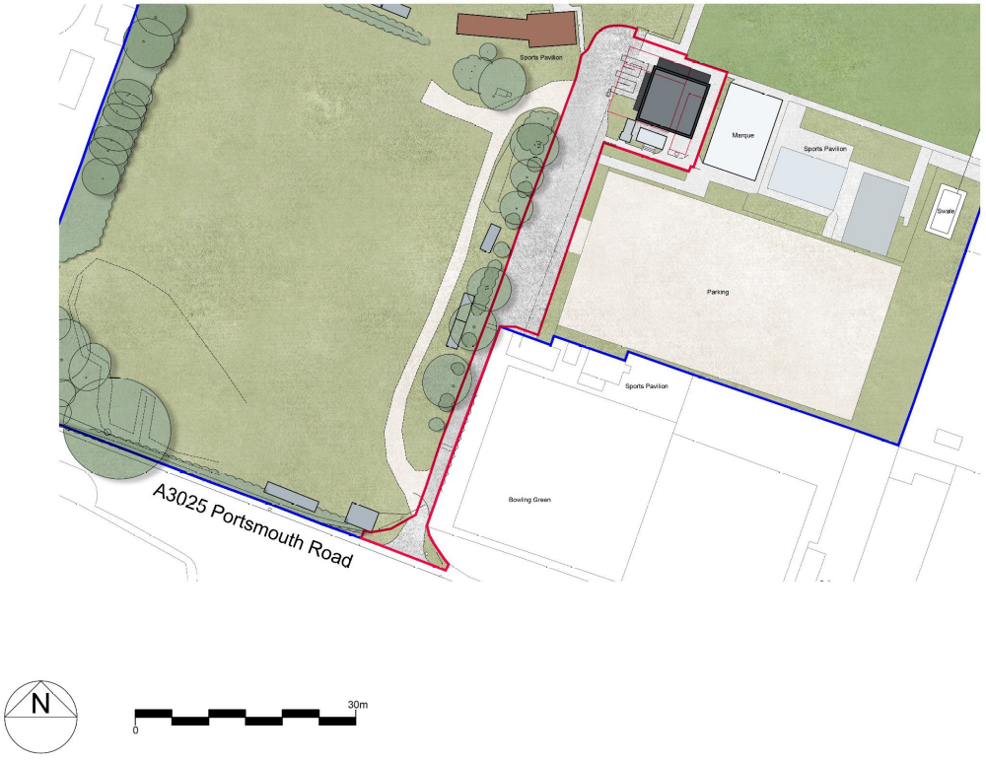
Exit Signage
Entry Signage
Access
Egress

