Bishopstoke is a village and civil parish in the Eastleigh district of Hampshire, England. It is recorded as "Stoke" as early as 948 AD when King Eadred granted land there to a thegn called Aelfric. Stoke later came into the possession of the Bishops of Winchester, giving rise to the modern name. Meller House, located on Church Road in west Bishopstoke, was originally a walled garden for ‘Spring Grove’; a historic location with various connections to the area’s past, including its relationship with the London and Southwestern Railway. The area was developed to house railway workers, and road names in Bishopstoke reflect this connection. The walled garden can be seen in this Ordnance Survey published in 1872, surveyed between 1867 to 1868. (left) and in this Ordinance Survey map published in 1909 with a greenhouse (right).
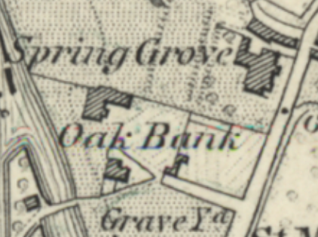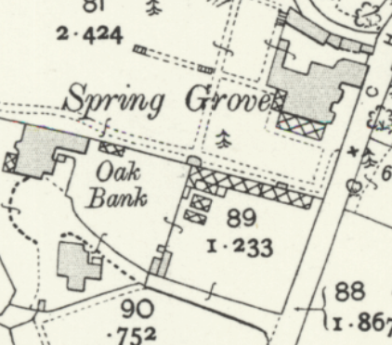
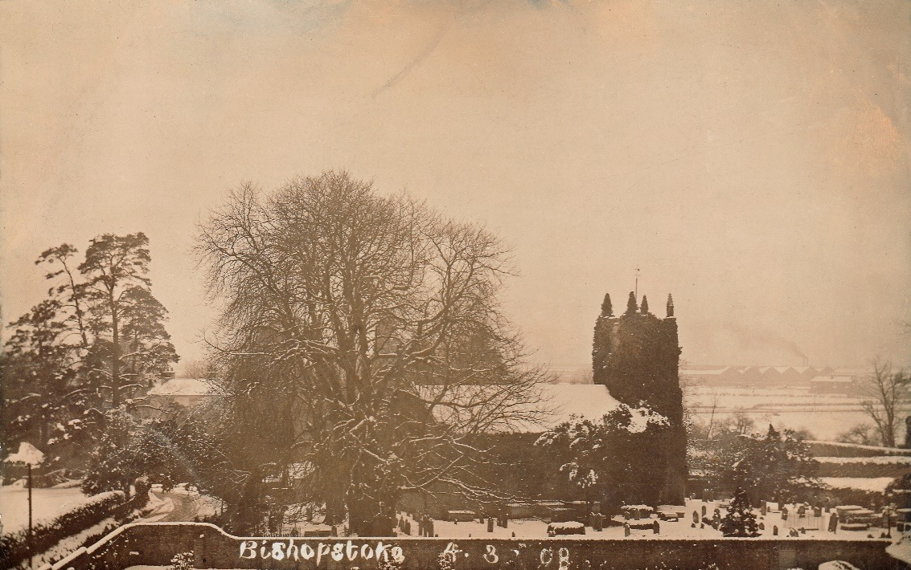
This picture was taken from ‘Spring Grove’ in 1908, showing the high brick wall that enclosed the property grounds. This separated Spring Grove from the road that led to Oakbank, and the church yard in which the 1825 St. Mary’s Church resided.
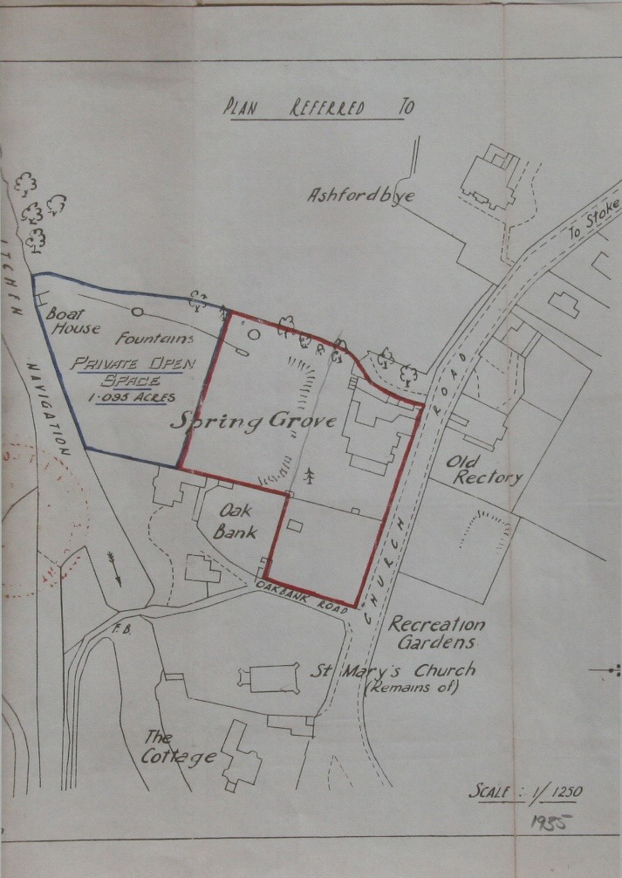
In 1936, Oakbank and (later) Spring Grove was purchased by Frank Dibben.
Oakbank and the gardens of Spring Grove were purchased by Dr Mellor and his wife in 1951. They sold the old Spring Grove House site in 1961 to be developed into what is now know as Church Close. The gardens of Spring Grove were integrated with those of Oakbank. The photograph below shows a similar view to the 1908 photograph, in which the high wall, separating the property from Oakbank Road, and the old church can be seen.

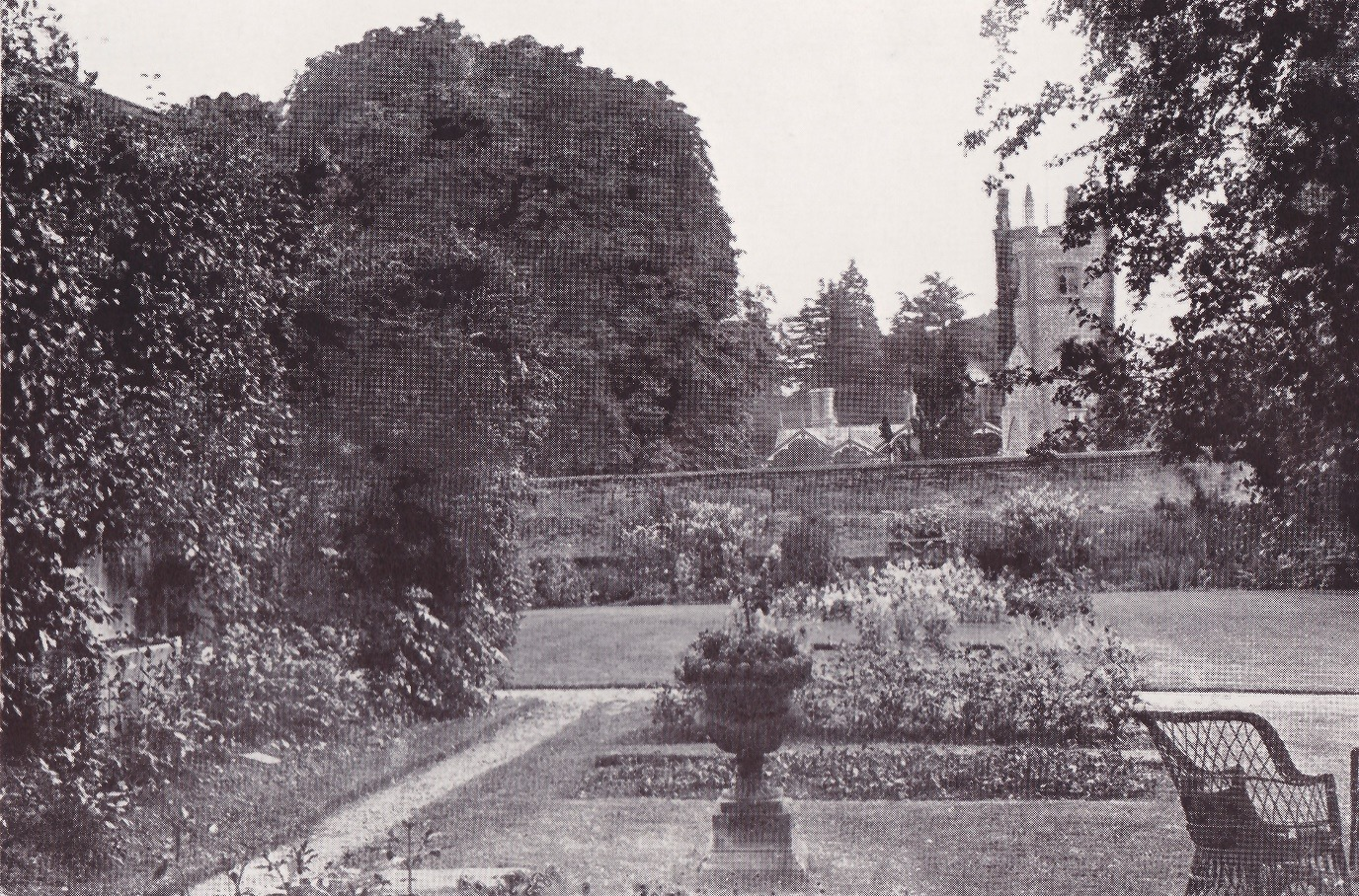

On the 24th of September 1974, the Duke of Gloucester, on behalf of the Hampshire Old People’s Housing Society opened Mellor House, a 19 flat retirement complex in what had been part of the garden of Oakgrove, the land being provided due to the generosity of Mrs Mellor and named in memory of her husband. 