
Ian Knight Consulting Ltd t/a Knight
Consulting First floor, 7 The Quarterdeck Port Solent, Portsmouth
Hampshire PO6 4TP

Tel: 01489 660194
Web: www.knight-consulting.co.uk

Design and Access Statement

Meller House, Bishopstoke, SO50 6HF

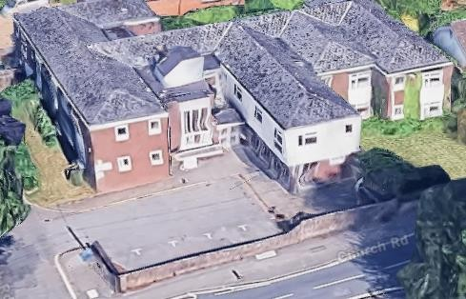

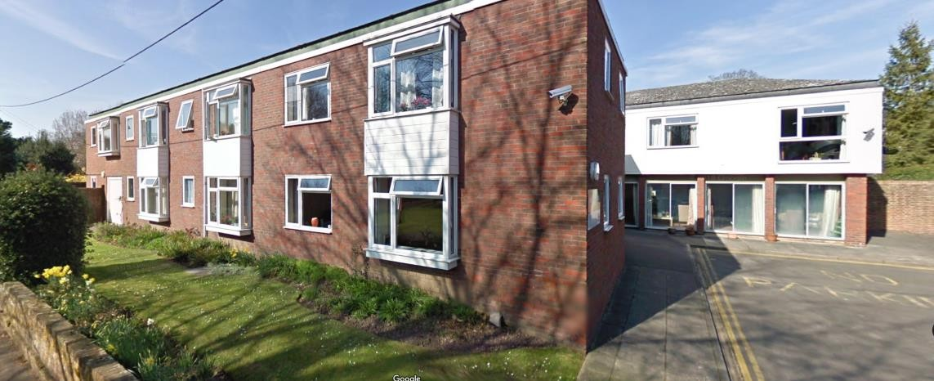

This Design and Access Statement is submitted in support of proposed external alterations at Meller House, Bishopstoke, SO50 6HF.

The proposal involves updating the building through the installation of several new doors and windows across both the ground and first floor. A new bin and cycle compound is proposed at the northmost Church Road access points. We propose to increase to 15 parking spaces (14 to the general open plan area, of which 5 existed) and the southern wing will be partially reduced in size.

External improvements also include the installation of fencing/gates in 1.2m estate railing style (black) to give demarcation without a sense of enclosure, while the internal layout of the first floor will benefit from the addition of tubular roof lights which have been added in the recent re-roofing exercise.

Regarding ecological considerations, the existing roof has recently been fully replaced; as such, there is no potential for bats to be present as none of the original roof structures exist. As can be seen in the photo below.

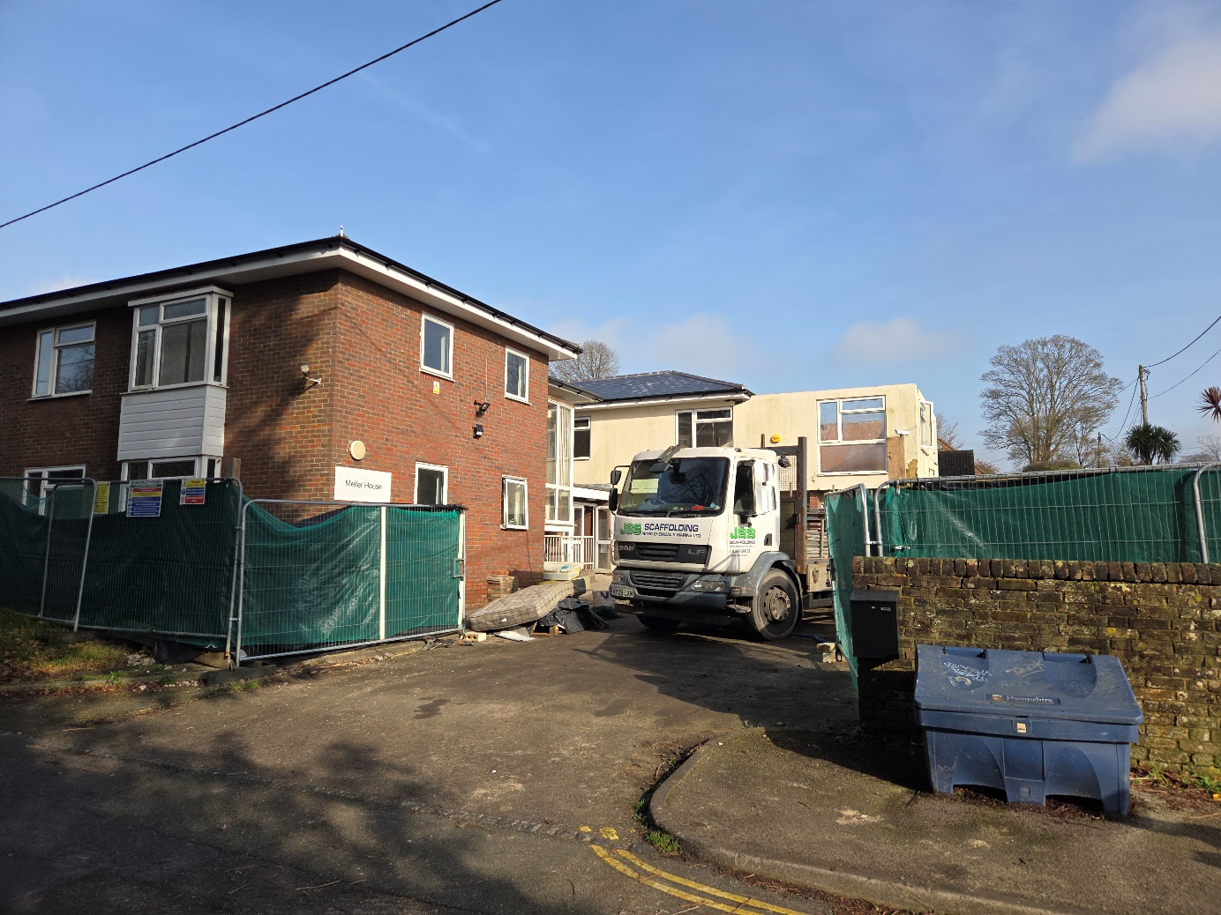

With regards to Great Crested Newts (identified Green/Amber risk by the P.E.A (attached). A DLL (district level license) has been applied for and the required fee paid by the applicant and a below ground retaining wall has already been completed to protect the historic boundary masonry wall – where ground levels differ at the pavement. From a BNG perspective, we understand the Planning Act 2025 has moved the de minimis threshold to 0.2ha – exempting our site.

Presently there is one window at first floor in the north flank wall which faces No.3 Church
Road. We propose a second new window but with obscured glass below 1.5m above floor level and a restricted opener to preserve the private amenity for No.3. All new windows and doors in white UPVC to match existing. The ground floor box bay windows we propose to replace with new French doors to provide access to individual private amenity spaces.

Regarding drainage we propose:
- The main building presently has a number of RWP positions that work with existing soakaways. This is unchanged.
- One exception is the proposed reduced wing – with a new RWP discharging to a 2m3 new soakaway (5m from building). This is to standard crated/geotex design.
- Note, the percolation rate on site is excellent (free draining gravel)
- Where the proposed extended carpark surface meets the existing – a full width linear slot drain is proposed (linked to the above soakaway).
- The proposed car park surface is permeable block paving
- There will therefore be zero additional surface water discharged from site.

