Ampfield Commercial Limited – Meller House, Bishopstoke SO50 6HF
Design & Access statement, with BNG, Nutrient, Heritage and Highway details

Located on the corner of Church Road and Oakbank Road, Bishopstoke, until 2024, Meller House was a semi-sheltered housing association site with 20 dwellings but more precisely, contained a 17m2 visitor bedroom, two 1bed flats, one 2bed manager flat (with offices) and seventeen bedsits (at 30m2 each). In addition, there was a laundry area and common room/kitchen along with various landlord stores. The entire internal gross area is 1208m2 (with non-dwelling accounting for 535m2 of that). The total site is 1532m2 and presently there are six parking spaces and shared grounds. Bins are at the rear corner facing Oakbank Road.
This is a resubmission following refusal of the initial application. All the points that previously caused concern have now been fully addressed.
Our client purchased the site late 2024. The proposal here is to convert the accommodation down from 21 to 15 units by merging some of the studios and amalgamating other spaces. The new accommodation would consist of four unchanged studios, two unchanged 1bed, two new 1bed, four new 2bed and three new 3bed. Nine dwellings therefore are created out of existing dwellings. Ten of the dwellings will now have external private amenity. A new bin & cycle compound is proposed near one of the Church Road access points and the parking is proposed to be increased to 14 to avoid offsite spillage. This requires a slight reduction in footprint (reduced by 35m2) and 115m2 of sloping lawn would be replaced with block paving and a retaining wall (to preserve the stone perimeter wall). In compensation, 55m of new hedgerow will be planted to all new private amenity boundaries.
Externally, the building had lacked appeal, and one key enhancement carried out was to add a new eave/soffit detail (in white UPVC) and replace the roof. Previously the roof had an aged, reconstituted slate covering which had reached the end of its natural life and we replaced with Cedral Thrutone in blue/black. The fibre cement slate present bay windows also are proposed to be dropped to French doors (for residents to access their private amenity). 1.2m estate railing style fencing (black) will give demarcation without a sense of enclosure – each private amenity area with new planting meeting the BNG requirement. However, to further enhance, housing for bats, swifts, sparrows, tits and bee/insects (one of each to the west, south & east elevations). Presently there is one window at first floor in the north flank wall which faces No.3 Church Road. We propose a second new window but with obscured glass below 1.5m above floor level and a restricted opener to preserve the private amenity for No.3. All new windows and doors in white UPVC to match existing.
The site qualifies for BNG Small Site Metrics, and the calculator is attached.
With the proposed move from 5 to 14 parking spaces and with secure cycle storage facilities all leading to deintensification of highway impact than present and with public transport directly outside the site, the train station within 10minutes walk and retail, employment, education and health facilities all in walking distance – along with public open space and play areas, the location is ideal for residential use and is a highly sustainable position.
We propose 240l of waste for multi person units and 120l for single occupancy (plus the same for recycling) and therefore have provided for 7No. 1100l Eurobins in the screened top of site adjacent to the pavement entrance although a private collection company would be used to aide management. Submitted plans detail the bin & bike areas
The proposed development incorporates a sustainable surface water management strategy designed to manage runoff at the source. Surface water from the roof area will be collected via a new Rainwater Pipe (RWP), while runoff from the hardstanding will be intercepted by a linear slot drain to prevent uncontrolled surface flow. These components will discharge into a dedicated 2m³ underground soakaway.

The site is within the Bishopstoke Conservation Area, so the mission to preserve and enhance has been met as proposed above with a tidying of the roofline and sensitive garden demarcation. The Victorian boundary walls are to be repaired and modified where proposed using site reclaimed bricks and lime mortar.
With a net reduction in dwelling numbers, we suggest this deintensification along with the opportunity to introduce water saving measures with lowered flow for cisterns, taps, showers etc – we’d present this scheme as a non-nutrient intensifier and we trust, in your competent authority status, you see no added risk to the environment after wastewater treatment. Please note however, we have used the only available supplied calculator which does not make provision for a de-intensified site and therefore provides an erroneous calculation given that the original scheme had 21 dwellings, 6 have been removed, 6 have been formed out of the remainder so the new provision of 15 dwellings only includes 9 through conversion (conjoining).
The scheme is not CIL payable with lawful use of the site for more than 6 of the previous 36 months.
We believe moving this site from vacant to a mixed new community including family units – will bring a building to life and enhance the wider community and we trust therefore this application be seen as a limited impact and ‘minor’ in nature. The new dwellings formed exceed the national prescribed space standards and the converted and refurbished dwellings will all receive upgrades that will exceed the building regulations, with quality accommodation delivering rentable units for those unable to get on the first rung of the housing ladder.

Photographic evidence for setting and context
This shows the building prior to recent reroofing works:
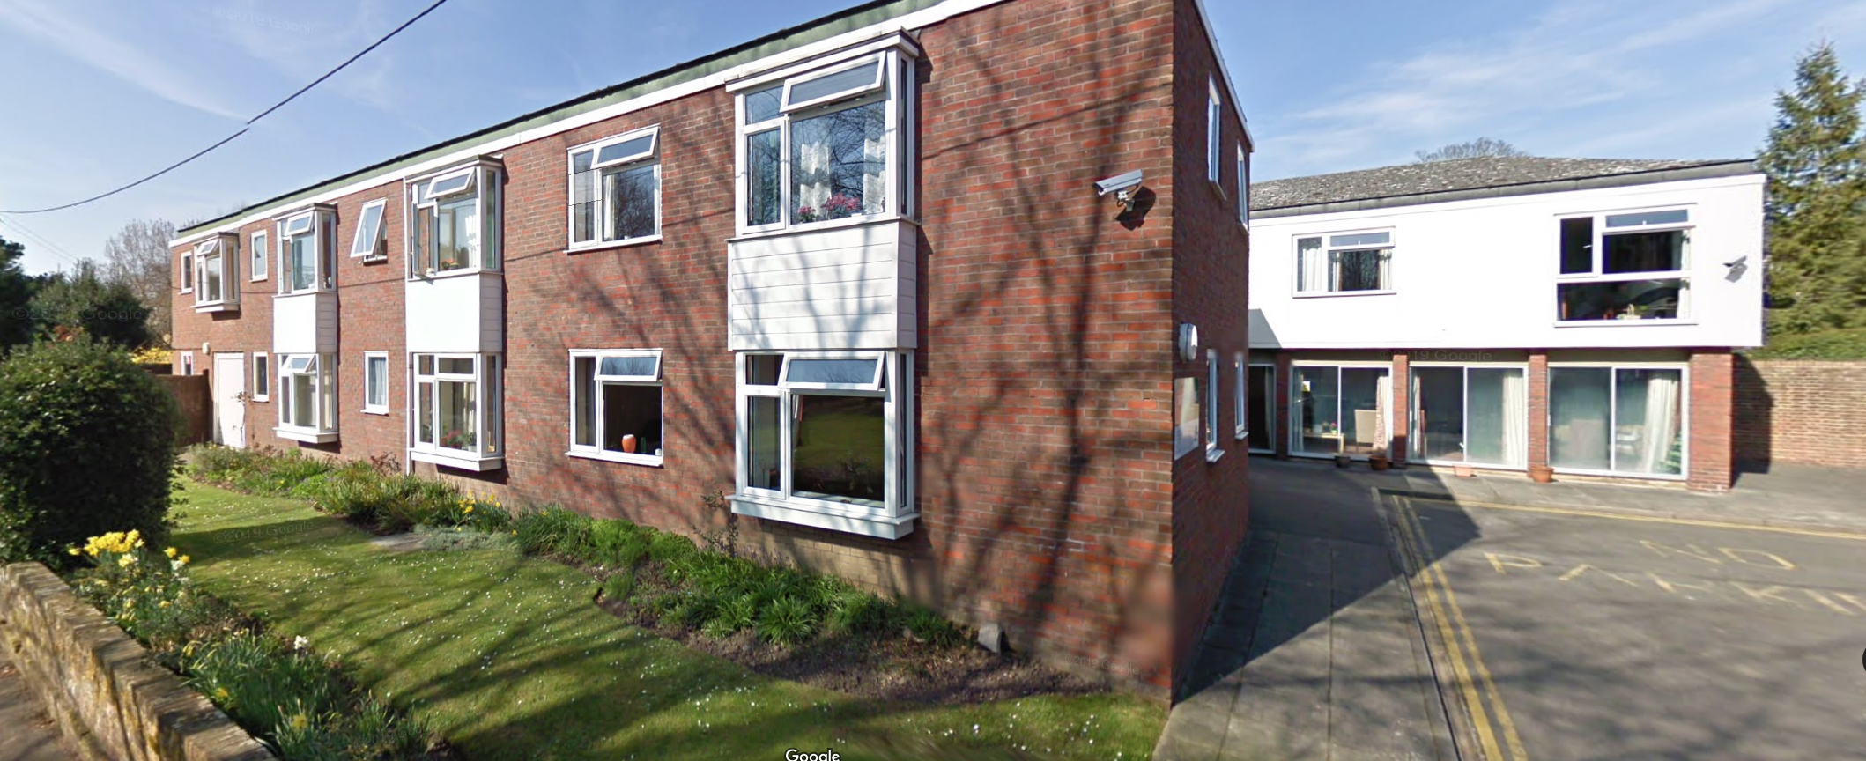

This shows the building as present:
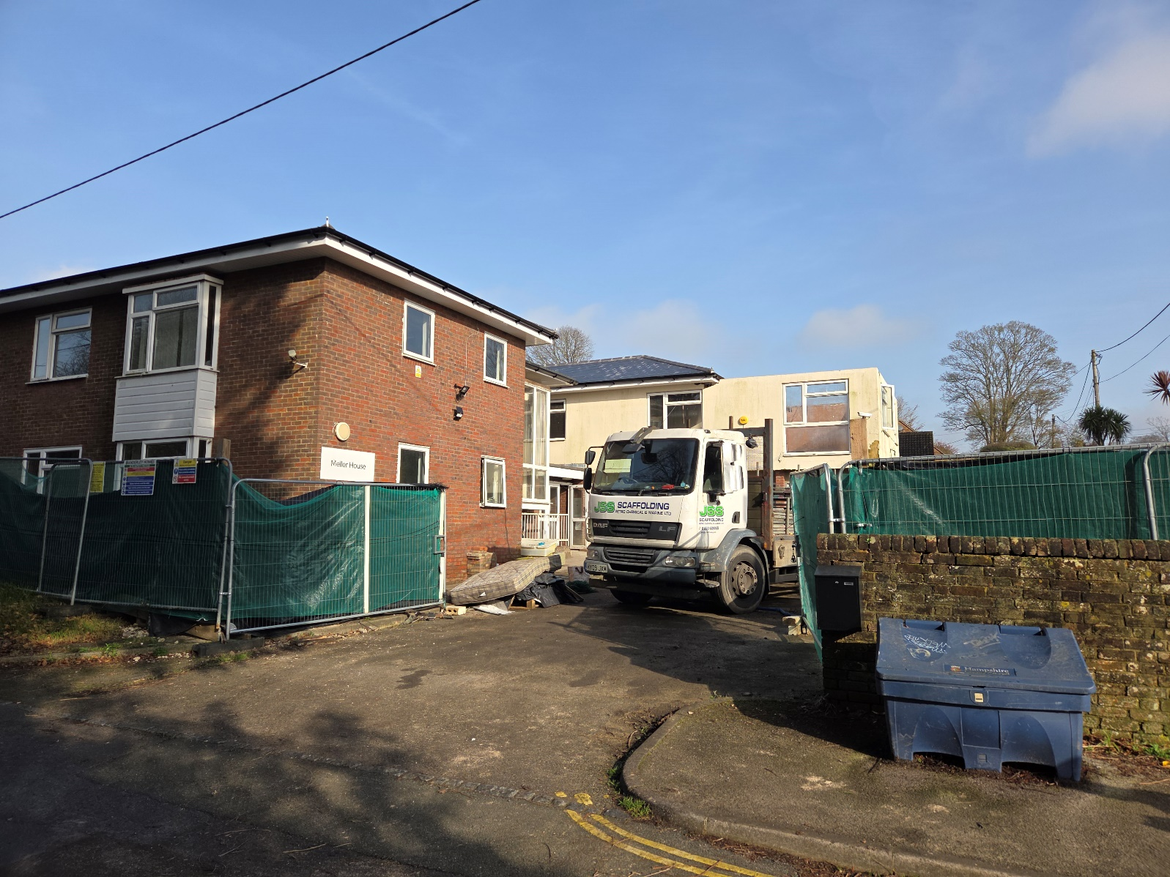
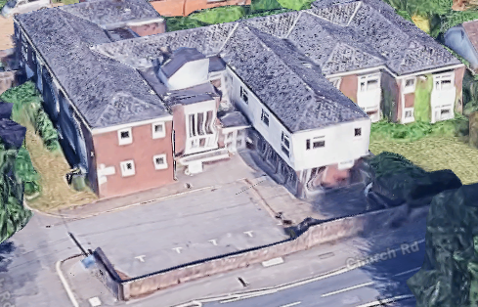

Evidence the site is in Flood Zone 1 (not susceptible to ponding or fluvial flooding)
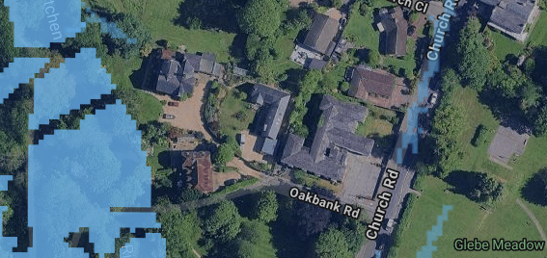

Accommodation Schedule (and evidence of compliance with National prescribed minimum standards)
Ex or Pp | Unit | Description | Floor | Area (m2) | Bed Size | Bed 1 (m) | Bed 1 (m2) | Bed 2 (m) | Bed 2 (m2) | Bed 3 (m) | Bed 3 (m2) | Former Flat No.
Existing | 1 | one bed | ground |  |  |  |  |  |  |  |  | 9
Existing | 2 | studio | ground |  |  |  |  |  |  |  |  | 8
Proposed | 3 | 2 floors | ground/first | 70 | 2Bed/ 3person | 5.3 x 3.4 | 18 | 3.8 x 2.1 | 7.6 |  |  | 7+
Proposed | 4 | 2 floors | ground/first | 122 | 3Bed /5 people | 3.3 x 5.3 | 19.5 | 3.5 x 2.8 | 10.1 | 5.1 x 2.7 | 13.7 | L+16+20
Existing | 5 | Studio | ground | 31.3 |  |  |  |  |  |  |  | 6
Proposed | 6 | one bed | ground | 51.5 | 1Bed/ 2 people | 5 x 2.5 | 13.2 |  |  |  |  | Common room
Proposed | 7 | 2 floors | ground/first | 70 | 2Bed/ 3 people | 4.4 x 2.6 | 11.5 | 2.5 x 2.6 | 7.5 |  |  | 5+14
Proposed | 8 | 2 floors | ground/first | 70 | 2Bed/ 3 people | 4.4 x 2.6 | 11.5 | 2.5 x 2.6 | 7.5 |  |  | 4+12
Proposed | 9 | 2 floors | ground/first | 70 | 2Bed/ 3 people | 4.4 x 2.6 | 11.5 | 2.5 x 2.6 | 7.5 |  |  | 3+13
Proposed | 10 | 2 floors | ground/first | 95.5 | 3Bed/ 4 people | 4.4 x 2.7 | 11.5 | 3.4 x 2.5 | 7.5 | 2.2 x 3.4 | 7.5 | 2+11
Proposed | 11 | 2 floors | ground/first | 84 | 3Bed/ 4 people | 4.3 x 2.8 | 11.5 | 2.3 x 3.4 | 7.5 | 2.3 x 3.4 | 7.5 | 1+10
Existing | 12 | one bed | first |  |  |  |  |  |  |  |  | 19
Existing | 13 | studio | first |  |  |  |  |  |  |  |  | 18
Proposed | 14 | one bed | first | 55.7 | 1Bed/ 2person | 3.7 x 3.2 | 11.8 |  |  |  |  | 21
Existing | 15 | studio | first |  |  |  |  |  |  |  |  | 15

Heritage Statement
A potted history of Meller House and the surrounding neighbourhood is contained within the application documents. In principle with regards to this application, the only relevant factor is the 1860 perimeter wall (primarily to Church Road) which we fully intend to retain and our proposed works in the immediate vicinity will preserve the structure of the wall.

