

Marina Drive Hamble -Le- Rice
Planning and heritage statement
Author of report -Alan Cotterill
Date 12-2-26
Introduction
Berkeley Homes built the above development approx. 25 years ago . The works included building 14no houses along with parking . There were some road improvement works involving making the entrance to Marina Drive wider . This was carried out by demolishing dilapidated brick retaining wall and constructing new log retaining wall with wall pushed back slightly to create easier vehicular access on marina Drive / Satchell Lane junction
Below extract from original construction drawing. Log retaining wall highlighted in red
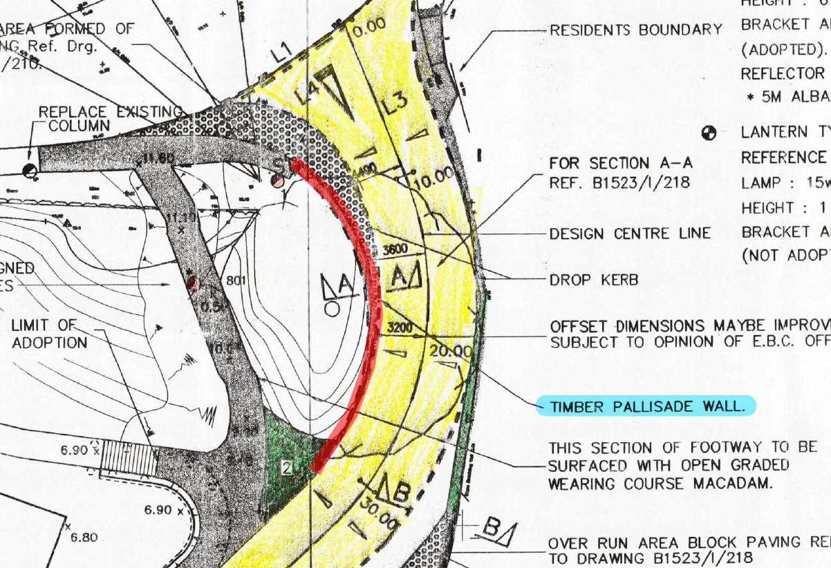

Proposed remedial works to estate roads
We are proposing to carry out remedial works to the estate roads following consultation with the estate management team and the residents . We have produced a detailed scope of works for road and drainage defects . We are currently obtaining quotations from sub-contractors to carry out the remedial works and will be placing orders shortly . Part of the defects works is to replace log retaining wall . We believe the replacement wall will require planning permission.
Please note there is a separate planning application to carry out some tree works in the same area . The application submitted by the residents .

Below drawing showing existing and proposed elevation (The replacement wall is approx. 22m long )
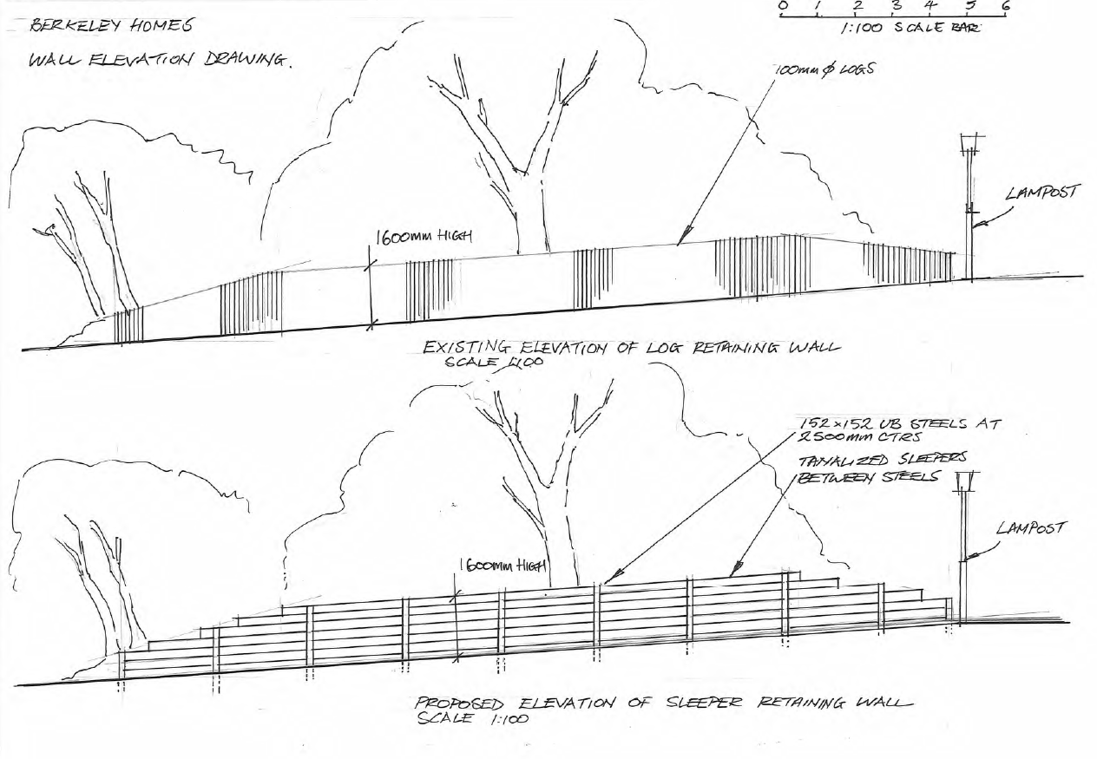

Below defects identified
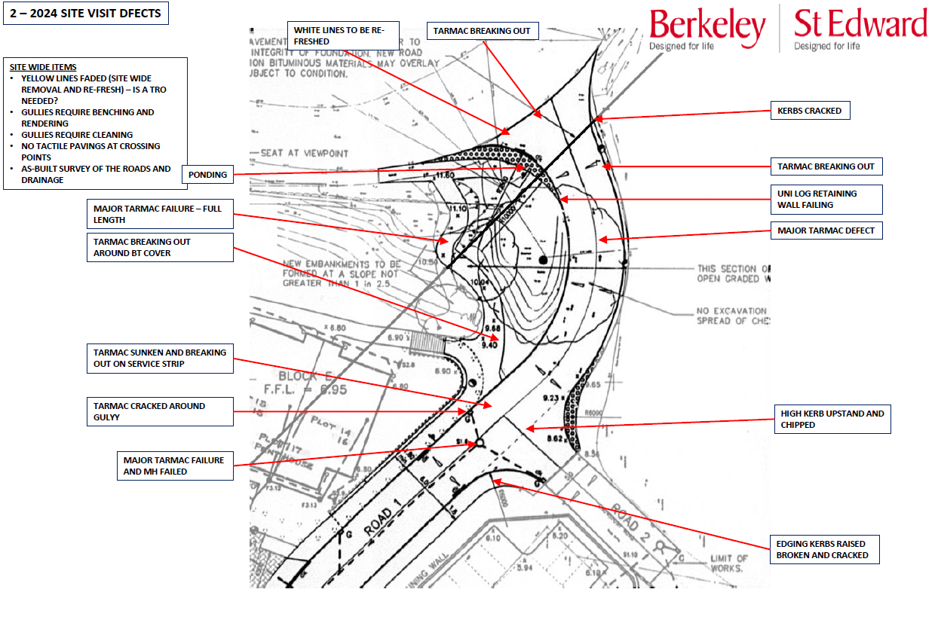

Description of work that requires planning permission
Replacement of log retaining wall on one side of Marina Drive with timber sleepers and steel posts . The log retaining wall needs replacing due to age approx. 30years old . Refer to photos of existing log retaining wall
Image below showing photo of proposed railway sleeper/steel retaining wall

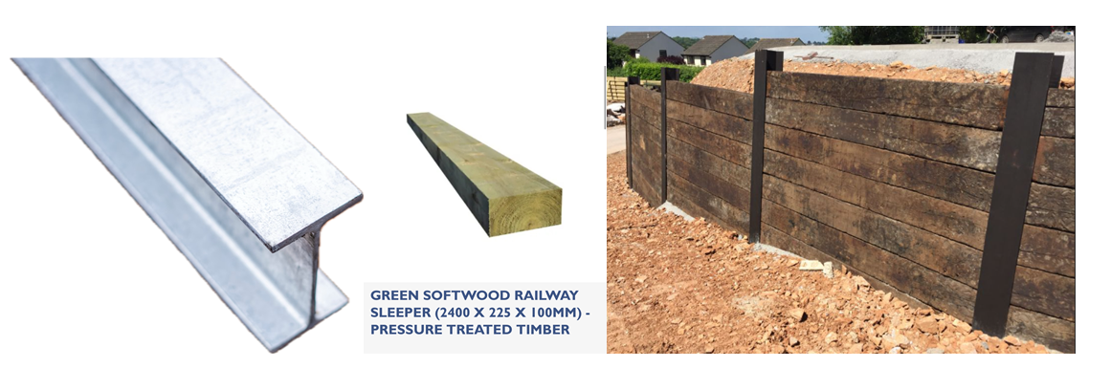

Location plan of development Berkeley Homes built approx. 25 years
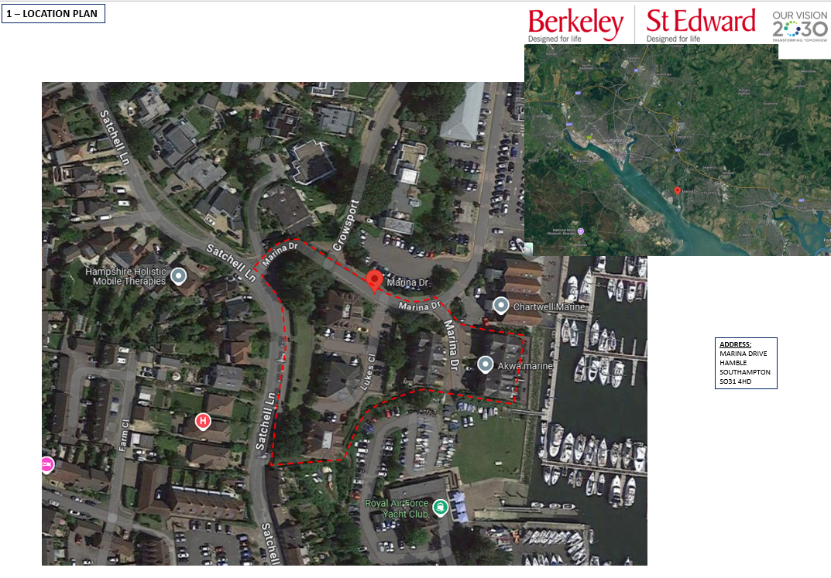

Below site plan of development . The proposed sleeper wall highlighted in green .
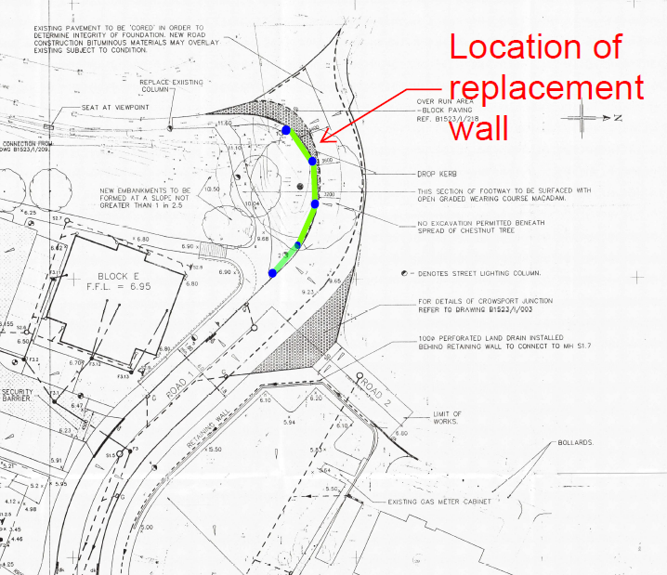

Below photos of existing log retaining wall
Photo 1
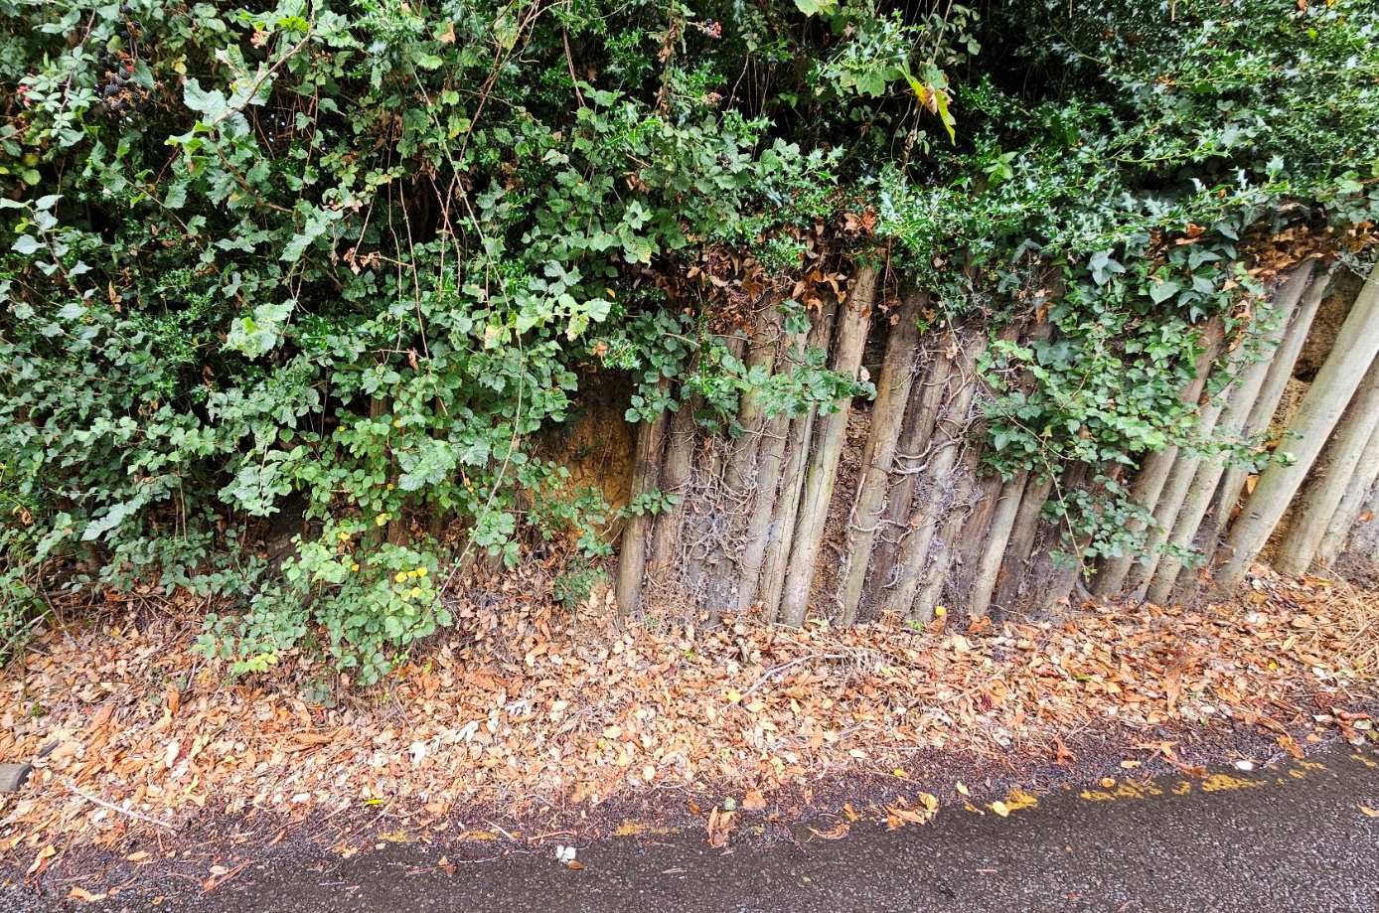
Photo 2 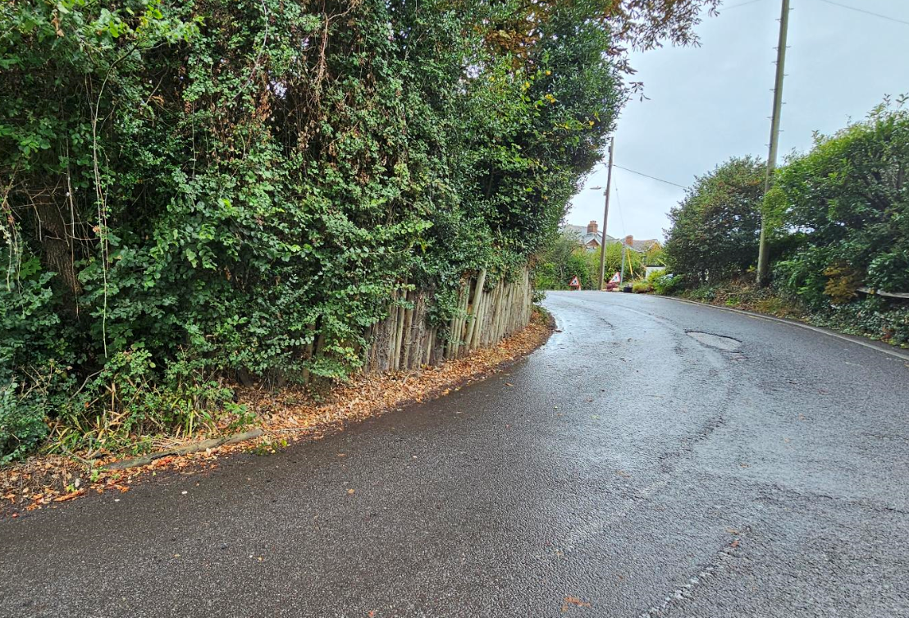
Photo 3
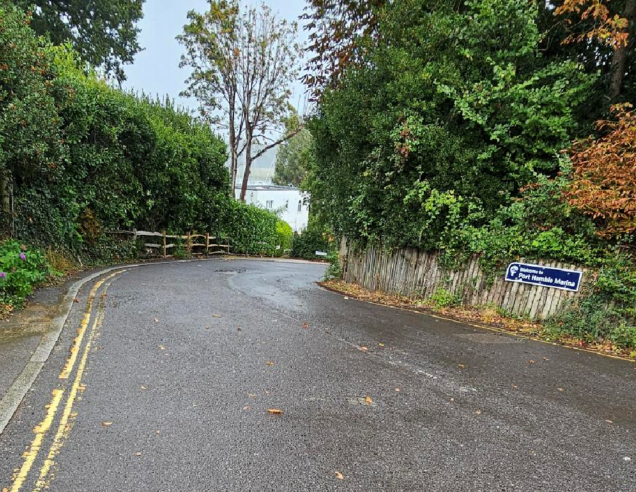
Photo 4 