Sketch plan for 3b woolston road
T1 – conifer

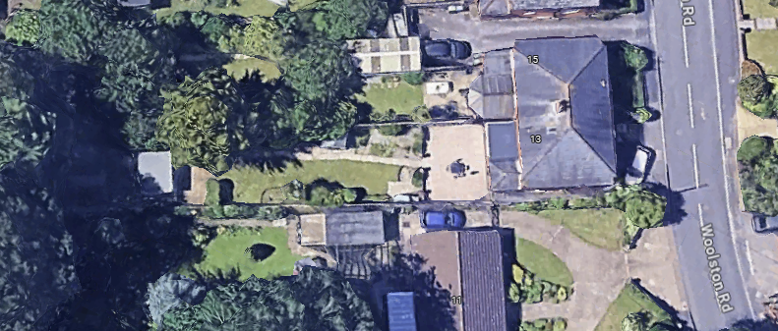
T1

