Sketch plan
31 randall Road SO53 5AJ

T1 Birch

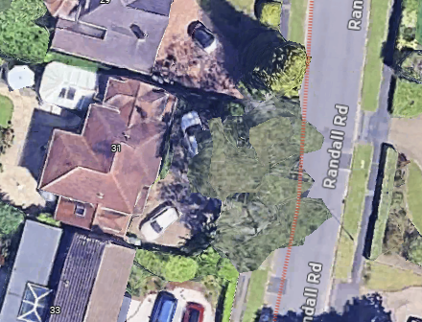
T1

