TPO Works Application: Supporting Statement
Property: 7 Corinthian Road, Chandlers Ford, Eastleigh, Hampshire, SO53 2BA
Tree Location: 7 & 9 Peverell Wood Avenue
Tree Species: Mature Oak
Council: Eastleigh Borough Council

1. Proposed Schedule of Works
The applicant seeks consent for the following specific arboriculture operations in accordance with BS 3998:2010:
- Crown Reduction: A reduction in overall height of 3m from the current estimated height of 17.5m, leaving an intended finished height of 14.5m.
- Lateral Reduction: A reduction of the overhanging canopy on the northern aspect by 3m, leaving an intended finished radial spread of 6m.
- Pruning Standards: All work will involve shortening branches to appropriate secondary growth points to maintain a balanced, natural shape and will avoid cutting through the main stem.
- Crown Lift: Lifting of the lower canopy to 4m above ground level.
- Deadwood Removal: Removal of all major dead, dying, or diseased wood throughout the crown. (Note: It is understood that LPA approval is not strictly required for the removal of dead branches )

2. Statement of Reasons
This application is submitted based on the following safety and amenity justifications:
A. Safety and Risk Mitigation
- The tree’s canopy currently encroaches over the applicant’s garden by approximately 9m.
- Directly beneath this canopy is a high-use children’s play area.
- There is a documented history of significant deadwood falling into this play area, posing a direct hazard to residents.
- The proposed reduction is the minimum necessary to reduce "sail area" and mechanical stress on the limbs, minimising the risk of failure over this high-occupancy zone.
B. Structural Integrity and Tree Health
- Reducing the weight on overextended lateral limbs will prevent "end-loading" failure.
- The proposed reduction to recognised growth points ensures the tree’s physiological health is maintained while managing its size in a suburban context.
C. Reasonable Enjoyment of Property
- The 9m encroachment results in near-total shading of the primary amenity space.
- This work seeks a compromise: retaining the tree’s contribution to the landscape while restoring a safe level of light and usage to the garden.

3. Photographic Evidence & Site Plan
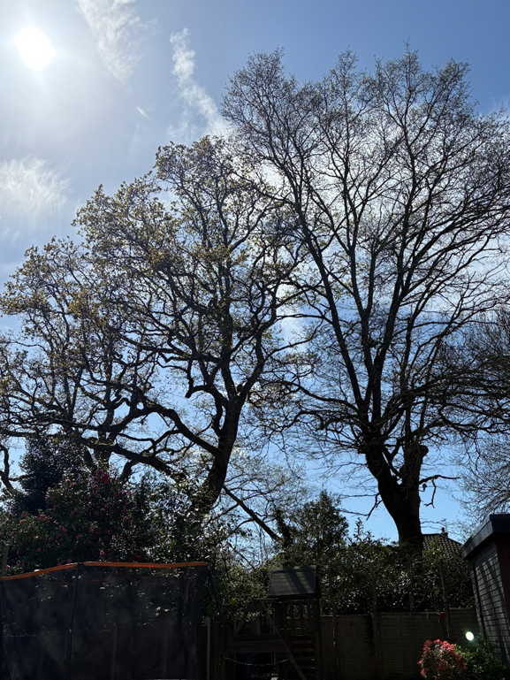

Annotated image showing the proposed 3-4m reduction line to suitable growth points.

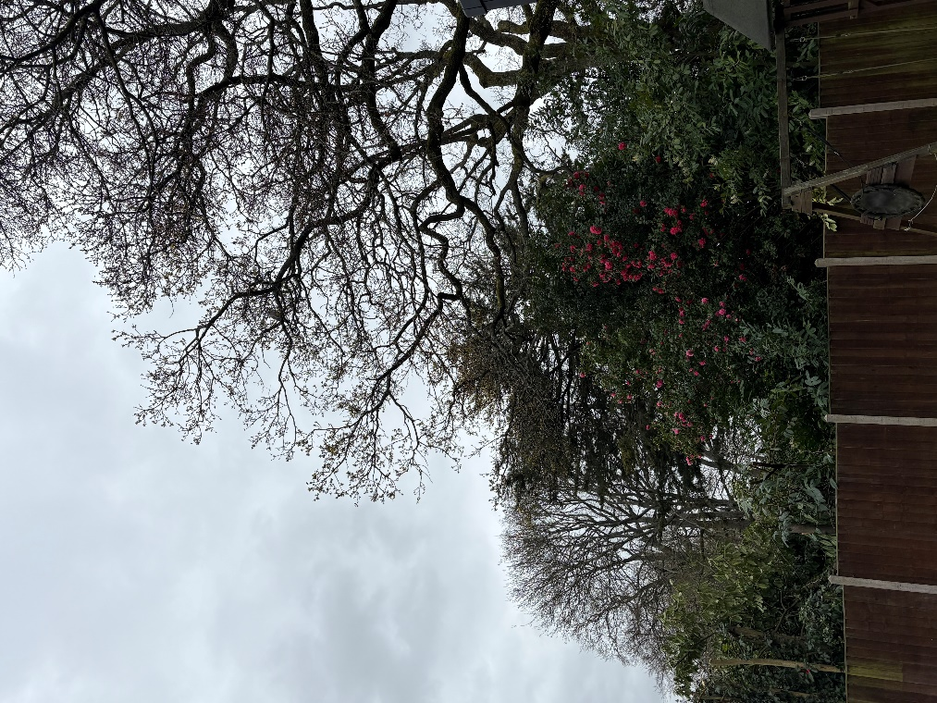

Overall view of the Oak showing the 10m encroachment over the boundary.

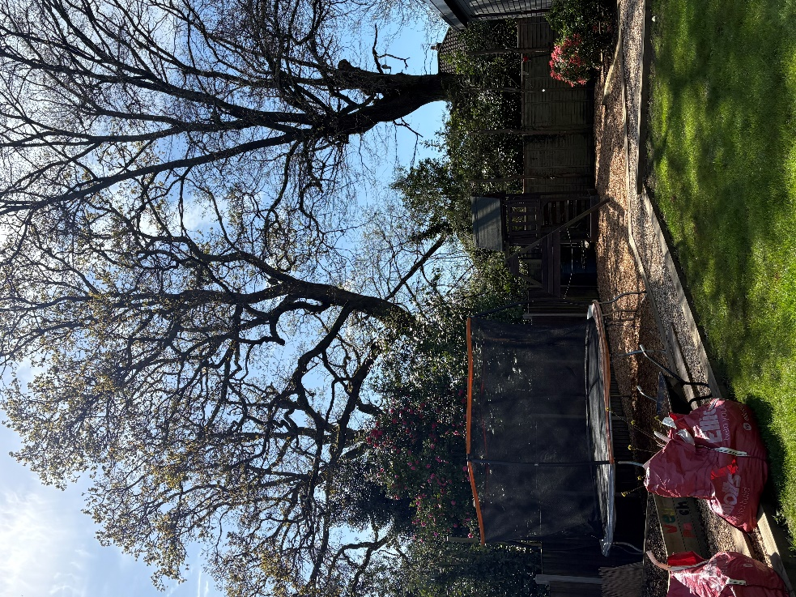

View of children’s play equipment positioned directly beneath overhanging deadwood.

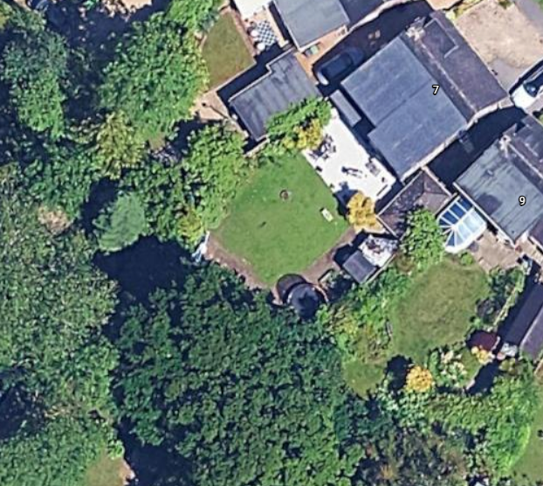

T1

Sketch plan identifying the tree (T1), the boundary line, and the house

4. Implementation
All works are to be carried out by a suitably qualified and insured arboricultural contractor in full accordance with BS 3998:2010 (Tree Work – Recommendations).
The applicant recognizes the amenity value of this specimen. In accordance with the guidance that the LPA may discuss alternative works:
Should the Local Planning Authority consider the proposed 4m reduction to be in excess of acceptable limits for this specimen, the applicant requests that the Tree Officer propose a modified specification (e.g., a 2m or 3m reduction) rather than issuing a flat refusal. The applicant is fully prepared to discuss a compromise that balances the tree's health with the safety and light requirements of the garden.

